## J-Tips Design Document

Take ‘br’ layout as example：

1: tips’s width great than target’s width, It should be look like this:

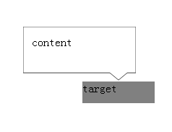

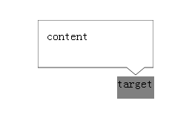

Rule: tip’s left= target’s view left+target’s width/2 –(tip’s width-2*arrow_padding)

2: tips’s width less than target’s width, It should be look like this:

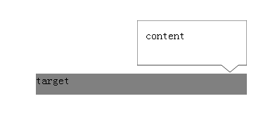

Rule: tip’s left= target’s view left+target’s width-tip’s width