# Annexe 3.0

All data available (ALL OF/F/S other than a few removed ones)

## WS

### Best models

|  |  |  |  |
| --- | --- | --- | --- |
| **Ridge Regression** | **Decision Tree** | **Gradient Boosting** | **Random Forest** |
| Alpha: 1.0  Solver: SAGA | Criterion: Friedman MSE  Max Features: Square Root  Min Samples Split: 3  Splitter: Best | Learning Rate: 0.1  Loss: Squared Error  Number of Estimators: 100  Warm Start: True | Criterion: Squared Error  Max Features: Square Root  Min Samples Split: 2  Number of Estimators: 50 |
| **AdaBoost** | **K-Nearest** | **MLP Regressor** | **Elastic Net** |
| Learning Rate: 1.0  Loss: Linear  Number of Estimators: 100 | Algorithm: Ball Tree  Leaf Size: 5  Metric: Cityblock  Number of Neighbors: 10  Weights: Distance | Activation: Tanh  Hidden Layer Sizes: (50, 50, 50)  Learning Rate: Constant  Solver: LBFGS | Copy X: False  Fit Intercept: True  L1 Ratio: 0.25  Positive: False  Precompute: True  Selection: Random  Warm Start: False |
| **SGD Regressor** | **Support Vector** | **Bayesian Ridge** | **Kernel Ridge** |
| Learning Rate: Invscaling  Loss: Huber  Penalty: L2  Warm Start: False | Degree: 1  Gamma: Auto  Kernel: RBF  Shrinking: True | Alpha 1: 1e-07  Alpha 2: 1e-05  Lambda 1: 1e-05  Lambda 2: 1e-07 | Alpha: 1e-05  Coef0: 0.0  Degree: 1  Kernel: RBF |
| **Linear Regression** | **RANSAC** | **TheilSen** | **Tensorflow** |
| Copy X: True  Fit Intercept: True  Positive: True | Loss: Squared Error  Max Trials: 50  Min Samples: 5 | Max Subpopulation: 10  Number of Subsamples: None | 9*64 layers |

### Prediction Results

**Model: Ridge**  
RMSE: 90.22670643258866  
**Model: DecisionTreeRegressor**  
RMSE: 1.9968172957008925  
**Model: GradientBoostingRegressor**  
RMSE: 0.544826987505936  
**Model: RandomForestRegressor**  
RMSE: 1.0987622584152377  
**Model: AdaBoostRegressor**  
RMSE: 0.7076541869093533  
**Model: KNeighborsRegressor**  
RMSE: 1.2748583437842687  
**Model: MLPRegressor**  
RMSE: 1.6081885999695513  
**Model: ElasticNet**  
RMSE: 1.4965730635872543  
**Model: SGDRegressor**  
RMSE: 59.99805784101674  
**Model: SVR**  
RMSE: 1.7361207355310198  
**Model: BayesianRidge**  
RMSE: 24.961305924495004  
**Model: KernelRidge**  
RMSE: 1.3995834713043132  
**Model: LinearRegression**  
RMSE: 30.075194146850553  
**Model: RANSACRegressor**  
RMSE: 143.52348656275498  
**Model: TheilSenRegressor**  
RMSE: 751.4759874475466  
**Model: TensorFlow**  
RMSE: 484.6445665205789

### Graphs

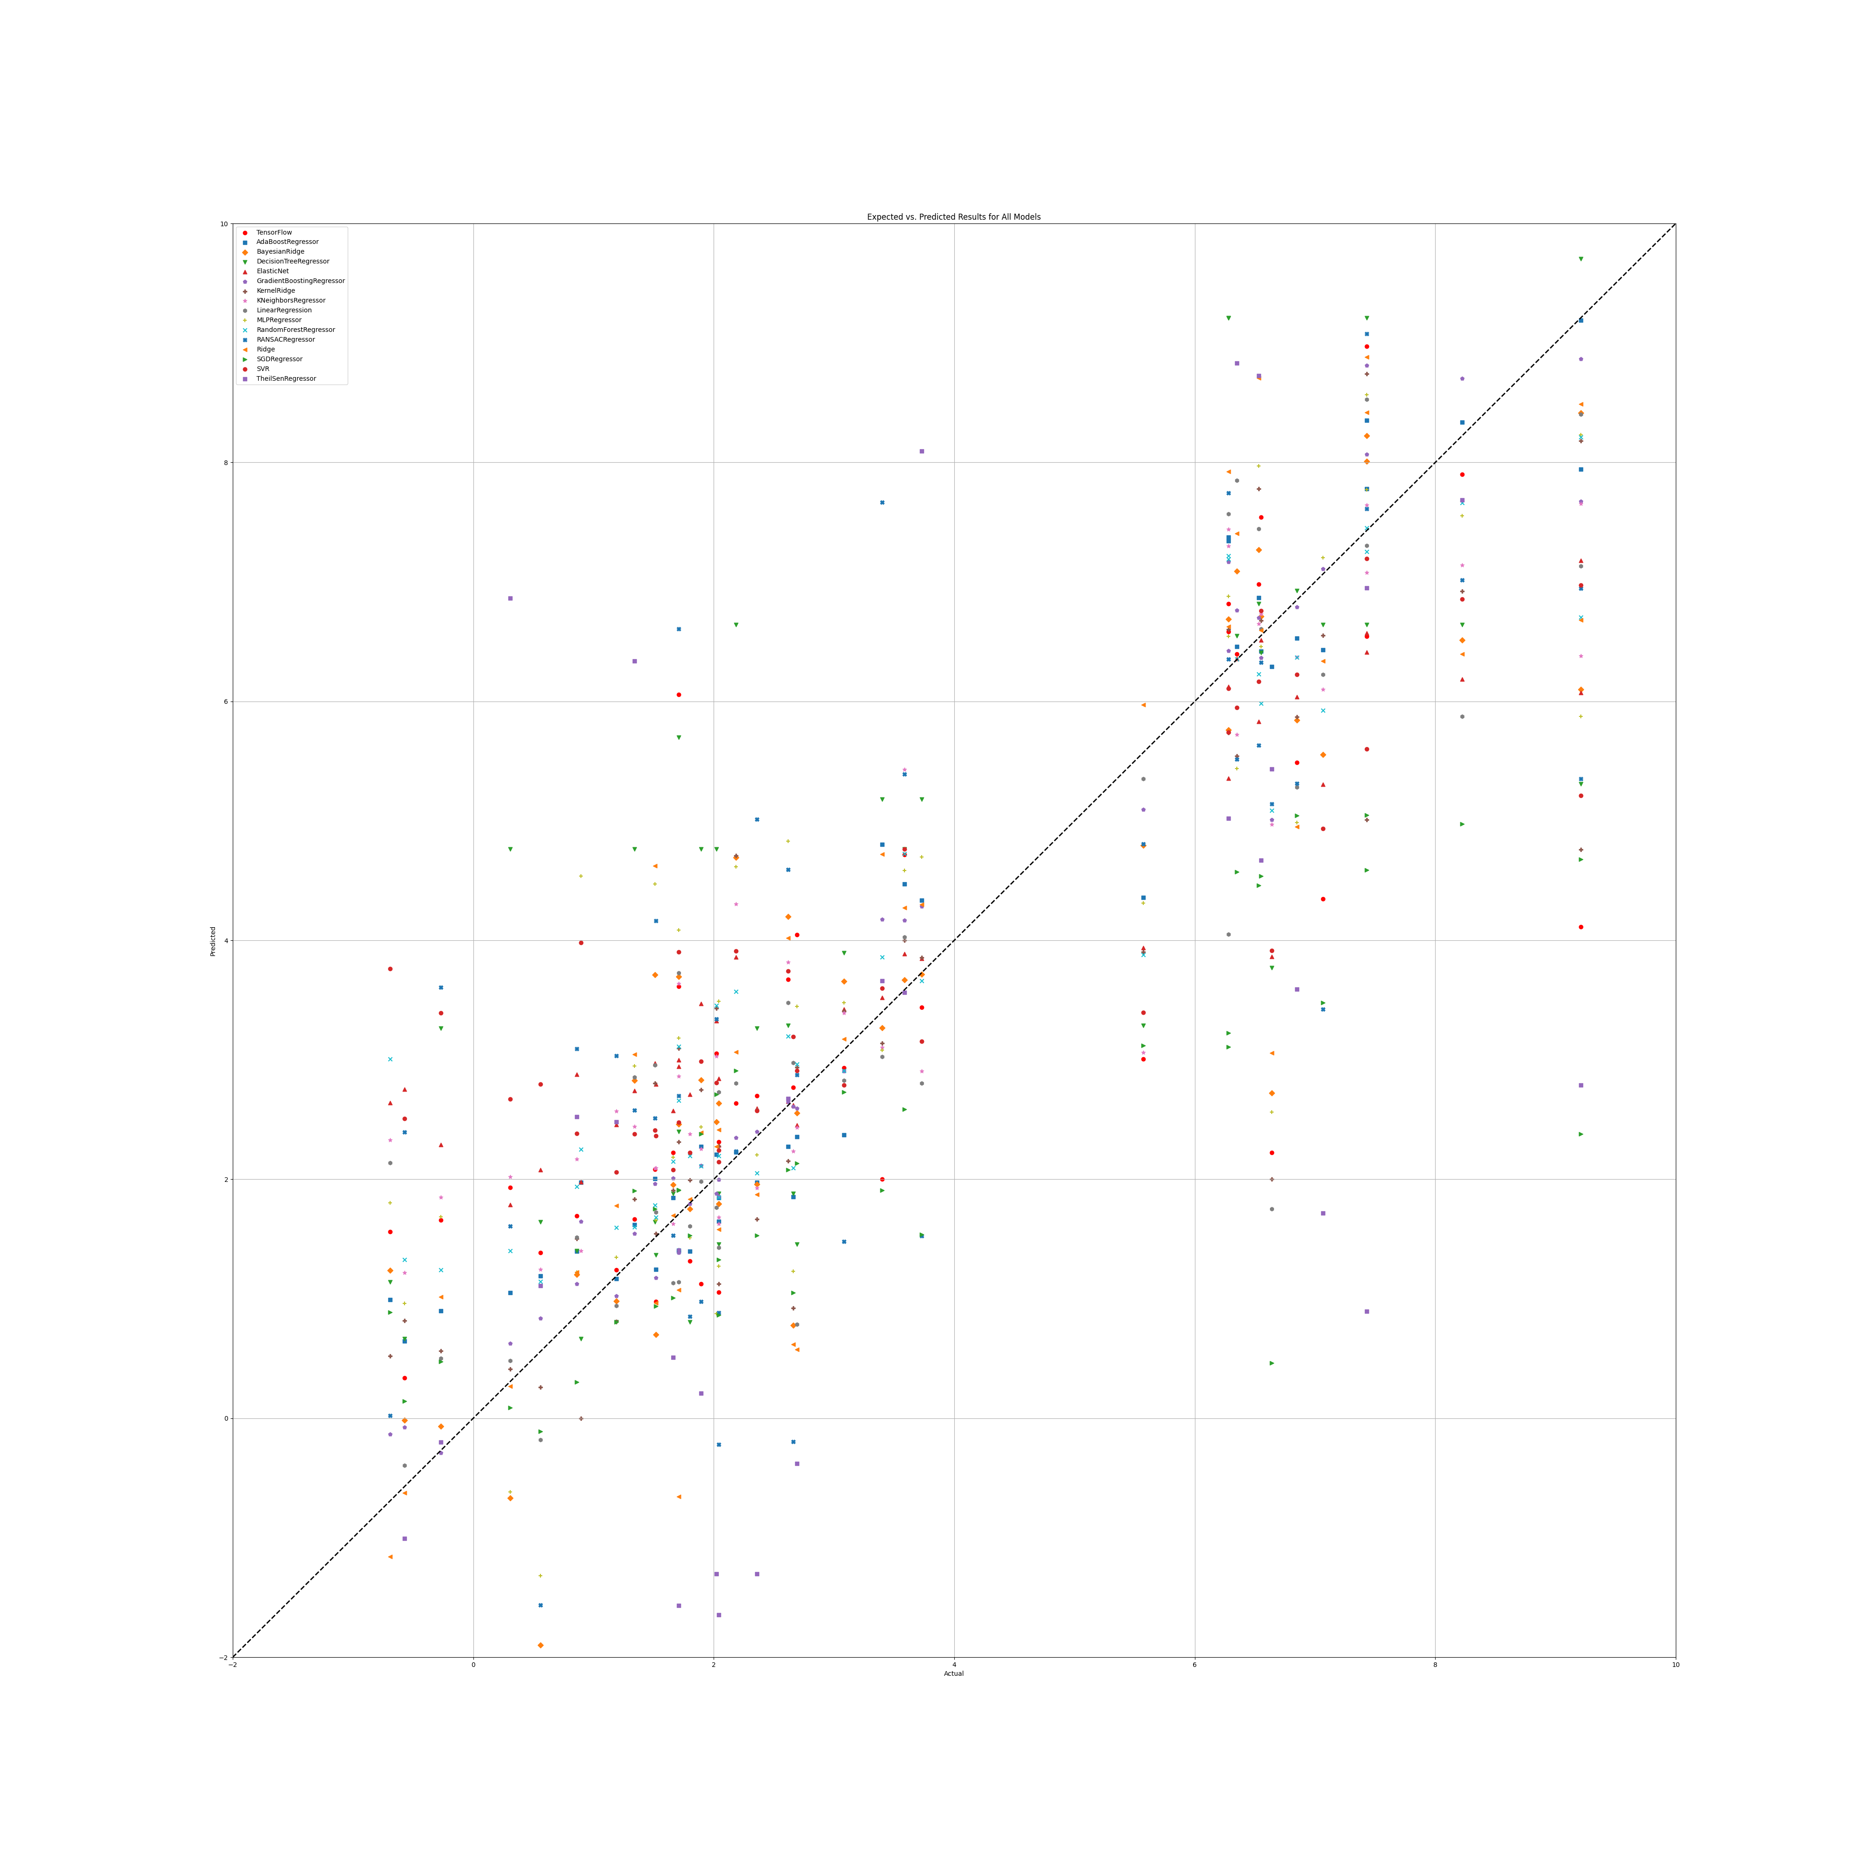

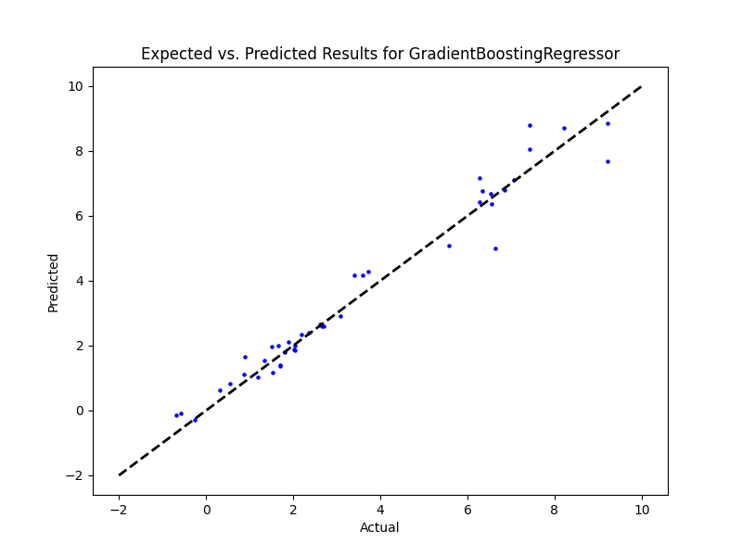

## WS Benefit

|  |  |  |  |
| --- | --- | --- | --- |
| **Ridge Regression** | **Decision Tree** | **Gradient Boosting** | **Random Forest** |
| Alpha: 0.1  Solver: SAGA | Criterion: Friedman MSE  Max Features: Square Root  Min Samples Split: 4  Splitter: Random | Learning Rate: 0.1  Loss: Squared Error  Number of Estimators: 50  Warm Start: True | Criterion: Absolute Error  Max Features: Square Root  Min Samples Split: 5  Number of Estimators: 100 |
| **AdaBoost** | **K-Nearest** | **MLP Regressor** | **Elastic Net** |
| Learning Rate: 1.0  Loss: Square  Number of Estimators: 50 | Algorithm: Brute  Leaf Size: 5  Metric: Cosine  Number of Neighbors: 10  Weights: Distance | Activation: Logistic  Hidden Layer Sizes: (50, 50, 50)  Learning Rate: Constant  Solver: LBFGS | Copy X: False  Fit Intercept: True  L1 Ratio: 0.25  Positive: False  Precompute: False  Selection: Random  Warm Start: True |
| **SGD Regressor** | **Support Vector** | **Bayesian Ridge** | **Kernel Ridge** |
| Learning Rate: Adaptive  Loss: Huber  Penalty: L1  Warm Start: True | Degree: 1  Gamma: Scale  Kernel: Sigmoid  Shrinking: False | Alpha 1: 1e-07  Alpha 2: 1e-05  Lambda 1: 1e-05  Lambda 2: 1e-07 | Alpha: 1.0  Coef0: 0.5  Degree: 1  Kernel: Sigmoid |
| **Linear Regression** | **RANSAC** | **TheilSen** | **Tensorflow** |
| Copy X: True  Fit Intercept: False  Positive: True | Loss: Squared Error  Max Trials: 1  Min Samples: 1 | Max Subpopulation: 100  Number of Subsamples: None | 9*64 |

## Prediction Results

**Model: Ridge**  
RMSE: 1006.9572722968278  
  
**Model: DecisionTreeRegressor**  
RMSE: 2.814785369119617  
  
**Model: GradientBoostingRegressor**  
RMSE: 1.2064709415972212  
  
**Model: RandomForestRegressor**  
RMSE: 2.2138284773999537  
  
**Model: AdaBoostRegressor**  
RMSE: 1.4692412631989573  
  
**Model: KNeighborsRegressor**  
RMSE: 2.5909836095578025  
  
**Model: MLPRegressor**  
RMSE: 2.895474116113076  
  
**Model: ElasticNet**  
RMSE: 43.8976780293878  
  
**Model: SGDRegressor**  
RMSE: 627.6216688266124  
  
**Model: SVR**  
RMSE: 4.668561660570477  
  
**Model: BayesianRidge**  
RMSE: 614.8306076054536  
  
**Model: KernelRidge**  
RMSE: 10.336258502816893  
  
**Model: LinearRegression**  
RMSE: 856.1078047304413  
  
**Model: RANSACRegressor**  
RMSE: 4.189465067686237  
  
**Model: TheilSenRegressor**  
RMSE: 1006.4518045394468  
**Model: TensorFlow**  
RMSE: 325.0057384048459

## Graphs

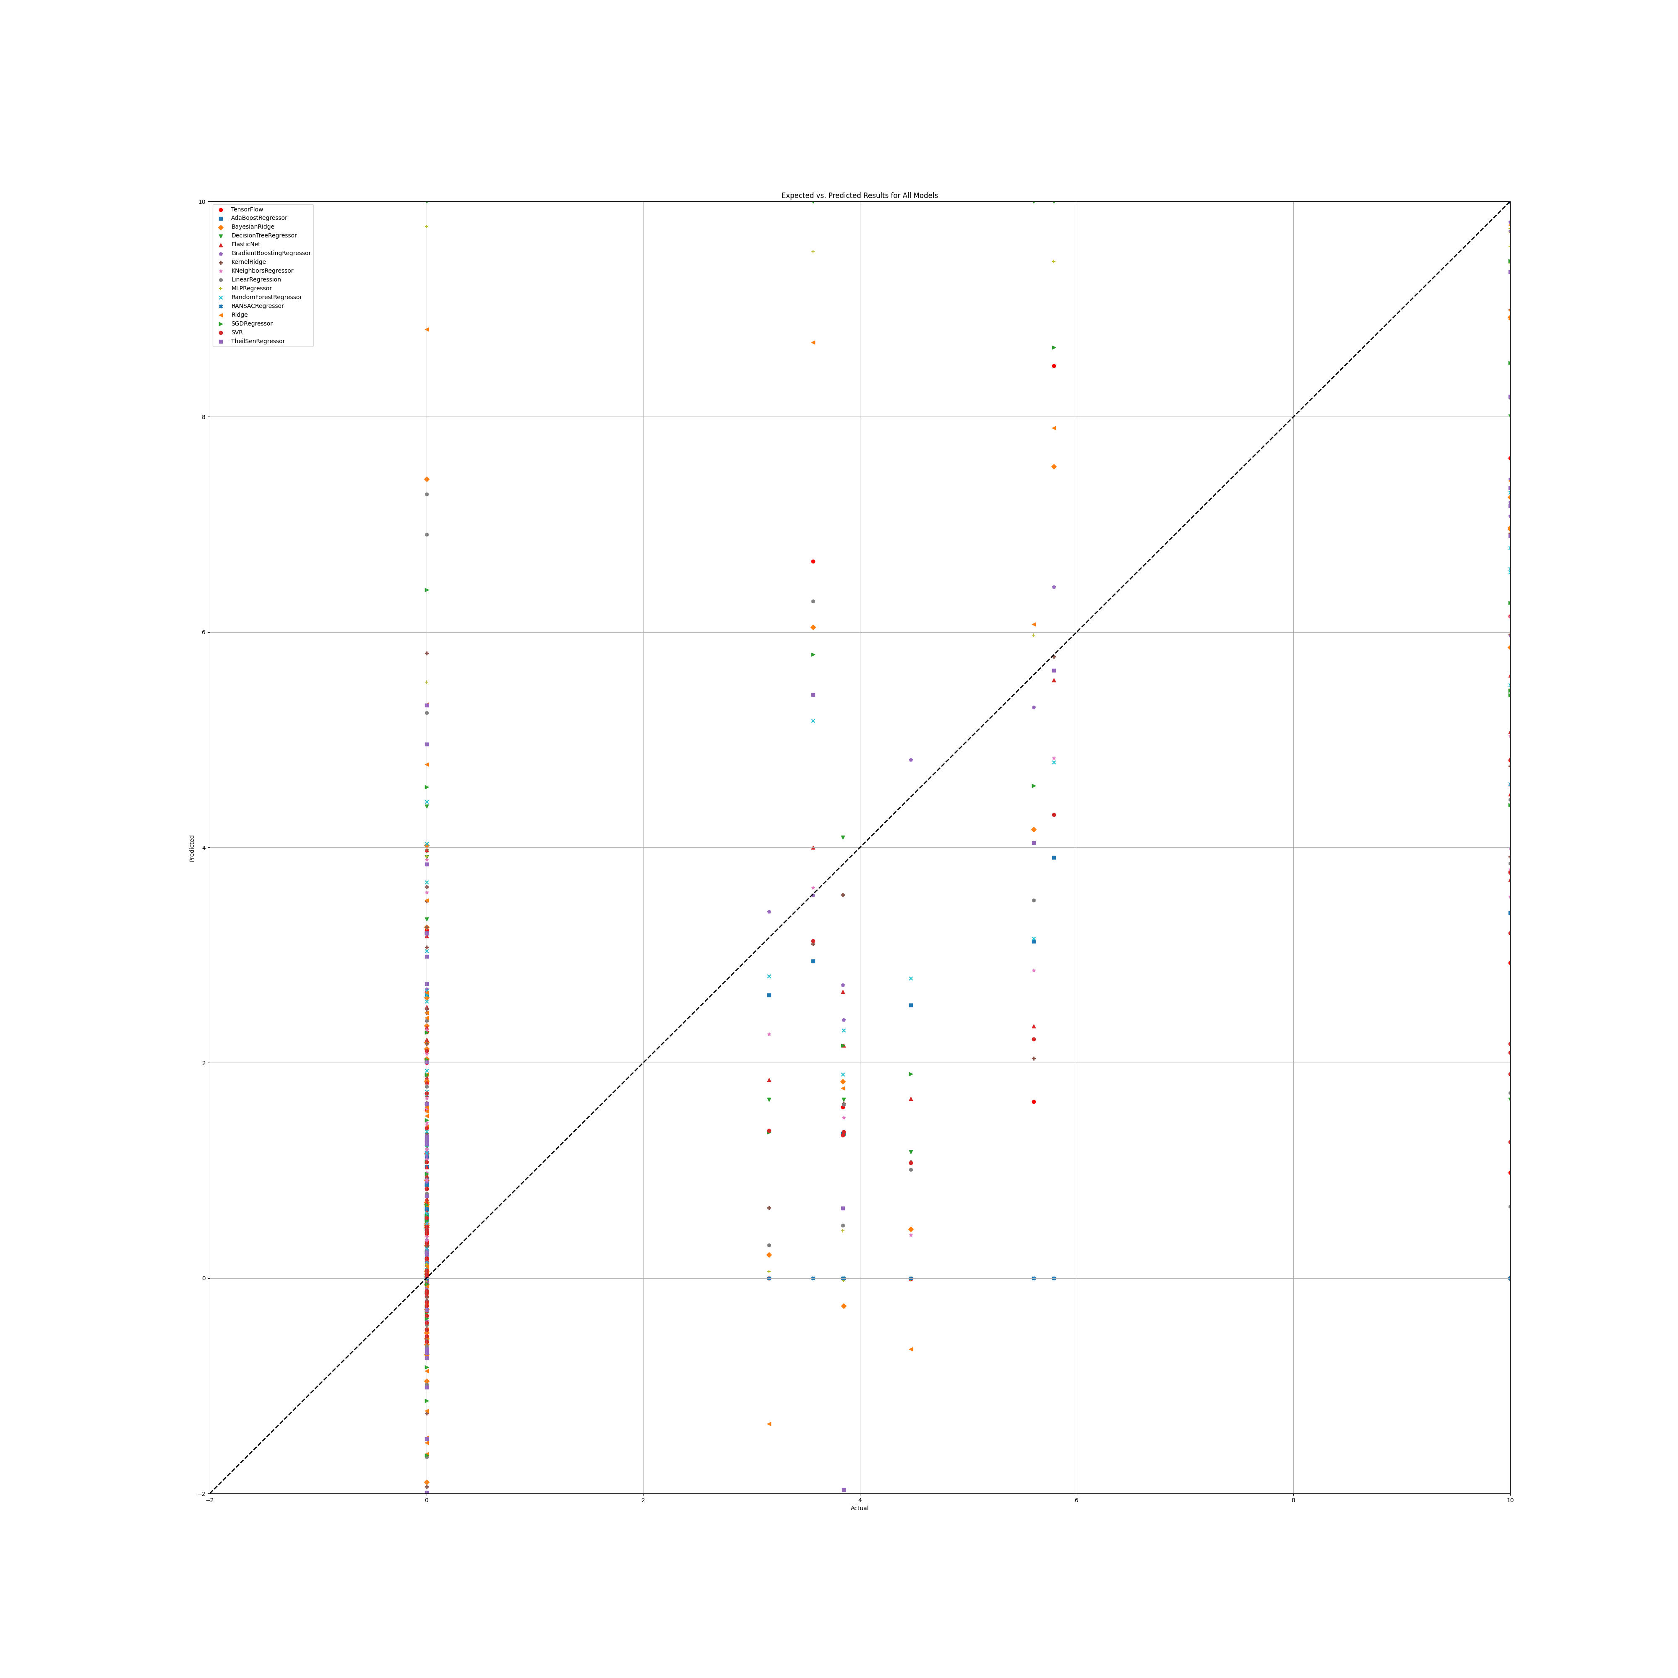

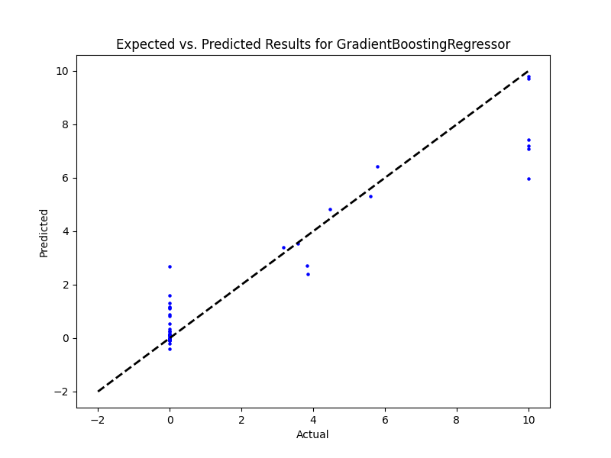

## NR

|  |  |  |  |
| --- | --- | --- | --- |
| **Ridge Regression** | **Decision Tree** | **Gradient Boosting** | **Random Forest** |
| Alpha: 0.5  Solver: SAGA | Criterion: Absolute Error  Max Features: Square Root  Min Samples Split: 2  Splitter: Best | Learning Rate: 0.1  Loss: Squared Error  Number of Estimators: 100  Warm Start: False | Criterion: Absolute Error  Max Features: Square Root  Min Samples Split: 2  Number of Estimators: 50 |
| **AdaBoost** | **K-Nearest** | **MLP Regressor** | **Elastic Net** |
| Learning Rate: 1.0  Loss: Square  Number of Estimators: 50 | Algorithm: Ball Tree  Leaf Size: 5  Metric: Cityblock  Number of Neighbors: 5  Weights: Distance | Activation: Logistic  Hidden Layer Sizes: (50, 50, 50)  Learning Rate: Adaptive  Solver: LBFGS | Copy X: True  Fit Intercept: True  L1 Ratio: 0.75  Positive: False  Precompute: False  Selection: Cyclic  Warm Start: True |
| **SGD Regressor** | **Support Vector** | **Bayesian Ridge** | **Kernel Ridge** |
| Learning Rate: Invscaling  Loss: Huber  Penalty: L1  Warm Start: False | Degree: 1  Gamma: Auto  Kernel: RBF  Shrinking: True | Alpha 1: 1e-07  Alpha 2: 1e-05  Lambda 1: 1e-05  Lambda 2: 1e-07 | Alpha: 1e-05  Coef0: 0.0  Degree: 1  Kernel: RBF |
| **Linear Regression** | **RANSAC** | **TheilSen** | **Tensorflow** |
| Copy X: True  Fit Intercept: True  Positive: False | Loss: Squared Error  Max Trials: 10  Min Samples: 10 | Max Subpopulation: 100  Number of Subsamples: None |  |

## Prediction results

**Model: Ridge**  
RMSE: 195.13283362485203  
  
**Model: DecisionTreeRegressor**  
RMSE: 2.3300994421913885  
  
**Model: GradientBoostingRegressor**  
RMSE: 0.6484348771468703  
  
**Model: RandomForestRegressor**  
RMSE: 0.9244580504346417  
  
**Model: AdaBoostRegressor**  
RMSE: 0.5822390614666533  
  
**Model: KNeighborsRegressor**  
RMSE: 1.1733041747459083  
  
**Model: MLPRegressor**  
RMSE: 1.4799891263792768  
  
**Model: ElasticNet**  
RMSE: 1.5347954590900423  
  
**Model: SGDRegressor**  
RMSE: 132.84110621955267  
  
**Model: SVR**  
RMSE: 1.687153314815784  
  
**Model: BayesianRidge**  
RMSE: 10.109147703528897  
  
**Model: KernelRidge**  
RMSE: 1.3944851395619184  
  
**Model: LinearRegression**  
RMSE: 27109600984.679623  
  
**Model: RANSACRegressor**  
RMSE: 95.35761653231444  
  
**Model: TheilSenRegressor**  
RMSE: 133.68813046043493  
  
**Model: TensorFlow**  
RMSE: 517.0788793400361

## Graph

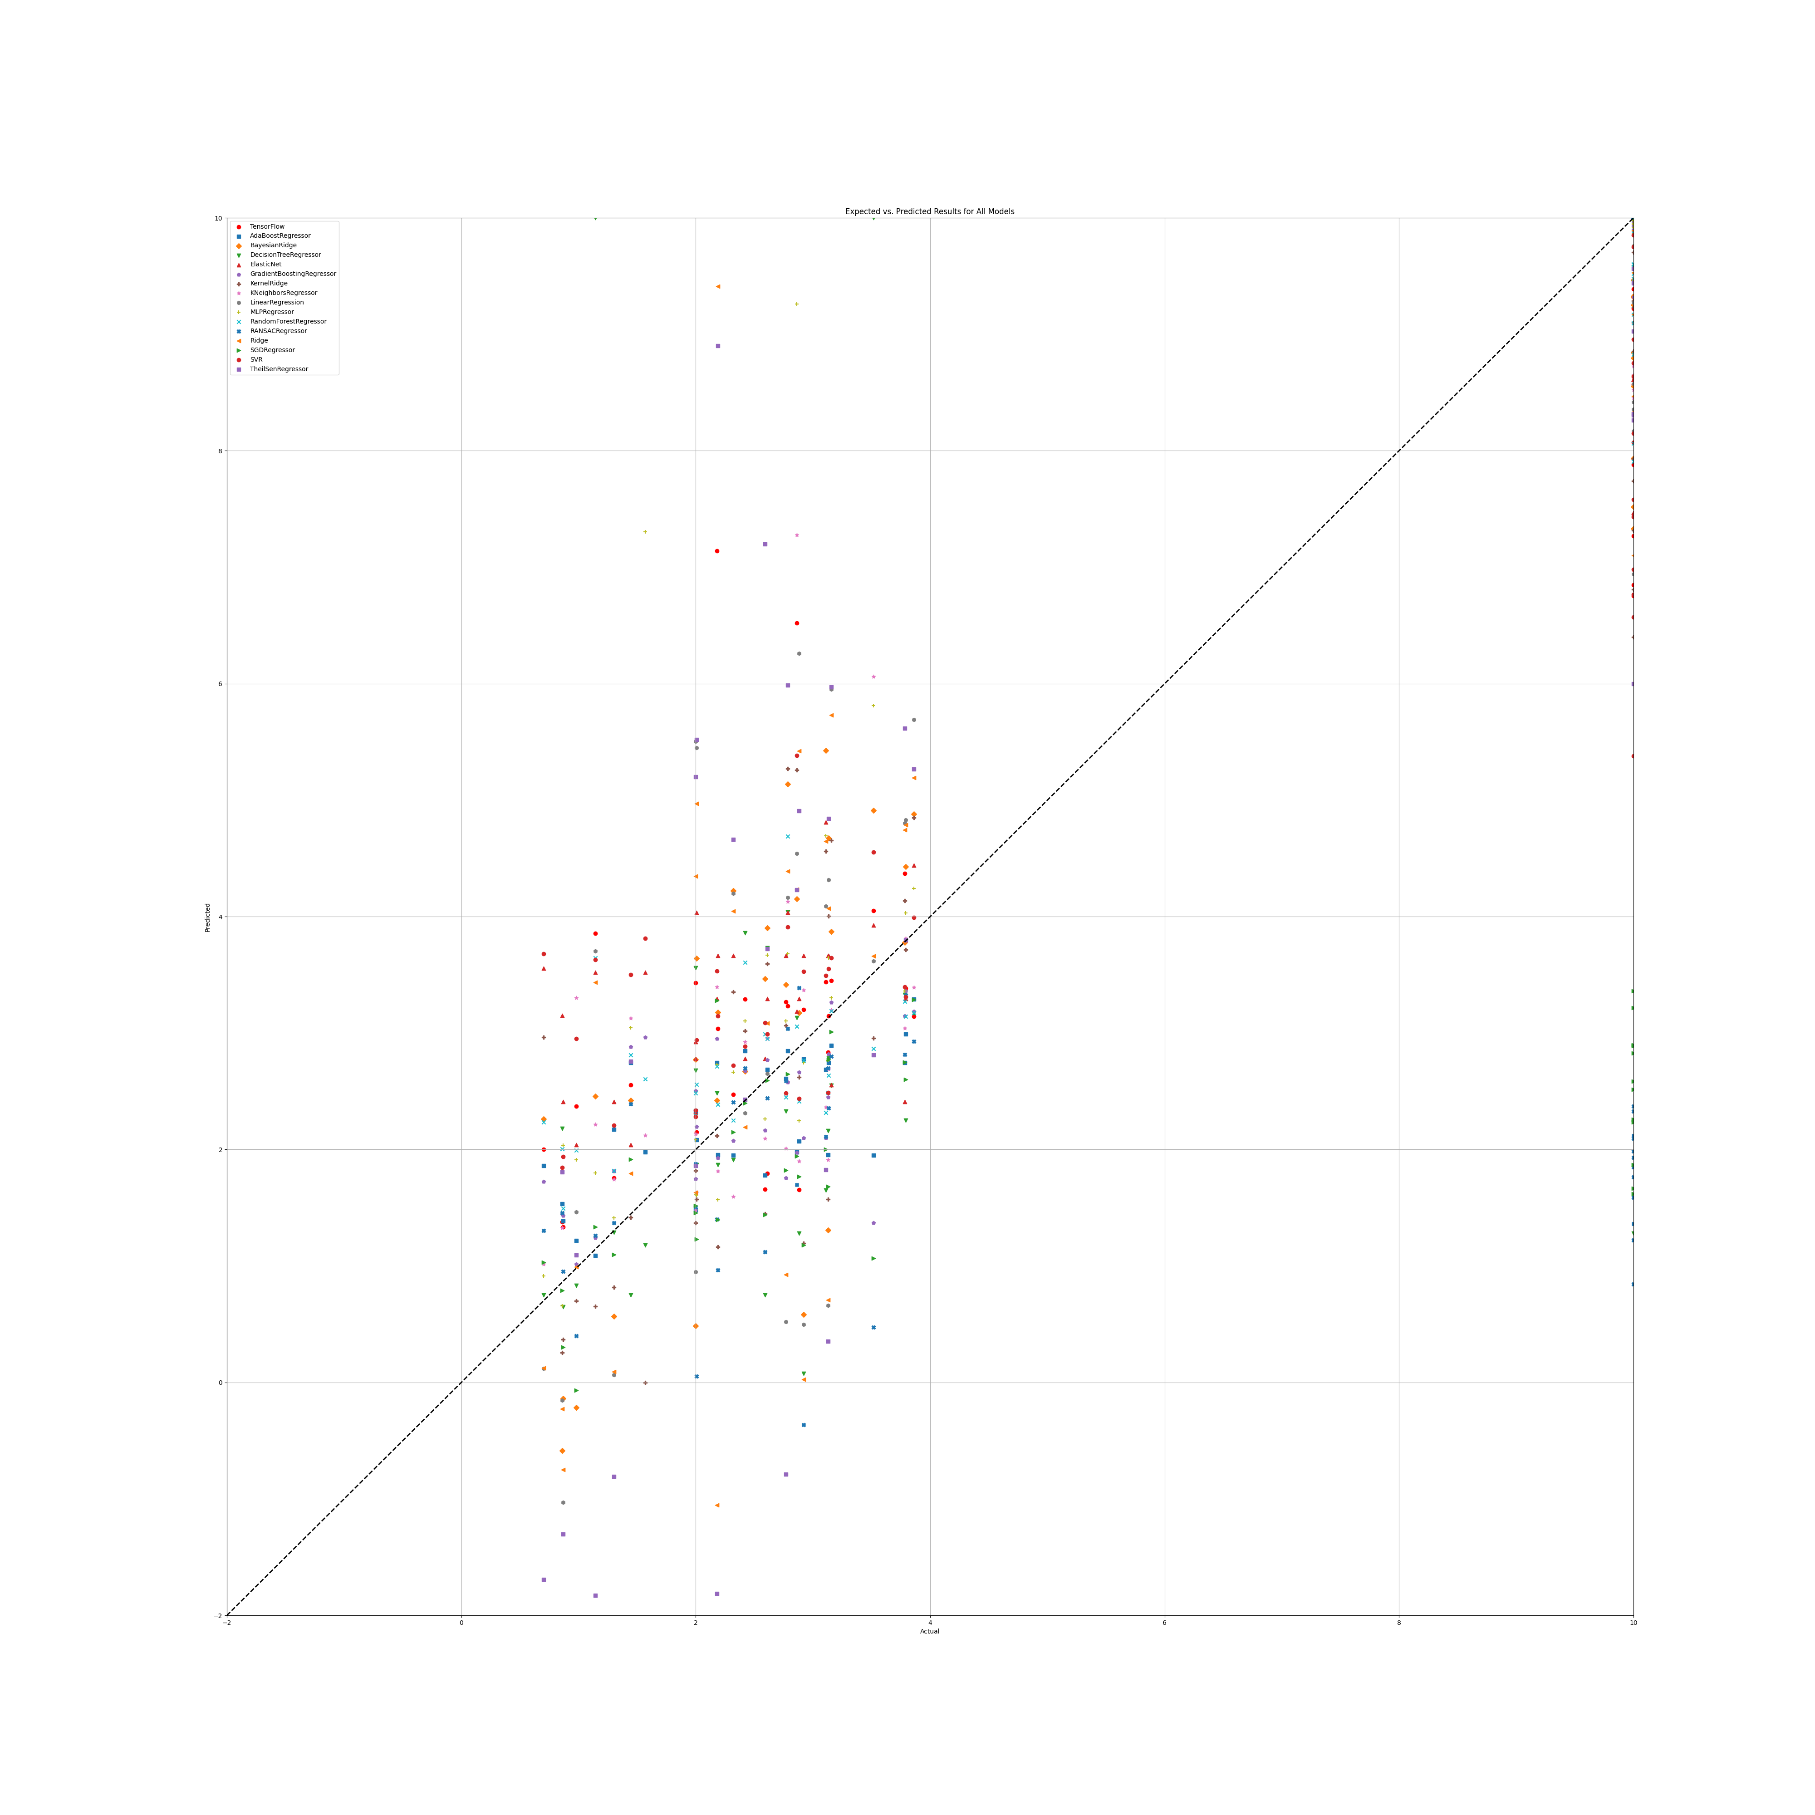

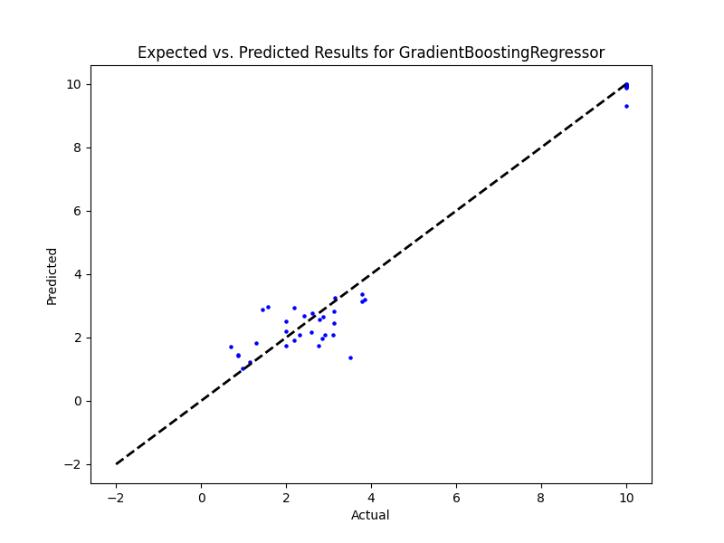

## NR Benefit

|  |  |  |  |
| --- | --- | --- | --- |
| **Ridge Regression** | **Decision Tree** | **Gradient Boosting** | **Random Forest** |
| Alpha: 1.0  Solver: SAGA | Criterion: Poisson  Max Features: Log2  Min Samples Split: 5  Splitter: Best | Learning Rate: 0.1  Loss: Huber  Number of Estimators: 100  Warm Start: False | Criterion: Squared Error  Max Features: Square Root  Min Samples Split: 5  Number of Estimators: 50 |
| **AdaBoost** | **K-Nearest** | **MLP Regressor** | **Elastic Net** |
| Learning Rate: 1.0  Loss: Exponential  Number of Estimators: 20 | Algorithm: Ball Tree  Leaf Size: 5  Metric: Cityblock  Number of Neighbors: 2  Weights: Distance | Activation: Tanh  Hidden Layer Sizes: (50, 50, 50)  Learning Rate: Adaptive  Solver: LBFGS | Copy X: True  Fit Intercept: True  L1 Ratio: 0.5  Positive: False  Precompute: False  Selection: Random  Warm Start: True |
| **SGD Regressor** | **Support Vector** | **Bayesian Ridge** | **Kernel Ridge** |
| Learning Rate: Invscaling  Loss: Huber  Penalty: L2  Warm Start: False | Degree: 1  Gamma: Scale  Kernel: Sigmoid  Shrinking: True | Alpha 1: 1e-07  Alpha 2: 1e-05  Lambda 1: 1e-05  Lambda 2: 1e-07 | Alpha: 1e-05  Coef0: 0.0  Degree: 1  Kernel: RBF |
| **Linear Regression** | **RANSAC** | **TheilSen** | **Tensorflow** |
| Copy X: True  Fit Intercept: True  Positive: False | Loss: Squared Error  Max Trials: 10  Min Samples: 50 | Max Subpopulation: 1000  Number of Subsamples: None |  |

## Prediction results

**Model: Ridge**  
RMSE: 818.9307851019263  
  
**Model: DecisionTreeRegressor**  
RMSE: 3.7178631151648633  
  
**Model: GradientBoostingRegressor**  
RMSE: 1.5263508298869712  
  
**Model: RandomForestRegressor**  
RMSE: 1.962740519031694  
  
**Model: AdaBoostRegressor**  
RMSE: 1.9167656330860758  
  
**Model: KNeighborsRegressor**  
RMSE: 2.9857133658269643  
  
**Model: MLPRegressor**  
RMSE: 3.3735058105282807  
  
**Model: ElasticNet**  
RMSE: 48.75850215740552  
  
**Model: SGDRegressor**  
RMSE: 150.81643022651718  
  
**Model: SVR**  
RMSE: 5.059801868468089  
  
**Model: BayesianRidge**  
RMSE: 352.8754455378979  
  
**Model: KernelRidge**  
RMSE: 3.081957133105729  
  
**Model: LinearRegression**  
RMSE: 8190879751194.571  
  
**Model: RANSACRegressor**  
RMSE: 1669.8244119902117  
  
**Model: TheilSenRegressor**  
RMSE: 880.6542348251088  
  
**Model: TensorFlow**  
RMSE: 380.68396219040244

## Graph

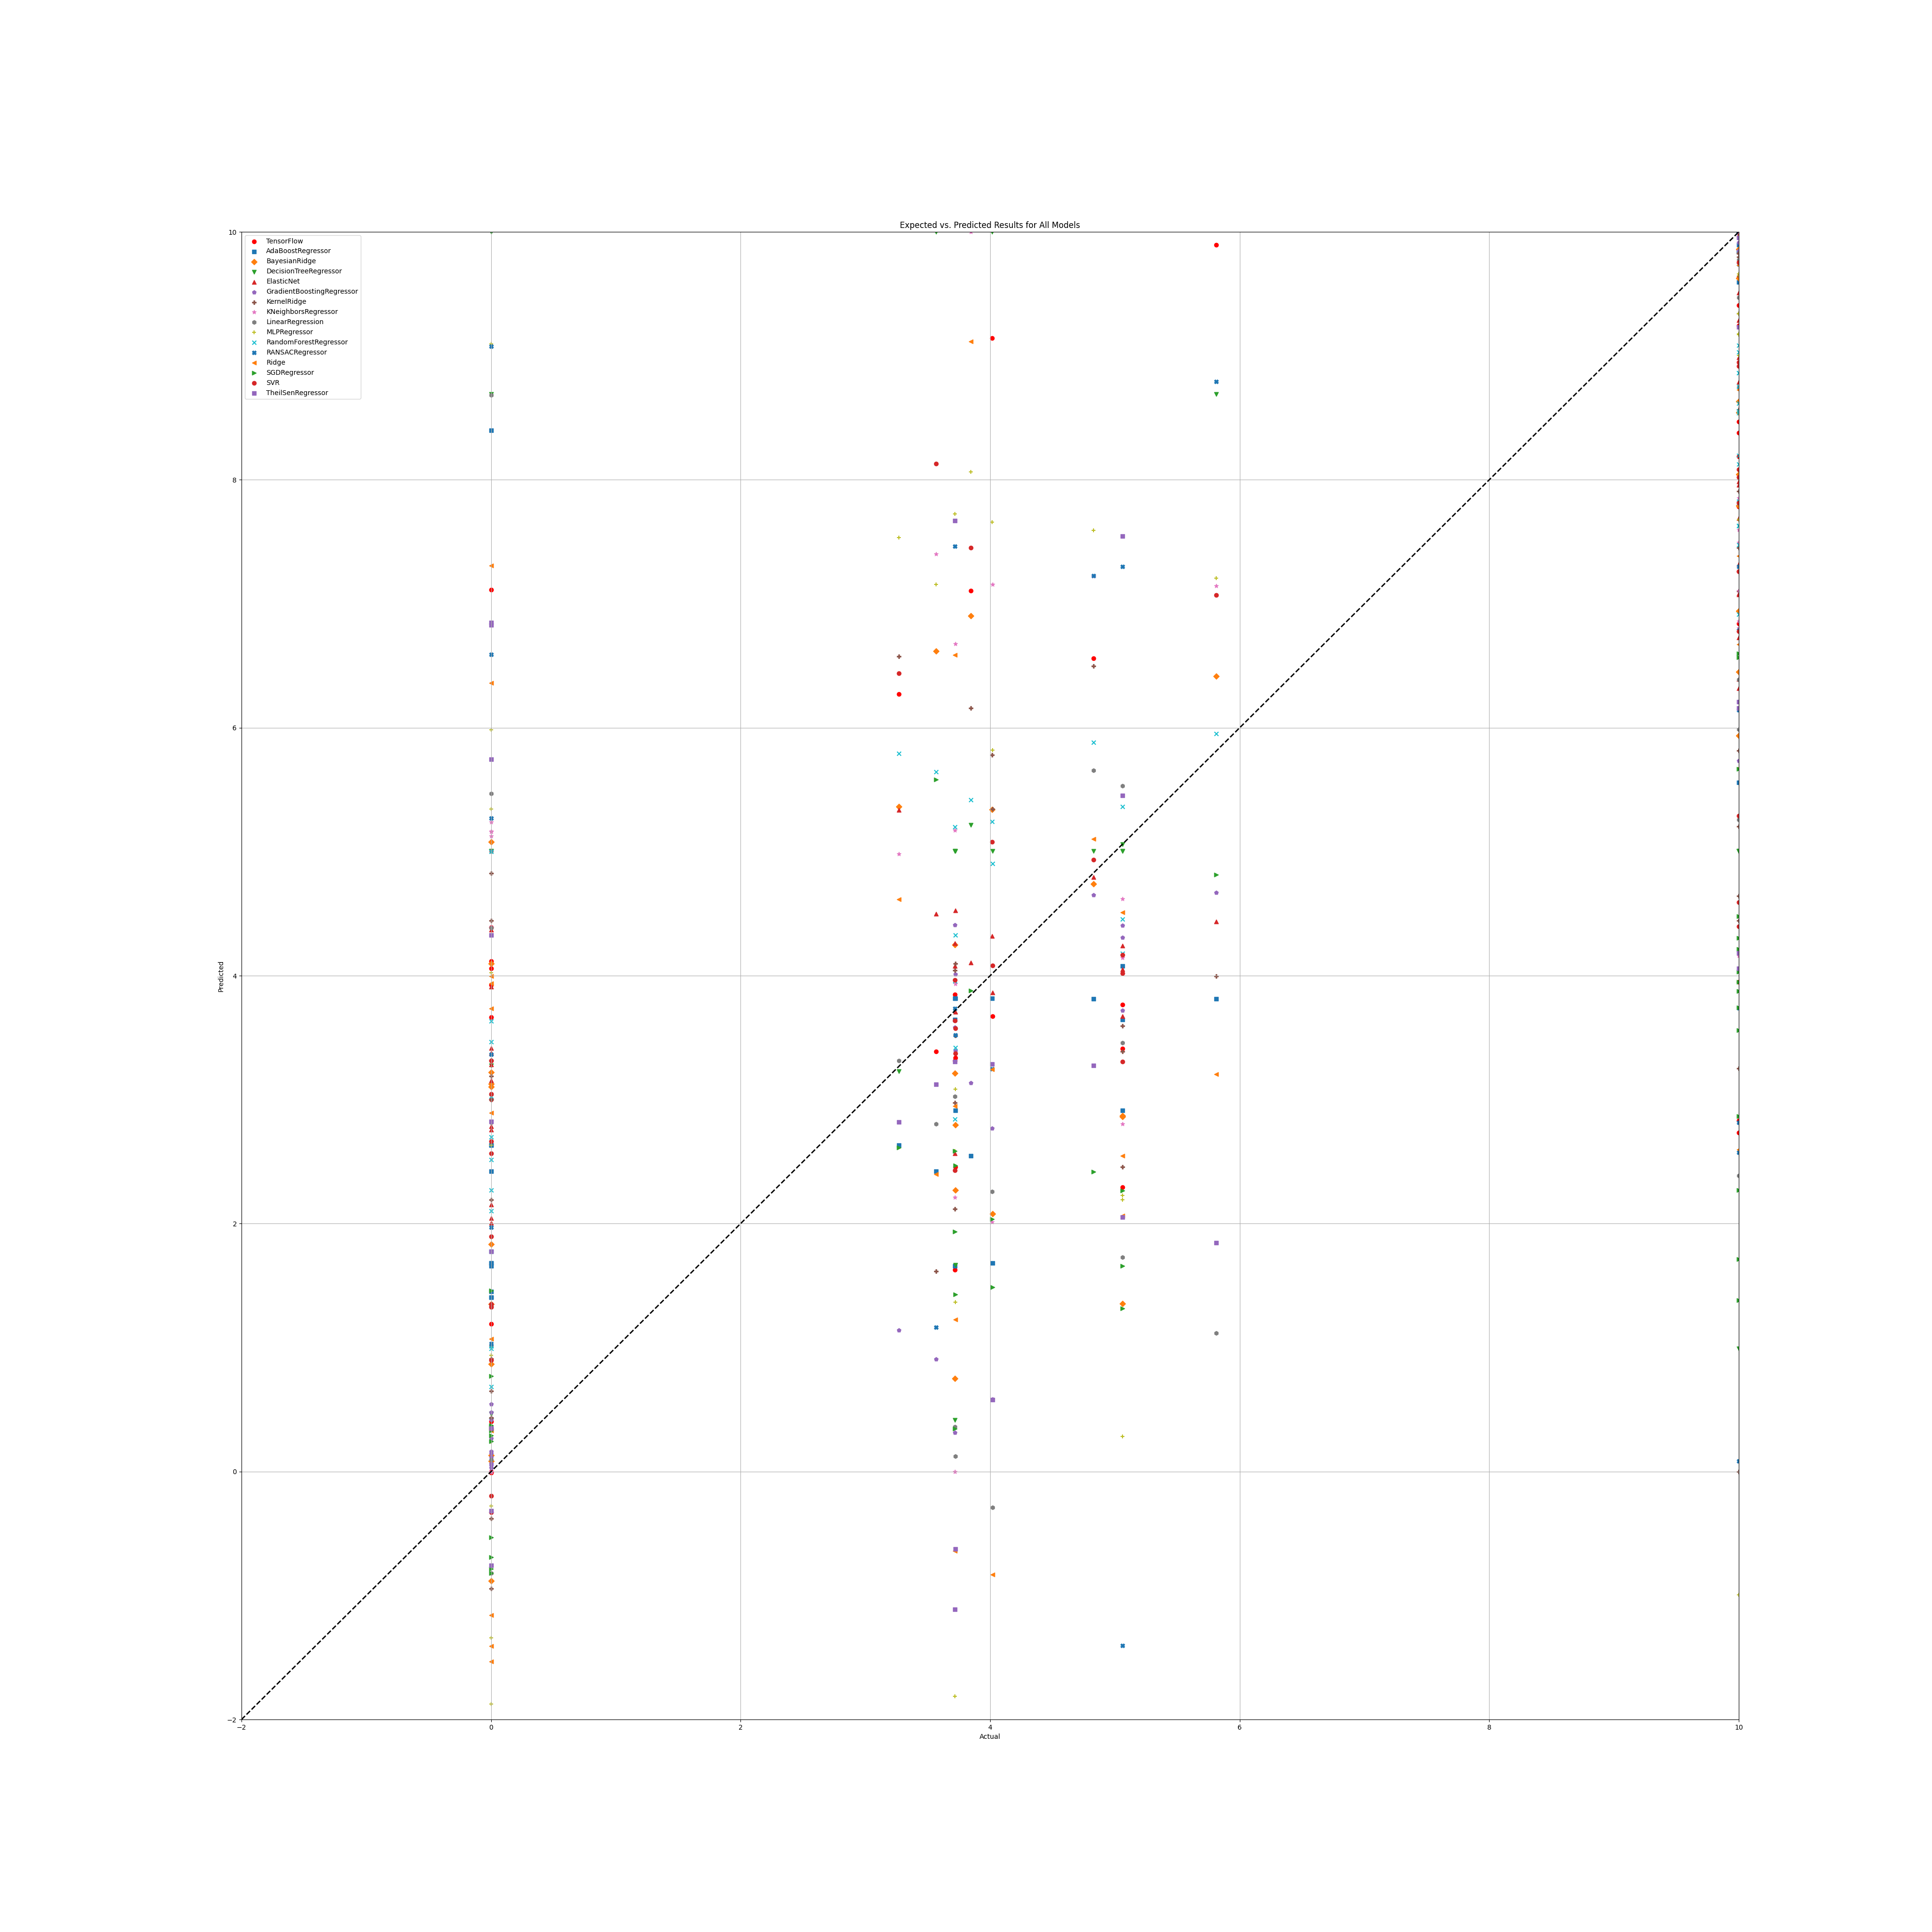

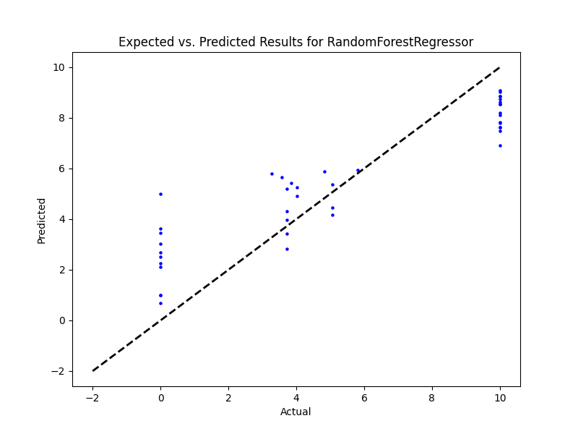

## PR

|  |  |  |  |
| --- | --- | --- | --- |
| **Ridge Regression** | **Decision Tree** | **Gradient Boosting** | **Random Forest** |
| alpha: 1.0  solver: 'saga' | criterion: 'poisson'  max_features: 'sqrt'  min_samples_split: 2  splitter: 'best' | learning_rate: 0.1  loss: 'huber'  n_estimators: 50  warm_start: False | criterion: 'absolute_error'  max_features: 'sqrt'  min_samples_split: 2  n_estimators: 50 |
| **AdaBoost** | **K-Nearest** | **MLP Regressor** | **Elastic Net** |
| learning_rate: 1.0  loss: 'square'  n_estimators: 50 | algorithm: 'brute'  leaf_size: 5  metric: 'cosine'  n_neighbors: 25  weights: 'distance' | activation: 'tanh'  hidden_layer_sizes: (100, 100, 100)  learning_rate: 'adaptive'  solver: 'sgd' | copy_X: True  fit_intercept: True  l1_ratio: 0.25  positive: False  precompute: True  selection: 'cyclic'  warm_start: True |
| **SGD Regressor** | **Support Vector** | **Bayesian Ridge** | **Kernel Ridge** |
| learning_rate: 'invscaling'  loss: 'huber'  penalty: 'l2'  warm_start: True | degree: 1  gamma: 'scale'  kernel: 'sigmoid'  shrinking: True | alpha_1: 1e-07  alpha_2: 1e-05  lambda_1: 1e-05  lambda_2: 1e-07 | alpha: 1.0  coef0: 0.5  degree: 1  kernel: 'sigmoid' |
| **Linear Regression** | **RANSAC** | **TheilSen** | **Tensorflow** |
| copy_X: True  fit_intercept: True  positive: True | loss: 'squared_error'  max_trials: 1  min_samples: 10 | max_subpopulation: 1000  n_subsamples: None |  |

## Prediction Results

**Model: Ridge**  
RMSE: 193.97331589674243  
  
**Model: DecisionTreeRegressor**  
RMSE: 0.8091747320205545  
  
**Model: GradientBoostingRegressor**  
RMSE: 0.49559868409668834  
  
**Model: RandomForestRegressor**  
RMSE: 1.0424958643732383  
  
**Model: AdaBoostRegressor**  
RMSE: 0.5163849424741108  
  
**Model: KNeighborsRegressor**  
RMSE: 1.1916003494864538  
  
**Model: MLPRegressor**  
RMSE: 1.6098740385430221  
  
**Model: ElasticNet**  
RMSE: 1.1503338167341848  
  
**Model: SGDRegressor**  
RMSE: 30.384216147993968  
  
**Model: SVR**  
RMSE: 1.754752364364336  
  
**Model: BayesianRidge**  
RMSE: 111.91291980637685  
  
**Model: KernelRidge**  
RMSE: 2.427373468915066  
  
**Model: LinearRegression**  
RMSE: 1.2531853828613675  
  
**Model: RANSACRegressor**  
RMSE: 65.17411411154274  
  
**Model: TheilSenRegressor**  
RMSE: 34.614965840872685  
  
**Model: TensorFlow**  
RMSE: 708.2861297016681

## Graph

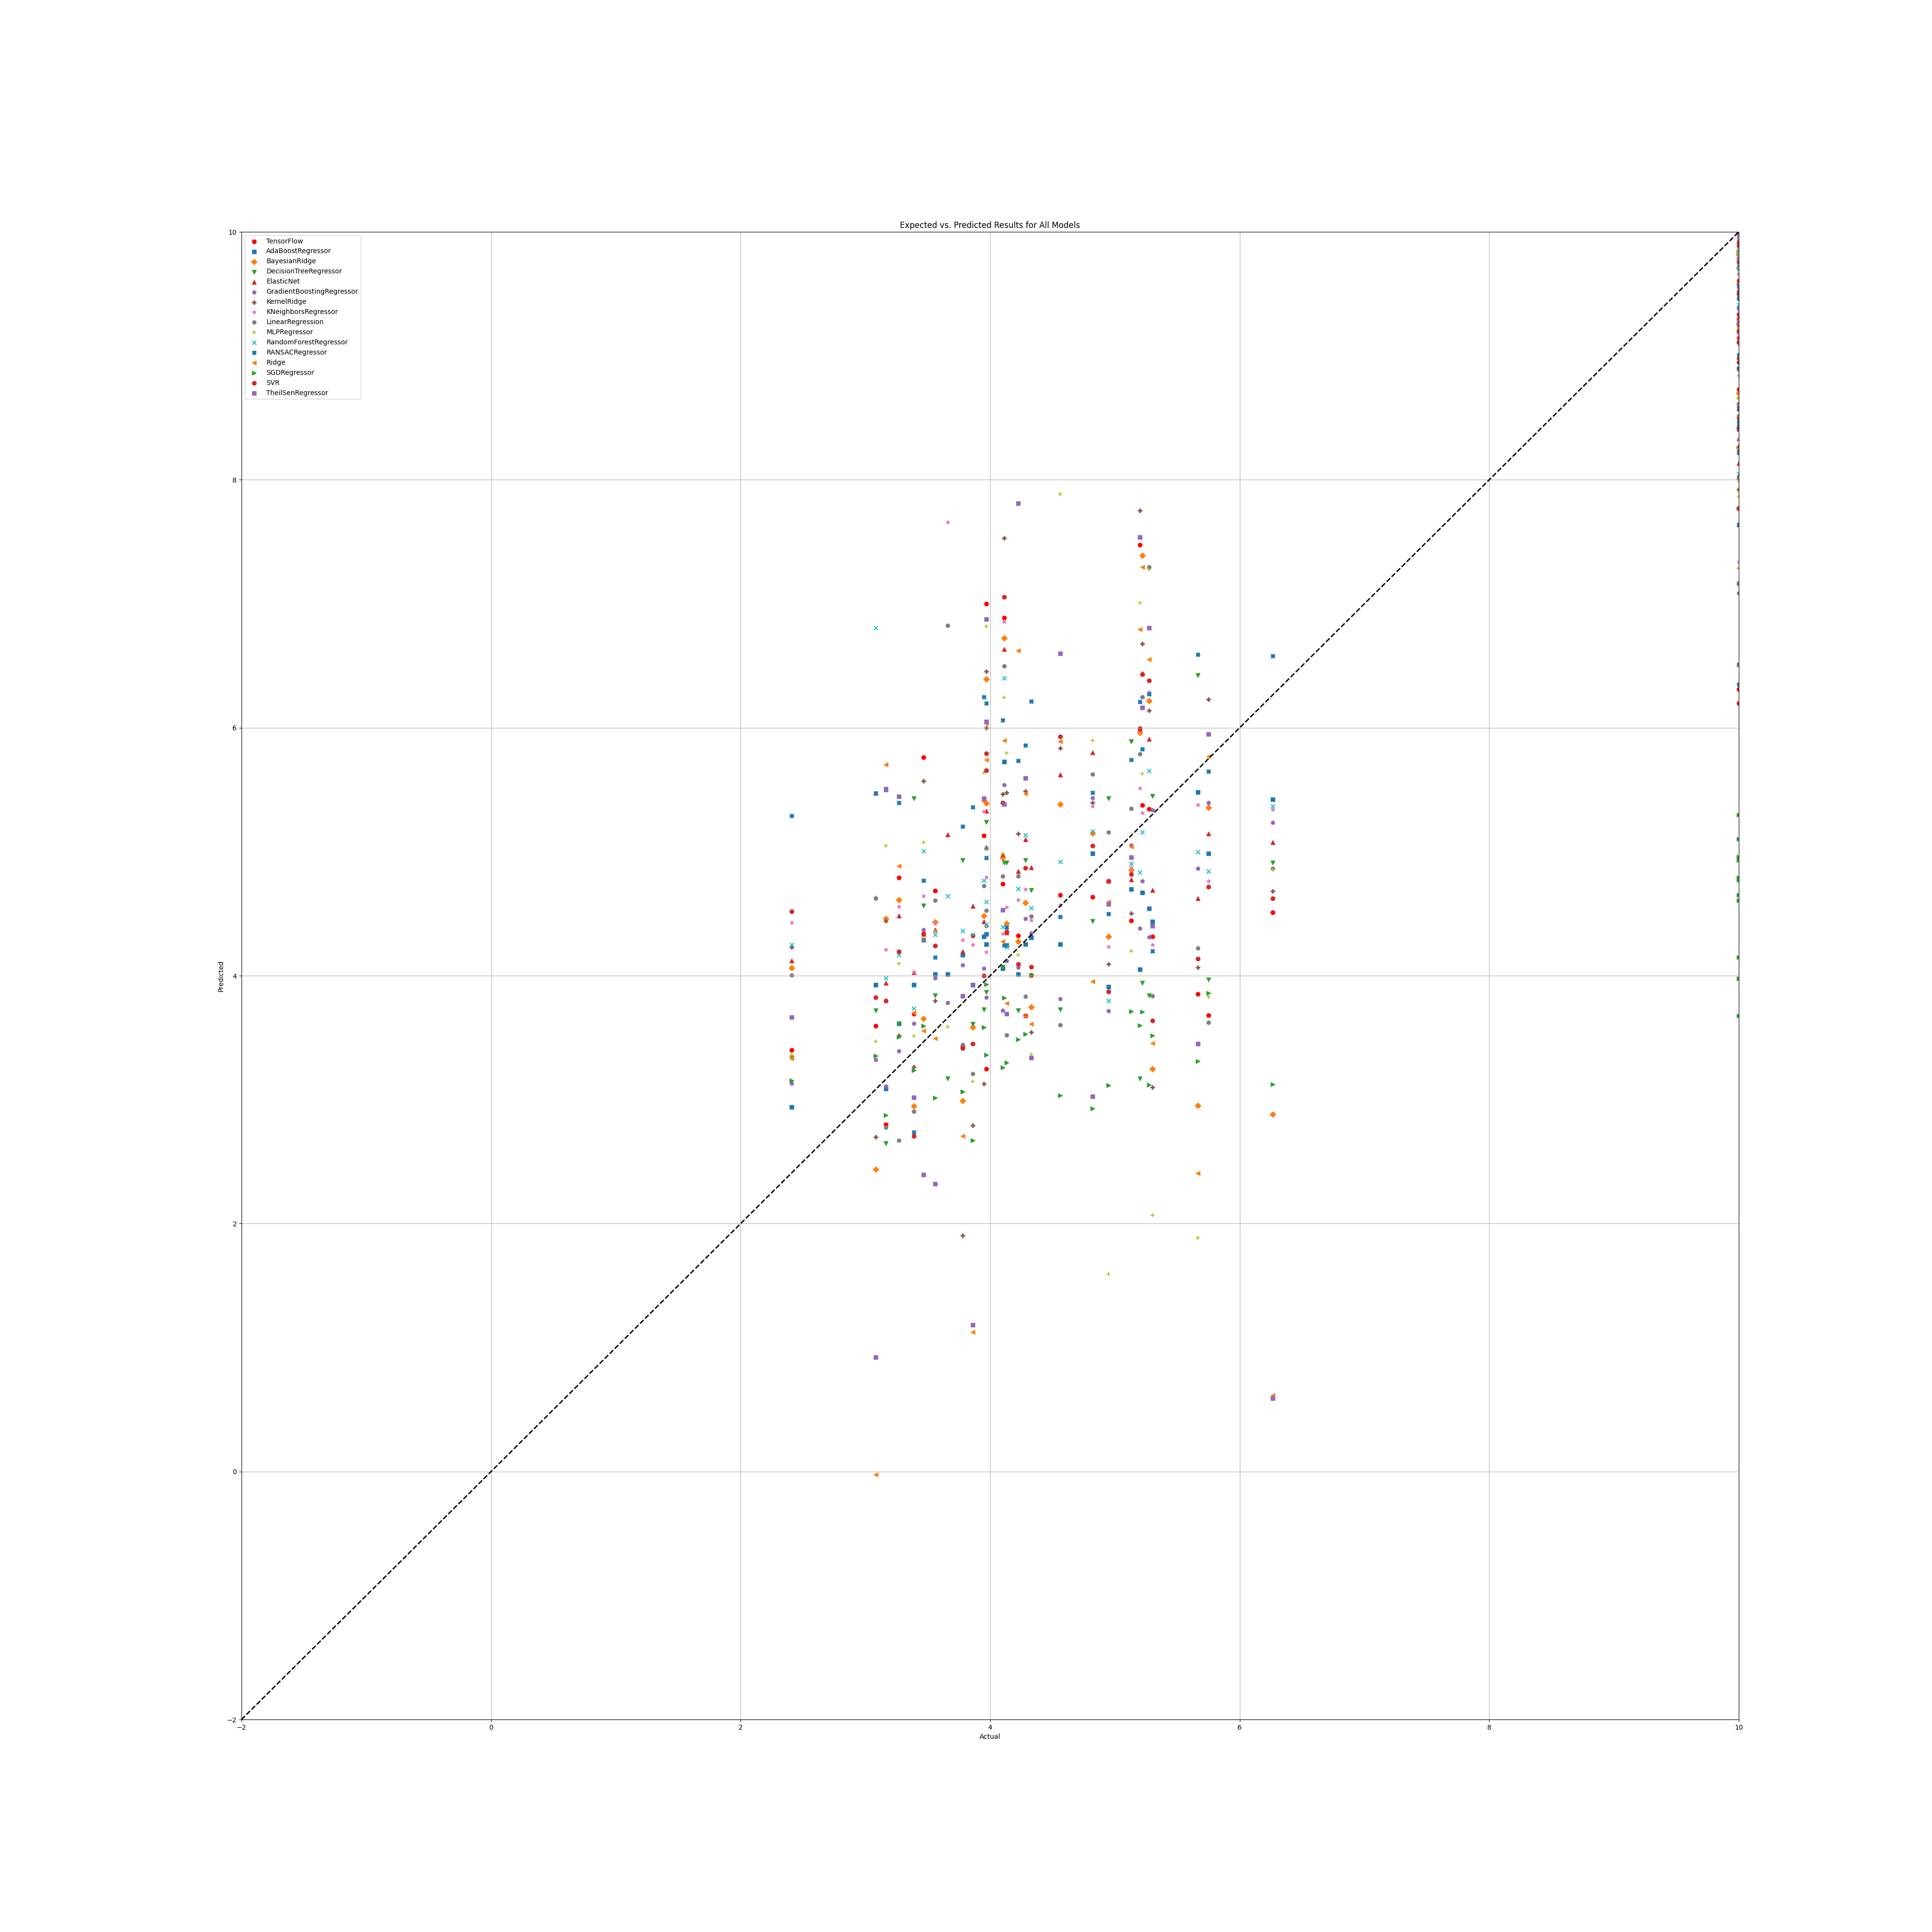

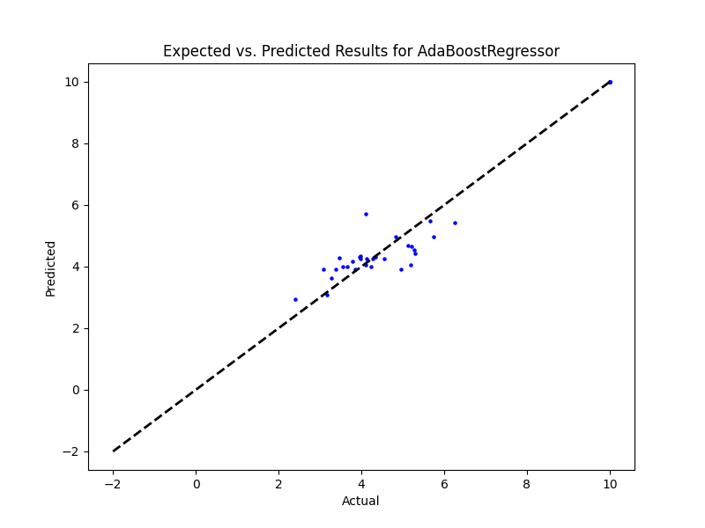

## PR Benefit

|  |  |  |  |
| --- | --- | --- | --- |
| **Ridge Regression** | **Decision Tree** | **Gradient Boosting** | **Random Forest** |
| alpha: 1.0  solver: 'saga' | criterion: 'squared_error'  max_features: 'sqrt'  min_samples_split: 2  splitter: 'random' | learning_rate: 0.1  loss: 'absolute_error'  n_estimators: 100  warm_start: False | criterion: 'absolute_error'  max_features: 'sqrt'  min_samples_split: 5  n_estimators: 50 |
| **AdaBoost** | **K-Nearest** | **MLP Regressor** | **Elastic Net** |
| learning_rate: 0.001  loss: 'exponential'  n_estimators: 20 | algorithm: 'brute'  leaf_size: 5  metric: 'cosine'  n_neighbors: 10  weights: 'distance' | activation: 'tanh'  hidden_layer_sizes: (100, 100, 100, 100)  learning_rate: 'constant'  solver: 'lbfgs' | copy_X: True  fit_intercept: True  l1_ratio: 0.5  positive: False  precompute: False  selection: 'random'  warm_start: True |
| **SGD Regressor** | **Support Vector** | **Bayesian Ridge** | **Kernel Ridge** |
| learning_rate: 'constant'  loss: 'epsilon_insensitive'penalty: 'elasticnet'  warm_start: False | degree: 1  gamma: 'scale'  kernel: 'sigmoid'  shrinking: True | alpha_1: 1e-07  alpha_2: 1e-05  lambda_1: 1e-05  lambda_2: 1e-07 | alpha: 1e-05  coef0: 0.0  degree: 1  kernel: 'rbf' |
| **Linear Regression** | **RANSAC** | **TheilSen** | **Tensorflow** |
| copy_X: True  fit_intercept: True  positive: True | loss: 'squared_error'  max_trials: 50  min_samples: 10 | max_subpopulation: 100  n_subsamples: None |  |

## Prediction Results

**Model: Ridge**  
RMSE: 442.5676626811256  
  
**Model: DecisionTreeRegressor**  
RMSE: 4.362862244105352  
  
**Model: GradientBoostingRegressor**  
RMSE: 2.108678222087836  
  
**Model: RandomForestRegressor**  
RMSE: 2.8493220399300325  
  
**Model: AdaBoostRegressor**  
RMSE: 2.136603832311086  
  
**Model: KNeighborsRegressor**  
RMSE: 3.5771744058964705  
  
**Model: MLPRegressor**  
RMSE: 2.7371584073165707  
  
**Model: ElasticNet**  
RMSE: 2.8239802874603015  
  
**Model: SGDRegressor**  
RMSE: 265.45373766799906  
  
**Model: SVR**  
RMSE: 3.2329788811072158  
  
**Model: BayesianRidge**  
RMSE: 156.66275932479178  
  
**Model: KernelRidge**  
RMSE: 3.253093600973788  
  
**Model: LinearRegression**  
RMSE: 77.56976067712434  
  
**Model: RANSACRegressor**  
RMSE: 93.29860297295983  
  
**Model: TheilSenRegressor**  
RMSE: 539.193380378599  
  
**Model: TensorFlow**  
RMSE: 270.6491907315888

## Graphs

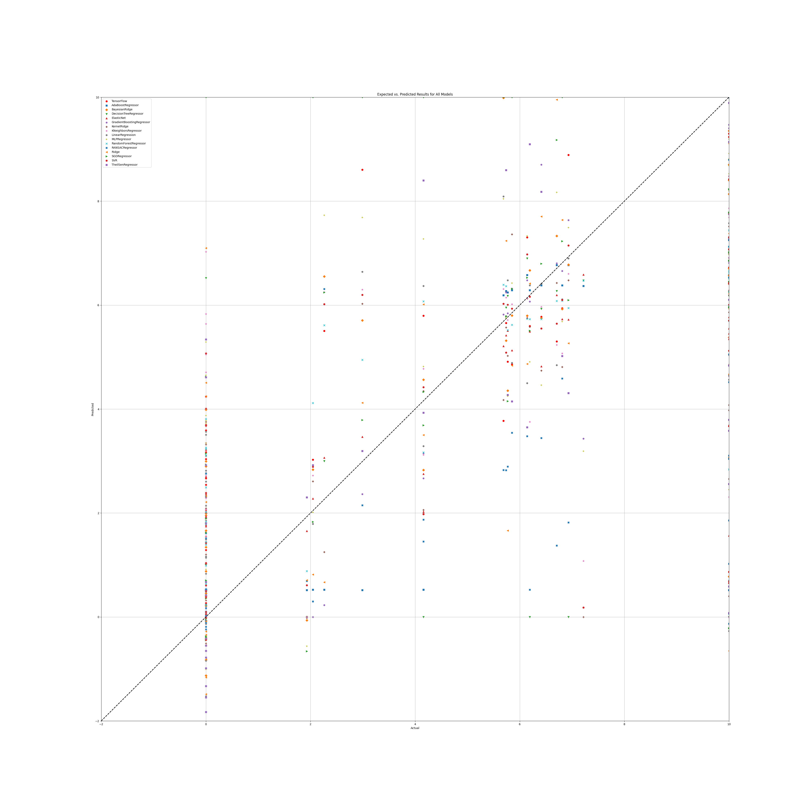

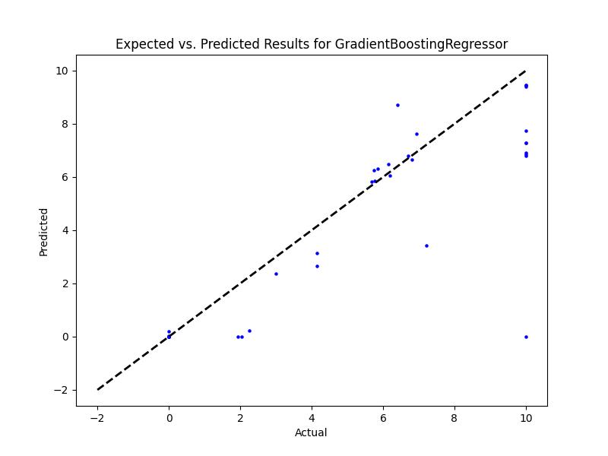

## SR

|  |  |  |  |
| --- | --- | --- | --- |
| **Ridge Regression** | **Decision Tree** | **Gradient Boosting** | **Random Forest** |
| alpha: 0.1  solver: 'sparse_cg' | criterion: 'friedman_mse'  max_features: 'sqrt'  min_samples_split: 3  splitter: 'best' | learning_rate: 0.1  loss: 'squared_error'  n_estimators: 100  warm_start: False | criterion: 'squared_error'  max_features: 'sqrt'  min_samples_split: 5  n_estimators: 100 |
| **AdaBoost** | **K-Nearest** | **MLP Regressor** | **Elastic Net** |
| learning_rate: 0.001  loss: 'square'  n_estimators: 50 | algorithm: 'brute'  leaf_size: 5  metric: 'cosine'  n_neighbors: 25  weights: 'distance' | activation: 'logistic'  hidden_layer_sizes: (100, 100, 100)  learning_rate: 'constant'  solver: 'lbfgs' | copy_X: False  fit_intercept: True  l1_ratio: 0.75  positive: False  precompute: False  selection: 'random'  warm_start: False |
| **SGD Regressor** | **Support Vector** | **Bayesian Ridge** | **Kernel Ridge** |
| learning_rate: 'constant'  loss: 'huber'  penalty: 'l2'  warm_start: True | degree: 1  gamma: 'scale'  kernel: 'sigmoid'  shrinking: True | alpha_1: 1e-07  alpha_2: 1e-05  lambda_1: 1e-05  lambda_2: 1e-07 | alpha: 1e-05  coef0: 0.0  degree: 1  kernel: 'rbf' |
| **Linear Regression** | **RANSAC** | **TheilSen** | **Tensorflow** |
| copy_X: True  fit_intercept: True  positive: True | loss: 'squared_error'  max_trials: 1  min_samples: 10 | max_subpopulation: 10  n_subsamples: None |  |

## Prediction Results

**Model: Ridge**  
RMSE: 111.01986577744104  
  
**Model: DecisionTreeRegressor**  
RMSE: 1.275982176394339  
  
**Model: GradientBoostingRegressor**  
RMSE: 0.8158734863874829  
  
**Model: RandomForestRegressor**  
RMSE: 1.3098551903682714  
  
**Model: AdaBoostRegressor**  
RMSE: 0.9397718307970826  
  
**Model: KNeighborsRegressor**  
RMSE: 1.9446698058804148  
  
**Model: MLPRegressor**  
RMSE: 1.8896809835893682  
  
**Model: ElasticNet**  
RMSE: 1.904531422962322  
  
**Model: SGDRegressor**  
RMSE: 21.861240037624455  
  
**Model: SVR**  
RMSE: 2.2716921523515063  
  
**Model: BayesianRidge**  
RMSE: 70.45870913247957  
  
**Model: KernelRidge**  
RMSE: 1.6500165026535893  
  
**Model: LinearRegression**  
RMSE: 20.535479212769232  
  
**Model: RANSACRegressor**  
RMSE: 47.42661096888678  
  
**Model: TheilSenRegressor**  
RMSE: 576.7269363459501  
  
**Model: TensorFlow**  
RMSE: 616.2267587995098

## Graph

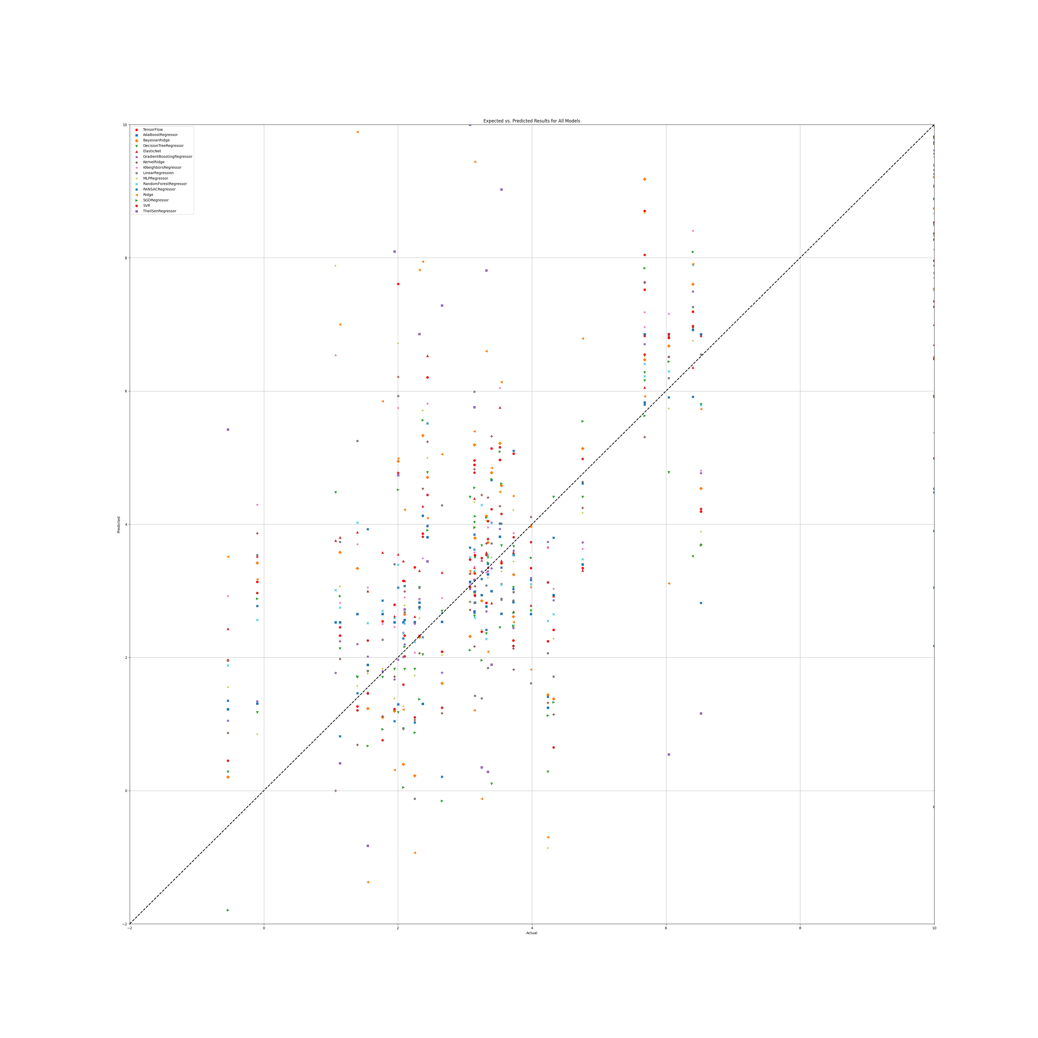

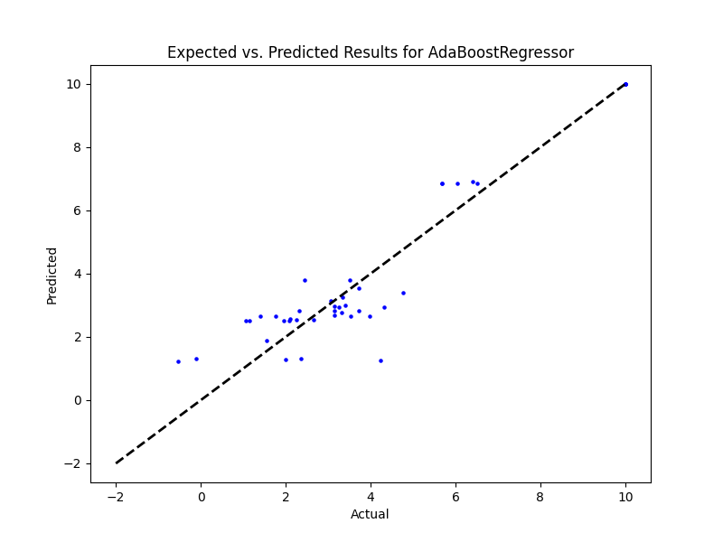/

## SR Benefit

|  |  |  |  |
| --- | --- | --- | --- |
| **Ridge Regression** | **Decision Tree** | **Gradient Boosting** | **Random Forest** |
| alpha: 1.0  solver: 'saga' | criterion: 'poisson'  max_features: 'sqrt'  min_samples_split: 3  splitter: 'random' | learning_rate: 0.1  loss: 'squared_error'  n_estimators: 25  warm_start: False | criterion: 'friedman_mse'  max_features: 'sqrt'  min_samples_split: 2  n_estimators: 100 |
| **AdaBoost** | **K-Nearest** | **MLP Regressor** | **Elastic Net** |
| learning_rate: 0.001  loss: 'linear'  n_estimators: 100 | algorithm: 'brute'  leaf_size: 5  metric: 'cosine'  n_neighbors: 10  weights: 'distance' | activation: 'logistic'  hidden_layer_sizes: (100, 100, 100)  learning_rate: 'adaptive'  solver: 'lbfgs' | copy_X: True  fit_intercept: True  l1_ratio: 0.5  positive: False  precompute: True  selection: 'random'  warm_start: False |
| **SGD Regressor** | **Support Vector** | **Bayesian Ridge** | **Kernel Ridge** |
| learning_rate: 'invscaling'  loss: 'huber'  penalty: 'elasticnet'  warm_start: False | degree: 1  gamma: 'scale'  kernel: 'sigmoid'  shrinking: True | alpha_1: 1e-07  alpha_2: 1e-05  lambda_1: 1e-05  lambda_2: 1e-07 | alpha: 1e-05  coef0: 0.0  degree: 1  kernel: 'rbf' |
| **Linear Regression** | **RANSAC** | **TheilSen** | **Tensorflow** |
| copy_X: True  fit_intercept: True  positive: True | loss: 'squared_error'  max_trials: 100  min_samples: 50 | max_subpopulation: 1000  n_subsamples: None |  |

**Model: Ridge**  
RMSE: 317.9829992967299  
  
**Model: DecisionTreeRegressor**  
RMSE: 2.8088463230917013  
  
**Model: GradientBoostingRegressor**  
RMSE: 0.8559442443479556  
  
**Model: RandomForestRegressor**  
RMSE: 2.168743334374573  
  
**Model: AdaBoostRegressor**  
RMSE: 0.297559877206814  
  
**Model: KNeighborsRegressor**  
RMSE: 2.6007828308011436  
  
**Model: MLPRegressor**  
RMSE: 1.9733347871181304  
  
**Model: ElasticNet**  
RMSE: 1.8757631491205806  
  
**Model: SGDRegressor**  
RMSE: 18.8633678227343  
  
**Model: SVR**  
RMSE: 2.310815145178886  
  
**Model: BayesianRidge**  
RMSE: 121.88201677424688  
  
**Model: KernelRidge**  
RMSE: 2.068315258390737  
  
**Model: LinearRegression**  
RMSE: 229.91118333108443  
  
**Model: RANSACRegressor**  
RMSE: 119.23811493496467  
  
**Model: TheilSenRegressor**  
RMSE: 477.61986536181104  
  
**Model: TensorFlow**  
RMSE: 380.45800944589445

## Graph

