# Annexe 3.2

only known of/f/s FUNCTION ONLY SINCE BENEFITS ARE WRONG CURRENTLY

## WS

### Best models

|  |  |  |  |
| --- | --- | --- | --- |
| **Ridge Regression** | **Decision Tree** | **Gradient Boosting** | **Random Forest** |
| alpha: 1.0  solver: 'lsqr' | criterion: 'friedman_mse'  max_features: 'sqrt'  min_samples_split: 5  splitter: 'random' | learning_rate: 0.1  loss: 'absolute_error'  n_estimators: 250  warm_start: True | criterion: 'absolute_error'  max_features: 'log2'  min_samples_split: 2  n_estimators: 100 |
| **AdaBoost** | **K-Nearest** | **MLP Regressor** | **Elastic Net** |
| learning_rate: 0.1  loss: 'linear'  n_estimators: 100 | algorithm: 'ball_tree'  leaf_size: 5  metric: 'cityblock'  n_neighbors: 5  weights: 'distance' | activation: 'relu'  hidden_layer_sizes: (100, 100, 100)  learning_rate: 'constant'  solver: 'sgd' | copy_X: True  fit_intercept: True  l1_ratio: 0.25  positive: False  precompute: True  selection: 'random'  warm_start: False |
| **SGD Regressor** | **Support Vector** | **Bayesian Ridge** | **Kernel Ridge** |
| learning_rate: 'invscaling'  loss: 'squared_error'  penalty: None  warm_start: True | degree: 1  gamma: 'scale'  kernel: 'poly'  shrinking: True | alpha_1: 1e-07  alpha_2: 1e-05  lambda_1: 1e-05  lambda_2: 1e-07 | alpha: 1.0  coef0: 1.0  degree: 2  kernel: 'poly' |
| **Linear Regression** | **RANSAC** | **TheilSen** | **Tensorflow** |
| copy_X: True  fit_intercept: True  positive: False | loss: 'absolute_error'  max_trials: 50  min_samples: 10 | max_subpopulation: 1000  n_subsamples: None |  |

### Prediction Results

Model: Ridge  
RMSE: 1.8033453452315618  
  
Model: DecisionTreeRegressor  
RMSE: 2.140679942576264  
  
Model: GradientBoostingRegressor  
RMSE: 1.6884099658499212  
  
Model: RandomForestRegressor  
RMSE: 1.726897630057528  
  
Model: AdaBoostRegressor  
RMSE: 1.7526020268802691  
  
Model: KNeighborsRegressor  
RMSE: 1.5178961659384982  
  
Model: MLPRegressor  
RMSE: 1.681857371753815  
  
Model: ElasticNet  
RMSE: 2.030327189680121  
  
Model: SGDRegressor  
RMSE: 1.786530763189344  
  
Model: SVR  
RMSE: 1.6514213918860092  
  
Model: BayesianRidge  
RMSE: 1.7095699451037323  
  
Model: KernelRidge  
RMSE: 1.6535716631247859  
  
Model: LinearRegression  
RMSE: 1.8108985990625046  
  
Model: RANSACRegressor  
RMSE: 1.7809529111874147  
  
Model: TheilSenRegressor  
RMSE: 1.9522606434561172  
  
Model: TensorFlow

RMSE: 1.7438271870427071

### Graphs

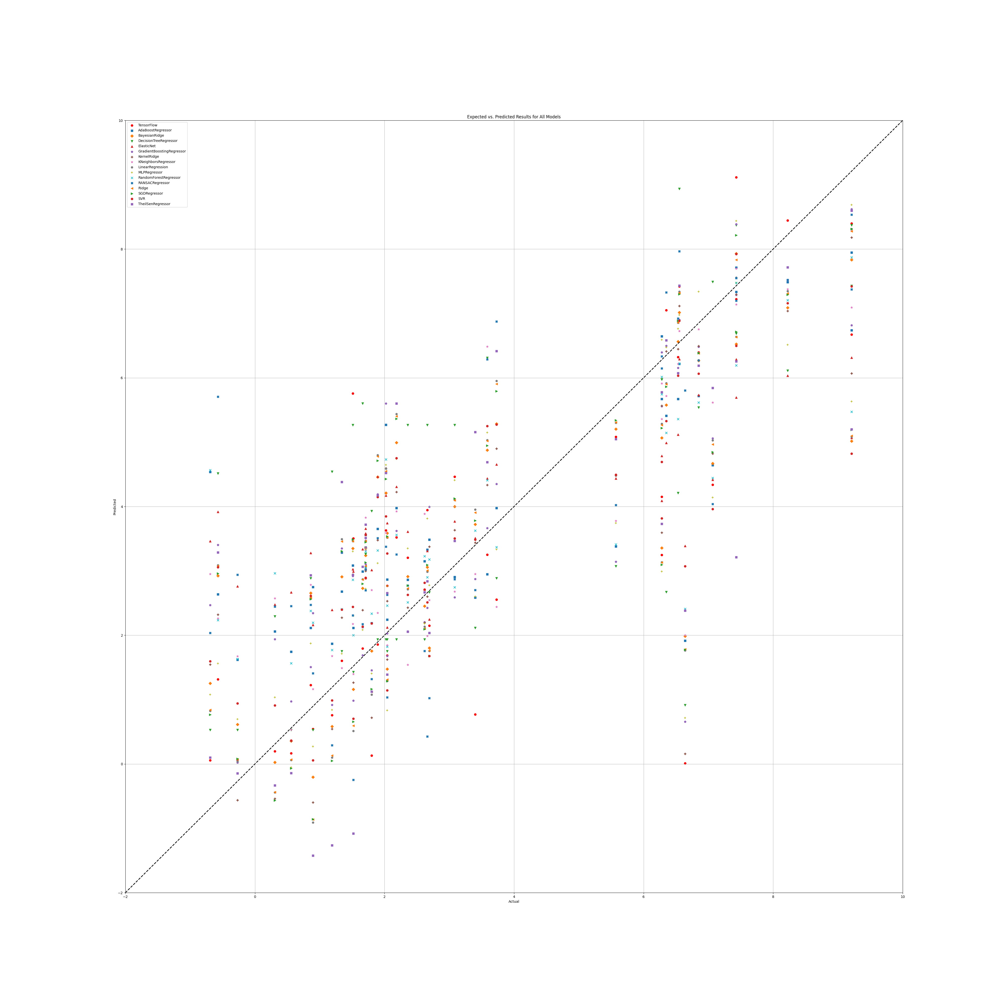

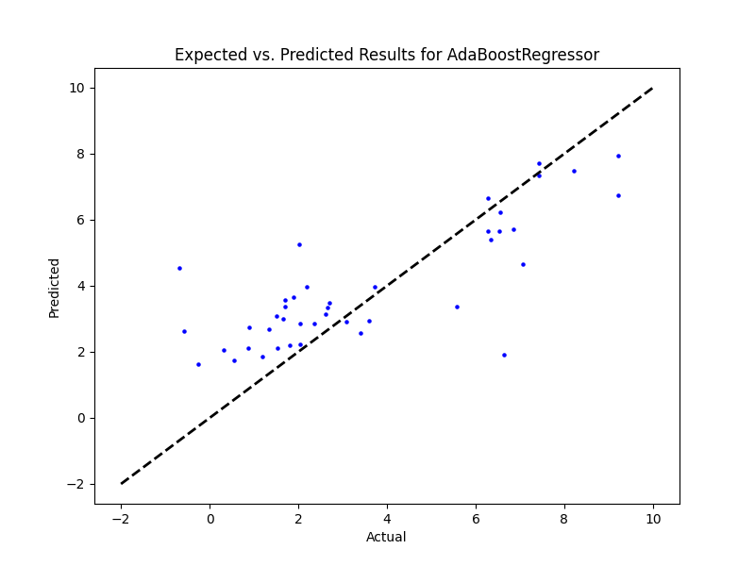

## WS Benefit

|  |  |  |  |
| --- | --- | --- | --- |
| **Ridge Regression** | **Decision Tree** | **Gradient Boosting** | **Random Forest** |
|  |  |  |  |
| **AdaBoost** | **K-Nearest** | **MLP Regressor** | **Elastic Net** |
|  |  |  |  |
| **SGD Regressor** | **Support Vector** | **Bayesian Ridge** | **Kernel Ridge** |
|  |  |  |  |
| **Linear Regression** | **RANSAC** | **TheilSen** | **Tensorflow** |
|  |  |  |  |

## Prediction Results

## Graphs

## NR

|  |  |  |  |
| --- | --- | --- | --- |
| **Ridge Regression** | **Decision Tree** | **Gradient Boosting** | **Random Forest** |
| Alpha: 1.0  Solver: 'lsqr' | Criterion: 'squared_error'  Max Features: 'sqrt'  Min Samples Split: 4  Splitter: 'best' | Learning Rate: 0.1  Loss: 'squared_error'  Number of Estimators: 25  Warm Start: True | Criterion: 'absolute_error'  Max Features: 'log2'  Min Samples Split: 5  Number of Estimators: 50 |
| **AdaBoost** | **K-Nearest** | **MLP Regressor** | **Elastic Net** |
| Learning Rate: 0.1  Loss: 'square'  Number of Estimators: 100 | Algorithm: 'ball_tree'  Leaf Size: 5  Metric: 'cityblock'  Number of Neighbors: 25  Weights: 'distance' | Activation: 'logistic'  Hidden Layer Sizes: (100, 100, 100)  Learning Rate: 'adaptive'  Solver: 'adam' | Copy X: True  Fit Intercept: True  L1 Ratio: 0.25  Positive: False  Precompute: True  Selection: 'random'  Warm Start: False |
| **SGD Regressor** | **Support Vector** | **Bayesian Ridge** | **Kernel Ridge** |
| Learning Rate: 'invscaling'  Loss: 'epsilon_insensitive'  Penalty: 'elasticnet'  Warm Start: False | Degree: 1  Gamma: 'scale'  Kernel: 'poly'  Shrinking: True | Alpha 1: 1e-07  Alpha 2: 1e-05  Lambda 1: 1e-05  Lambda 2: 1e-07 | Alpha: 1.0  Coef0: 1.0  Degree: 1  Kernel: 'poly' |
| **Linear Regression** | **RANSAC** | **TheilSen** | **Tensorflow** |
| Copy X: True  Fit Intercept: True  Positive: True | Loss: 'absolute_error'  Max Trials: 10  Min Samples: 10 | Max Subpopulation: 1000  Number of Subsamples: None |  |

## Prediction results

Model: Ridge  
RMSE: 2.68143991560563  
  
Model: DecisionTreeRegressor  
RMSE: 2.379427062103158  
  
Model: GradientBoostingRegressor  
RMSE: 2.440810809609957  
  
Model: RandomForestRegressor  
RMSE: 2.2588432636145943  
  
Model: AdaBoostRegressor  
RMSE: 2.2694281128499085  
  
Model: KNeighborsRegressor  
RMSE: 2.272737426739647  
  
Model: MLPRegressor  
RMSE: 3.2196648070966245  
  
Model: ElasticNet  
RMSE: 2.6804942488072085  
  
Model: SGDRegressor  
RMSE: 2.660239252735262  
  
Model: SVR  
RMSE: 2.3732622234405993  
  
Model: BayesianRidge  
RMSE: 2.4805456714923237  
  
Model: KernelRidge  
RMSE: 2.5185608832095343  
  
Model: LinearRegression  
RMSE: 2.9329581390036483  
  
Model: RANSACRegressor  
RMSE: 2.738956113225513  
  
Model: TheilSenRegressor  
RMSE: 2.8477073348408  
  
Model: TensorFlow  
RMSE: 2.6562236158620802

## Graph

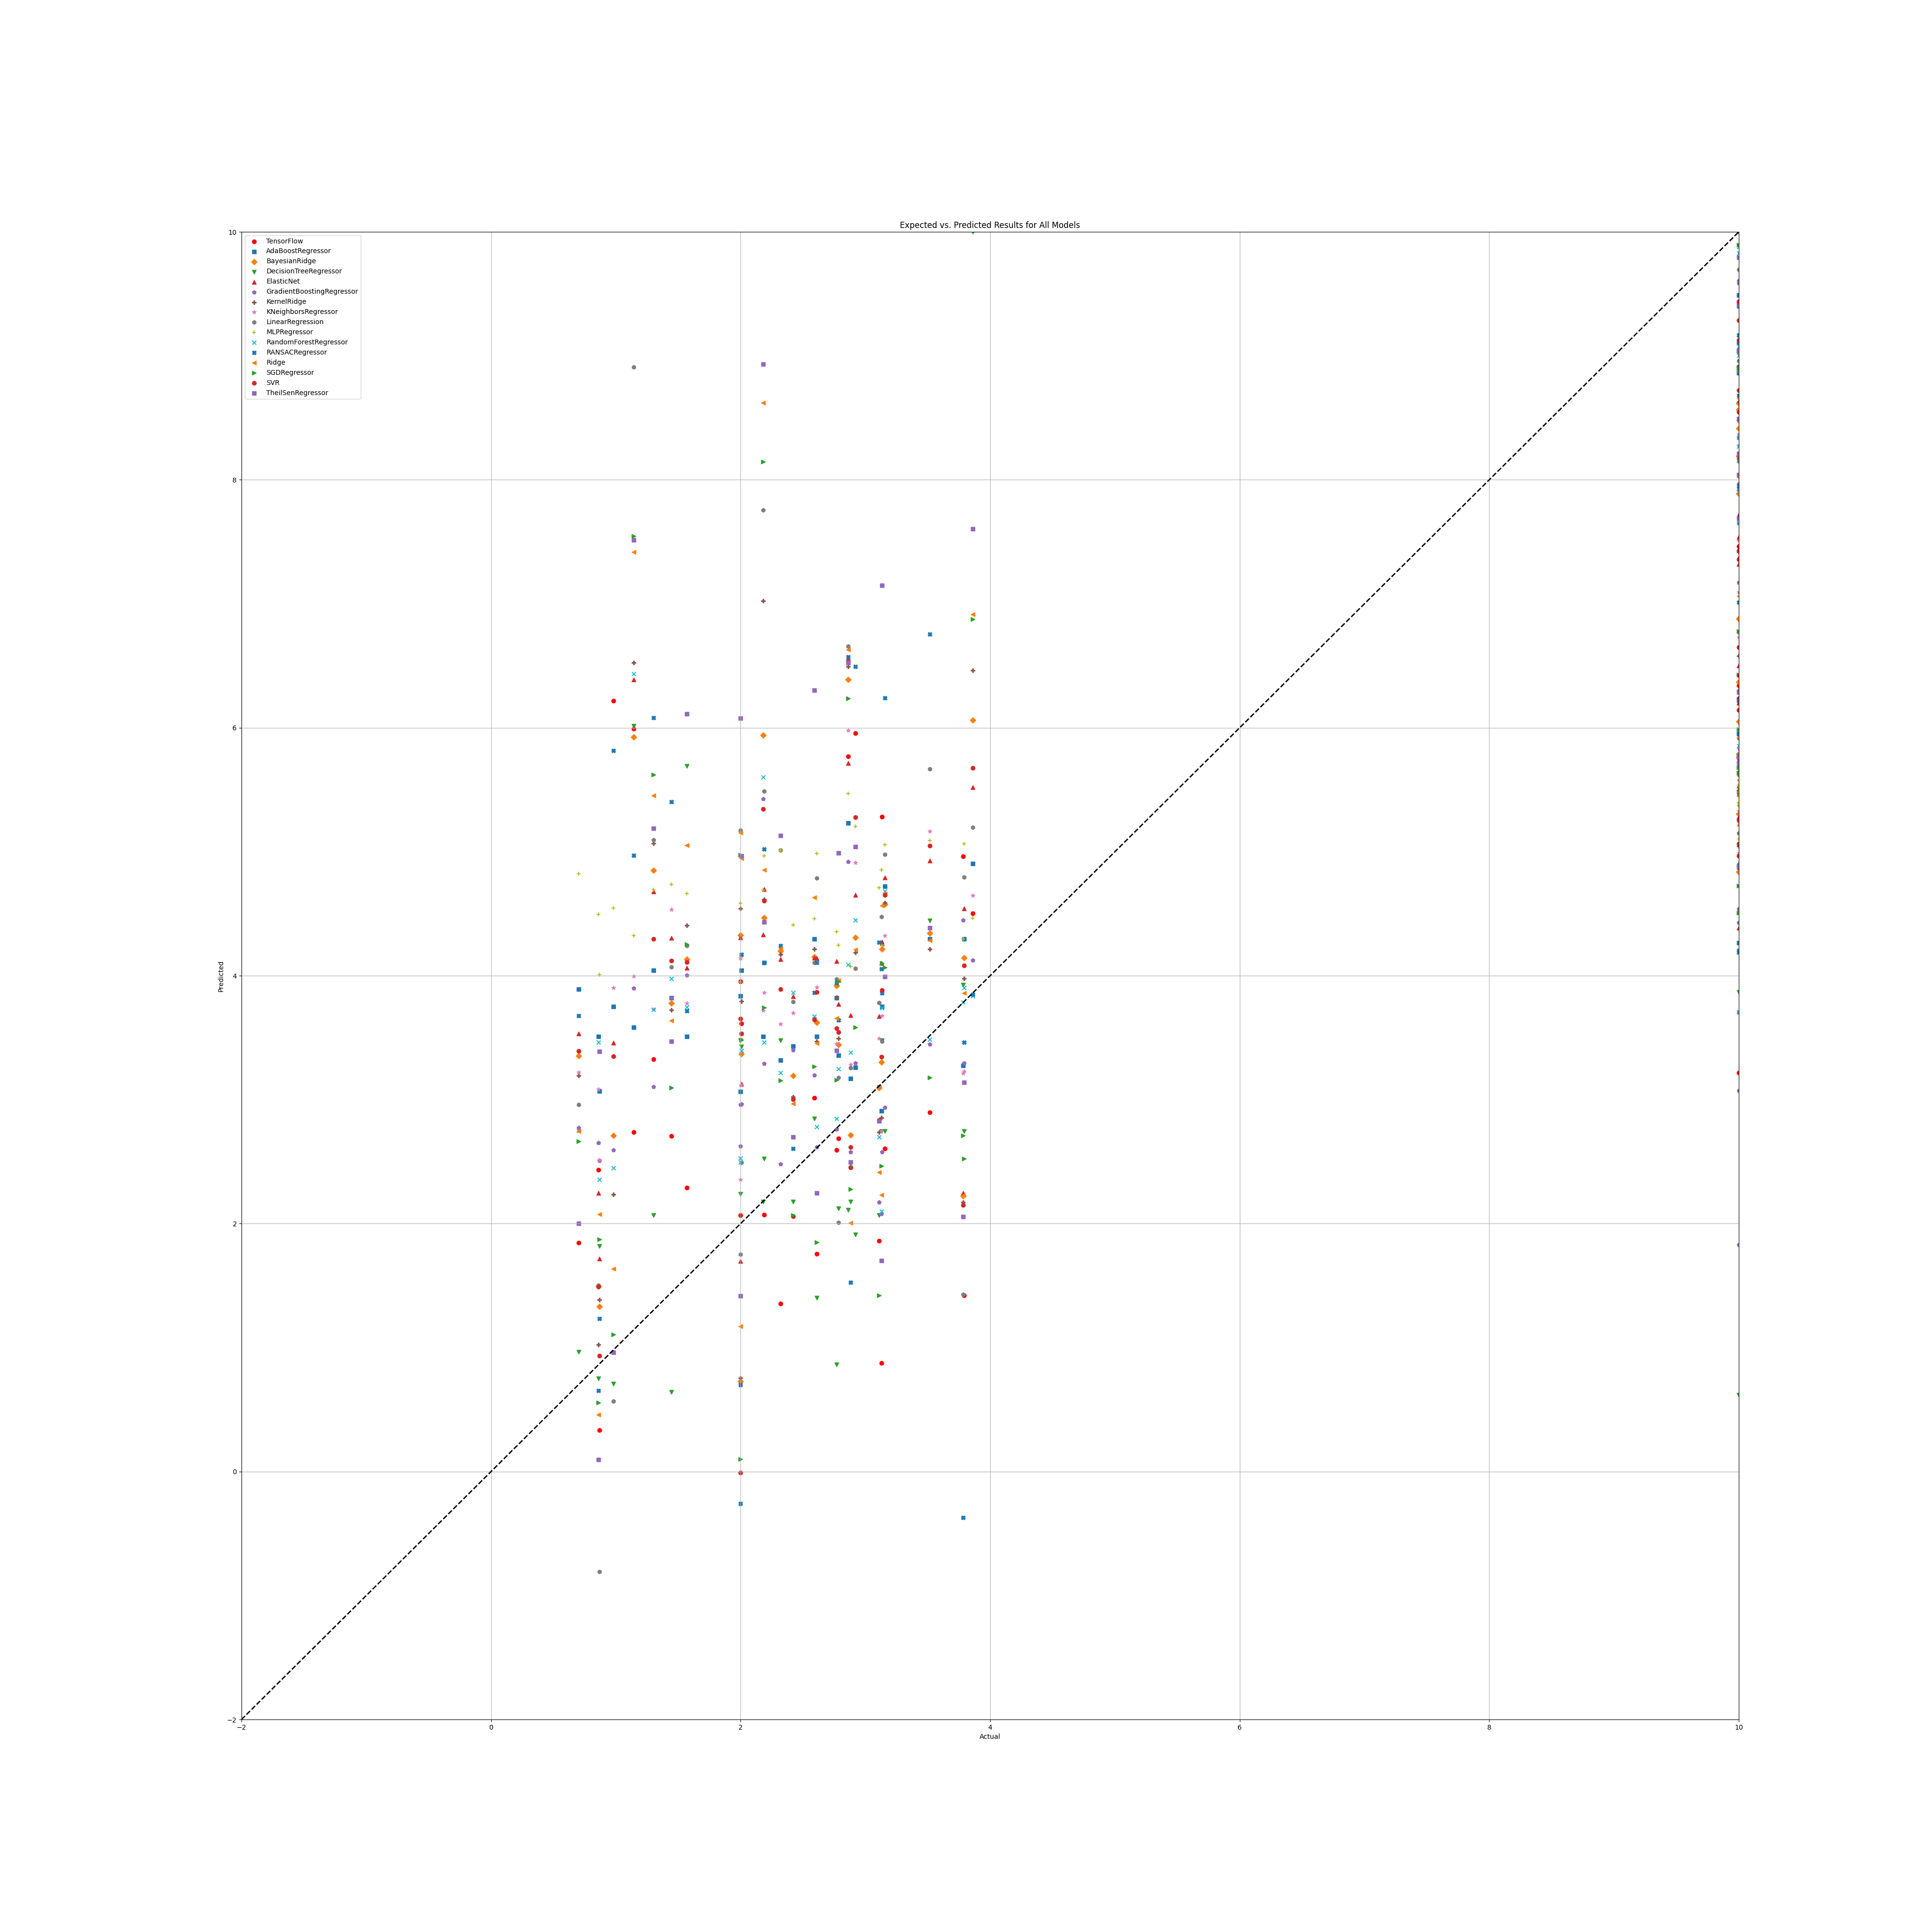

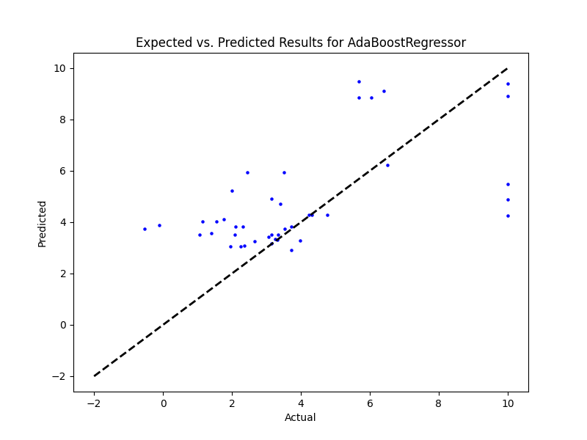

## NR Benefit

|  |  |  |  |
| --- | --- | --- | --- |
| **Ridge Regression** | **Decision Tree** | **Gradient Boosting** | **Random Forest** |
|  |  |  |  |
| **AdaBoost** | **K-Nearest** | **MLP Regressor** | **Elastic Net** |
|  |  |  |  |
| **SGD Regressor** | **Support Vector** | **Bayesian Ridge** | **Kernel Ridge** |
|  |  |  |  |
| **Linear Regression** | **RANSAC** | **TheilSen** | **Tensorflow** |
|  |  |  |  |

## Prediction results

## Graph

## PR

|  |  |  |  |
| --- | --- | --- | --- |
| **Ridge Regression** | **Decision Tree** | **Gradient Boosting** | **Random Forest** |
| Alpha: 0.1  Solver: 'lsqr' | Criterion: 'poisson'  Max Features: 'log2'  Min Samples Split: 4  Splitter: 'random' | Learning Rate: 0.1  Loss: 'squared_error'  Number of Estimators: 250  Warm Start: False | Criterion: 'absolute_error'  Max Features: 'sqrt'  Min Samples Split: 2  Number of Estimators: 50 |
| **AdaBoost** | **K-Nearest** | **MLP Regressor** | **Elastic Net** |
| Learning Rate: 0.01  Loss: 'square'  Number of Estimators: 100 | Algorithm: 'ball_tree'  Leaf Size: 5  Metric: 'cityblock'  Number of Neighbors: 5  Weights: 'uniform' | Activation: 'logistic'  Hidden Layer Sizes: (50, 50, 50)  Learning Rate: 'adaptive'  Solver: 'lbfgs' | Copy X: True  Fit Intercept: True  L1 Ratio: 0.25  Positive: False  Precompute: False  Selection: 'cyclic'  Warm Start: True |
| **SGD Regressor** | **Support Vector** | **Bayesian Ridge** | **Kernel Ridge** |
| Learning Rate: 'adaptive'  Loss: 'epsilon_insensitive'  Penalty: 'l1'  Warm Start: True | Degree: 1  Gamma: 'scale'  Kernel: 'sigmoid'  Shrinking: True | Alpha 1: 1e-07  Alpha 2: 1e-05  Lambda 1: 1e-05  Lambda 2: 1e-07 | Alpha: 0.1  Coef0: 0.0  Degree: 1  Kernel: 'rbf' |
| **Linear Regression** | **RANSAC** | **TheilSen** | **Tensorflow** |
| Copy X: True  Fit Intercept: True  Positive: True | Loss: 'squared_error'  Max Trials: 10  Min Samples: 10 | Max Subpopulation: 1000  Number of Subsamples: None |  |

## Prediction Results

Model: Ridge  
RMSE: 1.52215000156116  
  
Model: DecisionTreeRegressor  
RMSE: 2.0781436405970926  
  
Model: GradientBoostingRegressor  
RMSE: 1.0211698558590154  
  
Model: RandomForestRegressor  
RMSE: 1.361903410314646  
  
Model: AdaBoostRegressor  
RMSE: 0.981516590828347  
  
Model: KNeighborsRegressor  
RMSE: 1.2292513132180594  
  
Model: MLPRegressor  
RMSE: 1.1512002178545415  
  
Model: ElasticNet  
RMSE: 1.5381323269405878  
  
Model: SGDRegressor  
RMSE: 1.3570996975599257  
  
Model: SVR  
RMSE: 1.3201257231581744  
Model: BayesianRidge  
RMSE: 1.3576771939875611  
  
Model: KernelRidge  
RMSE: 1.3150644695011489  
  
Model: LinearRegression  
RMSE: 1.807211033398191  
  
Model: RANSACRegressor  
RMSE: 1.5978908300547403  
  
Model: TheilSenRegressor  
RMSE: 1.80063417679571  
  
Model: TensorFlow  
RMSE: 1.286761413903499

## Graph

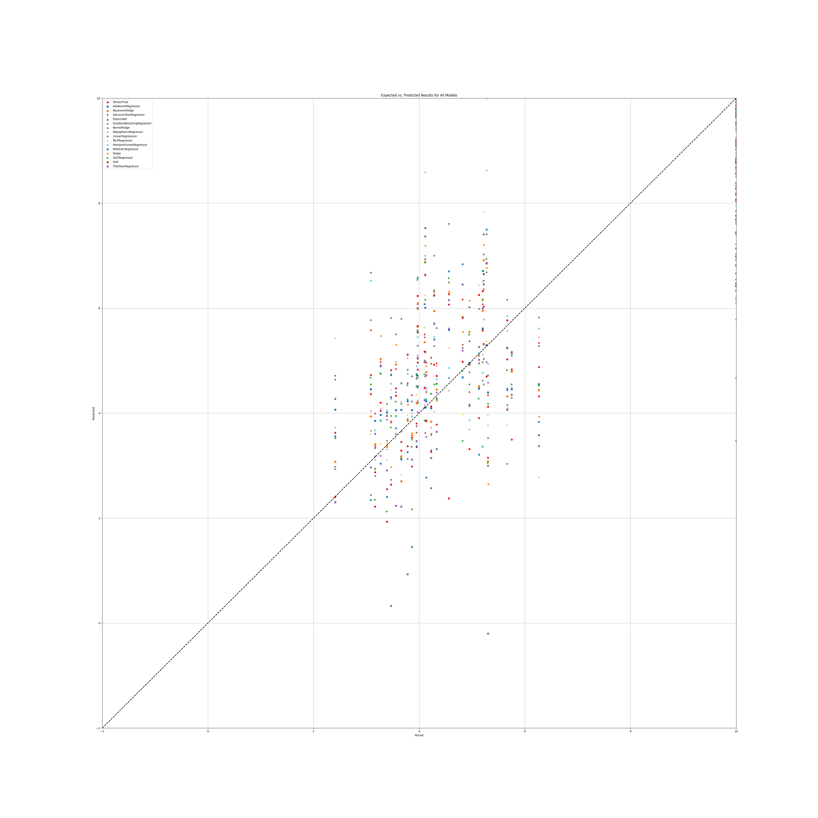

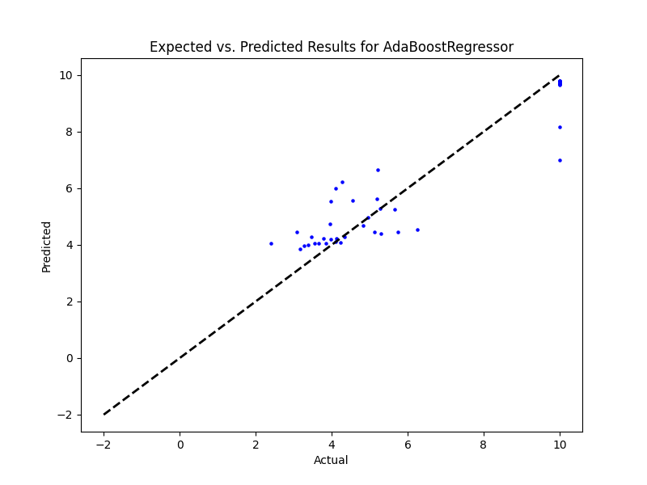

## PR Benefit

|  |  |  |  |
| --- | --- | --- | --- |
| **Ridge Regression** | **Decision Tree** | **Gradient Boosting** | **Random Forest** |
|  |  |  |  |
| **AdaBoost** | **K-Nearest** | **MLP Regressor** | **Elastic Net** |
|  |  |  |  |
| **SGD Regressor** | **Support Vector** | **Bayesian Ridge** | **Kernel Ridge** |
|  |  |  |  |
| **Linear Regression** | **RANSAC** | **TheilSen** | **Tensorflow** |
|  |  |  |  |

## Prediction Results

## Graphs

## SR

|  |  |  |  |
| --- | --- | --- | --- |
| **Ridge Regression** | **Decision Tree** | **Gradient Boosting** | **Random Forest** |
| Alpha: 1.0  Solver: 'lsqr' | Criterion: 'friedman_mse'  Max Features: 'log2'  Min Samples Split: 4  Splitter: 'random' | Learning Rate: 0.1  Loss: 'squared_error'  Number of Estimators: 50  Warm Start: False | Criterion: 'friedman_mse'  Max Features: 'log2'  Min Samples Split: 5  Number of Estimators: 50 |
| **AdaBoost** | **K-Nearest** | **MLP Regressor** | **Elastic Net** |
| Learning Rate: 0.1  Loss: 'exponential'  Number of Estimators: 100 | Algorithm: 'brute'  Leaf Size: 5  Metric: 'cosine'  Number of Neighbors: 25  Weights: 'distance' | Activation: 'relu'  Hidden Layer Sizes: (100, 100, 100)  Learning Rate: 'adaptive'  Solver: 'sgd' | Copy X: False  Fit Intercept: True  L1 Ratio: 0.25  Positive: False  Precompute: False  Selection: 'random'  Warm Start: True |
| **SGD Regressor** | **Support Vector** | **Bayesian Ridge** | **Kernel Ridge** |
| Learning Rate: 'invscaling'  Loss: 'squared_error'  Penalty: 'l2'  Warm Start: True | Degree: 1  Gamma: 'scale'  Kernel: 'poly'  Shrinking: True | Alpha 1: 1e-07  Alpha 2: 1e-05  Lambda 1: 1e-05  Lambda 2: 1e-07 | Alpha: 1.0  Coef0: 1.0  Degree: 2  Kernel: 'poly' |
| **Linear Regression** | **RANSAC** | **TheilSen** | **Tensorflow** |
| Copy X: True  Fit Intercept: True  Positive: False | Loss: 'absolute_error'  Max Trials: 10  Min Samples: 10 | Max Subpopulation: 1000  Number of Subsamples: None |  |

## Prediction Results

Model: Ridge  
RMSE: 2.2130419977540816  
  
Model: DecisionTreeRegressor  
RMSE: 2.937216927564808  
  
Model: GradientBoostingRegressor  
RMSE: 1.5264157082220973  
  
Model: RandomForestRegressor  
RMSE: 1.5659928688217364  
  
Model: AdaBoostRegressor  
RMSE: 1.5123084725066809  
  
Model: KNeighborsRegressor  
RMSE: 1.8217468614461292  
  
Model: MLPRegressor  
RMSE: 1.5585832580731185  
  
Model: ElasticNet  
RMSE: 1.9630493562348168  
  
Model: SGDRegressor  
RMSE: 2.1534523619585233  
  
Model: SVR  
RMSE: 1.997814239090598  
  
Model: BayesianRidge  
RMSE: 2.0075382628153275  
  
Model: KernelRidge  
RMSE: 1.8358268424340243  
  
Model: LinearRegression  
RMSE: 2.3455023781938804  
  
Model: RANSACRegressor  
RMSE: 2.6359673171721343  
  
Model: TheilSenRegressor  
RMSE: 2.518488342528243  
  
Model: TensorFlow  
RMSE: 1.8298622499777488

## Graph

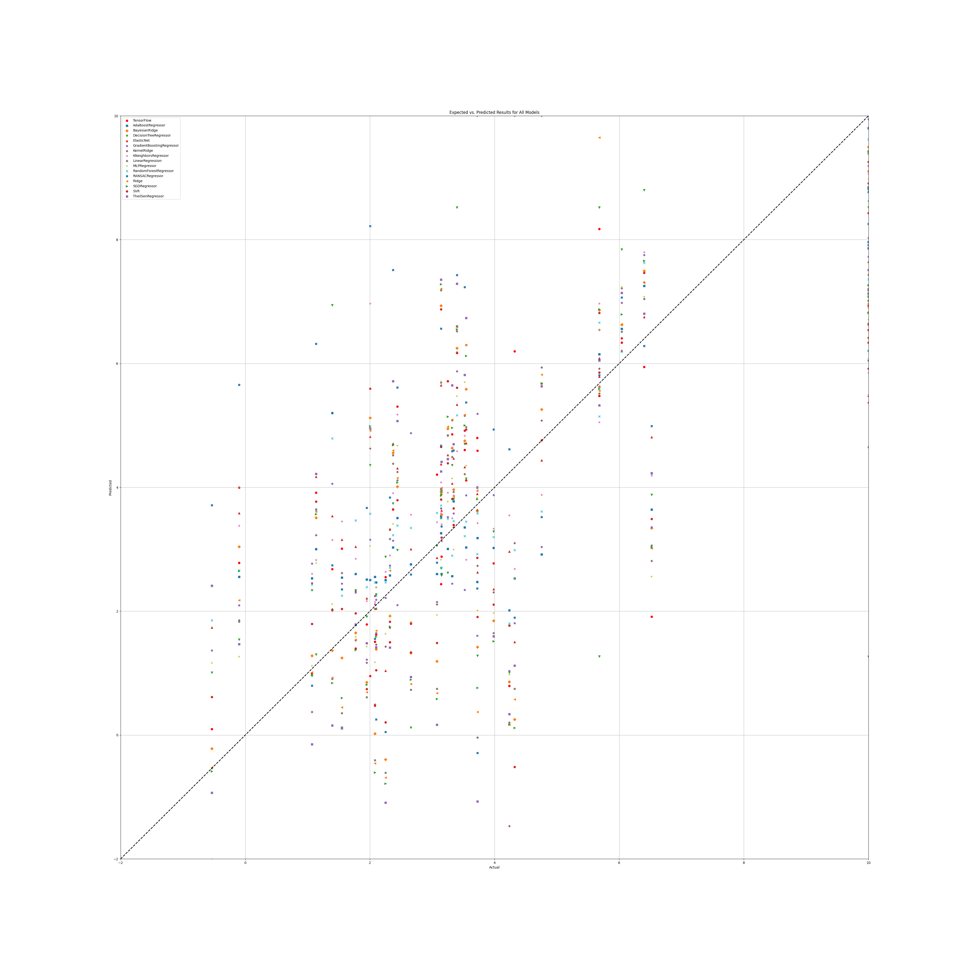

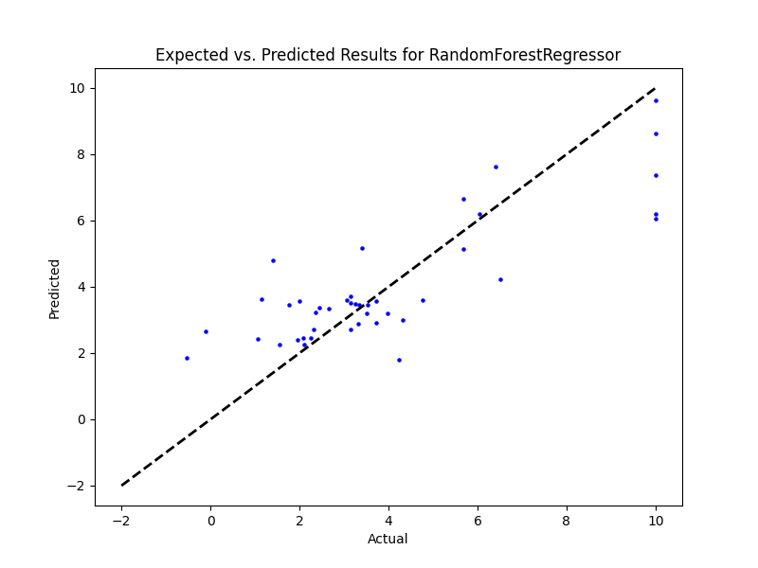

## SR Benefit

|  |  |  |  |
| --- | --- | --- | --- |
| **Ridge Regression** | **Decision Tree** | **Gradient Boosting** | **Random Forest** |
|  |  |  |  |
| **AdaBoost** | **K-Nearest** | **MLP Regressor** | **Elastic Net** |
|  |  |  |  |
| **SGD Regressor** | **Support Vector** | **Bayesian Ridge** | **Kernel Ridge** |
|  |  |  |  |
| **Linear Regression** | **RANSAC** | **TheilSen** | **Tensorflow** |
|  |  |  |  |

## Prediction Results

## Graph