# WS Function

Best hyperparameters for MLPRegressor: {}  
Model: Ridge  
Sample 1: Real SR = 5.57, Predicted SR = 4.625181737899203  
Sample 2: Real SR = 1.34, Predicted SR = 1.9466718123240634  
Sample 3: Real SR = 0.8949745906267642, Predicted SR = 2.7358970350777887  
Sample 4: Real SR = 1.800112930547713, Predicted SR = 3.4012343321950658  
Sample 5: Real SR = 0.86, Predicted SR = 4.395674711965279  
RMSE: 2.012808751161768  
  
  
Model: DecisionTreeRegressor  
Sample 1: Real SR = 5.57, Predicted SR = 5.03  
Sample 2: Real SR = 1.34, Predicted SR = 1.93  
Sample 3: Real SR = 0.8949745906267642, Predicted SR = 5.75592885375494  
Sample 4: Real SR = 1.800112930547713, Predicted SR = 0.88  
Sample 5: Real SR = 0.86, Predicted SR = 0.88  
RMSE: 2.778824554063241  
  
  
Model: RandomForestRegressor  
Sample 1: Real SR = 5.57, Predicted SR = 4.299921727837373  
Sample 2: Real SR = 1.34, Predicted SR = 1.8679686053077373  
Sample 3: Real SR = 0.8949745906267642, Predicted SR = 2.4492877893845306  
Sample 4: Real SR = 1.800112930547713, Predicted SR = 3.4239079051383383  
Sample 5: Real SR = 0.86, Predicted SR = 4.044340090344438  
RMSE: 2.281105737697798  
  
  
Model: GradientBoostingRegressor  
Sample 1: Real SR = 5.57, Predicted SR = 3.85249709373619  
Sample 2: Real SR = 1.34, Predicted SR = 2.743518041351743  
Sample 3: Real SR = 0.8949745906267642, Predicted SR = 3.2246492240046623  
Sample 4: Real SR = 1.800112930547713, Predicted SR = 3.973817475332699  
Sample 5: Real SR = 0.86, Predicted SR = 3.2795231263457993  
RMSE: 2.303621151991622  
  
  
Model: AdaBoostRegressor  
Sample 1: Real SR = 5.57, Predicted SR = 3.9308175365007676  
Sample 2: Real SR = 1.34, Predicted SR = 3.5813017202341335  
Sample 3: Real SR = 0.8949745906267642, Predicted SR = 2.149285714285715  
Sample 4: Real SR = 1.800112930547713, Predicted SR = 3.6403206838139366  
Sample 5: Real SR = 0.86, Predicted SR = 4.022265350357918  
RMSE: 2.327155929047246  
  
Model: SVR  
Sample 1: Real SR = 5.57, Predicted SR = 5.094269536276439  
Sample 2: Real SR = 1.34, Predicted SR = 2.001683261343834  
Sample 3: Real SR = 0.8949745906267642, Predicted SR = 1.3267421819544625  
Sample 4: Real SR = 1.800112930547713, Predicted SR = 3.0066695723555146  
Sample 5: Real SR = 0.86, Predicted SR = 4.63691430471121  
RMSE: 1.8105698905836995  
  
  
Model: KNeighborsRegressor  
Sample 1: Real SR = 5.57, Predicted SR = 4.270590626764539  
Sample 2: Real SR = 1.34, Predicted SR = 2.91332693393563  
Sample 3: Real SR = 0.8949745906267642, Predicted SR = 1.8947487295313383  
Sample 4: Real SR = 1.800112930547713, Predicted SR = 4.891404856013552  
Sample 5: Real SR = 0.86, Predicted SR = 3.658  
RMSE: 2.063644661506461  
  
  
Model: MLPRegressor  
Sample 1: Real SR = 5.57, Predicted SR = 5.883217488166241  
Sample 2: Real SR = 1.34, Predicted SR = 2.4235701443115034  
Sample 3: Real SR = 0.8949745906267642, Predicted SR = 1.0451935861568817  
Sample 4: Real SR = 1.800112930547713, Predicted SR = 2.969349838674701  
Sample 5: Real SR = 0.86, Predicted SR = 3.8287905656011008  
RMSE: 2.0544327361779136

Model: NN 10x64 nodes  
Sample predictions:  
Sample 1: Real WS = 5.57, Predicted WS = 5.224730491638184  
Sample 2: Real WS = 1.34, Predicted WS = 1.5794875621795654  
Sample 3: Real WS = 0.8949745906267642, Predicted WS = 0.8628495931625366  
Sample 4: Real WS = 1.800112930547713, Predicted WS = 1.8913427591323853  
Sample 5: Real WS = 0.86, Predicted WS = 2.4178855419158936

RMSE: 2.0945758990979813

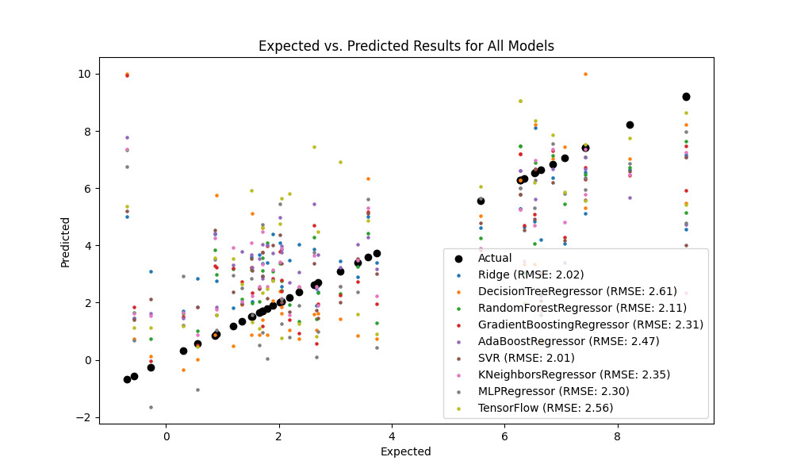

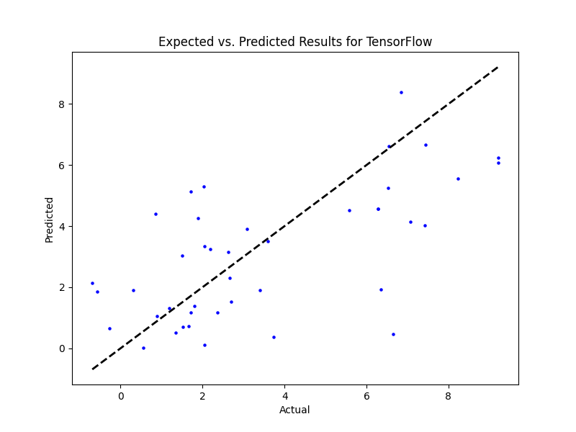

# WS Benefit

Best hyperparameters for MLPRegressor: {}  
Model: Ridge  
Sample 1: Real SR = 0.0, Predicted SR = -0.16345155598544503  
Sample 2: Real SR = 5.79, Predicted SR = 1.7106179560192878  
Sample 3: Real SR = 0.0, Predicted SR = 4.088689619228337  
Sample 4: Real SR = 0.0, Predicted SR = 1.9023440012585273  
Sample 5: Real SR = 3.84, Predicted SR = 1.041113133528506  
RMSE: 4.014613865831976  
  
  
Model: DecisionTreeRegressor  
Sample 1: Real SR = 0.0, Predicted SR = 0.0  
Sample 2: Real SR = 5.79, Predicted SR = 10.0  
Sample 3: Real SR = 0.0, Predicted SR = 0.0  
Sample 4: Real SR = 0.0, Predicted SR = 0.0  
Sample 5: Real SR = 3.84, Predicted SR = 0.0  
RMSE: 5.124595573538296  
  
  
Model: RandomForestRegressor  
Sample 1: Real SR = 0.0, Predicted SR = 0.1  
Sample 2: Real SR = 5.79, Predicted SR = 5.145166666666666  
Sample 3: Real SR = 0.0, Predicted SR = 5.032640493156883  
Sample 4: Real SR = 0.0, Predicted SR = 0.19330118764845608  
Sample 5: Real SR = 3.84, Predicted SR = 0.33346904196357885  
RMSE: 3.809767152896686  
  
  
Model: GradientBoostingRegressor  
Sample 1: Real SR = 0.0, Predicted SR = -0.28168072089175444  
Sample 2: Real SR = 5.79, Predicted SR = 4.611427170966875  
Sample 3: Real SR = 0.0, Predicted SR = 5.4066631749868765  
Sample 4: Real SR = 0.0, Predicted SR = 1.3492681701084102  
Sample 5: Real SR = 3.84, Predicted SR = 0.3775437380570767  
RMSE: 4.011438488745131  
  
  
Model: AdaBoostRegressor  
Sample 1: Real SR = 0.0, Predicted SR = 0.28171052631578947  
Sample 2: Real SR = 5.79, Predicted SR = 3.9080769230769232  
Sample 3: Real SR = 0.0, Predicted SR = 4.498626528996396  
Sample 4: Real SR = 0.0, Predicted SR = 2.0864  
Sample 5: Real SR = 3.84, Predicted SR = 1.14  
RMSE: 3.581266554406931  
  
  
Model: SVR  
Sample 1: Real SR = 0.0, Predicted SR = -0.07590299914101095  
Sample 2: Real SR = 5.79, Predicted SR = 0.1736273894207886  
Sample 3: Real SR = 0.0, Predicted SR = 0.34522990683696253  
Sample 4: Real SR = 0.0, Predicted SR = 0.132419909316094  
Sample 5: Real SR = 3.84, Predicted SR = 0.025956721960962437  
RMSE: 4.096575290227924  
  
  
Model: KNeighborsRegressor  
Sample 1: Real SR = 0.0, Predicted SR = 2.0  
Sample 2: Real SR = 5.79, Predicted SR = 4.0  
Sample 3: Real SR = 0.0, Predicted SR = 2.8140237529691214  
Sample 4: Real SR = 0.0, Predicted SR = 0.0  
Sample 5: Real SR = 3.84, Predicted SR = 0.0  
RMSE: 3.9596445224206183  
  
  
Model: MLPRegressor  
Sample 1: Real SR = 0.0, Predicted SR = 0.2849784989657748  
Sample 2: Real SR = 5.79, Predicted SR = 5.343582792398206  
Sample 3: Real SR = 0.0, Predicted SR = 2.299738405771019  
Sample 4: Real SR = 0.0, Predicted SR = 1.1084289027852792  
Sample 5: Real SR = 3.84, Predicted SR = -1.5909278270803837  
RMSE: 4.714732033623842

Model: NN 10x64 nodes  
Sample predictions:  
Sample 1: Real WS = 0.0, Predicted WS = -0.0060639698058366776  
Sample 2: Real WS = 5.79, Predicted WS = -0.01549471728503704  
Sample 3: Real WS = 0.0, Predicted WS = 2.2327945232391357  
Sample 4: Real WS = 0.0, Predicted WS = 0.013640312477946281  
Sample 5: Real WS = 3.84, Predicted WS = 0.004277888685464859

RMSE: 4.804008829882614

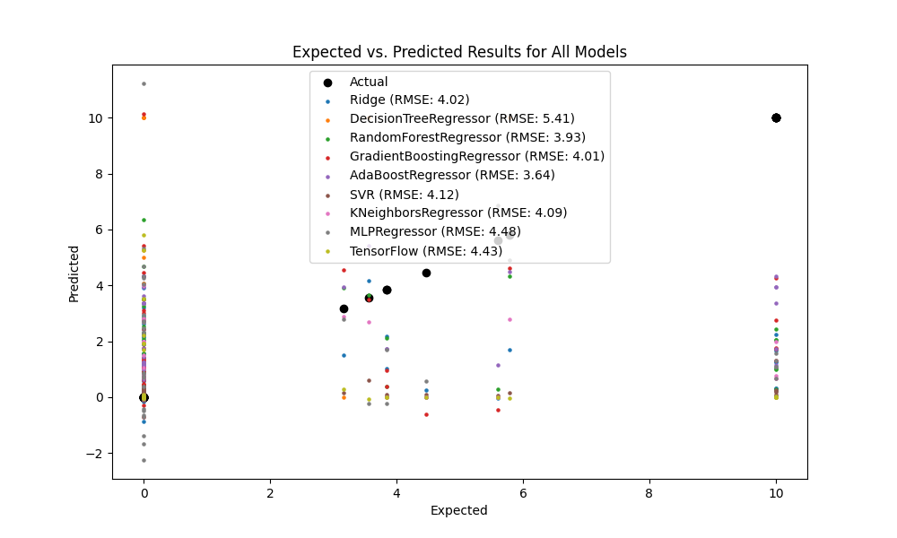

## SR Function

Best hyperparameters for MLPRegressor: {}  
Model: Ridge  
Sample 1: Real SR = 3.14, Predicted SR = 4.886618799911994  
Sample 2: Real SR = 1.95, Predicted SR = 2.432774872830897  
Sample 3: Real SR = 1.071415011787847, Predicted SR = 2.72497990132601  
Sample 4: Real SR = 3.073673531374684, Predicted SR = 4.705534557114696  
Sample 5: Real SR = 1.55, Predicted SR = 4.554366071870147  
RMSE: 2.0174905910083494  
  
  
Model: DecisionTreeRegressor  
Sample 1: Real SR = 3.14, Predicted SR = 2.31  
Sample 2: Real SR = 1.95, Predicted SR = 1.74  
Sample 3: Real SR = 1.071415011787847, Predicted SR = 3.98  
Sample 4: Real SR = 3.073673531374684, Predicted SR = 10.0  
Sample 5: Real SR = 1.55, Predicted SR = 2.12  
RMSE: 3.092262139303616  
  
  
Model: RandomForestRegressor  
Sample 1: Real SR = 3.14, Predicted SR = 3.4076319285993217  
Sample 2: Real SR = 1.95, Predicted SR = 1.9437131145229185  
Sample 3: Real SR = 1.071415011787847, Predicted SR = 2.642739919633944  
Sample 4: Real SR = 3.073673531374684, Predicted SR = 6.357210147466904  
Sample 5: Real SR = 1.55, Predicted SR = 2.458119272872661  
RMSE: 2.2161716185566473  
  
  
Model: GradientBoostingRegressor  
Sample 1: Real SR = 3.14, Predicted SR = 3.3042255752331013  
Sample 2: Real SR = 1.95, Predicted SR = 2.4856565951951404  
Sample 3: Real SR = 1.071415011787847, Predicted SR = 2.0569997523106545  
Sample 4: Real SR = 3.073673531374684, Predicted SR = 8.46456720210217  
Sample 5: Real SR = 1.55, Predicted SR = 2.734481862836364  
RMSE: 2.391478372995141  
  
  
Model: AdaBoostRegressor  
Sample 1: Real SR = 3.14, Predicted SR = 4.098465287982401  
Sample 2: Real SR = 1.95, Predicted SR = 2.8931111967553407  
Sample 3: Real SR = 1.071415011787847, Predicted SR = 2.143494183342328  
Sample 4: Real SR = 3.073673531374684, Predicted SR = 5.829846405826992  
Sample 5: Real SR = 1.55, Predicted SR = 4.441013615987401  
RMSE: 2.3511983513075374  
  
  
Model: SVR  
Sample 1: Real SR = 3.14, Predicted SR = 3.9838302626479565  
Sample 2: Real SR = 1.95, Predicted SR = 2.2780645398227763  
Sample 3: Real SR = 1.071415011787847, Predicted SR = 2.1903252758371243  
Sample 4: Real SR = 3.073673531374684, Predicted SR = 3.3339477480702793  
Sample 5: Real SR = 1.55, Predicted SR = 3.5305805340829526  
RMSE: 2.3162973182508044  
  
  
Model: KNeighborsRegressor  
Sample 1: Real SR = 3.14, Predicted SR = 2.9235143665039165  
Sample 2: Real SR = 1.95, Predicted SR = 2.705889678763071  
Sample 3: Real SR = 1.071415011787847, Predicted SR = 3.4322840582015934  
Sample 4: Real SR = 3.073673531374684, Predicted SR = 5.529770768204012  
Sample 5: Real SR = 1.55, Predicted SR = 4.18  
RMSE: 2.14436410239756  
  
  
Model: MLPRegressor  
Sample 1: Real SR = 3.14, Predicted SR = 4.191644110681451  
Sample 2: Real SR = 1.95, Predicted SR = 2.3028784946091756  
Sample 3: Real SR = 1.071415011787847, Predicted SR = 2.7307330064838613  
Sample 4: Real SR = 3.073673531374684, Predicted SR = 6.195222745979354  
Sample 5: Real SR = 1.55, Predicted SR = 3.475231121197156  
RMSE: 2.6429207930984493  
  
Model: NN 10x64 nodes  
Sample predictions:  
Sample 1: Real WS = 3.14, Predicted WS = 4.659679412841797  
Sample 2: Real WS = 1.95, Predicted WS = 1.8417454957962036  
Sample 3: Real WS = 1.071415011787847, Predicted WS = 0.9733684062957764  
Sample 4: Real WS = 3.073673531374684, Predicted WS = 3.1248393058776855  
Sample 5: Real WS = 1.55, Predicted WS = 2.902045726776123

RMSE: 2.4987018527796288

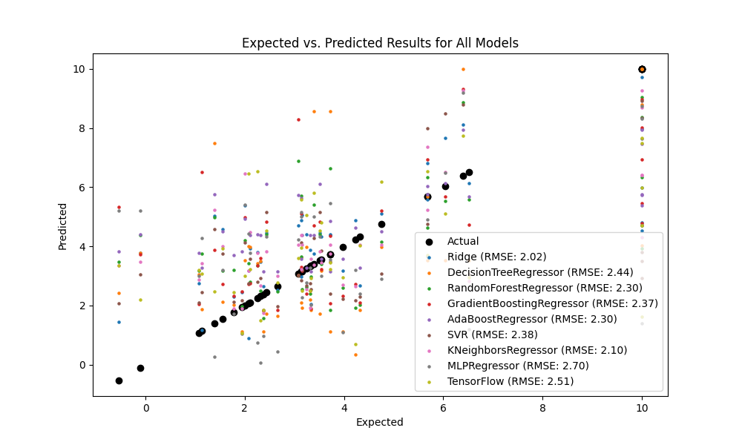

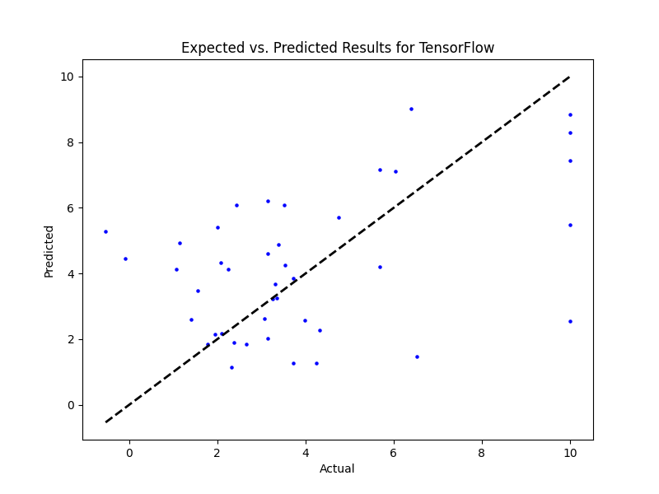

## SR Benefit

Model: Ridge  
Sample 1: Real SR = 10.0, Predicted SR = 2.839159450397456  
Sample 2: Real SR = 0.0, Predicted SR = 3.4942335530140616  
Sample 3: Real SR = 5.045325726224918, Predicted SR = 2.472515056111075  
Sample 4: Real SR = 4.077743931051089, Predicted SR = 4.672885015114274  
Sample 5: Real SR = 4.54, Predicted SR = 2.7112895265777626  
RMSE: 2.7649693835829985  
  
  
Model: DecisionTreeRegressor  
Sample 1: Real SR = 10.0, Predicted SR = 4.671852148658565  
Sample 2: Real SR = 0.0, Predicted SR = 4.62  
Sample 3: Real SR = 5.045325726224918, Predicted SR = 4.78  
Sample 4: Real SR = 4.077743931051089, Predicted SR = 0.0  
Sample 5: Real SR = 4.54, Predicted SR = 0.0  
RMSE: 4.061723466680952  
  
  
Model: RandomForestRegressor  
Sample 1: Real SR = 10.0, Predicted SR = 4.65309123617293  
Sample 2: Real SR = 0.0, Predicted SR = 4.32098120066949  
Sample 3: Real SR = 5.045325726224918, Predicted SR = 2.5666383891180904  
Sample 4: Real SR = 4.077743931051089, Predicted SR = 2.3199472118420275  
Sample 5: Real SR = 4.54, Predicted SR = 0.7885  
RMSE: 3.1369142842872946  
  
  
Model: GradientBoostingRegressor  
Sample 1: Real SR = 10.0, Predicted SR = 3.559584547631028  
Sample 2: Real SR = 0.0, Predicted SR = 3.489644391567342  
Sample 3: Real SR = 5.045325726224918, Predicted SR = 2.3253182309090015  
Sample 4: Real SR = 4.077743931051089, Predicted SR = 2.225668506652422  
Sample 5: Real SR = 4.54, Predicted SR = 1.7161285076255084  
RMSE: 3.0530694557114955  
  
  
Model: AdaBoostRegressor  
Sample 1: Real SR = 10.0, Predicted SR = 4.4483755837733705  
Sample 2: Real SR = 0.0, Predicted SR = 3.160103365760106  
Sample 3: Real SR = 5.045325726224918, Predicted SR = 3.7433130893958415  
Sample 4: Real SR = 4.077743931051089, Predicted SR = 3.160103365760106  
Sample 5: Real SR = 4.54, Predicted SR = 2.28647405000419  
RMSE: 3.066297761008374  
  
  
Model: SVR  
Sample 1: Real SR = 10.0, Predicted SR = 3.301981807192065  
Sample 2: Real SR = 0.0, Predicted SR = 4.510275827741105  
Sample 3: Real SR = 5.045325726224918, Predicted SR = 1.7002126877886337  
Sample 4: Real SR = 4.077743931051089, Predicted SR = 3.8750753599882293  
Sample 5: Real SR = 4.54, Predicted SR = 2.325440508330195  
RMSE: 2.8349388852708524  
  
  
Model: KNeighborsRegressor  
Sample 1: Real SR = 10.0, Predicted SR = 3.5794909163230315  
Sample 2: Real SR = 0.0, Predicted SR = 4.398820250836864  
Sample 3: Real SR = 5.045325726224918, Predicted SR = 1.9605684424341987  
Sample 4: Real SR = 4.077743931051089, Predicted SR = 0.95  
Sample 5: Real SR = 4.54, Predicted SR = 2.854  
RMSE: 3.275821062414312  
  
  
Model: MLPRegressor  
Sample 1: Real SR = 10.0, Predicted SR = 3.1876926797535914  
Sample 2: Real SR = 0.0, Predicted SR = 6.510915846401069  
Sample 3: Real SR = 5.045325726224918, Predicted SR = 1.5913213591468174  
Sample 4: Real SR = 4.077743931051089, Predicted SR = 3.219630484505521  
Sample 5: Real SR = 4.54, Predicted SR = -1.4431190925957509  
RMSE: 4.094173224603515

Model: NN 10x64 nodes  
Sample predictions:  
Sample 1: Real WS = 10.0, Predicted WS = 0.7585674524307251  
Sample 2: Real WS = 0.0, Predicted WS = 4.882223129272461  
Sample 3: Real WS = 5.045325726224918, Predicted WS = 2.361053228378296  
Sample 4: Real WS = 4.077743931051089, Predicted WS = 3.524625778198242  
Sample 5: Real WS = 4.54, Predicted WS = 1.149276852607727

RMSE: 3.893879741777484

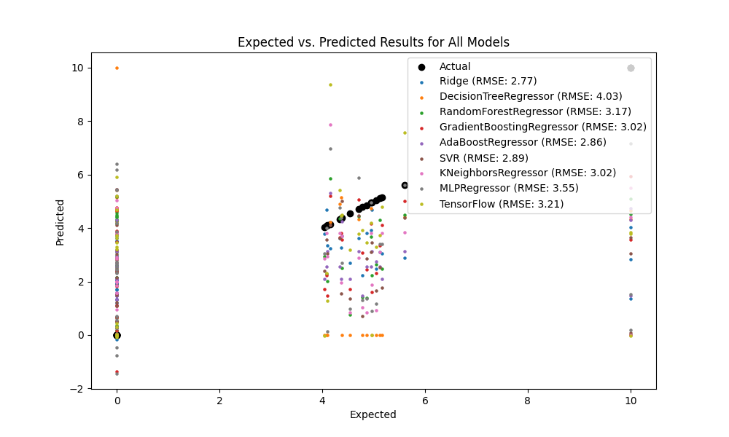

## NR

Best hyperparameters for MLPRegressor: {}  
Model: Ridge  
Sample 1: Real SR = 3.86, Predicted SR = 4.751660297777801  
Sample 2: Real SR = 2.0, Predicted SR = 1.2385615139224777  
Sample 3: Real SR = 1.570516742590589, Predicted SR = 3.930684194391861  
Sample 4: Real SR = 2.42215783927728, Predicted SR = 4.105345153871475  
Sample 5: Real SR = 1.3, Predicted SR = 4.7541524192114935  
RMSE: 2.4880086369141137  
  
  
Model: DecisionTreeRegressor  
Sample 1: Real SR = 3.86, Predicted SR = 3.17  
Sample 2: Real SR = 2.0, Predicted SR = 0.75  
Sample 3: Real SR = 1.570516742590589, Predicted SR = 1.382022977963089  
Sample 4: Real SR = 2.42215783927728, Predicted SR = 2.484253220548712  
Sample 5: Real SR = 1.3, Predicted SR = 1.91  
RMSE: 2.860150586384024  
  
  
Model: RandomForestRegressor  
Sample 1: Real SR = 3.86, Predicted SR = 2.8762925276640137  
Sample 2: Real SR = 2.0, Predicted SR = 2.4156927227553693  
Sample 3: Real SR = 1.570516742590589, Predicted SR = 5.356629997703658  
Sample 4: Real SR = 2.42215783927728, Predicted SR = 5.981870195990705  
Sample 5: Real SR = 1.3, Predicted SR = 2.979896915975758  
RMSE: 2.3292140377525365  
  
  
Model: GradientBoostingRegressor  
Sample 1: Real SR = 3.86, Predicted SR = 2.9187885912901304  
Sample 2: Real SR = 2.0, Predicted SR = 2.4325613517228377  
Sample 3: Real SR = 1.570516742590589, Predicted SR = 2.5602972453475106  
Sample 4: Real SR = 2.42215783927728, Predicted SR = 7.8049686485811725  
Sample 5: Real SR = 1.3, Predicted SR = 2.7732957742481896  
RMSE: 2.597131323026859  
  
  
Model: AdaBoostRegressor  
Sample 1: Real SR = 3.86, Predicted SR = 4.475158817998954  
Sample 2: Real SR = 2.0, Predicted SR = 3.744305484451713  
Sample 3: Real SR = 1.570516742590589, Predicted SR = 4.469263646961826  
Sample 4: Real SR = 2.42215783927728, Predicted SR = 5.688995030547798  
Sample 5: Real SR = 1.3, Predicted SR = 3.744305484451713  
RMSE: 2.5445659923881543  
  
  
Model: SVR  
Sample 1: Real SR = 3.86, Predicted SR = 3.516739055792655  
Sample 2: Real SR = 2.0, Predicted SR = 1.8802854782479668  
Sample 3: Real SR = 1.570516742590589, Predicted SR = 2.588767333066338  
Sample 4: Real SR = 2.42215783927728, Predicted SR = 3.1713621993671888  
Sample 5: Real SR = 1.3, Predicted SR = 3.458263606716537  
RMSE: 2.527546611293217  
  
  
Model: KNeighborsRegressor  
Sample 1: Real SR = 3.86, Predicted SR = 2.816844097851839  
Sample 2: Real SR = 2.0, Predicted SR = 2.9482490164134165  
Sample 3: Real SR = 1.570516742590589, Predicted SR = 3.457727849846191  
Sample 4: Real SR = 2.42215783927728, Predicted SR = 5.6028506441097425  
Sample 5: Real SR = 1.3, Predicted SR = 3.7560000000000002  
RMSE: 2.343539992515723  
  
  
Model: MLPRegressor  
Sample 1: Real SR = 3.86, Predicted SR = 3.6722474747014786  
Sample 2: Real SR = 2.0, Predicted SR = 1.7759880251242164  
Sample 3: Real SR = 1.570516742590589, Predicted SR = 2.6968862170705927  
Sample 4: Real SR = 2.42215783927728, Predicted SR = 5.496490550707813  
Sample 5: Real SR = 1.3, Predicted SR = 4.853810355740641  
RMSE: 2.7563987328995645

Model: NN 10x64 nodes  
Sample predictions:  
Sample 1: Real WS = 3.86, Predicted WS = 2.9881718158721924  
Sample 2: Real WS = 2.0, Predicted WS = 4.668152332305908  
Sample 3: Real WS = 1.570516742590589, Predicted WS = 1.5460153818130493  
Sample 4: Real WS = 2.42215783927728, Predicted WS = 3.095991849899292  
Sample 5: Real WS = 1.3, Predicted WS = 4.1524658203125

RMSE: 2.738134303696348

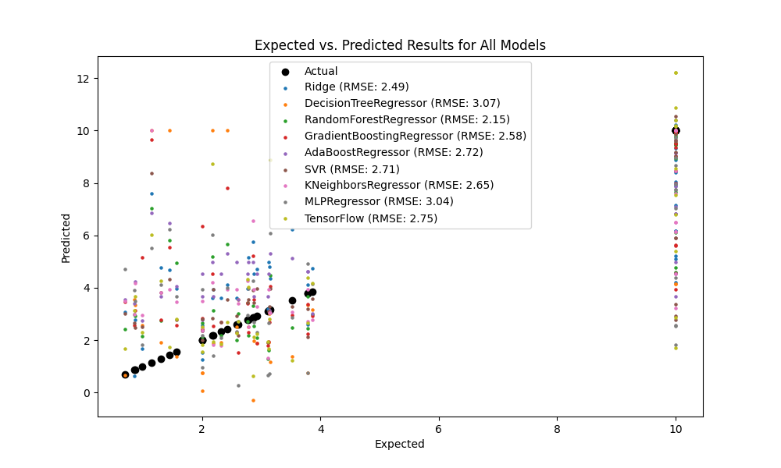  
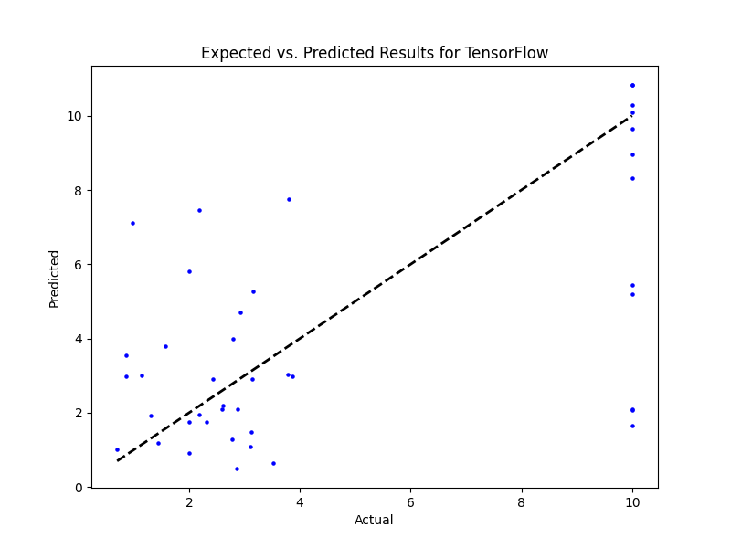

## NR Benefit

Best hyperparameters for MLPRegressor: {}  
Model: Ridge  
Sample 1: Real SR = 10.0, Predicted SR = 2.866575257360708  
Sample 2: Real SR = 10.0, Predicted SR = 5.465519408396202  
Sample 3: Real SR = 10.0, Predicted SR = 9.425904248557654  
Sample 4: Real SR = 10.0, Predicted SR = 6.983678819804583  
Sample 5: Real SR = 4.83, Predicted SR = 3.749116253974898  
RMSE: 3.3614916466003413  
  
  
Model: DecisionTreeRegressor  
Sample 1: Real SR = 10.0, Predicted SR = 10.0  
Sample 2: Real SR = 10.0, Predicted SR = 4.764957264957264  
Sample 3: Real SR = 10.0, Predicted SR = 10.0  
Sample 4: Real SR = 10.0, Predicted SR = 4.62  
Sample 5: Real SR = 4.83, Predicted SR = 0.0  
RMSE: 3.815769103104411  
  
  
Model: RandomForestRegressor  
Sample 1: Real SR = 10.0, Predicted SR = 6.671563532763537  
Sample 2: Real SR = 10.0, Predicted SR = 4.8009846153846185  
Sample 3: Real SR = 10.0, Predicted SR = 8.859399999999999  
Sample 4: Real SR = 10.0, Predicted SR = 4.095919658119659  
Sample 5: Real SR = 4.83, Predicted SR = 1.6073829059829061  
RMSE: 3.3236467690308396  
  
  
Model: GradientBoostingRegressor  
Sample 1: Real SR = 10.0, Predicted SR = 6.744620002394805  
Sample 2: Real SR = 10.0, Predicted SR = 4.245596029769369  
Sample 3: Real SR = 10.0, Predicted SR = 8.663255010386514  
Sample 4: Real SR = 10.0, Predicted SR = 4.129861388542768  
Sample 5: Real SR = 4.83, Predicted SR = 2.4418734157223936  
RMSE: 3.494106861365359  
  
  
Model: AdaBoostRegressor  
Sample 1: Real SR = 10.0, Predicted SR = 5.279173553719008  
Sample 2: Real SR = 10.0, Predicted SR = 4.890920060331825  
Sample 3: Real SR = 10.0, Predicted SR = 7.5675675675675675  
Sample 4: Real SR = 10.0, Predicted SR = 4.969106984969055  
Sample 5: Real SR = 4.83, Predicted SR = 4.478888888888889  
RMSE: 3.589496649681762  
  
  
Model: SVR  
Sample 1: Real SR = 10.0, Predicted SR = 3.693647758890032  
Sample 2: Real SR = 10.0, Predicted SR = 4.681587641355854  
Sample 3: Real SR = 10.0, Predicted SR = 9.993016997942116  
Sample 4: Real SR = 10.0, Predicted SR = 5.044888746145332  
Sample 5: Real SR = 4.83, Predicted SR = 2.839905434855246  
RMSE: 3.3320118493479978  
  
  
Model: KNeighborsRegressor  
Sample 1: Real SR = 10.0, Predicted SR = 6.649931623931624  
Sample 2: Real SR = 10.0, Predicted SR = 4.436991452991452  
Sample 3: Real SR = 10.0, Predicted SR = 10.0  
Sample 4: Real SR = 10.0, Predicted SR = 0.924  
Sample 5: Real SR = 4.83, Predicted SR = 2.9240000000000004  
RMSE: 4.028098987224177  
  
  
Model: MLPRegressor  
Sample 1: Real SR = 10.0, Predicted SR = 5.528196475988822  
Sample 2: Real SR = 10.0, Predicted SR = 5.2254759337492915  
Sample 3: Real SR = 10.0, Predicted SR = 12.139779132577493  
Sample 4: Real SR = 10.0, Predicted SR = 2.4901001071594195  
Sample 5: Real SR = 4.83, Predicted SR = 0.6764073185019251  
RMSE: 4.414393094402319

Model: NN 10x64 nodes  
Sample predictions:  
Sample 1: Real WS = 10.0, Predicted WS = 7.58756160736084  
Sample 2: Real WS = 10.0, Predicted WS = 5.016517162322998  
Sample 3: Real WS = 10.0, Predicted WS = 11.02863597869873  
Sample 4: Real WS = 10.0, Predicted WS = 4.39352560043335  
Sample 5: Real WS = 4.83, Predicted WS = 0.12387742102146149

RMSE: 4.027343501758554

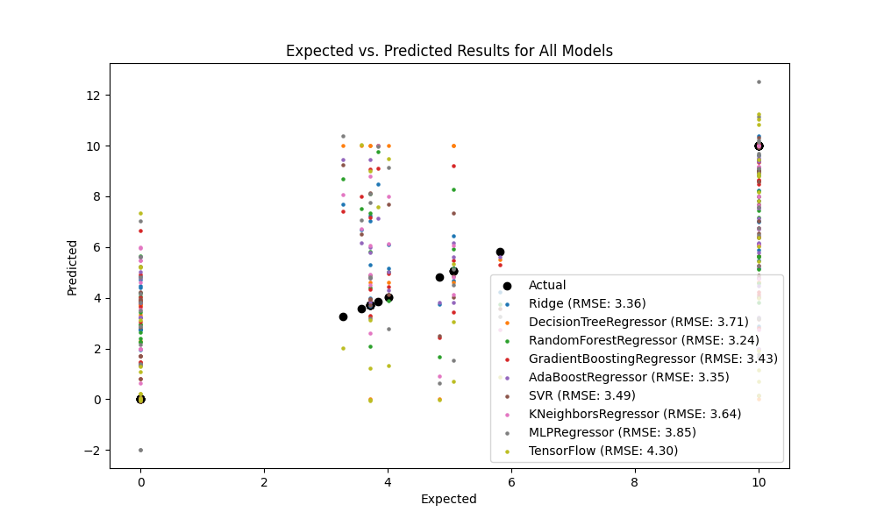

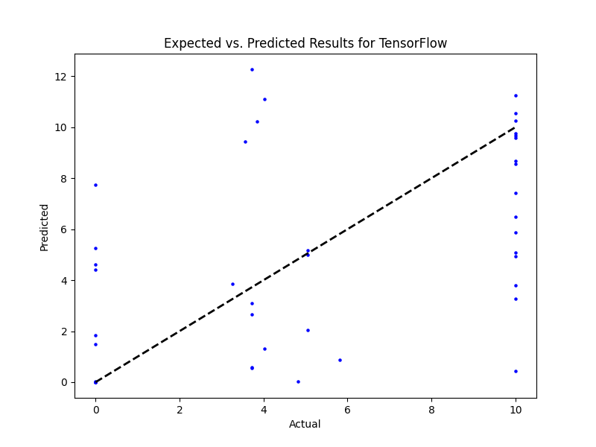

## PR

Best hyperparameters for MLPRegressor: {}  
Model: Ridge  
Sample 1: Real SR = 4.1, Predicted SR = 5.560384929531084  
Sample 2: Real SR = 4.95, Predicted SR = 3.233816404026099  
Sample 3: Real SR = 3.658444467902927, Predicted SR = 6.004431625244407  
Sample 4: Real SR = 2.408991972171535, Predicted SR = 4.623760874904971  
Sample 5: Real SR = 5.13, Predicted SR = 6.255870188956573  
RMSE: 1.992014607476453  
  
  
Model: DecisionTreeRegressor  
Sample 1: Real SR = 4.1, Predicted SR = 4.07  
Sample 2: Real SR = 4.95, Predicted SR = 3.243721923126547  
Sample 3: Real SR = 3.658444467902927, Predicted SR = 10.0  
Sample 4: Real SR = 2.408991972171535, Predicted SR = 5.67  
Sample 5: Real SR = 5.13, Predicted SR = 5.18  
RMSE: 2.64936863511727  
  
  
Model: RandomForestRegressor  
Sample 1: Real SR = 4.1, Predicted SR = 4.030291428772503  
Sample 2: Real SR = 4.95, Predicted SR = 4.047541511128539  
Sample 3: Real SR = 3.658444467902927, Predicted SR = 6.926092053941104  
Sample 4: Real SR = 2.408991972171535, Predicted SR = 5.597300098358074  
Sample 5: Real SR = 5.13, Predicted SR = 5.119104148409544  
RMSE: 1.750489666539416  
  
  
Model: GradientBoostingRegressor  
Sample 1: Real SR = 4.1, Predicted SR = 3.650620182346131  
Sample 2: Real SR = 4.95, Predicted SR = 4.075987048394479  
Sample 3: Real SR = 3.658444467902927, Predicted SR = 4.981086647544682  
Sample 4: Real SR = 2.408991972171535, Predicted SR = 5.914717545329272  
Sample 5: Real SR = 5.13, Predicted SR = 4.993656493681811  
RMSE: 1.8264941788252727  
  
  
Model: AdaBoostRegressor  
Sample 1: Real SR = 4.1, Predicted SR = 3.8980947186573704  
Sample 2: Real SR = 4.95, Predicted SR = 5.5874029870930055  
Sample 3: Real SR = 3.658444467902927, Predicted SR = 6.500147475671598  
Sample 4: Real SR = 2.408991972171535, Predicted SR = 4.933165645475368  
Sample 5: Real SR = 5.13, Predicted SR = 6.75213112454947  
RMSE: 1.9529230945074822  
  
  
Model: SVR  
Sample 1: Real SR = 4.1, Predicted SR = 5.101608530691417  
Sample 2: Real SR = 4.95, Predicted SR = 3.4054018323092343  
Sample 3: Real SR = 3.658444467902927, Predicted SR = 5.216171391736995  
Sample 4: Real SR = 2.408991972171535, Predicted SR = 4.8763340770034445  
Sample 5: Real SR = 5.13, Predicted SR = 5.438876493936233  
RMSE: 1.901669994478568  
  
  
Model: KNeighborsRegressor  
Sample 1: Real SR = 4.1, Predicted SR = 4.147057444801348  
Sample 2: Real SR = 4.95, Predicted SR = 3.6127443846253096  
Sample 3: Real SR = 3.658444467902927, Predicted SR = 4.41170410808329  
Sample 4: Real SR = 2.408991972171535, Predicted SR = 6.255370940634954  
Sample 5: Real SR = 5.13, Predicted SR = 5.898  
RMSE: 1.824299776393364  
  
  
Model: MLPRegressor  
Sample 1: Real SR = 4.1, Predicted SR = 5.561666593404049  
Sample 2: Real SR = 4.95, Predicted SR = 4.249245414173371  
Sample 3: Real SR = 3.658444467902927, Predicted SR = 4.07760550133857  
Sample 4: Real SR = 2.408991972171535, Predicted SR = 7.0804644967751145  
Sample 5: Real SR = 5.13, Predicted SR = 4.84443935409511  
RMSE: 2.010225299442041

Model: NN 10x64 nodes  
Sample predictions:  
Sample 1: Real WS = 4.1, Predicted WS = 4.705620765686035  
Sample 2: Real WS = 4.95, Predicted WS = 3.2908530235290527  
Sample 3: Real WS = 3.658444467902927, Predicted WS = 3.9553704261779785  
Sample 4: Real WS = 2.408991972171535, Predicted WS = 6.204776763916016  
Sample 5: Real WS = 5.13, Predicted WS = 3.8892135620117188

RMSE: 2.101118051576144

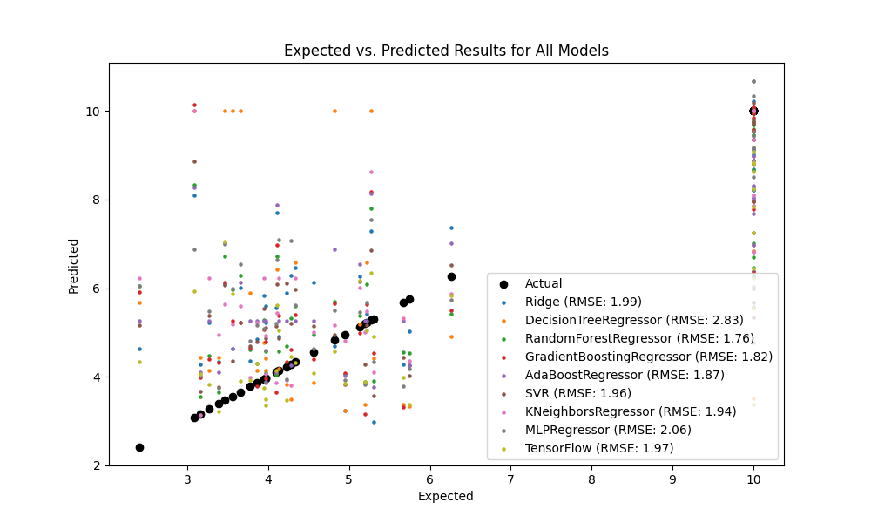

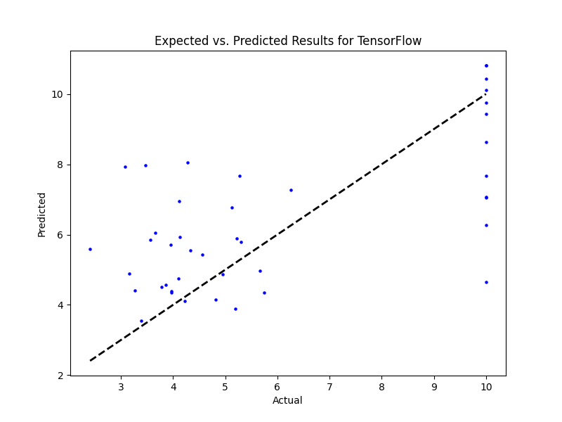

## PR Benefit

Best hyperparameters for MLPRegressor: {}  
Model: Ridge  
Sample 1: Real SR = 10.0, Predicted SR = 3.687516029398416  
Sample 2: Real SR = 2.99, Predicted SR = 5.395610626275099  
Sample 3: Real SR = 7.217671707260766, Predicted SR = 4.675305750622234  
Sample 4: Real SR = 5.739039593674248, Predicted SR = 6.6170622110723265  
Sample 5: Real SR = 6.41, Predicted SR = 3.5781275389527982  
RMSE: 3.640196460069589  
  
  
Model: DecisionTreeRegressor  
Sample 1: Real SR = 10.0, Predicted SR = 10.0  
Sample 2: Real SR = 2.99, Predicted SR = 6.57  
Sample 3: Real SR = 7.217671707260766, Predicted SR = 10.0  
Sample 4: Real SR = 5.739039593674248, Predicted SR = 10.0  
Sample 5: Real SR = 6.41, Predicted SR = 0.0  
RMSE: 4.97974036938447  
  
  
Model: RandomForestRegressor  
Sample 1: Real SR = 10.0, Predicted SR = 6.464243454923231  
Sample 2: Real SR = 2.99, Predicted SR = 5.8658142807671405  
Sample 3: Real SR = 7.217671707260766, Predicted SR = 5.131062602859451  
Sample 4: Real SR = 5.739039593674248, Predicted SR = 3.2845253096090126  
Sample 5: Real SR = 6.41, Predicted SR = 1.31540222869016  
RMSE: 4.007550731149487  
  
  
Model: GradientBoostingRegressor  
Sample 1: Real SR = 10.0, Predicted SR = 5.145216819397041  
Sample 2: Real SR = 2.99, Predicted SR = 6.194576495355447  
Sample 3: Real SR = 7.217671707260766, Predicted SR = 3.4746416196536605  
Sample 4: Real SR = 5.739039593674248, Predicted SR = 3.700771405290709  
Sample 5: Real SR = 6.41, Predicted SR = 0.8407643521601965  
RMSE: 3.9530659193204385  
  
  
Model: AdaBoostRegressor  
Sample 1: Real SR = 10.0, Predicted SR = 5.7979382554707195  
Sample 2: Real SR = 2.99, Predicted SR = 3.600807477252522  
Sample 3: Real SR = 7.217671707260766, Predicted SR = 3.74330452993849  
Sample 4: Real SR = 5.739039593674248, Predicted SR = 5.5018000280338395  
Sample 5: Real SR = 6.41, Predicted SR = 1.4331008765754234  
RMSE: 3.820010956827971  
  
  
Model: SVR  
Sample 1: Real SR = 10.0, Predicted SR = 4.427146359456721  
Sample 2: Real SR = 2.99, Predicted SR = 6.452590280284058  
Sample 3: Real SR = 7.217671707260766, Predicted SR = 3.574982408204708  
Sample 4: Real SR = 5.739039593674248, Predicted SR = 5.590298578225293  
Sample 5: Real SR = 6.41, Predicted SR = 3.43195570712778  
RMSE: 3.7494250797720854  
  
  
Model: KNeighborsRegressor  
Sample 1: Real SR = 10.0, Predicted SR = 5.108169868570769  
Sample 2: Real SR = 2.99, Predicted SR = 6.268522286901601  
Sample 3: Real SR = 7.217671707260766, Predicted SR = 3.6157124717600304  
Sample 4: Real SR = 5.739039593674248, Predicted SR = 1.294  
Sample 5: Real SR = 6.41, Predicted SR = 3.2079999999999997  
RMSE: 4.439759389768821  
  
  
Model: MLPRegressor  
Sample 1: Real SR = 10.0, Predicted SR = 4.982278977292179  
Sample 2: Real SR = 2.99, Predicted SR = 8.204770406035788  
Sample 3: Real SR = 7.217671707260766, Predicted SR = 3.546929786222897  
Sample 4: Real SR = 5.739039593674248, Predicted SR = 4.359368689175502  
Sample 5: Real SR = 6.41, Predicted SR = -0.09704061024271221  
RMSE: 4.575087822820211

Model: NN 10x64 nodes  
Sample predictions:  
Sample 1: Real WS = 10.0, Predicted WS = 7.118138313293457  
Sample 2: Real WS = 2.99, Predicted WS = 7.424680233001709  
Sample 3: Real WS = 7.217671707260766, Predicted WS = 1.57015061378479  
Sample 4: Real WS = 5.739039593674248, Predicted WS = 5.564515590667725  
Sample 5: Real WS = 6.41, Predicted WS = -0.0005911644548177719

RMSE: 4.725741690372465

