# Annex 2.0

Data for our second iteration of ML algorithms.

# Annex 2.1

## NR

### Grid search results

**Ridge()**  
Best hyperparameters for Ridge: {'ridge__alpha': 1.0, 'ridge__solver': 'lsqr'}

**DecisionTreeRegressor()**  
Best hyperparameters for DecisionTreeRegressor: {'decisiontreeregressor__criterion': 'friedman_mse', 'decisiontreeregressor__max_features': 3, 'decisiontreeregressor__min_samples_split': 5, 'decisiontreeregressor__splitter': 'best'}

**GradientBoostingRegressor()**  
Best hyperparameters for GradientBoostingRegressor: {'gradientboostingregressor__learning_rate': 0.1, 'gradientboostingregressor__loss': 'huber', 'gradientboostingregressor__n_estimators': 25, 'gradientboostingregressor__warm_start': False}

**RandomForestRegressor()**  
Best hyperparameters for RandomForestRegressor: {'randomforestregressor__criterion': 'absolute_error', 'randomforestregressor__max_features': 'log2', 'randomforestregressor__min_samples_split': 5, 'randomforestregressor__n_estimators': 100}

**AdaBoostRegressor()**  
Best hyperparameters for AdaBoostRegressor: {'adaboostregressor__learning_rate': 10, 'adaboostregressor__loss': 'square', 'adaboostregressor__n_estimators': 1}

**KNeighborsRegressor()**  
Best hyperparameters for KNeighborsRegressor: {'kneighborsregressor__algorithm': 'ball_tree', 'kneighborsregressor__leaf_size': 5, 'kneighborsregressor__metric': 'cityblock', 'kneighborsregressor__n_neighbors': 10, 'kneighborsregressor__weights': 'distance'}

**MLPRegressor()**  
Best hyperparameters for MLPRegressor: {'mlpregressor__activation': 'relu', 'mlpregressor__hidden_layer_sizes': (100, 100, 100), 'mlpregressor__learning_rate': 'adaptive', 'mlpregressor__solver': 'sgd'}  
ElasticNet()

Best hyperparameters for ElasticNet: {'elasticnet__copy_X': True, 'elasticnet__fit_intercept': True, 'elasticnet__l1_ratio': 0.25, 'elasticnet__positive': False, 'elasticnet__precompute': False, 'elasticnet__selection': 'random', 'elasticnet__warm_start': False}

**SGDRegressor()**  
Best hyperparameters for SGDRegressor: {'sgdregressor__learning_rate': 'constant', 'sgdregressor__loss': 'squared_error', 'sgdregressor__penalty': 'elasticnet', 'sgdregressor__warm_start': True}

**SVR(cache_size=1000)**  
Best hyperparameters for SVR: {'svr__degree': 1, 'svr__gamma': 'scale', 'svr__kernel': 'rbf', 'svr__shrinking': True}

**BayesianRidge(max_iter=1000)**  
Best hyperparameters for BayesianRidge: {'bayesianridge__alpha_1': 1e-07, 'bayesianridge__alpha_2': 1e-05, 'bayesianridge__lambda_1': 1e-05, 'bayesianridge__lambda_2': 1e-07}  
KernelRidge()  
Best hyperparameters for KernelRidge: {'kernelridge__alpha': 1.0, 'kernelridge__coef0': 0.5, 'kernelridge__degree': 3, 'kernelridge__kernel': 'poly'}

**LinearRegression()**  
Best hyperparameters for LinearRegression: {'linearregression__copy_X': True, 'linearregression__fit_intercept': True, 'linearregression__positive': False}

**RANSACRegressor()**  
Best hyperparameters for RANSACRegressor: {'ransacregressor__loss': 'absolute_error', 'ransacregressor__max_trials': 100, 'ransacregressor__min_samples': 50}

**TheilSenRegressor()**  
Best hyperparameters for TheilSenRegressor: {'theilsenregressor__max_subpopulation': 1000, 'theilsenregressor__n_subsamples': 25}

**Tensorflow()**

TensorFlow RMSE: 3.391352102153281

### Prediction results

Model: Ridge  
RMSE: 3.0212481768005413  
Sample predictions:  
Sample 1: Real NR = 10.0, Predicted NR = 8.535104961531776  
Sample 2: Real NR = 3.0, Predicted NR = 2.963133334286255  
Sample 3: Real NR = 0.27, Predicted NR = 5.549521374411243  
Sample 4: Real NR = 10.0, Predicted NR = 4.822872683206046  
Sample 5: Real NR = 1.65, Predicted NR = 5.575825322223221  
  
  
Model: DecisionTreeRegressor  
RMSE: 4.066867781392477  
Sample predictions:  
Sample 1: Real NR = 10.0, Predicted NR = 2.687049731370855  
Sample 2: Real NR = 3.0, Predicted NR = 2.12  
Sample 3: Real NR = 0.27, Predicted NR = 1.6864854192406071  
Sample 4: Real NR = 10.0, Predicted NR = 2.1233333333333335  
Sample 5: Real NR = 1.65, Predicted NR = 0.43333333333333335  
  
  
Model: GradientBoostingRegressor  
RMSE: 2.8021263744102036  
Sample predictions:  
Sample 1: Real NR = 10.0, Predicted NR = 2.8412959564621425  
Sample 2: Real NR = 3.0, Predicted NR = 2.9544399538445356  
Sample 3: Real NR = 0.27, Predicted NR = 2.6445162921005  
Sample 4: Real NR = 10.0, Predicted NR = 2.858820059846753  
Sample 5: Real NR = 1.65, Predicted NR = 2.369863847095946  
  
  
Model: RandomForestRegressor  
RMSE: 2.6958610441257633  
Sample predictions:  
Sample 1: Real NR = 10.0, Predicted NR = 6.536474628751595  
Sample 2: Real NR = 3.0, Predicted NR = 3.367200139780936  
Sample 3: Real NR = 0.27, Predicted NR = 5.029133670129758  
Sample 4: Real NR = 10.0, Predicted NR = 2.4666812209331885  
Sample 5: Real NR = 1.65, Predicted NR = 3.3250577266541184

Model: AdaBoostRegressor  
RMSE: 3.0095612002762913  
Sample predictions:  
Sample 1: Real NR = 10.0, Predicted NR = 2.312524617523553  
Sample 2: Real NR = 3.0, Predicted NR = 2.8728838006509956  
Sample 3: Real NR = 0.27, Predicted NR = 2.8728838006509956  
Sample 4: Real NR = 10.0, Predicted NR = 2.8728838006509956  
Sample 5: Real NR = 1.65, Predicted NR = 2.8728838006509956  
  
  
Model: KNeighborsRegressor  
RMSE: 2.821855178008047  
Sample predictions:  
Sample 1: Real NR = 10.0, Predicted NR = 7.210920855432196  
Sample 2: Real NR = 3.0, Predicted NR = 3.2070140360000923  
Sample 3: Real NR = 0.27, Predicted NR = 5.417775258839862  
Sample 4: Real NR = 10.0, Predicted NR = 2.6102898814892863  
Sample 5: Real NR = 1.65, Predicted NR = 2.5387987046406417  
  
  
Model: MLPRegressor  
RMSE: 2.8860835574036305  
Sample predictions:  
Sample 1: Real NR = 10.0, Predicted NR = 5.855947288471162  
Sample 2: Real NR = 3.0, Predicted NR = 1.8414767606373679  
Sample 3: Real NR = 0.27, Predicted NR = 4.286086095756203  
Sample 4: Real NR = 10.0, Predicted NR = 3.8398298612367485  
Sample 5: Real NR = 1.65, Predicted NR = 1.3599217628275673  
  
  
Model: ElasticNet  
RMSE: 3.0501572672706763  
Sample predictions:  
Sample 1: Real NR = 10.0, Predicted NR = 6.506570221826927  
Sample 2: Real NR = 3.0, Predicted NR = 3.72103885237526  
Sample 3: Real NR = 0.27, Predicted NR = 5.887571498115979  
Sample 4: Real NR = 10.0, Predicted NR = 5.2833159374266705  
Sample 5: Real NR = 1.65, Predicted NR = 5.01316413108079  
  
  
Model: SGDRegressor  
RMSE: 3.149174604648292  
Sample predictions:  
Sample 1: Real NR = 10.0, Predicted NR = 8.78905190749909  
Sample 2: Real NR = 3.0, Predicted NR = 3.133389778985432  
Sample 3: Real NR = 0.27, Predicted NR = 5.514173659148129  
Sample 4: Real NR = 10.0, Predicted NR = 5.290091068601994  
Sample 5: Real NR = 1.65, Predicted NR = 6.194795249029508  
  
Model: SVR  
RMSE: 3.000151040602319  
Sample predictions:  
Sample 1: Real NR = 10.0, Predicted NR = 6.676308910034457  
Sample 2: Real NR = 3.0, Predicted NR = 3.072913281577529  
Sample 3: Real NR = 0.27, Predicted NR = 5.756508369550152  
Sample 4: Real NR = 10.0, Predicted NR = 3.4393329835293804  
Sample 5: Real NR = 1.65, Predicted NR = 2.7313159379503844  
  
  
Model: BayesianRidge  
RMSE: 3.0153984319942224  
Sample predictions:  
Sample 1: Real NR = 10.0, Predicted NR = 7.7304116493086195  
Sample 2: Real NR = 3.0, Predicted NR = 2.9488694147249306  
Sample 3: Real NR = 0.27, Predicted NR = 6.218863629375973  
Sample 4: Real NR = 10.0, Predicted NR = 5.081923909626166  
Sample 5: Real NR = 1.65, Predicted NR = 5.480738247828803  
  
  
Model: KernelRidge  
RMSE: 3.1515269993431665  
Sample predictions:  
Sample 1: Real NR = 10.0, Predicted NR = 5.114022514942213  
Sample 2: Real NR = 3.0, Predicted NR = 1.7070517009645463  
Sample 3: Real NR = 0.27, Predicted NR = 5.386745523261439  
Sample 4: Real NR = 10.0, Predicted NR = 3.2646271072201634  
Sample 5: Real NR = 1.65, Predicted NR = 0.6051060860369334  
  
  
**Model: LinearRegression**  
**RMSE: 3.0319560023050465**  
**Sample predictions:**  
**Sample 1: Real NR = 10.0, Predicted NR = 8.593886916728584**  
**Sample 2: Real NR = 3.0, Predicted NR = 2.943510721108897**  
**Sample 3: Real NR = 0.27, Predicted NR = 5.374342926257988**  
**Sample 4: Real NR = 10.0, Predicted NR = 4.7326994464398915**  
**Sample 5: Real NR = 1.65, Predicted NR = 5.569971659554478**  
  
  
Model: RANSACRegressor  
RMSE: 3.1313507690646354  
Sample predictions:  
Sample 1: Real NR = 10.0, Predicted NR = 9.598922016048922  
Sample 2: Real NR = 3.0, Predicted NR = -0.31930208545075445  
Sample 3: Real NR = 0.27, Predicted NR = 5.8180481460015026  
Sample 4: Real NR = 10.0, Predicted NR = 6.4407341885685  
Sample 5: Real NR = 1.65, Predicted NR = 5.5647021781292025

**Model: TheilSenRegressor**  
**RMSE: 3.0362122062469017**  
**Sample predictions:**  
**Sample 1: Real NR = 10.0, Predicted NR = 8.6332337284814**  
**Sample 2: Real NR = 3.0, Predicted NR = 2.8554000003995563**  
**Sample 3: Real NR = 0.27, Predicted NR = 5.769734429918167**  
**Sample 4: Real NR = 10.0, Predicted NR = 4.468026926474803**  
**Sample 5: Real NR = 1.65, Predicted NR = 5.116829866535686**  
  
  
Model: TensorFlow  
RMSE: 3.391352102153281  
Sample predictions:  
Sample 1: Real NR = 10.0, Predicted NR = [5.2674794]  
Sample 2: Real NR = 3.0, Predicted NR = [2.3385613]  
Sample 3: Real NR = 0.27, Predicted NR = [4.666978]  
Sample 4: Real NR = 10.0, Predicted NR = [3.4063628]  
Sample 5: Real NR = 1.65, Predicted NR = [1.8184125]

### Graph results

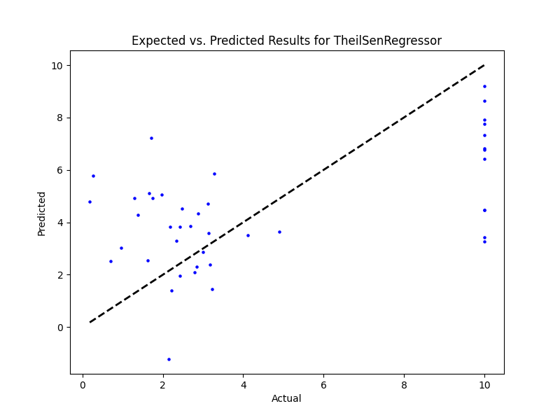

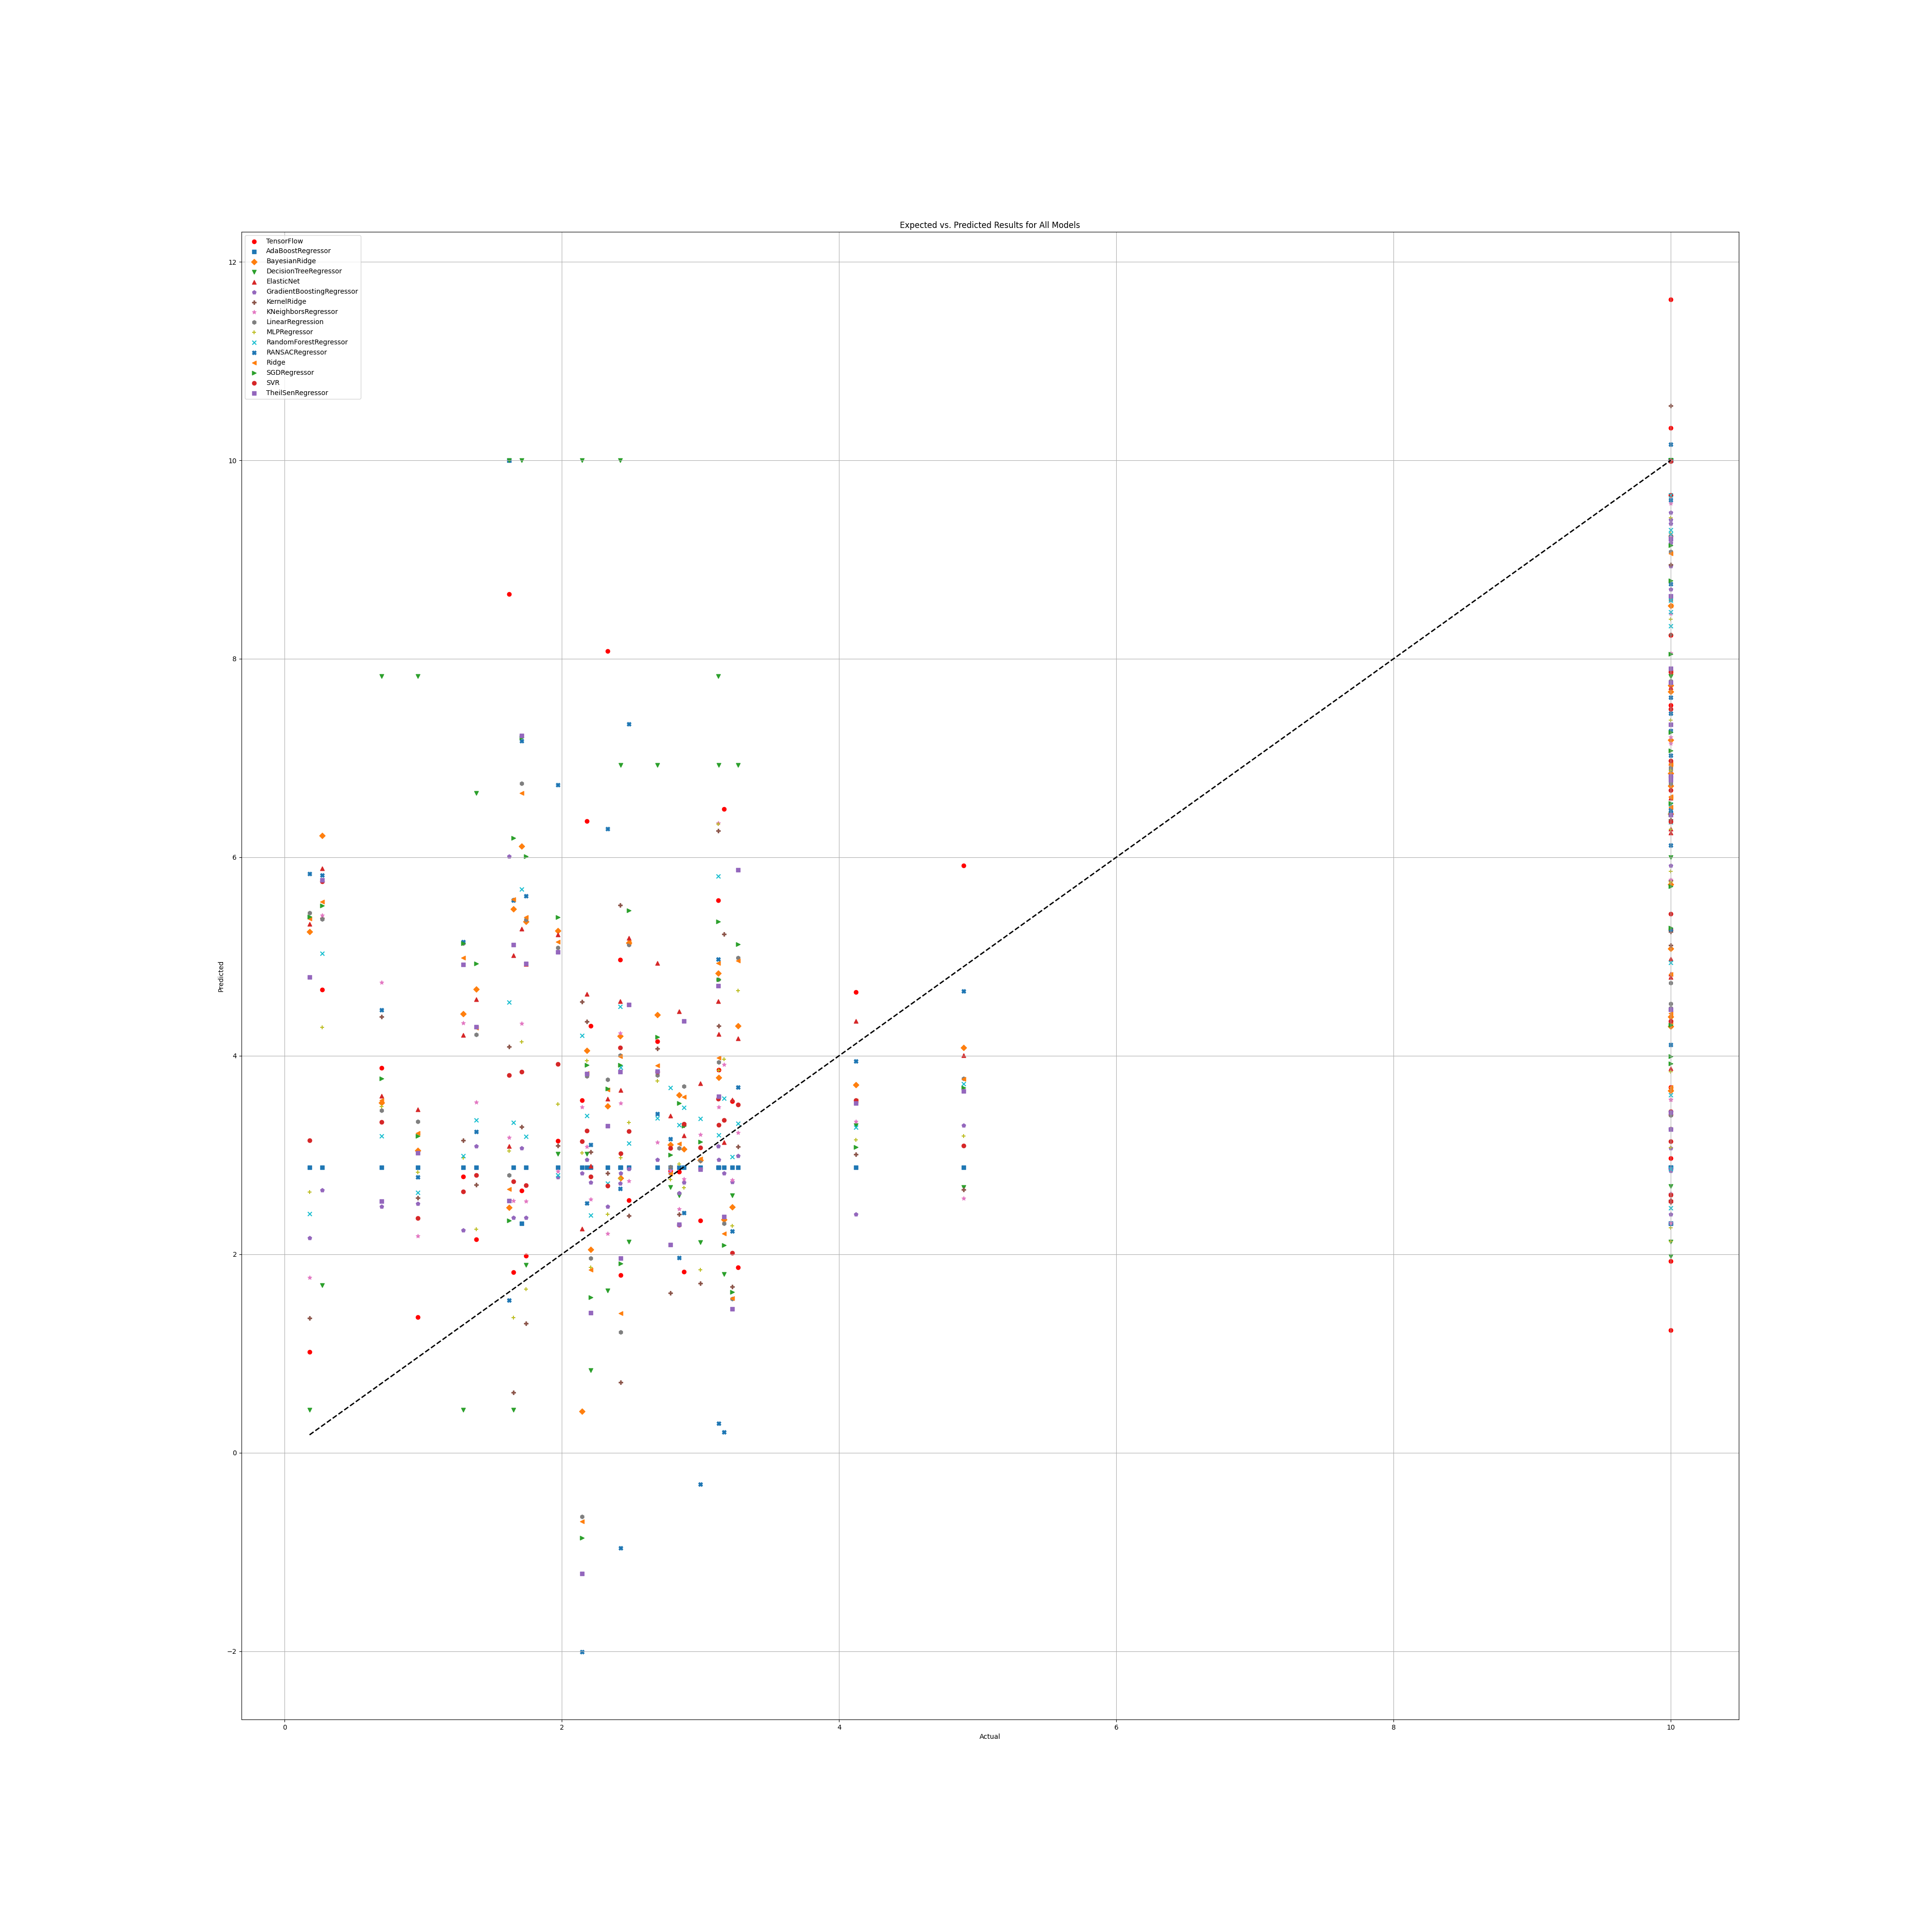

## NR Benefit

### Grid search results

**Ridge()**  
Best hyperparameters for Ridge: {'ridge__alpha': 1.0, 'ridge__solver': 'saga'}

**DecisionTreeRegressor()**  
Best hyperparameters for DecisionTreeRegressor: {'decisiontreeregressor__criterion': 'poisson', 'decisiontreeregressor__max_features': 3, 'decisiontreeregressor__min_samples_split': 2, 'decisiontreeregressor__splitter': 'best'}

**GradientBoostingRegressor()**  
Best hyperparameters for GradientBoostingRegressor: {'gradientboostingregressor__learning_rate': 0.1, 'gradientboostingregressor__loss': 'huber', 'gradientboostingregressor__n_estimators': 25, 'gradientboostingregressor__warm_start': True}

**RandomForestRegressor()**  
Best hyperparameters for RandomForestRegressor: {'randomforestregressor__criterion': 'poisson', 'randomforestregressor__max_features': 1, 'randomforestregressor__min_samples_split': 2, 'randomforestregressor__n_estimators': 100}

**AdaBoostRegressor()**  
Best hyperparameters for AdaBoostRegressor: {'adaboostregressor__learning_rate': 0.01, 'adaboostregressor__loss': 'square', 'adaboostregressor__n_estimators': 50}

**KNeighborsRegressor()**  
Best hyperparameters for KNeighborsRegressor: {'kneighborsregressor__algorithm': 'ball_tree', 'kneighborsregressor__leaf_size': 5, 'kneighborsregressor__metric': 'cityblock', 'kneighborsregressor__n_neighbors': 25, 'kneighborsregressor__weights': 'distance'}

**MLPRegressor()**  
Best hyperparameters for MLPRegressor: {'mlpregressor__activation': 'tanh', 'mlpregressor__hidden_layer_sizes': (50, 50, 50), 'mlpregressor__learning_rate': 'adaptive', 'mlpregressor__solver': 'sgd'}

**ElasticNet()**  
Best hyperparameters for ElasticNet: {'elasticnet__copy_X': True, 'elasticnet__fit_intercept': True, 'elasticnet__l1_ratio': 0.25, 'elasticnet__positive': False, 'elasticnet__precompute': True, 'elasticnet__selection': 'random', 'elasticnet__warm_start': False}

**SGDRegressor()**  
Best hyperparameters for SGDRegressor: {'sgdregressor__learning_rate': 'constant', 'sgdregressor__loss': 'squared_error', 'sgdregressor__penalty': 'l1', 'sgdregressor__warm_start': False}

**SVR(cache_size=1000)**  
Best hyperparameters for SVR: {'svr__degree': 1, 'svr__gamma': 'scale', 'svr__kernel': 'rbf', 'svr__shrinking': True}  
BayesianRidge(max_iter=1000)  
Best hyperparameters for BayesianRidge: {'bayesianridge__alpha_1': 1e-07, 'bayesianridge__alpha_2': 1e-05, 'bayesianridge__lambda_1': 1e-07, 'bayesianridge__lambda_2': 1e-05}

**KernelRidge()**  
Best hyperparameters for KernelRidge: {'kernelridge__alpha': 1.0, 'kernelridge__coef0': 0.5, 'kernelridge__degree': 2, 'kernelridge__kernel': 'poly'}

**LinearRegression()**  
Best hyperparameters for LinearRegression: {'linearregression__copy_X': True, 'linearregression__fit_intercept': True, 'linearregression__positive': True}

**RANSACRegressor()**  
Best hyperparameters for RANSACRegressor: {'ransacregressor__loss': 'absolute_error', 'ransacregressor__max_trials': 50, 'ransacregressor__min_samples': 2}

**TheilSenRegressor()**  
Best hyperparameters for TheilSenRegressor: {'theilsenregressor__max_subpopulation': 10000, 'theilsenregressor__n_subsamples': 25}

**Tensorflow()**

TensorFlow RMSE: 4.928126418929349

### Prediction results

Model: Ridge  
Model saved as saved_models\Ridge_model.pkl  
RMSE: 3.3373323887602004  
Sample predictions:  
Sample 1: Real NR = 0.0, Predicted NR = 1.7042491086696248  
Sample 2: Real NR = 3.72, Predicted NR = 8.014276043285294  
Sample 3: Real NR = 3.72, Predicted NR = 2.2658604519688024  
Sample 4: Real NR = 0.0, Predicted NR = 5.214969917695026  
Sample 5: Real NR = 0.0, Predicted NR = 3.5067681111366236  
  
  
Model: DecisionTreeRegressor  
Model saved as saved_models\DecisionTreeRegressor_model.pkl  
RMSE: 4.810570424520807  
Sample predictions:  
Sample 1: Real NR = 0.0, Predicted NR = 3.292839395746373  
Sample 2: Real NR = 3.72, Predicted NR = 10.0  
Sample 3: Real NR = 3.72, Predicted NR = 3.292839395746373  
Sample 4: Real NR = 0.0, Predicted NR = 3.292839395746373  
Sample 5: Real NR = 0.0, Predicted NR = 3.292839395746373  
  
  
Model: GradientBoostingRegressor  
Model saved as saved_models\GradientBoostingRegressor_model.pkl  
RMSE: 4.033911642295977  
Sample predictions:  
Sample 1: Real NR = 0.0, Predicted NR = 0.9741158617538889  
Sample 2: Real NR = 3.72, Predicted NR = 5.04894742214047  
Sample 3: Real NR = 3.72, Predicted NR = 1.7413823401546222  
Sample 4: Real NR = 0.0, Predicted NR = 7.244299426885847  
Sample 5: Real NR = 0.0, Predicted NR = 2.152862133045941  
  
  
Model: RandomForestRegressor  
Model saved as saved_models\RandomForestRegressor_model.pkl  
RMSE: 3.7413301975190714  
Sample predictions:  
Sample 1: Real NR = 0.0, Predicted NR = 3.2010800442898146  
Sample 2: Real NR = 3.72, Predicted NR = 5.742625684968052  
Sample 3: Real NR = 3.72, Predicted NR = 2.453173850245848  
Sample 4: Real NR = 0.0, Predicted NR = 6.126454707614503  
Sample 5: Real NR = 0.0, Predicted NR = 3.751388995837866  
  
  
Model: AdaBoostRegressor  
Model saved as saved_models\AdaBoostRegressor_model.pkl  
RMSE: 3.783709136432791  
Sample predictions:  
Sample 1: Real NR = 0.0, Predicted NR = 1.8579860139860143  
Sample 2: Real NR = 3.72, Predicted NR = 4.269435897435898  
Sample 3: Real NR = 3.72, Predicted NR = 1.93011988011988  
Sample 4: Real NR = 0.0, Predicted NR = 5.8387250712250705  
Sample 5: Real NR = 0.0, Predicted NR = 2.829330024813896  
  
  
Model: KNeighborsRegressor  
Model saved as saved_models\KNeighborsRegressor_model.pkl  
RMSE: 3.7454775534708826  
Sample predictions:  
Sample 1: Real NR = 0.0, Predicted NR = 1.73099777083234  
Sample 2: Real NR = 3.72, Predicted NR = 5.6793001627079835  
Sample 3: Real NR = 3.72, Predicted NR = 3.306888221918447  
Sample 4: Real NR = 0.0, Predicted NR = 6.109562912855282  
Sample 5: Real NR = 0.0, Predicted NR = 3.684769182121473  
  
  
Model: MLPRegressor  
Model saved as saved_models\MLPRegressor_model.pkl  
RMSE: 3.661595158008043  
Sample predictions:  
Sample 1: Real NR = 0.0, Predicted NR = 0.7103732133200923  
Sample 2: Real NR = 3.72, Predicted NR = 6.78249548665958  
Sample 3: Real NR = 3.72, Predicted NR = 0.783522725538276  
Sample 4: Real NR = 0.0, Predicted NR = 6.600678791331184  
Sample 5: Real NR = 0.0, Predicted NR = 1.7713917850168075  
  
  
Model: ElasticNet  
Model saved as saved_models\ElasticNet_model.pkl  
RMSE: 3.646638558803014  
Sample predictions:  
Sample 1: Real NR = 0.0, Predicted NR = 3.3036872099627566  
Sample 2: Real NR = 3.72, Predicted NR = 6.883015191133236  
Sample 3: Real NR = 3.72, Predicted NR = 3.6803863916523785  
Sample 4: Real NR = 0.0, Predicted NR = 4.952942205837276  
Sample 5: Real NR = 0.0, Predicted NR = 4.374347876661634  
  
  
Model: SGDRegressor  
Model saved as saved_models\SGDRegressor_model.pkl  
RMSE: 3.5898789845441983  
Sample predictions:  
Sample 1: Real NR = 0.0, Predicted NR = 2.38848963161389  
Sample 2: Real NR = 3.72, Predicted NR = 6.6082678102773045  
Sample 3: Real NR = 3.72, Predicted NR = 2.2299096827696547  
Sample 4: Real NR = 0.0, Predicted NR = 5.641098475834268  
Sample 5: Real NR = 0.0, Predicted NR = 2.945067768823717  
  
  
Model: SVR  
Model saved as saved_models\SVR_model.pkl  
RMSE: 3.675191202279166  
Sample predictions:  
Sample 1: Real NR = 0.0, Predicted NR = 0.968508798859459  
Sample 2: Real NR = 3.72, Predicted NR = 6.1756471383083165  
Sample 3: Real NR = 3.72, Predicted NR = 1.633445019302859  
Sample 4: Real NR = 0.0, Predicted NR = 5.256165058289178  
Sample 5: Real NR = 0.0, Predicted NR = 3.4183886602750935  
  
  
Model: BayesianRidge  
Model saved as saved_models\BayesianRidge_model.pkl  
RMSE: 3.485008072900754  
Sample predictions:  
Sample 1: Real NR = 0.0, Predicted NR = 2.600553128442072  
Sample 2: Real NR = 3.72, Predicted NR = 7.55128038718856  
Sample 3: Real NR = 3.72, Predicted NR = 2.864071950348597  
Sample 4: Real NR = 0.0, Predicted NR = 5.04024610186824  
Sample 5: Real NR = 0.0, Predicted NR = 4.012430075978838  
  
  
Model: KernelRidge  
Model saved as saved_models\KernelRidge_model.pkl  
RMSE: 4.129589694063964  
Sample predictions:  
Sample 1: Real NR = 0.0, Predicted NR = 0.969791121073629  
Sample 2: Real NR = 3.72, Predicted NR = 3.3439156851511838  
Sample 3: Real NR = 3.72, Predicted NR = 0.753878045349321  
Sample 4: Real NR = 0.0, Predicted NR = 6.527254079182344  
Sample 5: Real NR = 0.0, Predicted NR = 4.890413436393058  
  
  
Model: LinearRegression  
Model saved as saved_models\LinearRegression_model.pkl  
RMSE: 3.5025991402077548  
Sample predictions:  
Sample 1: Real NR = 0.0, Predicted NR = 3.279908279920068  
Sample 2: Real NR = 3.72, Predicted NR = 7.465947857835954  
Sample 3: Real NR = 3.72, Predicted NR = 3.3867143487936904  
Sample 4: Real NR = 0.0, Predicted NR = 3.385695805326815  
Sample 5: Real NR = 0.0, Predicted NR = 4.3562094379728995  
  
  
Model: RANSACRegressor  
Model saved as saved_models\RANSACRegressor_model.pkl  
RMSE: 3.831624149556518  
Sample predictions:  
Sample 1: Real NR = 0.0, Predicted NR = 0.5570360532678653  
Sample 2: Real NR = 3.72, Predicted NR = 7.870302772619761  
Sample 3: Real NR = 3.72, Predicted NR = 3.456186988213207  
Sample 4: Real NR = 0.0, Predicted NR = 0.6451376534624838  
Sample 5: Real NR = 0.0, Predicted NR = 4.3614164843996015  
  
  
Model: TheilSenRegressor  
Model saved as saved_models\TheilSenRegressor_model.pkl  
RMSE: 3.3871953579677707  
Sample predictions:  
Sample 1: Real NR = 0.0, Predicted NR = 1.2850970561917188  
Sample 2: Real NR = 3.72, Predicted NR = 8.899808665934584  
Sample 3: Real NR = 3.72, Predicted NR = 1.3900731893643115  
Sample 4: Real NR = 0.0, Predicted NR = 5.629271495444542  
Sample 5: Real NR = 0.0, Predicted NR = 2.9296132754622652  
  
  
Model: TensorFlow  
Model saved as saved_models\TensorFlow_model.h5  
RMSE: 4.928126418929349  
Sample predictions:  
Sample 1: Real NR = 0.0, Predicted NR = [0.76315105]  
Sample 2: Real NR = 3.72, Predicted NR = [7.4072204]  
Sample 3: Real NR = 3.72, Predicted NR = [-0.0230687]  
Sample 4: Real NR = 0.0, Predicted NR = [6.3002467]  
Sample 5: Real NR = 0.0, Predicted NR = [3.0404594]

### Graph results

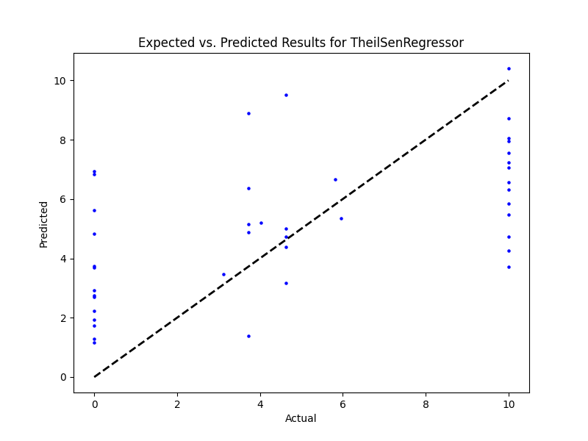

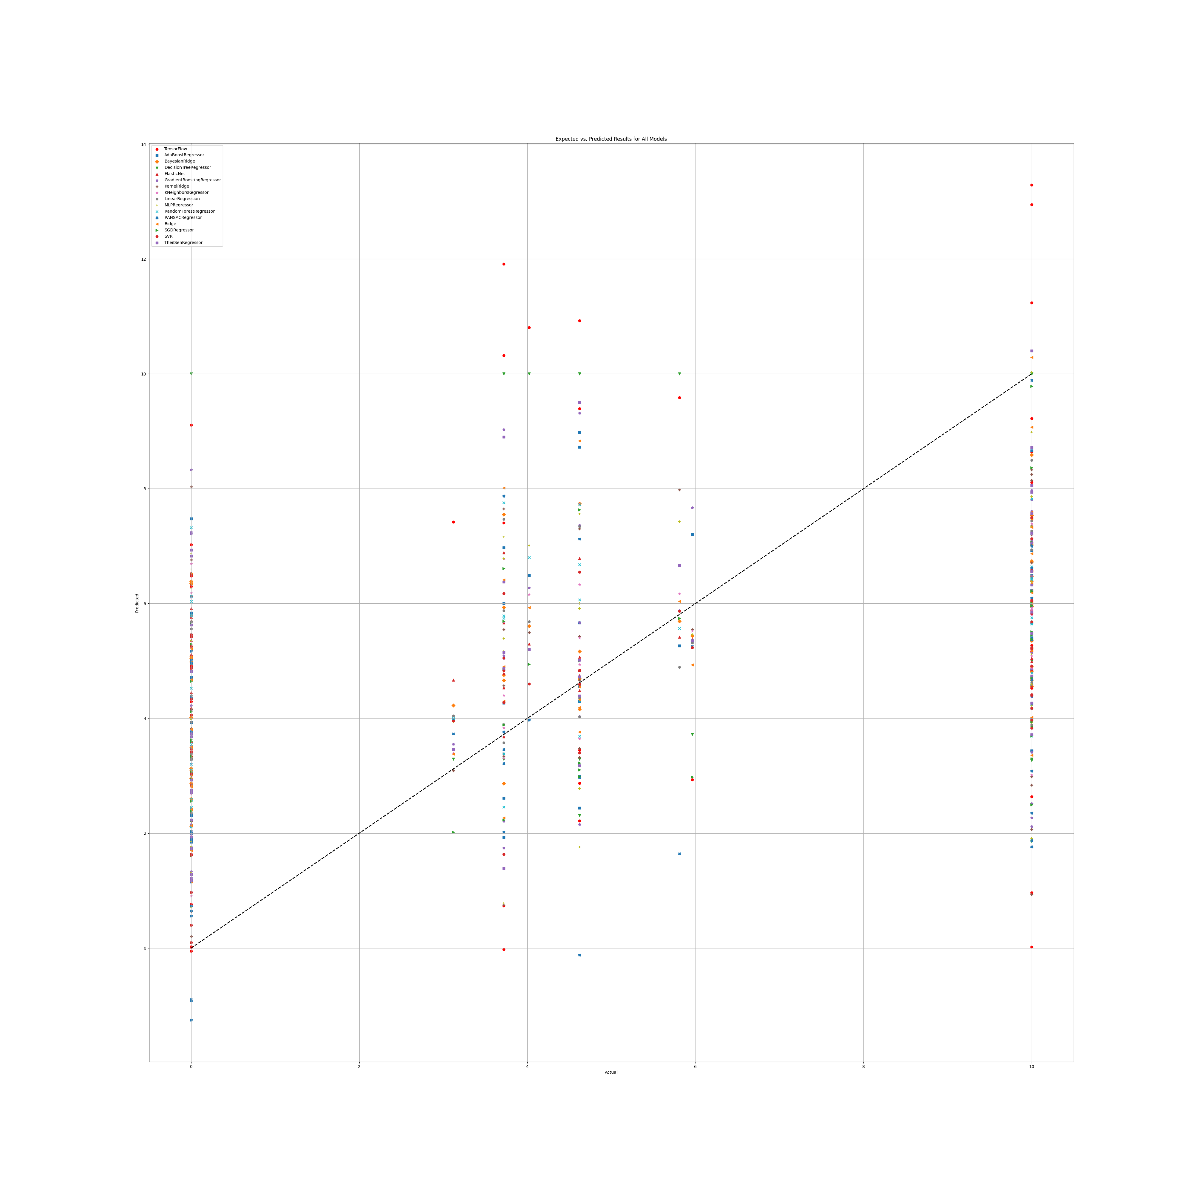

# Annex 2.2

## WS

### Grid search results

**Ridge()**  
Best hyperparameters for Ridge: {'ridge__alpha': 1.0, 'ridge__solver': 'lsqr'}

**DecisionTreeRegressor()**  
Best hyperparameters for DecisionTreeRegressor: {'decisiontreeregressor__criterion': 'squared_error', 'decisiontreeregressor__max_features': 3, 'decisiontreeregressor__min_samples_split': 5, 'decisiontreeregressor__splitter': 'best'}

**GradientBoostingRegressor()**  
Best hyperparameters for GradientBoostingRegressor: {'gradientboostingregressor__learning_rate': 0.1, 'gradientboostingregressor__loss': 'huber', 'gradientboostingregressor__n_estimators': 25, 'gradientboostingregressor__warm_start': True}

**RandomForestRegressor()**  
Best hyperparameters for RandomForestRegressor: {'randomforestregressor__criterion': 'friedman_mse', 'randomforestregressor__max_features': 'sqrt', 'randomforestregressor__min_samples_split': 2, 'randomforestregressor__n_estimators': 100}

**AdaBoostRegressor()**  
Best hyperparameters for AdaBoostRegressor: {'adaboostregressor__learning_rate': 0.1, 'adaboostregressor__loss': 'exponential', 'adaboostregressor__n_estimators': 50}

**KNeighborsRegressor()**  
Best hyperparameters for KNeighborsRegressor: {'kneighborsregressor__algorithm': 'ball_tree', 'kneighborsregressor__leaf_size': 5, 'kneighborsregressor__metric': 'cityblock', 'kneighborsregressor__n_neighbors': 10, 'kneighborsregressor__weights': 'distance'}

**MLPRegressor()**  
Best hyperparameters for MLPRegressor: {'mlpregressor__activation': 'relu', 'mlpregressor__hidden_layer_sizes': (50, 50, 50), 'mlpregressor__learning_rate': 'constant', 'mlpregressor__solver': 'sgd'}

**ElasticNet()**  
Best hyperparameters for ElasticNet: {'elasticnet__copy_X': True, 'elasticnet__fit_intercept': True, 'elasticnet__l1_ratio': 0.25, 'elasticnet__positive': False, 'elasticnet__precompute': True, 'elasticnet__selection': 'random', 'elasticnet__warm_start': True}

**SGDRegressor()**  
Best hyperparameters for SGDRegressor: {'sgdregressor__learning_rate': 'constant', 'sgdregressor__loss': 'squared_error', 'sgdregressor__penalty': 'l1', 'sgdregressor__warm_start': False}

**SVR(cache_size=1000)**  
Best hyperparameters for SVR: {'svr__degree': 1, 'svr__gamma': 'scale', 'svr__kernel': 'rbf', 'svr__shrinking': True}

**BayesianRidge(max_iter=1000)**  
Best hyperparameters for BayesianRidge: {'bayesianridge__alpha_1': 1e-07, 'bayesianridge__alpha_2': 1e-05, 'bayesianridge__lambda_1': 1e-05, 'bayesianridge__lambda_2': 1e-07}

**KernelRidge()**  
Best hyperparameters for KernelRidge: {'kernelridge__alpha': 1.0, 'kernelridge__coef0': 0.5, 'kernelridge__degree': 2, 'kernelridge__kernel': 'poly'}

**LinearRegression()**  
Best hyperparameters for LinearRegression: {'linearregression__copy_X': True, 'linearregression__fit_intercept': True, 'linearregression__positive': False}

**RANSACRegressor()**  
Best hyperparameters for RANSACRegressor: {'ransacregressor__loss': 'absolute_error', 'ransacregressor__max_trials': 50, 'ransacregressor__min_samples': 2}

**TheilSenRegressor()**  
Best hyperparameters for TheilSenRegressor: {'theilsenregressor__max_subpopulation': 100, 'theilsenregressor__n_subsamples': 25}  
TensorFlow

### Prediction results

Model: Ridge  
Model saved as saved_models\Ridge_model.pkl  
RMSE: 2.168294714727106  
Sample predictions:  
Sample 1: Real NR = 7.080039525691701, Predicted NR = 6.212938775004492  
Sample 2: Real NR = 2.4, Predicted NR = 3.413978458201929  
Sample 3: Real NR = -0.21, Predicted NR = 5.1172041454306045  
Sample 4: Real NR = 7.411773009599097, Predicted NR = 4.175881097707585  
Sample 5: Real NR = 3.73, Predicted NR = 4.739440625723574  
  
  
Model: DecisionTreeRegressor  
Model saved as saved_models\DecisionTreeRegressor_model.pkl  
RMSE: 2.6291746952388078  
Sample predictions:  
Sample 1: Real NR = 7.080039525691701, Predicted NR = 4.667022868435912  
Sample 2: Real NR = 2.4, Predicted NR = 5.23  
Sample 3: Real NR = -0.21, Predicted NR = 2.502682100508188  
Sample 4: Real NR = 7.411773009599097, Predicted NR = 1.81  
Sample 5: Real NR = 3.73, Predicted NR = 3.77  
  
  
Model: GradientBoostingRegressor  
Model saved as saved_models\GradientBoostingRegressor_model.pkl  
RMSE: 1.95509694380115  
Sample predictions:  
Sample 1: Real NR = 7.080039525691701, Predicted NR = 4.476936842138297  
Sample 2: Real NR = 2.4, Predicted NR = 4.2484577855412375  
Sample 3: Real NR = -0.21, Predicted NR = 3.4295130749526153  
Sample 4: Real NR = 7.411773009599097, Predicted NR = 2.425674210404482  
Sample 5: Real NR = 3.73, Predicted NR = 2.792262893235161  
  
  
Model: RandomForestRegressor  
Model saved as saved_models\RandomForestRegressor_model.pkl  
RMSE: 2.0345456941880435  
Sample predictions:  
Sample 1: Real NR = 7.080039525691701, Predicted NR = 4.961049520045174  
Sample 2: Real NR = 2.4, Predicted NR = 4.369075098814229  
Sample 3: Real NR = -0.21, Predicted NR = 4.484455392433655  
Sample 4: Real NR = 7.411773009599097, Predicted NR = 1.8805248447204954  
Sample 5: Real NR = 3.73, Predicted NR = 2.688205590062115  
  
  
Model: AdaBoostRegressor  
Model saved as saved_models\AdaBoostRegressor_model.pkl  
RMSE: 1.9892720915100681  
Sample predictions:  
Sample 1: Real NR = 7.080039525691701, Predicted NR = 4.681027133853221  
Sample 2: Real NR = 2.4, Predicted NR = 3.513262987012986  
Sample 3: Real NR = -0.21, Predicted NR = 3.544771187310714  
Sample 4: Real NR = 7.411773009599097, Predicted NR = 2.778510888483996  
Sample 5: Real NR = 3.73, Predicted NR = 3.2829983060417844  
  
  
Model: KNeighborsRegressor  
Model saved as saved_models\KNeighborsRegressor_model.pkl  
RMSE: 2.1013294590911515  
Sample predictions:  
Sample 1: Real NR = 7.080039525691701, Predicted NR = 5.596316741146418  
Sample 2: Real NR = 2.4, Predicted NR = 4.237835535021529  
Sample 3: Real NR = -0.21, Predicted NR = 5.35154264035705  
Sample 4: Real NR = 7.411773009599097, Predicted NR = 2.1446227655041077  
Sample 5: Real NR = 3.73, Predicted NR = 2.6724132049176963  
  
  
Model: MLPRegressor  
Model saved as saved_models\MLPRegressor_model.pkl  
RMSE: 2.1273303881276995  
Sample predictions:  
Sample 1: Real NR = 7.080039525691701, Predicted NR = 5.577862624718388  
Sample 2: Real NR = 2.4, Predicted NR = 3.0420647450182914  
Sample 3: Real NR = -0.21, Predicted NR = 5.099342878247968  
Sample 4: Real NR = 7.411773009599097, Predicted NR = 3.4519240271498535  
Sample 5: Real NR = 3.73, Predicted NR = 3.395710593082251  
  
  
Model: ElasticNet  
Model saved as saved_models\ElasticNet_model.pkl  
RMSE: 2.2102059059655024  
Sample predictions:  
Sample 1: Real NR = 7.080039525691701, Predicted NR = 4.8368169046112435  
Sample 2: Real NR = 2.4, Predicted NR = 3.7700355672960035  
Sample 3: Real NR = -0.21, Predicted NR = 4.72972223096109  
Sample 4: Real NR = 7.411773009599097, Predicted NR = 4.400473657808657  
Sample 5: Real NR = 3.73, Predicted NR = 4.168695054181731  
  
  
Model: SGDRegressor  
Model saved as saved_models\SGDRegressor_model.pkl  
RMSE: 2.3047901846077385  
Sample predictions:  
Sample 1: Real NR = 7.080039525691701, Predicted NR = 6.0256906719705645  
Sample 2: Real NR = 2.4, Predicted NR = 3.1653632830951253  
Sample 3: Real NR = -0.21, Predicted NR = 5.660515357517598  
Sample 4: Real NR = 7.411773009599097, Predicted NR = 3.9016914670635945  
Sample 5: Real NR = 3.73, Predicted NR = 5.025081712039208  
  
  
Model: SVR  
Model saved as saved_models\SVR_model.pkl  
RMSE: 2.2596341497039147  
Sample predictions:  
Sample 1: Real NR = 7.080039525691701, Predicted NR = 4.935668002597432  
Sample 2: Real NR = 2.4, Predicted NR = 3.79236493170238  
Sample 3: Real NR = -0.21, Predicted NR = 5.223097471991349  
Sample 4: Real NR = 7.411773009599097, Predicted NR = 3.642266332742193  
Sample 5: Real NR = 3.73, Predicted NR = 3.1943703894181237  
  
  
Model: BayesianRidge  
Model saved as saved_models\BayesianRidge_model.pkl  
RMSE: 2.172926823707297  
Sample predictions:  
Sample 1: Real NR = 7.080039525691701, Predicted NR = 5.689995087674275  
Sample 2: Real NR = 2.4, Predicted NR = 3.1860949257845976  
Sample 3: Real NR = -0.21, Predicted NR = 5.322323910733187  
Sample 4: Real NR = 7.411773009599097, Predicted NR = 4.259045835102416  
Sample 5: Real NR = 3.73, Predicted NR = 4.574543910221052  
  
  
Model: KernelRidge  
Model saved as saved_models\KernelRidge_model.pkl  
RMSE: 2.20346067112972  
Sample predictions:  
Sample 1: Real NR = 7.080039525691701, Predicted NR = 3.802805616974132  
Sample 2: Real NR = 2.4, Predicted NR = 3.6891723945122403  
Sample 3: Real NR = -0.21, Predicted NR = 4.700181586969572  
Sample 4: Real NR = 7.411773009599097, Predicted NR = 3.9790105511351346  
Sample 5: Real NR = 3.73, Predicted NR = 2.7856212932274413  
  
  
Model: LinearRegression  
Model saved as saved_models\LinearRegression_model.pkl  
RMSE: 2.1693103433976093  
Sample predictions:  
Sample 1: Real NR = 7.080039525691701, Predicted NR = 6.245035577334552  
Sample 2: Real NR = 2.4, Predicted NR = 3.4086825844028654  
Sample 3: Real NR = -0.21, Predicted NR = 5.0245620831202675  
Sample 4: Real NR = 7.411773009599097, Predicted NR = 4.127688268206089  
Sample 5: Real NR = 3.73, Predicted NR = 4.737507063416903  
  
  
Model: RANSACRegressor  
Model saved as saved_models\RANSACRegressor_model.pkl  
RMSE: 2.6979487413763006  
Sample predictions:  
Sample 1: Real NR = 7.080039525691701, Predicted NR = 5.941645708881687  
Sample 2: Real NR = 2.4, Predicted NR = 2.8467966539880987  
Sample 3: Real NR = -0.21, Predicted NR = 6.987312182103997  
Sample 4: Real NR = 7.411773009599097, Predicted NR = 2.839987946538462  
Sample 5: Real NR = 3.73, Predicted NR = 5.666469484689189  
  
  
Model: TheilSenRegressor  
Model saved as saved_models\TheilSenRegressor_model.pkl  
RMSE: 2.2302709952478983  
Sample predictions:  
Sample 1: Real NR = 7.080039525691701, Predicted NR = 6.035787163082679  
Sample 2: Real NR = 2.4, Predicted NR = 3.667362168208873  
Sample 3: Real NR = -0.21, Predicted NR = 4.918568454766635  
Sample 4: Real NR = 7.411773009599097, Predicted NR = 4.141623385610335  
Sample 5: Real NR = 3.73, Predicted NR = 4.412846044707104  
  
  
Model: TensorFlow  
Model saved as saved_models\TensorFlow_model.h5  
RMSE: 2.473296837356511  
Sample predictions:  
Sample 1: Real NR = 7.080039525691701, Predicted NR = [4.64648]  
Sample 2: Real NR = 2.4, Predicted NR = [2.367259]  
Sample 3: Real NR = -0.21, Predicted NR = [4.4633784]  
Sample 4: Real NR = 7.411773009599097, Predicted NR = [3.1039295]  
Sample 5: Real NR = 3.73, Predicted NR = [1.3945694]

### Graph results

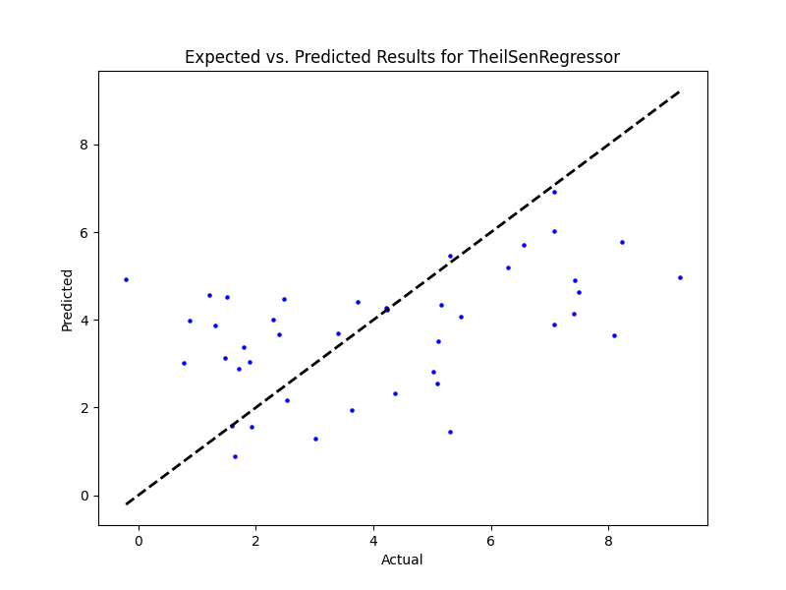

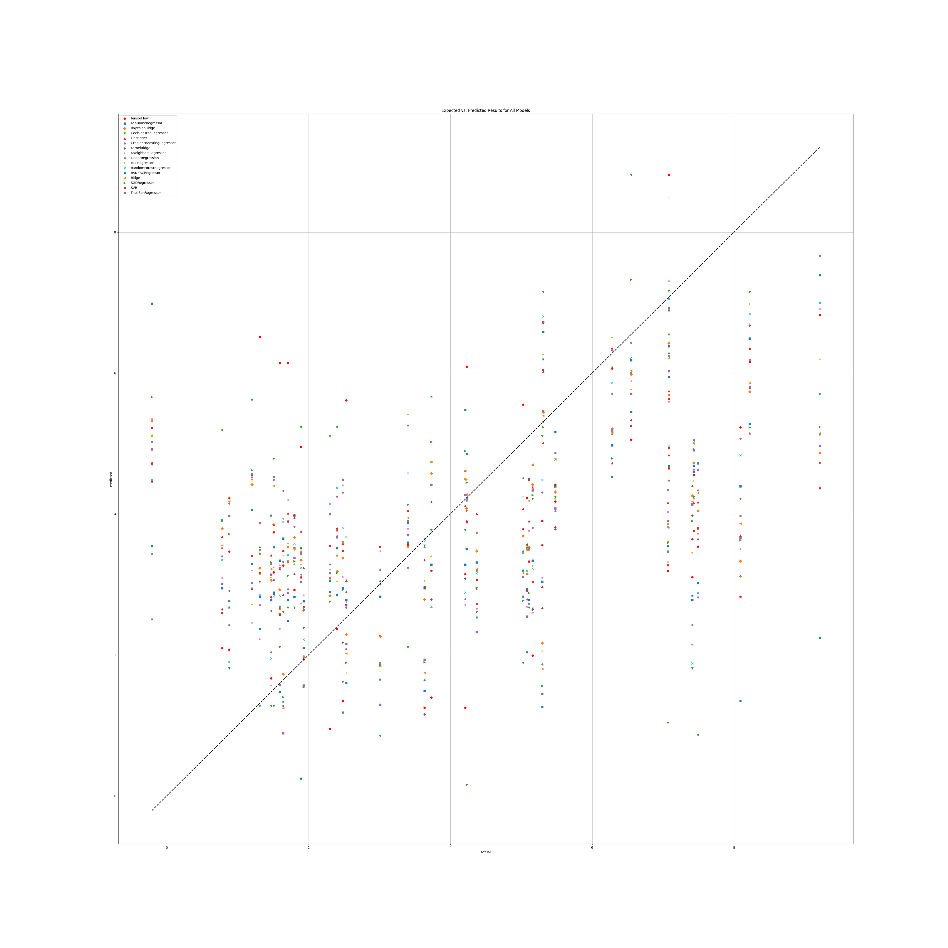

## WS Benefit

### Grid search results

**Ridge()**  
Best hyperparameters for Ridge: {'ridge__alpha': 1.0, 'ridge__solver': 'saga'}

**DecisionTreeRegressor()**  
Best hyperparameters for DecisionTreeRegressor: {'decisiontreeregressor__criterion': 'poisson', 'decisiontreeregressor__max_features': 1, 'decisiontreeregressor__min_samples_split': 3, 'decisiontreeregressor__splitter': 'random'}

**GradientBoostingRegressor()**  
Best hyperparameters for GradientBoostingRegressor: {'gradientboostingregressor__learning_rate': 0.01, 'gradientboostingregressor__loss': 'squared_error', 'gradientboostingregressor__n_estimators': 50, 'gradientboostingregressor__warm_start': False}

**RandomForestRegressor()**  
Best hyperparameters for RandomForestRegressor: {'randomforestregressor__criterion': 'squared_error', 'randomforestregressor__max_features': 1, 'randomforestregressor__min_samples_split': 5, 'randomforestregressor__n_estimators': 100}

**AdaBoostRegressor()**  
Best hyperparameters for AdaBoostRegressor: {'adaboostregressor__learning_rate': 0.1, 'adaboostregressor__loss': 'exponential', 'adaboostregressor__n_estimators': 100}

**KNeighborsRegressor()**  
Best hyperparameters for KNeighborsRegressor: {'kneighborsregressor__algorithm': 'ball_tree', 'kneighborsregressor__leaf_size': 5, 'kneighborsregressor__metric': 'cityblock', 'kneighborsregressor__n_neighbors': 25, 'kneighborsregressor__weights': 'distance'}

**MLPRegressor()**  
Best hyperparameters for MLPRegressor: {'mlpregressor__activation': 'tanh', 'mlpregressor__hidden_layer_sizes': (50, 50, 50), 'mlpregressor__learning_rate': 'constant', 'mlpregressor__solver': 'sgd'}

**ElasticNet()**  
Best hyperparameters for ElasticNet: {'elasticnet__copy_X': True, 'elasticnet__fit_intercept': True, 'elasticnet__l1_ratio': 0.25, 'elasticnet__positive': False, 'elasticnet__precompute': True, 'elasticnet__selection': 'random', 'elasticnet__warm_start': False}

**SGDRegressor()**  
Best hyperparameters for SGDRegressor: {'sgdregressor__learning_rate': 'invscaling', 'sgdregressor__loss': 'squared_error', 'sgdregressor__penalty': 'l2', 'sgdregressor__warm_start': False}

**SVR(cache_size=1000)**  
Best hyperparameters for SVR: {'svr__degree': 1, 'svr__gamma': 'auto', 'svr__kernel': 'rbf', 'svr__shrinking': True}

**BayesianRidge(max_iter=1000)**  
Best hyperparameters for BayesianRidge: {'bayesianridge__alpha_1': 1e-05, 'bayesianridge__alpha_2': 1e-07, 'bayesianridge__lambda_1': 1e-07, 'bayesianridge__lambda_2': 1e-05}

**KernelRidge()**  
Best hyperparameters for KernelRidge: {'kernelridge__alpha': 1.0, 'kernelridge__coef0': 0.0, 'kernelridge__degree': 1, 'kernelridge__kernel': 'rbf'}

**LinearRegression()**  
Best hyperparameters for LinearRegression: {'linearregression__copy_X': True, 'linearregression__fit_intercept': True, 'linearregression__positive': False}

**RANSACRegressor()**  
Best hyperparameters for RANSACRegressor: {'ransacregressor__loss': 'absolute_error', 'ransacregressor__max_trials': 150, 'ransacregressor__min_samples': None}

**TheilSenRegressor()**  
Best hyperparameters for TheilSenRegressor: {'theilsenregressor__max_subpopulation': 10000, 'theilsenregressor__n_subsamples': None}

**TensorFlow()**

TensorFlow RMSE: 3.982902886294298

### Prediction results

Model: Ridge  
Model saved as saved_models\Ridge_model.pkl  
RMSE: 3.6102074292866613  
Sample predictions:  
Sample 1: Real NR = 0.0, Predicted NR = 1.328075798989027  
Sample 2: Real NR = 0.0, Predicted NR = -0.6470463965270119  
Sample 3: Real NR = 0.0, Predicted NR = -0.5832953417087234  
Sample 4: Real NR = 0.0, Predicted NR = 2.8504132222668215  
Sample 5: Real NR = 0.0, Predicted NR = 0.4062832634257383  
  
  
Model: DecisionTreeRegressor  
Model saved as saved_models\DecisionTreeRegressor_model.pkl  
RMSE: 3.9776957281797687  
Sample predictions:  
Sample 1: Real NR = 0.0, Predicted NR = 1.3100696927775313  
Sample 2: Real NR = 0.0, Predicted NR = 1.775  
Sample 3: Real NR = 0.0, Predicted NR = 0.9551851851851851  
Sample 4: Real NR = 0.0, Predicted NR = 3.3333333333333335  
Sample 5: Real NR = 0.0, Predicted NR = 0.9551851851851851  
  
  
Model: GradientBoostingRegressor  
Model saved as saved_models\GradientBoostingRegressor_model.pkl  
RMSE: 3.54052042237814  
Sample predictions:  
Sample 1: Real NR = 0.0, Predicted NR = 1.1922872997711933  
Sample 2: Real NR = 0.0, Predicted NR = 1.1741986589558724  
Sample 3: Real NR = 0.0, Predicted NR = 1.1922872997711933  
Sample 4: Real NR = 0.0, Predicted NR = 2.992795799969344  
Sample 5: Real NR = 0.0, Predicted NR = 1.1922872997711933  
  
  
Model: RandomForestRegressor  
Model saved as saved_models\RandomForestRegressor_model.pkl  
RMSE: 3.7775192624147755  
Sample predictions:  
Sample 1: Real NR = 0.0, Predicted NR = 1.5967814281491046  
Sample 2: Real NR = 0.0, Predicted NR = 0.42824601242317994  
Sample 3: Real NR = 0.0, Predicted NR = 0.9900838939922759  
Sample 4: Real NR = 0.0, Predicted NR = 5.553505247184384  
Sample 5: Real NR = 0.0, Predicted NR = 0.7164172953393549  
  
  
Model: AdaBoostRegressor  
Model saved as saved_models\AdaBoostRegressor_model.pkl  
RMSE: 3.886109049357561  
Sample predictions:  
Sample 1: Real NR = 0.0, Predicted NR = 2.137676408631701  
Sample 2: Real NR = 0.0, Predicted NR = 0.6826931342608302  
Sample 3: Real NR = 0.0, Predicted NR = 1.311273052849334  
Sample 4: Real NR = 0.0, Predicted NR = 5.92854371677412  
Sample 5: Real NR = 0.0, Predicted NR = 0.9331959975063328  
  
  
Model: KNeighborsRegressor  
Model saved as saved_models\KNeighborsRegressor_model.pkl  
RMSE: 3.444636575476839  
Sample predictions:  
Sample 1: Real NR = 0.0, Predicted NR = 1.492428001214262  
Sample 2: Real NR = 0.0, Predicted NR = 0.6553850518644814  
Sample 3: Real NR = 0.0, Predicted NR = 0.9739355337757025  
Sample 4: Real NR = 0.0, Predicted NR = 2.8389834852619065  
Sample 5: Real NR = 0.0, Predicted NR = 0.5510594989956189  
  
  
Model: MLPRegressor  
Model saved as saved_models\MLPRegressor_model.pkl  
RMSE: 3.718096004168725  
Sample predictions:  
Sample 1: Real NR = 0.0, Predicted NR = 1.3439032897352112  
Sample 2: Real NR = 0.0, Predicted NR = -0.9775102831017504  
Sample 3: Real NR = 0.0, Predicted NR = -0.2427805858625915  
Sample 4: Real NR = 0.0, Predicted NR = 3.106426903316203  
Sample 5: Real NR = 0.0, Predicted NR = 0.0401775149067907  
  
  
Model: ElasticNet  
Model saved as saved_models\ElasticNet_model.pkl  
RMSE: 3.4063512557784126  
Sample predictions:  
Sample 1: Real NR = 0.0, Predicted NR = 1.3886628510090737  
Sample 2: Real NR = 0.0, Predicted NR = 1.2144923493645199  
Sample 3: Real NR = 0.0, Predicted NR = 1.0638669033037464  
Sample 4: Real NR = 0.0, Predicted NR = 1.9542615286888676  
Sample 5: Real NR = 0.0, Predicted NR = 1.2011076510095327  
  
  
Model: SGDRegressor  
Model saved as saved_models\SGDRegressor_model.pkl  
RMSE: 3.609621193254935  
Sample predictions:  
Sample 1: Real NR = 0.0, Predicted NR = 1.3378801880992333  
Sample 2: Real NR = 0.0, Predicted NR = -0.6614303467375766  
Sample 3: Real NR = 0.0, Predicted NR = -0.6389999034869631  
Sample 4: Real NR = 0.0, Predicted NR = 2.8118627023805707  
Sample 5: Real NR = 0.0, Predicted NR = 0.3951226069326905  
  
  
Model: SVR  
Model saved as saved_models\SVR_model.pkl  
RMSE: 3.7923229862428296  
Sample predictions:  
Sample 1: Real NR = 0.0, Predicted NR = 0.1869666614733889  
Sample 2: Real NR = 0.0, Predicted NR = -0.025241763576419163  
Sample 3: Real NR = 0.0, Predicted NR = 0.08329358013030314  
Sample 4: Real NR = 0.0, Predicted NR = 0.3233218169989993  
Sample 5: Real NR = 0.0, Predicted NR = -0.027248687141792183  
  
  
Model: BayesianRidge  
Model saved as saved_models\BayesianRidge_model.pkl  
RMSE: 3.4599576343953338  
Sample predictions:  
Sample 1: Real NR = 0.0, Predicted NR = 1.4398864056001381  
Sample 2: Real NR = 0.0, Predicted NR = 0.42687202521499734  
Sample 3: Real NR = 0.0, Predicted NR = -0.06999893300124316  
Sample 4: Real NR = 0.0, Predicted NR = 2.3386045325114524  
Sample 5: Real NR = 0.0, Predicted NR = 0.7723768816420601  
  
  
Model: KernelRidge  
Model saved as saved_models\KernelRidge_model.pkl  
RMSE: 3.7170153489133764  
Sample predictions:  
Sample 1: Real NR = 0.0, Predicted NR = 1.6072201340602539  
Sample 2: Real NR = 0.0, Predicted NR = -0.30580592927312744  
Sample 3: Real NR = 0.0, Predicted NR = 0.4063550947952099  
Sample 4: Real NR = 0.0, Predicted NR = 2.772753383281995  
Sample 5: Real NR = 0.0, Predicted NR = 0.5044261188243377  
  
  
Model: LinearRegression  
Model saved as saved_models\LinearRegression_model.pkl  
RMSE: 3.6143743675138875  
Sample predictions:  
Sample 1: Real NR = 0.0, Predicted NR = 1.3181958745797007  
Sample 2: Real NR = 0.0, Predicted NR = -0.6648135635002641  
Sample 3: Real NR = 0.0, Predicted NR = -0.5620517818431667  
Sample 4: Real NR = 0.0, Predicted NR = 2.874495362836403  
Sample 5: Real NR = 0.0, Predicted NR = 0.4022970314893579  
  
  
Model: RANSACRegressor  
Model saved as saved_models\RANSACRegressor_model.pkl  
RMSE: 4.551856223450195  
Sample predictions:  
Sample 1: Real NR = 0.0, Predicted NR = -3.34683649588995  
Sample 2: Real NR = 0.0, Predicted NR = 3.4718617375325493  
Sample 3: Real NR = 0.0, Predicted NR = 0.07004823003240146  
Sample 4: Real NR = 0.0, Predicted NR = 1.3678565980407735  
Sample 5: Real NR = 0.0, Predicted NR = -1.736060658703924  
  
  
Model: TheilSenRegressor  
Model saved as saved_models\TheilSenRegressor_model.pkl  
RMSE: 3.6159945664441424  
Sample predictions:  
Sample 1: Real NR = 0.0, Predicted NR = 1.1088296948615446  
Sample 2: Real NR = 0.0, Predicted NR = -0.5513228480702324  
Sample 3: Real NR = 0.0, Predicted NR = -1.4531583325363122  
Sample 4: Real NR = 0.0, Predicted NR = 2.6688464625609583  
Sample 5: Real NR = 0.0, Predicted NR = 0.13534840684423366  
  
  
Model: TensorFlow  
Model saved as saved_models\TensorFlow_model.h5  
RMSE: 3.982902886294298  
Sample predictions:  
Sample 1: Real NR = 0.0, Predicted NR = [0.00012064]  
Sample 2: Real NR = 0.0, Predicted NR = [-0.02765]  
Sample 3: Real NR = 0.0, Predicted NR = [1.171105]  
Sample 4: Real NR = 0.0, Predicted NR = [6.041437]  
Sample 5: Real NR = 0.0, Predicted NR = [0.00352734]

### Graph results

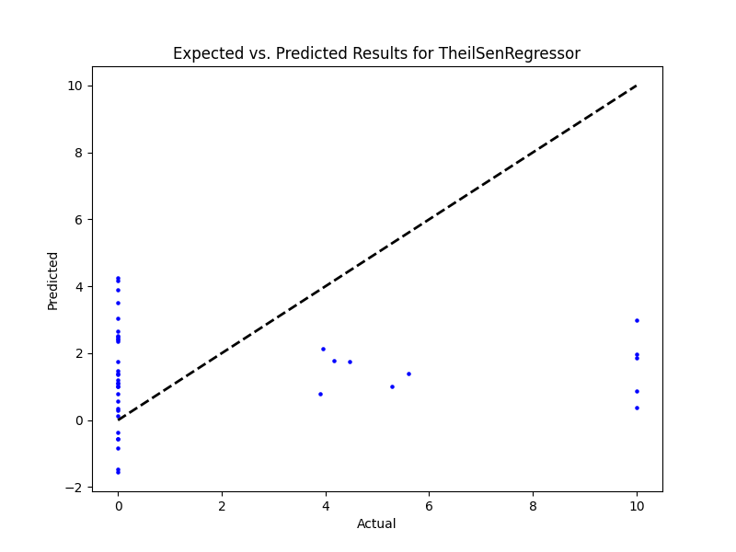

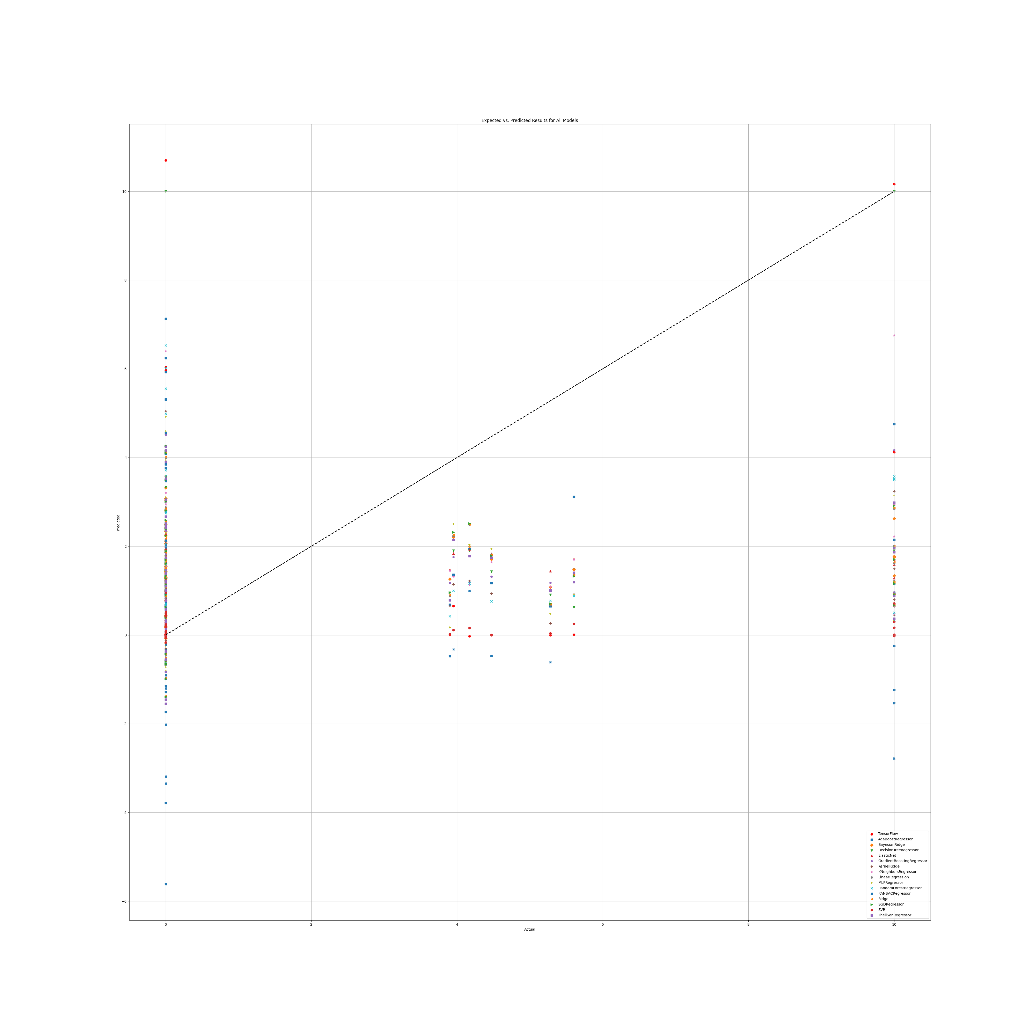

# Annex 2.3

## PR

### Grid search results

**Ridge()**  
Best hyperparameters for Ridge: {'ridge__alpha': 1.0, 'ridge__solver': 'lsqr'}

**DecisionTreeRegressor()**  
Best hyperparameters for DecisionTreeRegressor: {'decisiontreeregressor__criterion': 'friedman_mse', 'decisiontreeregressor__max_features': 'log2', 'decisiontreeregressor__min_samples_split': 5, 'decisiontreeregressor__splitter': 'best'}

**GradientBoostingRegressor()**  
Best hyperparameters for GradientBoostingRegressor: {'gradientboostingregressor__learning_rate': 0.01, 'gradientboostingregressor__loss': 'huber', 'gradientboostingregressor__n_estimators': 250, 'gradientboostingregressor__warm_start': True}

**RandomForestRegressor()**  
Best hyperparameters for RandomForestRegressor: {'randomforestregressor__criterion': 'squared_error', 'randomforestregressor__max_features': 'log2', 'randomforestregressor__min_samples_split': 5, 'randomforestregressor__n_estimators': 100}

**AdaBoostRegressor()**  
Best hyperparameters for AdaBoostRegressor: {'adaboostregressor__learning_rate': 0.1, 'adaboostregressor__loss': 'square', 'adaboostregressor__n_estimators': 20}

**KNeighborsRegressor()**  
Best hyperparameters for KNeighborsRegressor: {'kneighborsregressor__algorithm': 'ball_tree', 'kneighborsregressor__leaf_size': 5, 'kneighborsregressor__metric': 'cityblock', 'kneighborsregressor__n_neighbors': 10, 'kneighborsregressor__weights': 'distance'}

**MLPRegressor()**  
Best hyperparameters for MLPRegressor: {'mlpregressor__activation': 'relu', 'mlpregressor__hidden_layer_sizes': (100, 100, 100), 'mlpregressor__learning_rate': 'constant', 'mlpregressor__solver': 'adam'}

**ElasticNet()**  
Best hyperparameters for ElasticNet: {'elasticnet__copy_X': False, 'elasticnet__fit_intercept': True, 'elasticnet__l1_ratio': 0.25, 'elasticnet__positive': False, 'elasticnet__precompute': False, 'elasticnet__selection': 'random', 'elasticnet__warm_start': True}

**SGDRegressor()**  
Best hyperparameters for SGDRegressor: {'sgdregressor__learning_rate': 'constant', 'sgdregressor__loss': 'squared_error', 'sgdregressor__penalty': 'elasticnet', 'sgdregressor__warm_start': True}

**SVR(cache_size=1000)**  
Best hyperparameters for SVR: {'svr__degree': 1, 'svr__gamma': 'scale', 'svr__kernel': 'rbf', 'svr__shrinking': True}

**BayesianRidge(max_iter=1000)**  
Best hyperparameters for BayesianRidge: {'bayesianridge__alpha_1': 1e-07, 'bayesianridge__alpha_2': 1e-05, 'bayesianridge__lambda_1': 1e-05, 'bayesianridge__lambda_2': 1e-07}

**KernelRidge()**  
Best hyperparameters for KernelRidge: {'kernelridge__alpha': 1.0, 'kernelridge__coef0': 0.5, 'kernelridge__degree': 3, 'kernelridge__kernel': 'poly'}

**LinearRegression()**  
Best hyperparameters for LinearRegression: {'linearregression__copy_X': True, 'linearregression__fit_intercept': True, 'linearregression__positive': False}

**RANSACRegressor()**  
Best hyperparameters for RANSACRegressor: {'ransacregressor__loss': 'absolute_error', 'ransacregressor__max_trials': 10, 'ransacregressor__min_samples': 50}

**TheilSenRegressor()**  
Best hyperparameters for TheilSenRegressor: {'theilsenregressor__max_subpopulation': 1000, 'theilsenregressor__n_subsamples': 25}

**TensorFlow()**

TensorFlow RMSE: 2.6448251324102365

### Prediction results

Model: Ridge  
Model saved as saved_models\Ridge_model.pkl  
RMSE: 2.131742619193776  
Sample predictions:  
Sample 1: Real NR = 10.0, Predicted NR = 9.811153505471314  
Sample 2: Real NR = 4.91, Predicted NR = 3.697802387451901  
Sample 3: Real NR = 5.24, Predicted NR = 7.843258430737245  
Sample 4: Real NR = 10.0, Predicted NR = 6.258529361241307  
Sample 5: Real NR = 6.19, Predicted NR = 7.827331304736717  
  
  
Model: DecisionTreeRegressor  
Model saved as saved_models\DecisionTreeRegressor_model.pkl  
RMSE: 2.230974806492567  
Sample predictions:  
Sample 1: Real NR = 10.0, Predicted NR = 4.09  
Sample 2: Real NR = 4.91, Predicted NR = 3.832448814424957  
Sample 3: Real NR = 5.24, Predicted NR = 7.0525  
Sample 4: Real NR = 10.0, Predicted NR = 3.8073132048366927  
Sample 5: Real NR = 6.19, Predicted NR = 6.8285584468137515  
  
  
Model: GradientBoostingRegressor  
Model saved as saved_models\GradientBoostingRegressor_model.pkl  
RMSE: 2.148483685813433  
Sample predictions:  
Sample 1: Real NR = 10.0, Predicted NR = 6.058645106938658  
Sample 2: Real NR = 4.91, Predicted NR = 4.1658310671723  
Sample 3: Real NR = 5.24, Predicted NR = 5.987668571969922  
Sample 4: Real NR = 10.0, Predicted NR = 4.093808341453611  
Sample 5: Real NR = 6.19, Predicted NR = 5.220907740894405  
  
  
Model: RandomForestRegressor  
Model saved as saved_models\RandomForestRegressor_model.pkl  
RMSE: 2.0295951530897045  
Sample predictions:  
Sample 1: Real NR = 10.0, Predicted NR = 7.983090814058304  
Sample 2: Real NR = 4.91, Predicted NR = 4.361786213065867  
Sample 3: Real NR = 5.24, Predicted NR = 7.4869320636882835  
Sample 4: Real NR = 10.0, Predicted NR = 3.831904811749122  
Sample 5: Real NR = 6.19, Predicted NR = 6.074823699568949  
  
  
Model: AdaBoostRegressor  
Model saved as saved_models\AdaBoostRegressor_model.pkl  
RMSE: 2.033360839341242  
Sample predictions:  
Sample 1: Real NR = 10.0, Predicted NR = 7.033409894809656  
Sample 2: Real NR = 4.91, Predicted NR = 4.621130933890728  
Sample 3: Real NR = 5.24, Predicted NR = 6.943402192761915  
Sample 4: Real NR = 10.0, Predicted NR = 4.2543758899081805  
Sample 5: Real NR = 6.19, Predicted NR = 6.174639513076774  
  
  
Model: KNeighborsRegressor  
Model saved as saved_models\KNeighborsRegressor_model.pkl  
RMSE: 2.077010767255798  
Sample predictions:  
Sample 1: Real NR = 10.0, Predicted NR = 8.387806921849586  
Sample 2: Real NR = 4.91, Predicted NR = 4.113449151099437  
Sample 3: Real NR = 5.24, Predicted NR = 7.9253273462123515  
Sample 4: Real NR = 10.0, Predicted NR = 4.1480735326876275  
Sample 5: Real NR = 6.19, Predicted NR = 5.908186673696696  
  
  
Model: MLPRegressor  
Model saved as saved_models\MLPRegressor_model.pkl  
RMSE: 2.4835928260028477  
Sample predictions:  
Sample 1: Real NR = 10.0, Predicted NR = 7.696433250040922  
Sample 2: Real NR = 4.91, Predicted NR = 3.2699703899463377  
Sample 3: Real NR = 5.24, Predicted NR = 7.028984505890088  
Sample 4: Real NR = 10.0, Predicted NR = 4.609048345813182  
Sample 5: Real NR = 6.19, Predicted NR = 5.2572549046545465  
  
  
Model: ElasticNet  
Model saved as saved_models\ElasticNet_model.pkl  
RMSE: 2.260746988043628  
Sample predictions:  
Sample 1: Real NR = 10.0, Predicted NR = 7.9196838845969175  
Sample 2: Real NR = 4.91, Predicted NR = 4.842685910235535  
Sample 3: Real NR = 5.24, Predicted NR = 7.4019897254187645  
Sample 4: Real NR = 10.0, Predicted NR = 6.589415462790116  
Sample 5: Real NR = 6.19, Predicted NR = 6.853612295799182  
  
  
Model: SGDRegressor  
Model saved as saved_models\SGDRegressor_model.pkl  
RMSE: 2.1161863874420184  
Sample predictions:  
Sample 1: Real NR = 10.0, Predicted NR = 10.193082210382446  
Sample 2: Real NR = 4.91, Predicted NR = 3.3577996099541925  
Sample 3: Real NR = 5.24, Predicted NR = 8.221200711153442  
Sample 4: Real NR = 10.0, Predicted NR = 6.314844263873329  
Sample 5: Real NR = 6.19, Predicted NR = 7.748389073089033  
  
  
Model: SVR  
Model saved as saved_models\SVR_model.pkl  
RMSE: 2.2472547433932655  
Sample predictions:  
Sample 1: Real NR = 10.0, Predicted NR = 8.242679146569397  
Sample 2: Real NR = 4.91, Predicted NR = 4.28699808995713  
Sample 3: Real NR = 5.24, Predicted NR = 7.863905430538296  
Sample 4: Real NR = 10.0, Predicted NR = 5.124523834814899  
Sample 5: Real NR = 6.19, Predicted NR = 5.912777510695158  
  
  
Model: BayesianRidge  
Model saved as saved_models\BayesianRidge_model.pkl  
RMSE: 2.1090803825423525  
Sample predictions:  
Sample 1: Real NR = 10.0, Predicted NR = 9.342763448540179  
Sample 2: Real NR = 4.91, Predicted NR = 3.8527480133301335  
Sample 3: Real NR = 5.24, Predicted NR = 8.028223694058818  
Sample 4: Real NR = 10.0, Predicted NR = 6.416422108894602  
Sample 5: Real NR = 6.19, Predicted NR = 7.633074622411199  
  
  
Model: KernelRidge  
Model saved as saved_models\KernelRidge_model.pkl  
RMSE: 2.4292608711310537  
Sample predictions:  
Sample 1: Real NR = 10.0, Predicted NR = 7.019257110927741  
Sample 2: Real NR = 4.91, Predicted NR = 2.6591120852224175  
Sample 3: Real NR = 5.24, Predicted NR = 7.4748248704837374  
Sample 4: Real NR = 10.0, Predicted NR = 4.56371238197447  
Sample 5: Real NR = 6.19, Predicted NR = 4.831842846797885  
  
  
Model: LinearRegression  
Model saved as saved_models\LinearRegression_model.pkl  
RMSE: 2.138924948813281  
Sample predictions:  
Sample 1: Real NR = 10.0, Predicted NR = 9.849765762252424  
Sample 2: Real NR = 4.91, Predicted NR = 3.680729019148317  
Sample 3: Real NR = 5.24, Predicted NR = 7.753972066366554  
Sample 4: Real NR = 10.0, Predicted NR = 6.209005581413151  
Sample 5: Real NR = 6.19, Predicted NR = 7.830455930878071  
  
  
Model: RANSACRegressor  
Model saved as saved_models\RANSACRegressor_model.pkl  
RMSE: 3.0413971947565583  
Sample predictions:  
Sample 1: Real NR = 10.0, Predicted NR = 10.458299346230922  
Sample 2: Real NR = 4.91, Predicted NR = 2.3415403898877303  
Sample 3: Real NR = 5.24, Predicted NR = 7.6339203207254505  
Sample 4: Real NR = 10.0, Predicted NR = 5.105837379418757  
Sample 5: Real NR = 6.19, Predicted NR = 6.660958556348329  
  
  
Model: TheilSenRegressor  
Model saved as saved_models\TheilSenRegressor_model.pkl  
RMSE: 2.1674599135095733  
Sample predictions:  
Sample 1: Real NR = 10.0, Predicted NR = 9.69183178392293  
Sample 2: Real NR = 4.91, Predicted NR = 3.8606580623857205  
Sample 3: Real NR = 5.24, Predicted NR = 8.12281227512371  
Sample 4: Real NR = 10.0, Predicted NR = 6.015019129717143  
Sample 5: Real NR = 6.19, Predicted NR = 7.604747856288442  
  
  
Model: TensorFlow  
Model saved as saved_models\TensorFlow_model.h5  
RMSE: 2.6448251324102365  
Sample predictions:  
Sample 1: Real NR = 10.0, Predicted NR = [9.469343]  
Sample 2: Real NR = 4.91, Predicted NR = [4.008755]  
Sample 3: Real NR = 5.24, Predicted NR = [10.452569]  
Sample 4: Real NR = 10.0, Predicted NR = [4.084122]  
Sample 5: Real NR = 6.19, Predicted NR = [4.885344]

### Graph results

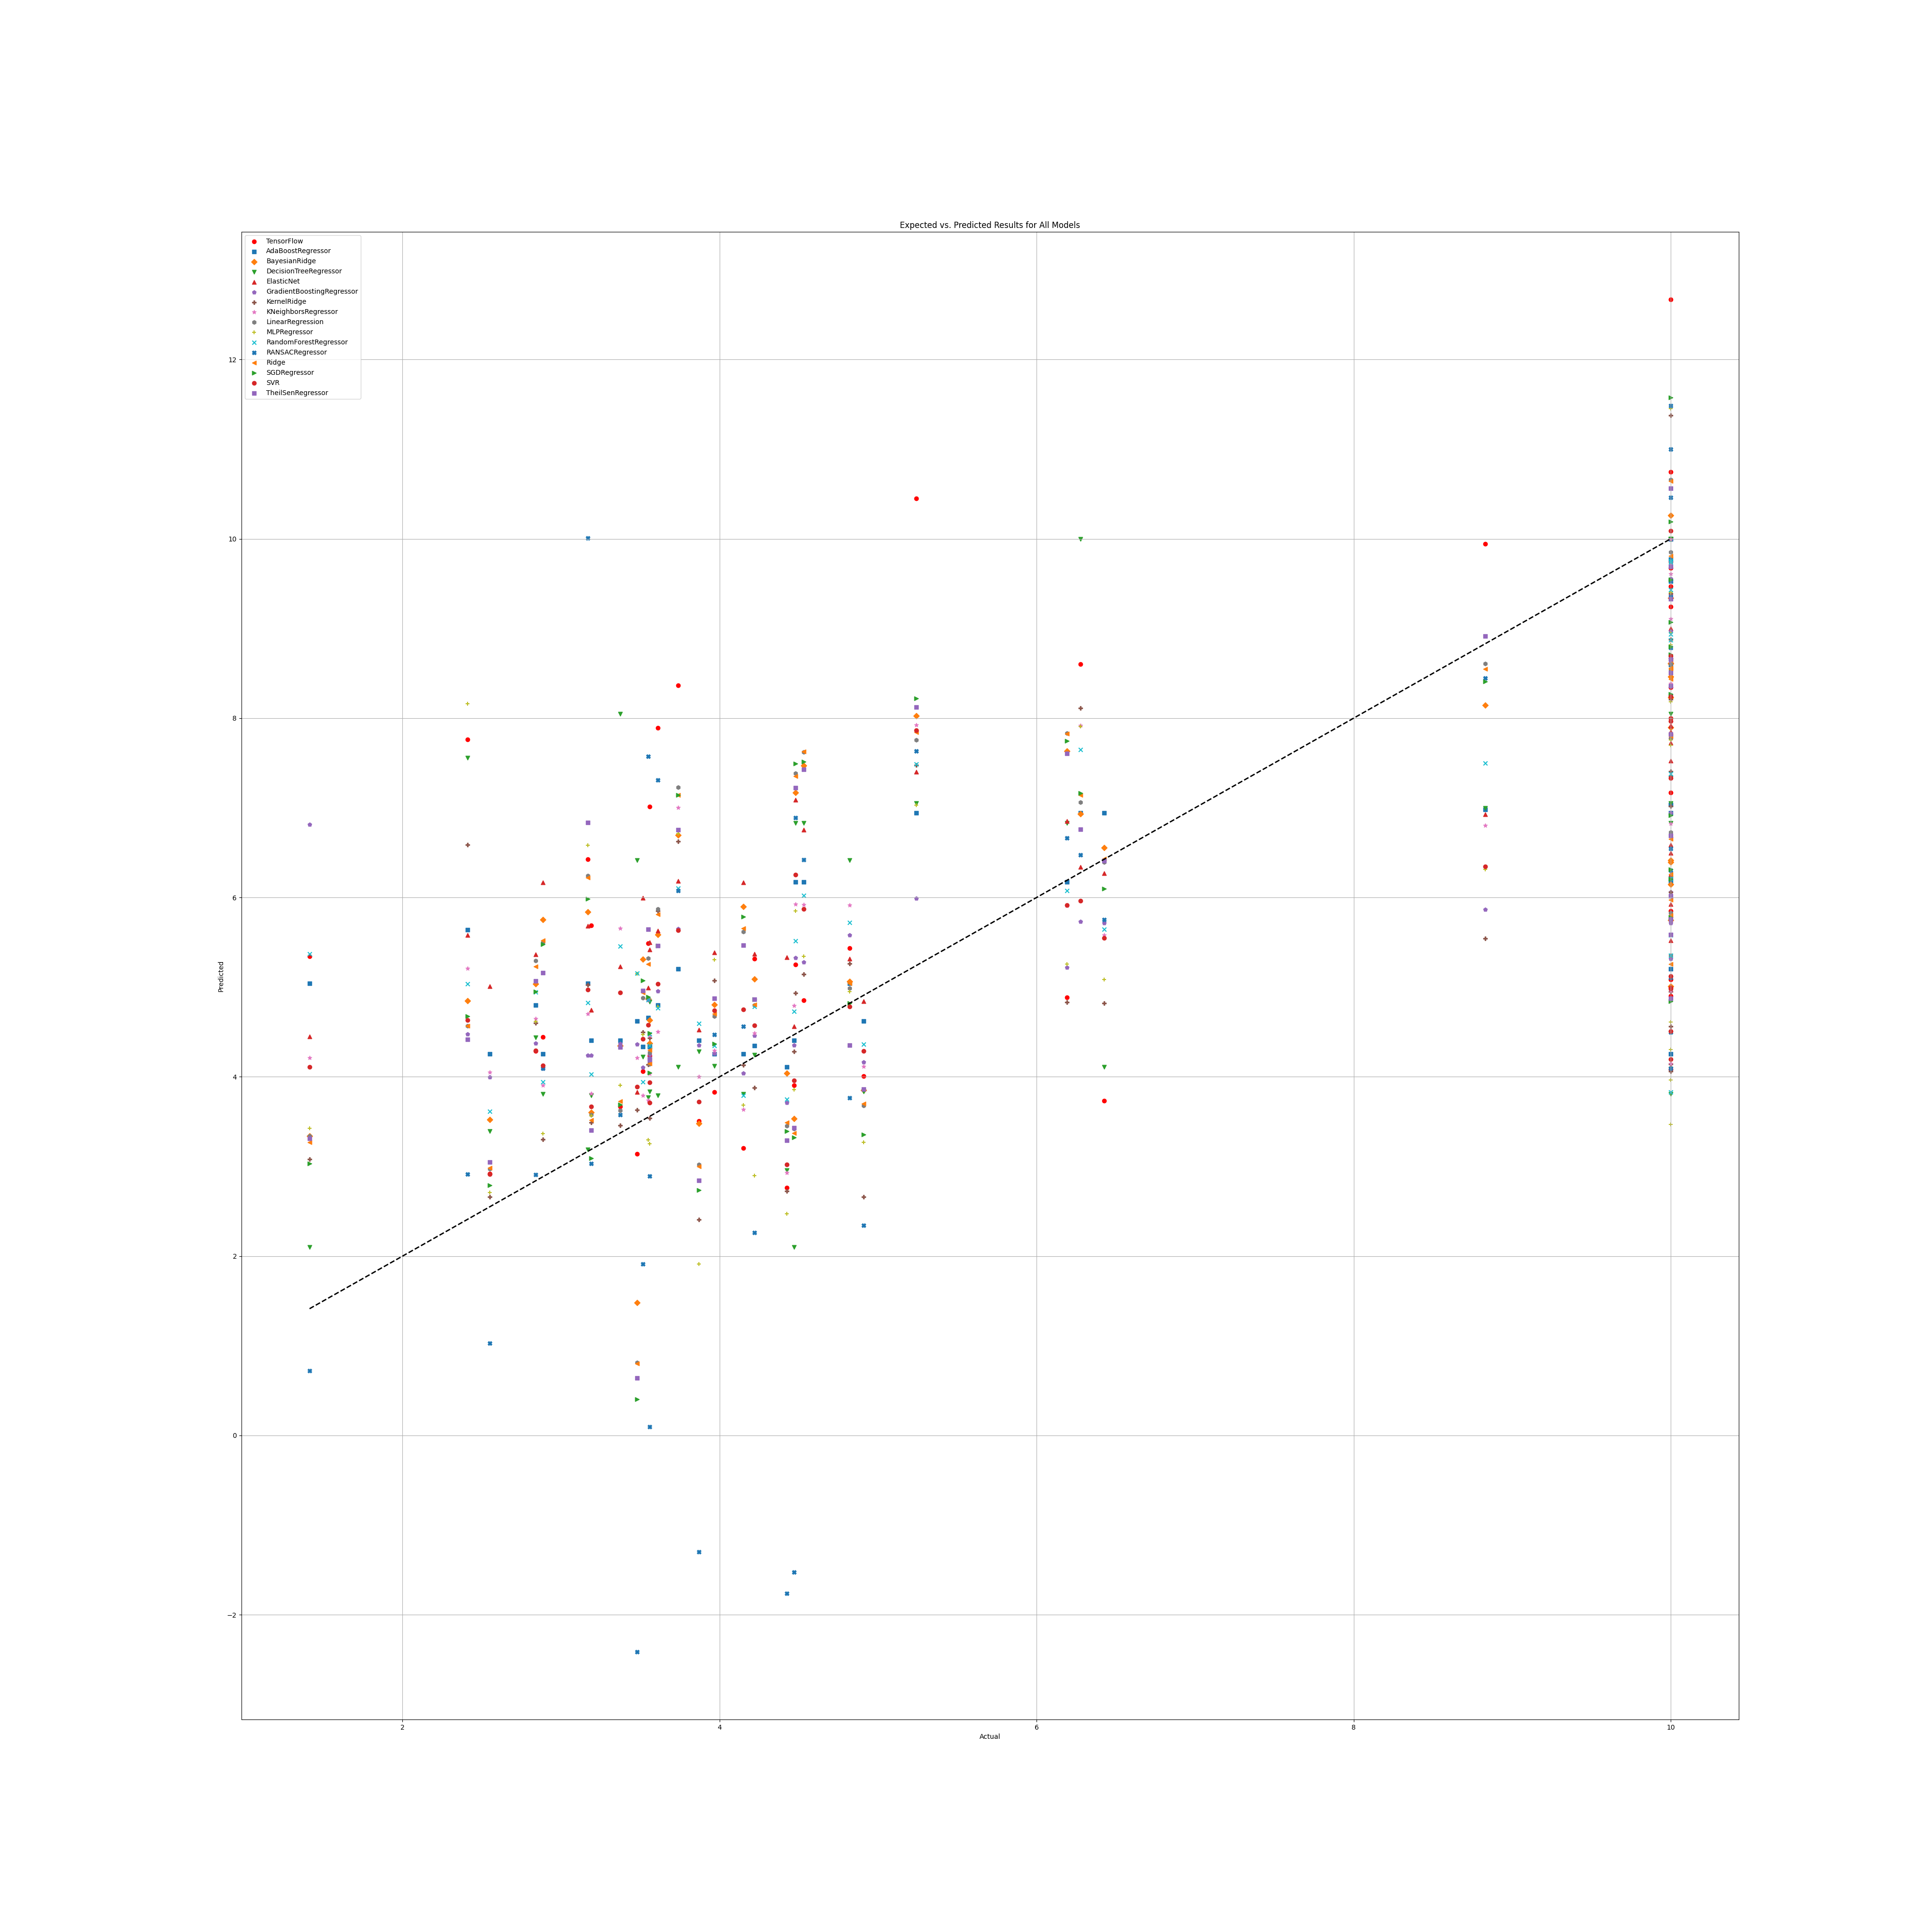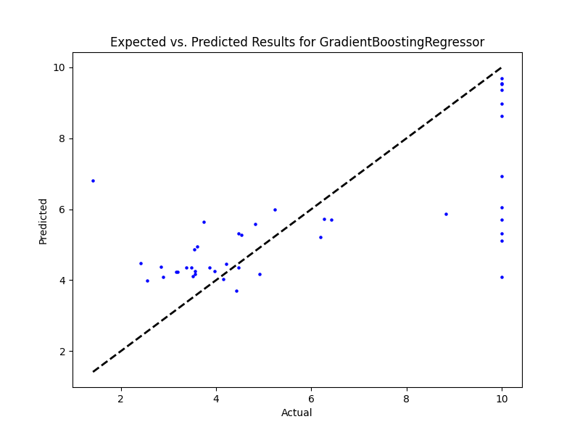

## PR Benefit

### Grid search results

**Ridge()**  
Best hyperparameters for Ridge: {'ridge__alpha': 1.0, 'ridge__solver': 'saga'}

**DecisionTreeRegressor()**  
Best hyperparameters for DecisionTreeRegressor: {'decisiontreeregressor__criterion': 'poisson', 'decisiontreeregressor__max_features': 3, 'decisiontreeregressor__min_samples_split': 4, 'decisiontreeregressor__splitter': 'random'}

**GradientBoostingRegressor()**  
Best hyperparameters for GradientBoostingRegressor: {'gradientboostingregressor__learning_rate': 0.1, 'gradientboostingregressor__loss': 'huber', 'gradientboostingregressor__n_estimators': 100, 'gradientboostingregressor__warm_start': True}

**RandomForestRegressor()**  
Best hyperparameters for RandomForestRegressor: {'randomforestregressor__criterion': 'absolute_error', 'randomforestregressor__max_features': 'sqrt', 'randomforestregressor__min_samples_split': 5, 'randomforestregressor__n_estimators': 100}

**AdaBoostRegressor()**  
Best hyperparameters for AdaBoostRegressor: {'adaboostregressor__learning_rate': 0.1, 'adaboostregressor__loss': 'square', 'adaboostregressor__n_estimators': 100}

**KNeighborsRegressor()**  
Best hyperparameters for KNeighborsRegressor: {'kneighborsregressor__algorithm': 'ball_tree', 'kneighborsregressor__leaf_size': 5, 'kneighborsregressor__metric': 'cityblock', 'kneighborsregressor__n_neighbors': 25, 'kneighborsregressor__weights': 'distance'}

**MLPRegressor()**  
Best hyperparameters for MLPRegressor: {'mlpregressor__activation': 'relu', 'mlpregressor__hidden_layer_sizes': (50, 50, 50), 'mlpregressor__learning_rate': 'constant', 'mlpregressor__solver': 'sgd'}

**ElasticNet()**  
Best hyperparameters for ElasticNet: {'elasticnet__copy_X': True, 'elasticnet__fit_intercept': True, 'elasticnet__l1_ratio': 0.25, 'elasticnet__positive': False, 'elasticnet__precompute': False, 'elasticnet__selection': 'random', 'elasticnet__warm_start': True}

**SGDRegressor()**  
Best hyperparameters for SGDRegressor: {'sgdregressor__learning_rate': 'constant', 'sgdregressor__loss': 'squared_epsilon_insensitive', 'sgdregressor__penalty': 'l2', 'sgdregressor__warm_start': True}

**SVR(cache_size=1000)**  
Best hyperparameters for SVR: {'svr__degree': 1, 'svr__gamma': 'scale', 'svr__kernel': 'rbf', 'svr__shrinking': True}

**BayesianRidge(max_iter=1000)**  
Best hyperparameters for BayesianRidge: {'bayesianridge__alpha_1': 1e-05, 'bayesianridge__alpha_2': 1e-07, 'bayesianridge__lambda_1': 1e-07, 'bayesianridge__lambda_2': 1e-05}

**KernelRidge()**  
Best hyperparameters for KernelRidge: {'kernelridge__alpha': 1.0, 'kernelridge__coef0': 1.0, 'kernelridge__degree': 2, 'kernelridge__kernel': 'poly'}

**LinearRegression()**  
Best hyperparameters for LinearRegression: {'linearregression__copy_X': True, 'linearregression__fit_intercept': True, 'linearregression__positive': True}

**RANSACRegressor()**  
Best hyperparameters for RANSACRegressor: {'ransacregressor__loss': 'squared_error', 'ransacregressor__max_trials': 100, 'ransacregressor__min_samples': 10}

**TheilSenRegressor()**  
Best hyperparameters for TheilSenRegressor: {'theilsenregressor__max_subpopulation': 1000, 'theilsenregressor__n_subsamples': 25}

**TensorFlow()**

TensorFlow RMSE: 4.89033300673706

### Prediction results

Model: Ridge  
Model saved as saved_models\Ridge_model.pkl  
RMSE: 3.263043178078421  
Sample predictions:  
Sample 1: Real NR = 0.0, Predicted NR = -0.6081932395315333  
Sample 2: Real NR = 5.78, Predicted NR = 7.015132666799476  
Sample 3: Real NR = 5.41, Predicted NR = 1.8520576211956679  
Sample 4: Real NR = 0.0, Predicted NR = 5.183909281378873  
Sample 5: Real NR = 0.0, Predicted NR = 1.4891437089709374  
  
  
Model: DecisionTreeRegressor  
Model saved as saved_models\DecisionTreeRegressor_model.pkl  
RMSE: 4.401765679398765  
Sample predictions:  
Sample 1: Real NR = 0.0, Predicted NR = 1.6666666666666667  
Sample 2: Real NR = 5.78, Predicted NR = 10.0  
Sample 3: Real NR = 5.41, Predicted NR = 1.154  
Sample 4: Real NR = 0.0, Predicted NR = 1.1960000000000002  
Sample 5: Real NR = 0.0, Predicted NR = 6.314371464850516  
  
  
Model: GradientBoostingRegressor  
Model saved as saved_models\GradientBoostingRegressor_model.pkl  
RMSE: 3.7373982140560873  
Sample predictions:  
Sample 1: Real NR = 0.0, Predicted NR = 2.0853134255843093  
Sample 2: Real NR = 5.78, Predicted NR = 5.171546823457596  
Sample 3: Real NR = 5.41, Predicted NR = -0.14725136609457226  
Sample 4: Real NR = 0.0, Predicted NR = 6.925358812261516  
Sample 5: Real NR = 0.0, Predicted NR = 1.9816143964816535  
  
  
Model: RandomForestRegressor  
Model saved as saved_models\RandomForestRegressor_model.pkl  
RMSE: 3.6320149680446088  
Sample predictions:  
Sample 1: Real NR = 0.0, Predicted NR = 2.228860231526526  
Sample 2: Real NR = 5.78, Predicted NR = 4.958226105275308  
Sample 3: Real NR = 5.41, Predicted NR = 1.1398761918503983  
Sample 4: Real NR = 0.0, Predicted NR = 6.602025820814301  
Sample 5: Real NR = 0.0, Predicted NR = 2.942142608960935  
  
  
Model: AdaBoostRegressor  
Model saved as saved_models\AdaBoostRegressor_model.pkl  
RMSE: 3.5708949262168814  
Sample predictions:  
Sample 1: Real NR = 0.0, Predicted NR = 3.573407737281563  
Sample 2: Real NR = 5.78, Predicted NR = 4.661232380225108  
Sample 3: Real NR = 5.41, Predicted NR = 1.514512382457667  
Sample 4: Real NR = 0.0, Predicted NR = 5.700635986637287  
Sample 5: Real NR = 0.0, Predicted NR = 3.126215057331948  
  
  
Model: KNeighborsRegressor  
Model saved as saved_models\KNeighborsRegressor_model.pkl  
RMSE: 3.5090418042021727  
Sample predictions:  
Sample 1: Real NR = 0.0, Predicted NR = 1.2163760312067537  
Sample 2: Real NR = 5.78, Predicted NR = 5.446041990430398  
Sample 3: Real NR = 5.41, Predicted NR = 0.8091579514871772  
Sample 4: Real NR = 0.0, Predicted NR = 5.812394521480615  
Sample 5: Real NR = 0.0, Predicted NR = 2.907735254778647  
  
  
Model: MLPRegressor  
Model saved as saved_models\MLPRegressor_model.pkl  
RMSE: 3.38280620335305  
Sample predictions:  
Sample 1: Real NR = 0.0, Predicted NR = 0.17411001333853093  
Sample 2: Real NR = 5.78, Predicted NR = 8.039619742242815  
Sample 3: Real NR = 5.41, Predicted NR = 0.805232381481336  
Sample 4: Real NR = 0.0, Predicted NR = 6.764081720588799  
Sample 5: Real NR = 0.0, Predicted NR = 2.7793586196229265  
  
  
Model: ElasticNet  
Model saved as saved_models\ElasticNet_model.pkl  
RMSE: 3.4665728443728043  
Sample predictions:  
Sample 1: Real NR = 0.0, Predicted NR = 1.7024653509664627  
Sample 2: Real NR = 5.78, Predicted NR = 5.393736562137965  
Sample 3: Real NR = 5.41, Predicted NR = 2.9328389239916492  
Sample 4: Real NR = 0.0, Predicted NR = 4.058278407624574  
Sample 5: Real NR = 0.0, Predicted NR = 2.896359194071101  
  
  
Model: SGDRegressor  
Model saved as saved_models\SGDRegressor_model.pkl  
RMSE: 3.2393897539792373  
Sample predictions:  
Sample 1: Real NR = 0.0, Predicted NR = 0.9598984267690716  
Sample 2: Real NR = 5.78, Predicted NR = 4.844649811962685  
Sample 3: Real NR = 5.41, Predicted NR = 2.7694273104221594  
Sample 4: Real NR = 0.0, Predicted NR = 3.6718526759898866  
Sample 5: Real NR = 0.0, Predicted NR = 2.6607563624049377  
  
  
Model: SVR  
Model saved as saved_models\SVR_model.pkl  
RMSE: 3.487469500399701  
Sample predictions:  
Sample 1: Real NR = 0.0, Predicted NR = -0.1848570845184314  
Sample 2: Real NR = 5.78, Predicted NR = 4.399404153906992  
Sample 3: Real NR = 5.41, Predicted NR = 0.3394592570020376  
Sample 4: Real NR = 0.0, Predicted NR = 4.390286561521647  
Sample 5: Real NR = 0.0, Predicted NR = 1.6141782217644205  
  
  
Model: BayesianRidge  
Model saved as saved_models\BayesianRidge_model.pkl  
RMSE: 3.3029548773769113  
Sample predictions:  
Sample 1: Real NR = 0.0, Predicted NR = 0.6370786607219077  
Sample 2: Real NR = 5.78, Predicted NR = 6.309451310859304  
Sample 3: Real NR = 5.41, Predicted NR = 2.2430115723469664  
Sample 4: Real NR = 0.0, Predicted NR = 4.558055676711771  
Sample 5: Real NR = 0.0, Predicted NR = 2.193881763905253  
  
  
Model: KernelRidge  
Model saved as saved_models\KernelRidge_model.pkl  
RMSE: 3.578134516937305  
Sample predictions:  
Sample 1: Real NR = 0.0, Predicted NR = 0.28827424875132124  
Sample 2: Real NR = 5.78, Predicted NR = 4.207002013288644  
Sample 3: Real NR = 5.41, Predicted NR = -0.5391759602252897  
Sample 4: Real NR = 0.0, Predicted NR = 6.102435188530265  
Sample 5: Real NR = 0.0, Predicted NR = 3.060277410664174  
  
  
Model: LinearRegression  
Model saved as saved_models\LinearRegression_model.pkl  
RMSE: 3.3853744713406013  
Sample predictions:  
Sample 1: Real NR = 0.0, Predicted NR = 1.916896074662905  
Sample 2: Real NR = 5.78, Predicted NR = 6.687703516839287  
Sample 3: Real NR = 5.41, Predicted NR = 2.212881107534244  
Sample 4: Real NR = 0.0, Predicted NR = 3.1039893639934175  
Sample 5: Real NR = 0.0, Predicted NR = 2.9287397186671353  
  
  
Model: RANSACRegressor  
Model saved as saved_models\RANSACRegressor_model.pkl  
RMSE: 4.608872935056589  
Sample predictions:  
Sample 1: Real NR = 0.0, Predicted NR = -0.23220875529094887  
Sample 2: Real NR = 5.78, Predicted NR = 13.917523911401538  
Sample 3: Real NR = 5.41, Predicted NR = -0.789263844087988  
Sample 4: Real NR = 0.0, Predicted NR = 5.439195156894138  
Sample 5: Real NR = 0.0, Predicted NR = 1.2873881402031593  
  
  
Model: TheilSenRegressor  
Model saved as saved_models\TheilSenRegressor_model.pkl  
RMSE: 3.3769146656424187  
Sample predictions:  
Sample 1: Real NR = 0.0, Predicted NR = -0.8023962879216362  
Sample 2: Real NR = 5.78, Predicted NR = 7.30413625980802  
Sample 3: Real NR = 5.41, Predicted NR = 1.1746947324607082  
Sample 4: Real NR = 0.0, Predicted NR = 5.411442360277887  
Sample 5: Real NR = 0.0, Predicted NR = 1.2521745073136743  
  
  
Model: TensorFlow  
Model saved as saved_models\TensorFlow_model.h5  
RMSE: 4.89033300673706  
Sample predictions:  
Sample 1: Real NR = 0.0, Predicted NR = [-0.05398033]  
Sample 2: Real NR = 5.78, Predicted NR = [8.860217]  
Sample 3: Real NR = 5.41, Predicted NR = [-0.07292966]  
Sample 4: Real NR = 0.0, Predicted NR = [8.727272]  
Sample 5: Real NR = 0.0, Predicted NR = [3.5584793]

### Graph results

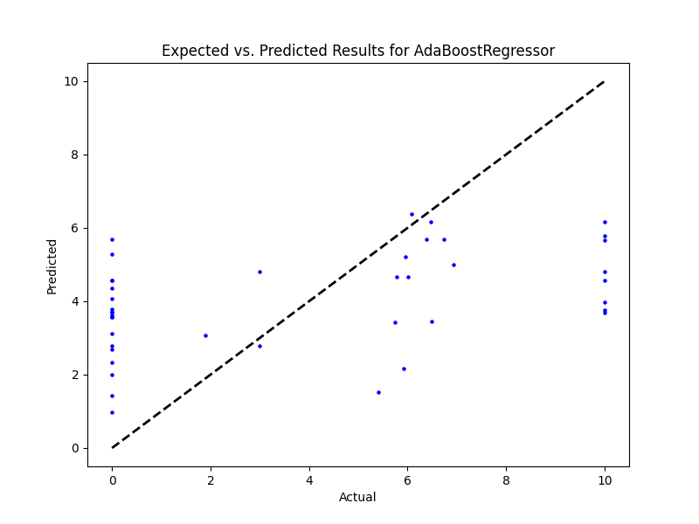

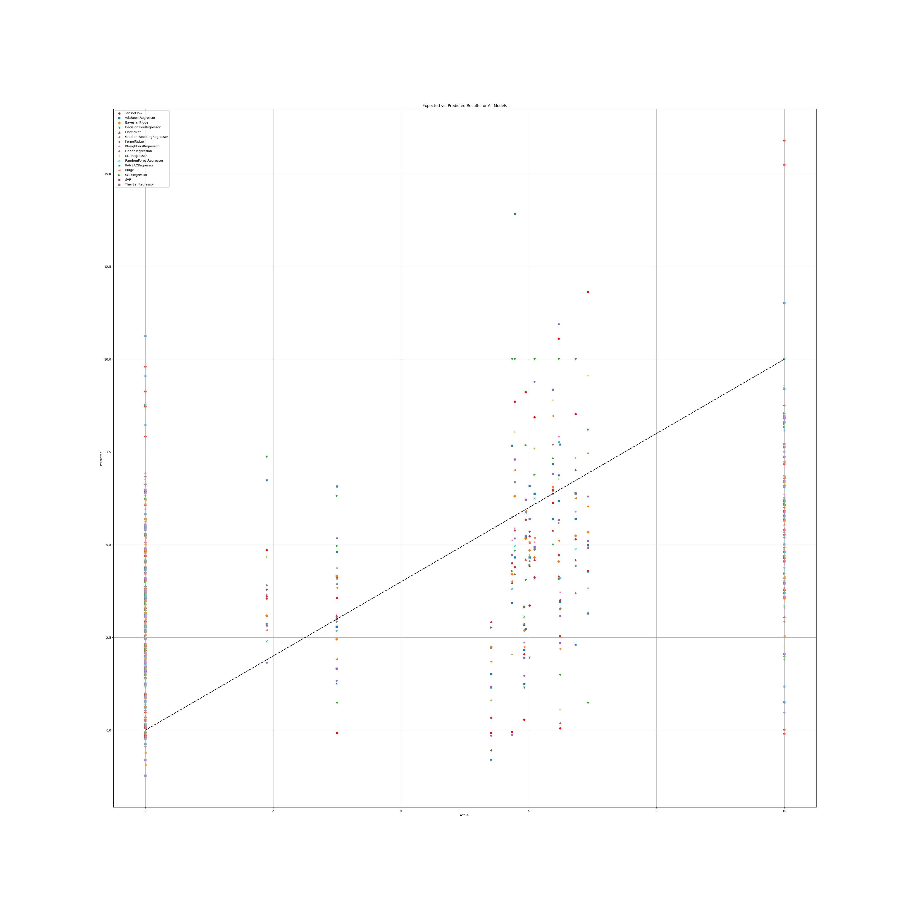

# Annex 2.4

## SR

### Grid search results

**Ridge()**  
Best hyperparameters for Ridge: {'ridge__alpha': 1.0, 'ridge__solver': 'saga'}

**DecisionTreeRegressor()**  
Best hyperparameters for DecisionTreeRegressor: {'decisiontreeregressor__criterion': 'friedman_mse', 'decisiontreeregressor__max_features': 'sqrt', 'decisiontreeregressor__min_samples_split': 4, 'decisiontreeregressor__splitter': 'random'}

**GradientBoostingRegressor()**  
Best hyperparameters for GradientBoostingRegressor: {'gradientboostingregressor__learning_rate': 0.1, 'gradientboostingregressor__loss': 'squared_error', 'gradientboostingregressor__n_estimators': 50, 'gradientboostingregressor__warm_start': False}

**RandomForestRegressor()**  
Best hyperparameters for RandomForestRegressor: {'randomforestregressor__criterion': 'absolute_error', 'randomforestregressor__max_features': 1, 'randomforestregressor__min_samples_split': 5, 'randomforestregressor__n_estimators': 50}

**AdaBoostRegressor()**  
Best hyperparameters for AdaBoostRegressor: {'adaboostregressor__learning_rate': 0.1, 'adaboostregressor__loss': 'linear', 'adaboostregressor__n_estimators': 50}

**KNeighborsRegressor()**  
Best hyperparameters for KNeighborsRegressor: {'kneighborsregressor__algorithm': 'ball_tree', 'kneighborsregressor__leaf_size': 5, 'kneighborsregressor__metric': 'cityblock', 'kneighborsregressor__n_neighbors': 25, 'kneighborsregressor__weights': 'uniform'}

**MLPRegressor()**  
Best hyperparameters for MLPRegressor: {'mlpregressor__activation': 'relu', 'mlpregressor__hidden_layer_sizes': (50, 50, 50), 'mlpregressor__learning_rate': 'adaptive', 'mlpregressor__solver': 'sgd'}

**ElasticNet()**  
Best hyperparameters for ElasticNet: {'elasticnet__copy_X': False, 'elasticnet__fit_intercept': True, 'elasticnet__l1_ratio': 0.25, 'elasticnet__positive': False, 'elasticnet__precompute': False, 'elasticnet__selection': 'random', 'elasticnet__warm_start': True}

**SGDRegressor()**  
Best hyperparameters for SGDRegressor: {'sgdregressor__learning_rate': 'constant', 'sgdregressor__loss': 'squared_error', 'sgdregressor__penalty': 'l1', 'sgdregressor__warm_start': False}  
SVR(cache_size=1000)  
Best hyperparameters for SVR: {'svr__degree': 1, 'svr__gamma': 'scale', 'svr__kernel': 'rbf', 'svr__shrinking': True}

**BayesianRidge(max_iter=1000)**  
Best hyperparameters for BayesianRidge: {'bayesianridge__alpha_1': 1e-07, 'bayesianridge__alpha_2': 1e-05, 'bayesianridge__lambda_1': 1e-05, 'bayesianridge__lambda_2': 1e-07}

**KernelRidge()**  
Best hyperparameters for KernelRidge: {'kernelridge__alpha': 1.0, 'kernelridge__coef0': 0.5, 'kernelridge__degree': 2, 'kernelridge__kernel': 'poly'}

**LinearRegression()**  
Best hyperparameters for LinearRegression: {'linearregression__copy_X': True, 'linearregression__fit_intercept': True, 'linearregression__positive': False}

**RANSACRegressor()**  
Best hyperparameters for RANSACRegressor: {'ransacregressor__loss': 'absolute_error', 'ransacregressor__max_trials': 150, 'ransacregressor__min_samples': 50}

**TheilSenRegressor()**  
Best hyperparameters for TheilSenRegressor: {'theilsenregressor__max_subpopulation': 10000, 'theilsenregressor__n_subsamples': None}

**TensorFlow()**

TensorFlow RMSE: 3.803565380720229

### Prediction results

Model: Ridge  
Model saved as saved_models\Ridge_model.pkl  
RMSE: 2.9507680937104905  
Sample predictions:  
Sample 1: Real NR = 10.0, Predicted NR = 6.4921626763026135  
Sample 2: Real NR = 3.14, Predicted NR = 4.2511745600540936  
Sample 3: Real NR = 0.54, Predicted NR = 5.492193540605832  
Sample 4: Real NR = 10.0, Predicted NR = 4.711763788817571  
Sample 5: Real NR = 1.08, Predicted NR = 4.859626801101199  
  
  
Model: DecisionTreeRegressor  
Model saved as saved_models\DecisionTreeRegressor_model.pkl  
RMSE: 3.564615196382932  
Sample predictions:  
Sample 1: Real NR = 10.0, Predicted NR = 10.0  
Sample 2: Real NR = 3.14, Predicted NR = 3.233487394957984  
Sample 3: Real NR = 0.54, Predicted NR = -0.49  
Sample 4: Real NR = 10.0, Predicted NR = 8.56  
Sample 5: Real NR = 1.08, Predicted NR = -0.49  
  
  
Model: GradientBoostingRegressor  
Model saved as saved_models\GradientBoostingRegressor_model.pkl  
RMSE: 2.7107275652231335  
Sample predictions:  
Sample 1: Real NR = 10.0, Predicted NR = 7.901488513062001  
Sample 2: Real NR = 3.14, Predicted NR = 3.5975166049456826  
Sample 3: Real NR = 0.54, Predicted NR = 3.521866341341439  
Sample 4: Real NR = 10.0, Predicted NR = 2.6130045810489526  
Sample 5: Real NR = 1.08, Predicted NR = 2.2327657295095387  
  
  
Model: RandomForestRegressor  
Model saved as saved_models\RandomForestRegressor_model.pkl  
RMSE: 2.8414241495290447  
Sample predictions:  
Sample 1: Real NR = 10.0, Predicted NR = 5.87908973747847  
Sample 2: Real NR = 3.14, Predicted NR = 3.4939387628373213  
Sample 3: Real NR = 0.54, Predicted NR = 5.459012802108796  
Sample 4: Real NR = 10.0, Predicted NR = 2.7621383554798857  
Sample 5: Real NR = 1.08, Predicted NR = 2.884231219527398  
  
  
Model: AdaBoostRegressor  
Model saved as saved_models\AdaBoostRegressor_model.pkl  
RMSE: 2.880001850521088  
Sample predictions:  
Sample 1: Real NR = 10.0, Predicted NR = 5.362267907162866  
Sample 2: Real NR = 3.14, Predicted NR = 3.2131614265740147  
Sample 3: Real NR = 0.54, Predicted NR = 4.734023589929374  
Sample 4: Real NR = 10.0, Predicted NR = 3.1123609838011497  
Sample 5: Real NR = 1.08, Predicted NR = 3.707772306857339  
  
  
Model: KNeighborsRegressor  
Model saved as saved_models\KNeighborsRegressor_model.pkl  
RMSE: 2.95386207347177  
Sample predictions:  
Sample 1: Real NR = 10.0, Predicted NR = 6.345582624857172  
Sample 2: Real NR = 3.14, Predicted NR = 3.1690614545990514  
Sample 3: Real NR = 0.54, Predicted NR = 5.5910325040859705  
Sample 4: Real NR = 10.0, Predicted NR = 2.945690729028273  
Sample 5: Real NR = 1.08, Predicted NR = 3.6558587744908637  
  
  
Model: MLPRegressor  
Model saved as saved_models\MLPRegressor_model.pkl  
RMSE: 3.0001649717764405  
Sample predictions:  
Sample 1: Real NR = 10.0, Predicted NR = 5.26121400774116  
Sample 2: Real NR = 3.14, Predicted NR = 3.249559588531532  
Sample 3: Real NR = 0.54, Predicted NR = 5.368933580742883  
Sample 4: Real NR = 10.0, Predicted NR = 3.651485060076032  
Sample 5: Real NR = 1.08, Predicted NR = 2.649388222943185  
  
  
Model: ElasticNet  
Model saved as saved_models\ElasticNet_model.pkl  
RMSE: 3.03837045050522  
Sample predictions:  
Sample 1: Real NR = 10.0, Predicted NR = 5.095891248477119  
Sample 2: Real NR = 3.14, Predicted NR = 4.299104637664701  
Sample 3: Real NR = 0.54, Predicted NR = 5.178262660577107  
Sample 4: Real NR = 10.0, Predicted NR = 4.930549252629536  
Sample 5: Real NR = 1.08, Predicted NR = 4.251859200819982  
  
  
Model: SGDRegressor  
Model saved as saved_models\SGDRegressor_model.pkl  
RMSE: 3.077098147848998  
Sample predictions:  
Sample 1: Real NR = 10.0, Predicted NR = 6.877424461969124  
Sample 2: Real NR = 3.14, Predicted NR = 4.3531292459901225  
Sample 3: Real NR = 0.54, Predicted NR = 5.368098381735735  
Sample 4: Real NR = 10.0, Predicted NR = 4.649510168822139  
Sample 5: Real NR = 1.08, Predicted NR = 5.570137105881734  
  
  
Model: SVR  
Model saved as saved_models\SVR_model.pkl  
RMSE: 3.1211638877759476  
Sample predictions:  
Sample 1: Real NR = 10.0, Predicted NR = 4.735056819458079  
Sample 2: Real NR = 3.14, Predicted NR = 3.3289345755297846  
Sample 3: Real NR = 0.54, Predicted NR = 5.057367360062168  
Sample 4: Real NR = 10.0, Predicted NR = 2.7419710397726376  
Sample 5: Real NR = 1.08, Predicted NR = 2.580359400167322  
  
  
Model: BayesianRidge  
Model saved as saved_models\BayesianRidge_model.pkl  
RMSE: 2.9855351527082066  
Sample predictions:  
Sample 1: Real NR = 10.0, Predicted NR = 6.052640328799509  
Sample 2: Real NR = 3.14, Predicted NR = 3.7404583217661997  
Sample 3: Real NR = 0.54, Predicted NR = 5.766255536542809  
Sample 4: Real NR = 10.0, Predicted NR = 4.71058471880095  
Sample 5: Real NR = 1.08, Predicted NR = 4.801822267435864  
  
  
Model: KernelRidge  
Model saved as saved_models\KernelRidge_model.pkl  
RMSE: 3.158656271603077  
Sample predictions:  
Sample 1: Real NR = 10.0, Predicted NR = 3.26747855653855  
Sample 2: Real NR = 3.14, Predicted NR = 1.046523671415537  
Sample 3: Real NR = 0.54, Predicted NR = 4.0811256243312295  
Sample 4: Real NR = 10.0, Predicted NR = 3.10782739085104  
Sample 5: Real NR = 1.08, Predicted NR = 1.8364413268901614  
  
  
Model: LinearRegression  
Model saved as saved_models\LinearRegression_model.pkl  
RMSE: 2.9485807880253505  
Sample predictions:  
Sample 1: Real NR = 10.0, Predicted NR = 6.509306164182552  
Sample 2: Real NR = 3.14, Predicted NR = 4.259907887794796  
Sample 3: Real NR = 0.54, Predicted NR = 5.445401150118646  
Sample 4: Real NR = 10.0, Predicted NR = 4.692586957861898  
Sample 5: Real NR = 1.08, Predicted NR = 4.857117072653769  
  
  
Model: RANSACRegressor  
Model saved as saved_models\RANSACRegressor_model.pkl  
RMSE: 3.428393508218978  
Sample predictions:  
Sample 1: Real NR = 10.0, Predicted NR = 4.675573492778696  
Sample 2: Real NR = 3.14, Predicted NR = 5.308505345447494  
Sample 3: Real NR = 0.54, Predicted NR = 3.0134382415667726  
Sample 4: Real NR = 10.0, Predicted NR = 5.44233785478225  
Sample 5: Real NR = 1.08, Predicted NR = 1.3416018778900383  
  
  
Model: TheilSenRegressor  
Model saved as saved_models\TheilSenRegressor_model.pkl  
RMSE: 2.84257916776103  
Sample predictions:  
Sample 1: Real NR = 10.0, Predicted NR = 6.6304535407875616  
Sample 2: Real NR = 3.14, Predicted NR = 4.048638687290529  
Sample 3: Real NR = 0.54, Predicted NR = 5.796259282169332  
Sample 4: Real NR = 10.0, Predicted NR = 4.315105833440057  
Sample 5: Real NR = 1.08, Predicted NR = 4.409285244888396  
  
  
Model: TensorFlow  
Model saved as saved_models\TensorFlow_model.h5  
RMSE: 3.803565380720229  
Sample predictions:  
Sample 1: Real NR = 10.0, Predicted NR = [0.908573]  
Sample 2: Real NR = 3.14, Predicted NR = [3.2426248]  
Sample 3: Real NR = 0.54, Predicted NR = [8.107951]  
Sample 4: Real NR = 10.0, Predicted NR = [2.4204807]  
Sample 5: Real NR = 1.08, Predicted NR = [0.99967647]

### Graph results

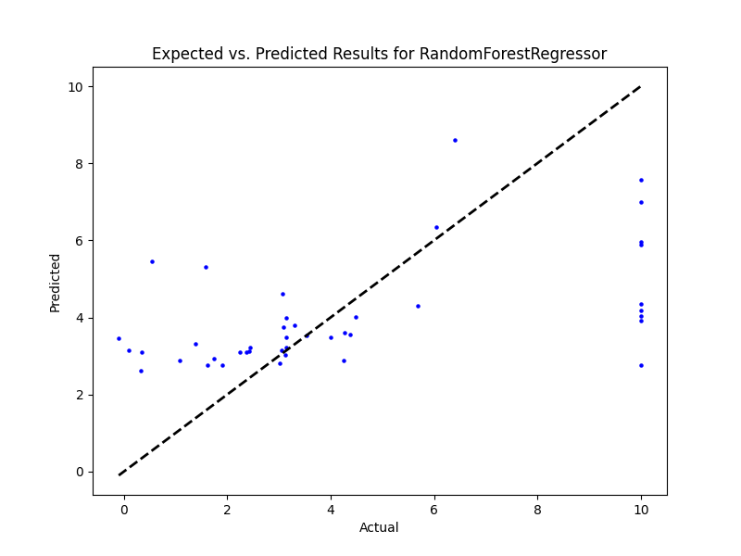

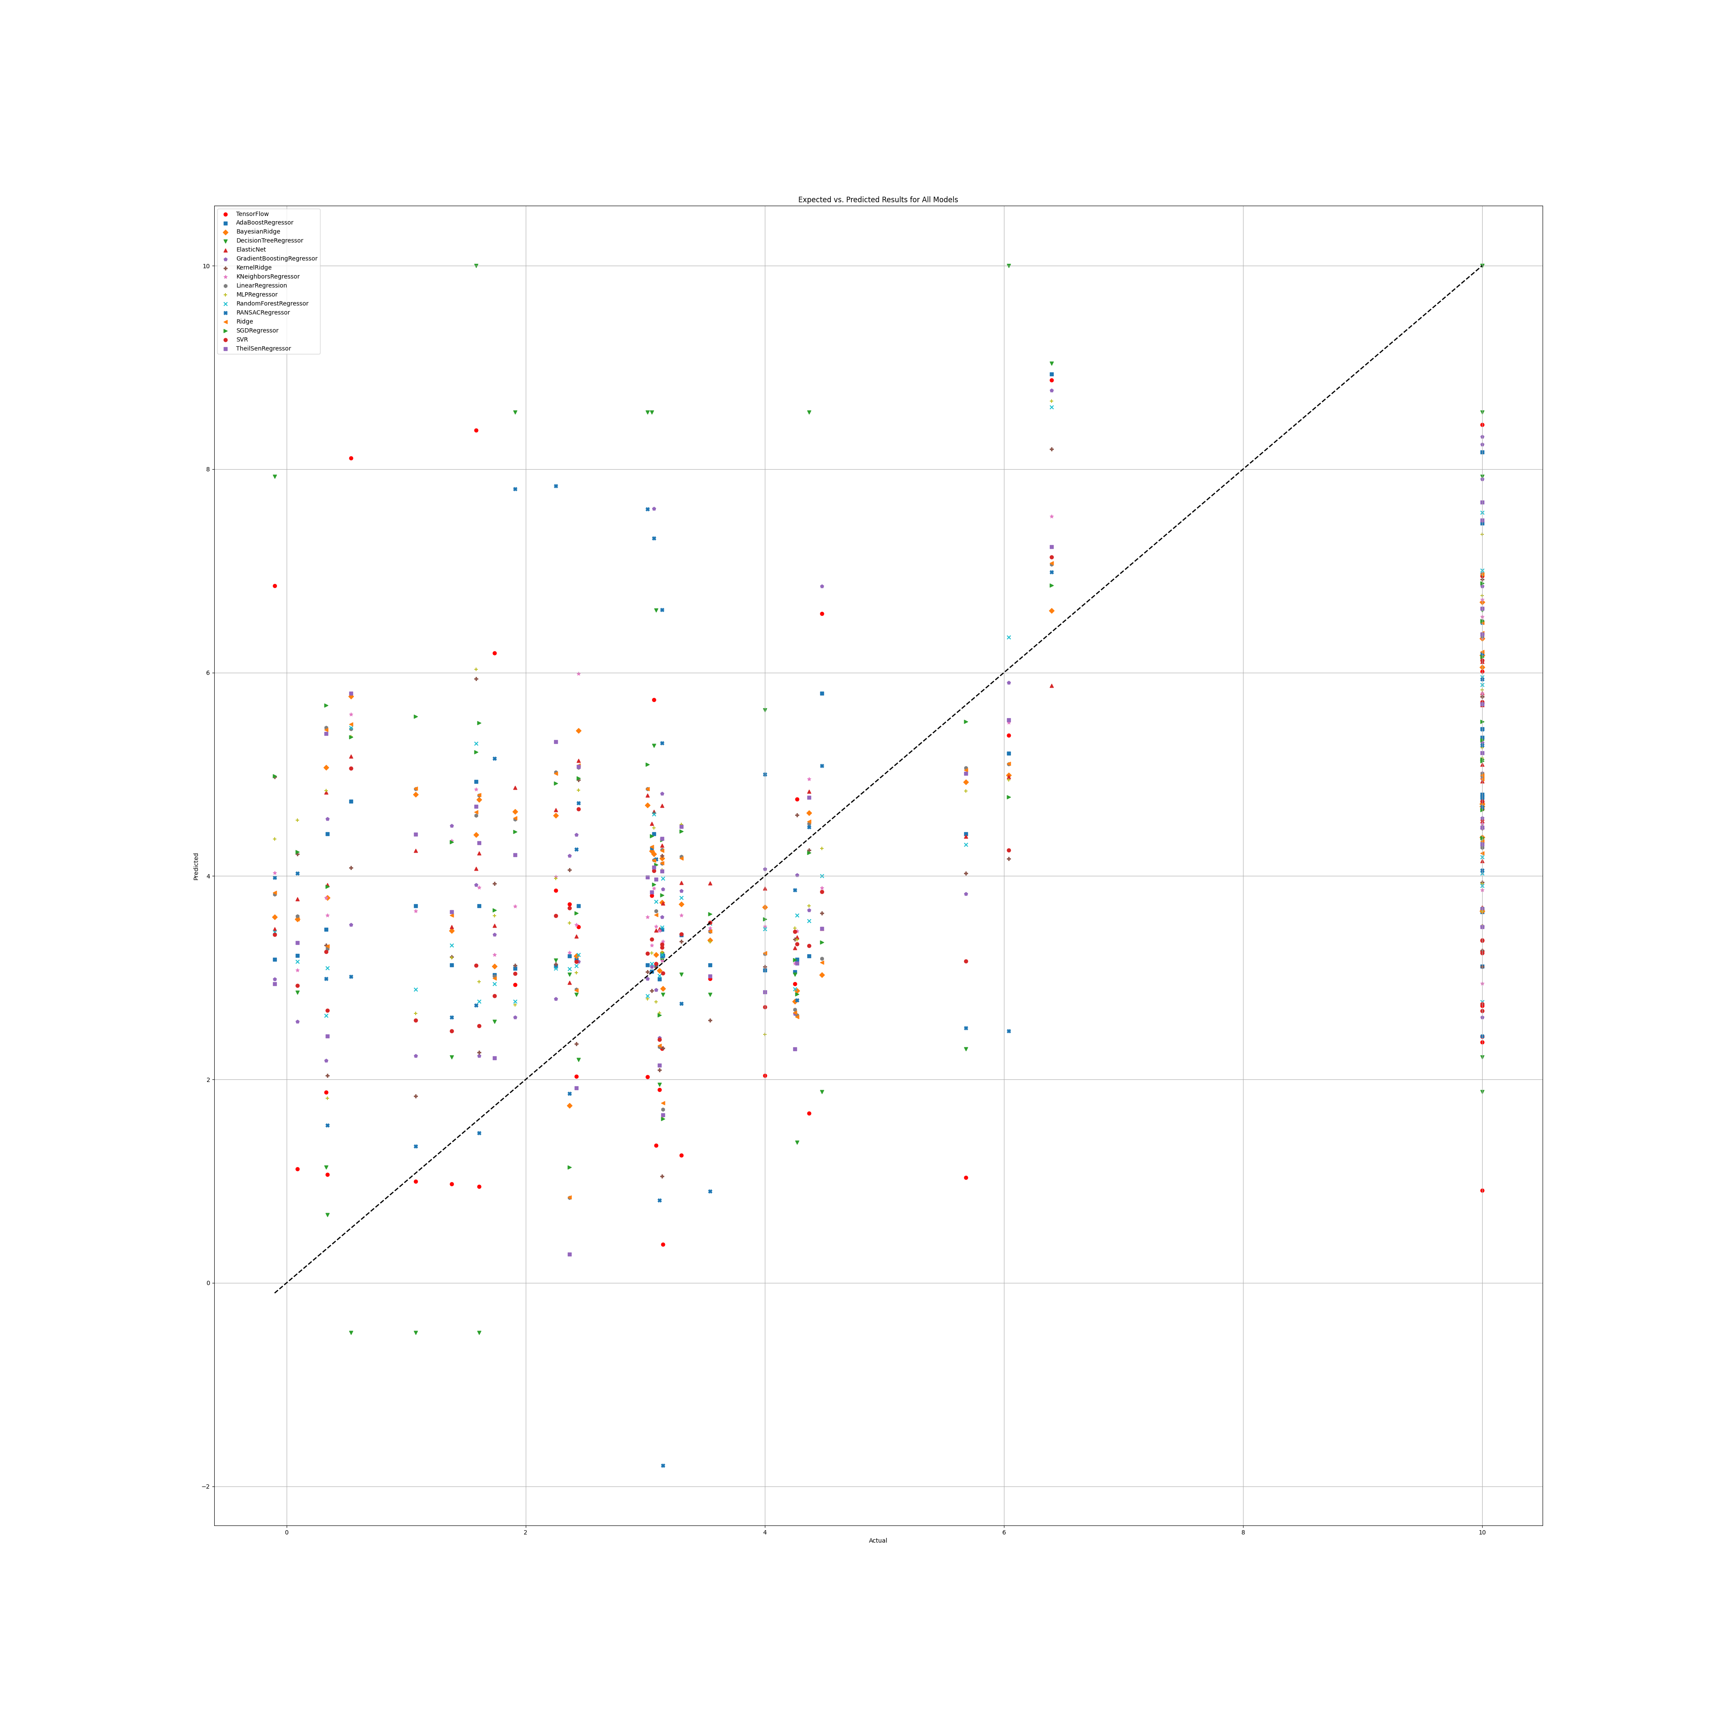

## SR Benefit

### Grid search results

**Ridge()**  
Best hyperparameters for Ridge: {'ridge__alpha': 1.0, 'ridge__solver': 'saga'}

**DecisionTreeRegressor()**  
Best hyperparameters for DecisionTreeRegressor: {'decisiontreeregressor__criterion': 'poisson', 'decisiontreeregressor__max_features': 'sqrt', 'decisiontreeregressor__min_samples_split': 4, 'decisiontreeregressor__splitter': 'random'}

**GradientBoostingRegressor()**  
Best hyperparameters for GradientBoostingRegressor: {'gradientboostingregressor__learning_rate': 0.1, 'gradientboostingregressor__loss': 'huber', 'gradientboostingregressor__n_estimators': 100, 'gradientboostingregressor__warm_start': True}

**RandomForestRegressor()**  
Best hyperparameters for RandomForestRegressor: {'randomforestregressor__criterion': 'absolute_error', 'randomforestregressor__max_features': 3, 'randomforestregressor__min_samples_split': 2, 'randomforestregressor__n_estimators': 100}

**AdaBoostRegressor()**  
Best hyperparameters for AdaBoostRegressor: {'adaboostregressor__learning_rate': 0.0001, 'adaboostregressor__loss': 'linear', 'adaboostregressor__n_estimators': 100}

**KNeighborsRegressor()**  
Best hyperparameters for KNeighborsRegressor: {'kneighborsregressor__algorithm': 'ball_tree', 'kneighborsregressor__leaf_size': 5, 'kneighborsregressor__metric': 'cityblock', 'kneighborsregressor__n_neighbors': 25, 'kneighborsregressor__weights': 'distance'}

**MLPRegressor()**  
Best hyperparameters for MLPRegressor: {'mlpregressor__activation': 'relu', 'mlpregressor__hidden_layer_sizes': (100, 100, 100), 'mlpregressor__learning_rate': 'adaptive', 'mlpregressor__solver': 'sgd'}

**ElasticNet()**  
Best hyperparameters for ElasticNet: {'elasticnet__copy_X': True, 'elasticnet__fit_intercept': True, 'elasticnet__l1_ratio': 0.25, 'elasticnet__positive': False, 'elasticnet__precompute': True, 'elasticnet__selection': 'random', 'elasticnet__warm_start': True}

**SGDRegressor()**  
Best hyperparameters for SGDRegressor: {'sgdregressor__learning_rate': 'constant', 'sgdregressor__loss': 'squared_epsilon_insensitive', 'sgdregressor__penalty': 'elasticnet', 'sgdregressor__warm_start': False}

**SVR(cache_size=1000)**  
Best hyperparameters for SVR: {'svr__degree': 1, 'svr__gamma': 'scale', 'svr__kernel': 'rbf', 'svr__shrinking': True}

**BayesianRidge(max_iter=1000)**  
Best hyperparameters for BayesianRidge: {'bayesianridge__alpha_1': 1e-05, 'bayesianridge__alpha_2': 1e-07, 'bayesianridge__lambda_1': 1e-07, 'bayesianridge__lambda_2': 1e-05}

**KernelRidge()**  
Best hyperparameters for KernelRidge: {'kernelridge__alpha': 1.0, 'kernelridge__coef0': 1.0, 'kernelridge__degree': 2, 'kernelridge__kernel': 'poly'}

**LinearRegression()**  
Best hyperparameters for LinearRegression: {'linearregression__copy_X': True, 'linearregression__fit_intercept': True, 'linearregression__positive': False}

**RANSACRegressor()**  
Best hyperparameters for RANSACRegressor: {'ransacregressor__loss': 'squared_error', 'ransacregressor__max_trials': 50, 'ransacregressor__min_samples': 10}

**TheilSenRegressor()**  
Best hyperparameters for TheilSenRegressor: {'theilsenregressor__max_subpopulation': 10000, 'theilsenregressor__n_subsamples': 25}

**TensorFlow()**

TensorFlow RMSE: 3.332703809935921

### Prediction results

Model: Ridge  
Model saved as saved_models\Ridge_model.pkl  
RMSE: 2.6863444149719578  
Sample predictions:  
Sample 1: Real NR = 0.0, Predicted NR = -0.6127423175338231  
Sample 2: Real NR = 4.11, Predicted NR = 5.268622592156445  
Sample 3: Real NR = 3.86, Predicted NR = 1.0728829674531308  
Sample 4: Real NR = 0.0, Predicted NR = 3.8327879854232823  
Sample 5: Real NR = 0.0, Predicted NR = 0.6783970604584941  
  
  
Model: DecisionTreeRegressor  
Model saved as saved_models\DecisionTreeRegressor_model.pkl  
RMSE: 3.2922462283276492  
Sample predictions:  
Sample 1: Real NR = 0.0, Predicted NR = 0.6574707320144131  
Sample 2: Real NR = 4.11, Predicted NR = 8.186666666666666  
Sample 3: Real NR = 3.86, Predicted NR = 0.6574707320144131  
Sample 4: Real NR = 0.0, Predicted NR = 1.4133333333333333  
Sample 5: Real NR = 0.0, Predicted NR = 0.6574707320144131  
  
  
Model: GradientBoostingRegressor  
Model saved as saved_models\GradientBoostingRegressor_model.pkl  
RMSE: 3.0173404275245526  
Sample predictions:  
Sample 1: Real NR = 0.0, Predicted NR = 0.44466023823689615  
Sample 2: Real NR = 4.11, Predicted NR = 4.321165080417786  
Sample 3: Real NR = 3.86, Predicted NR = 0.7811962490189636  
Sample 4: Real NR = 0.0, Predicted NR = 3.9310834059636  
Sample 5: Real NR = 0.0, Predicted NR = 2.3874640699398757  
  
  
Model: RandomForestRegressor  
Model saved as saved_models\RandomForestRegressor_model.pkl  
RMSE: 2.85508654663352  
Sample predictions:  
Sample 1: Real NR = 0.0, Predicted NR = 1.73320304901081  
Sample 2: Real NR = 4.11, Predicted NR = 3.0281651004753485  
Sample 3: Real NR = 3.86, Predicted NR = 1.3598770375360232  
Sample 4: Real NR = 0.0, Predicted NR = 3.966292663975258  
Sample 5: Real NR = 0.0, Predicted NR = 1.709923155803337  
  
  
Model: AdaBoostRegressor  
Model saved as saved_models\AdaBoostRegressor_model.pkl  
RMSE: 2.832635222860757  
Sample predictions:  
Sample 1: Real NR = 0.0, Predicted NR = 0.49963781958046777  
Sample 2: Real NR = 4.11, Predicted NR = 3.7575304703746566  
Sample 3: Real NR = 3.86, Predicted NR = 0.35351916431145197  
Sample 4: Real NR = 0.0, Predicted NR = 3.439625363124128  
Sample 5: Real NR = 0.0, Predicted NR = 0.8071574304341844  
  
  
Model: KNeighborsRegressor  
Model saved as saved_models\KNeighborsRegressor_model.pkl  
RMSE: 2.8271134040433203  
Sample predictions:  
Sample 1: Real NR = 0.0, Predicted NR = 0.9492265878542704  
Sample 2: Real NR = 4.11, Predicted NR = 3.984000651916741  
Sample 3: Real NR = 3.86, Predicted NR = 0.5788722730509894  
Sample 4: Real NR = 0.0, Predicted NR = 3.9198605348650526  
Sample 5: Real NR = 0.0, Predicted NR = 1.9879777250855737  
  
  
Model: MLPRegressor  
Model saved as saved_models\MLPRegressor_model.pkl  
RMSE: 2.8958215066901634  
Sample predictions:  
Sample 1: Real NR = 0.0, Predicted NR = -0.3015779752416511  
Sample 2: Real NR = 4.11, Predicted NR = 5.303795317904804  
Sample 3: Real NR = 3.86, Predicted NR = -0.013458098809474793  
Sample 4: Real NR = 0.0, Predicted NR = 5.100293214758062  
Sample 5: Real NR = 0.0, Predicted NR = 1.3878154238950096  
  
  
Model: ElasticNet  
Model saved as saved_models\ElasticNet_model.pkl  
RMSE: 2.882354043296509  
Sample predictions:  
Sample 1: Real NR = 0.0, Predicted NR = 1.2236056165697842  
Sample 2: Real NR = 4.11, Predicted NR = 3.414040062797452  
Sample 3: Real NR = 3.86, Predicted NR = 2.09240687153217  
Sample 4: Real NR = 0.0, Predicted NR = 2.6628732500896413  
Sample 5: Real NR = 0.0, Predicted NR = 1.9151425064553311  
  
  
Model: SGDRegressor  
Model saved as saved_models\SGDRegressor_model.pkl  
RMSE: 2.5665188014835683  
Sample predictions:  
Sample 1: Real NR = 0.0, Predicted NR = -0.04855367117111786  
Sample 2: Real NR = 4.11, Predicted NR = 6.826385528274122  
Sample 3: Real NR = 3.86, Predicted NR = 1.5439755192500466  
Sample 4: Real NR = 0.0, Predicted NR = 3.653444938346149  
Sample 5: Real NR = 0.0, Predicted NR = 1.59099198839772  
  
  
Model: SVR  
Model saved as saved_models\SVR_model.pkl  
RMSE: 3.0153224951404383  
Sample predictions:  
Sample 1: Real NR = 0.0, Predicted NR = -0.24131479197770966  
Sample 2: Real NR = 4.11, Predicted NR = 2.690823981477555  
Sample 3: Real NR = 3.86, Predicted NR = -0.06406802010777168  
Sample 4: Real NR = 0.0, Predicted NR = 3.4162409576028834  
Sample 5: Real NR = 0.0, Predicted NR = 0.631523257536525  
  
  
Model: BayesianRidge  
Model saved as saved_models\BayesianRidge_model.pkl  
RMSE: 2.718634844557523  
Sample predictions:  
Sample 1: Real NR = 0.0, Predicted NR = 0.22372190078837884  
Sample 2: Real NR = 4.11, Predicted NR = 4.60077748228241  
Sample 3: Real NR = 3.86, Predicted NR = 1.488346991003241  
Sample 4: Real NR = 0.0, Predicted NR = 3.3708711935217095  
Sample 5: Real NR = 0.0, Predicted NR = 1.2343898212902416  
  
  
Model: KernelRidge  
Model saved as saved_models\KernelRidge_model.pkl  
RMSE: 2.880718694651274  
Sample predictions:  
Sample 1: Real NR = 0.0, Predicted NR = -0.12485563287745904  
Sample 2: Real NR = 4.11, Predicted NR = 3.058329555399446  
Sample 3: Real NR = 3.86, Predicted NR = 0.03843109815002421  
Sample 4: Real NR = 0.0, Predicted NR = 4.545603450487871  
Sample 5: Real NR = 0.0, Predicted NR = 1.7216796576235325  
  
  
Model: LinearRegression  
Model saved as saved_models\LinearRegression_model.pkl  
RMSE: 2.687424507154232  
Sample predictions:  
Sample 1: Real NR = 0.0, Predicted NR = -0.628150473355757  
Sample 2: Real NR = 4.11, Predicted NR = 5.279812669971289  
Sample 3: Real NR = 3.86, Predicted NR = 1.0642924732373982  
Sample 4: Real NR = 0.0, Predicted NR = 3.8424083560625384  
Sample 5: Real NR = 0.0, Predicted NR = 0.6684146354342237  
  
  
Model: RANSACRegressor  
Model saved as saved_models\RANSACRegressor_model.pkl  
RMSE: 3.8681845095265306  
Sample predictions:  
Sample 1: Real NR = 0.0, Predicted NR = 5.287425117687825  
Sample 2: Real NR = 4.11, Predicted NR = 4.284327138508779  
Sample 3: Real NR = 3.86, Predicted NR = 4.068652978749919  
Sample 4: Real NR = 0.0, Predicted NR = 5.073540120995736  
Sample 5: Real NR = 0.0, Predicted NR = 4.684458129204628  
  
  
Model: TheilSenRegressor  
Model saved as saved_models\TheilSenRegressor_model.pkl  
RMSE: 2.79880098662138  
Sample predictions:  
Sample 1: Real NR = 0.0, Predicted NR = -0.6947058924711476  
Sample 2: Real NR = 4.11, Predicted NR = 5.126517648038064  
Sample 3: Real NR = 3.86, Predicted NR = 0.5023682283367459  
Sample 4: Real NR = 0.0, Predicted NR = 3.726664813948605  
Sample 5: Real NR = 0.0, Predicted NR = 0.458878970028304  
  
  
Model: TensorFlow  
Model saved as saved_models\TensorFlow_model.h5  
RMSE: 3.332703809935921  
Sample predictions:  
Sample 1: Real NR = 0.0, Predicted NR = [-0.06363055]  
Sample 2: Real NR = 4.11, Predicted NR = [6.0349674]  
Sample 3: Real NR = 3.86, Predicted NR = [-0.0051042]  
Sample 4: Real NR = 0.0, Predicted NR = [4.4831667]  
Sample 5: Real NR = 0.0, Predicted NR = [-0.00334849]

### Graph results

