Annex 3.1.1

All data available

Images of models for water retention

Data from data_all_numerical_ws.xlsx

**Model 1**

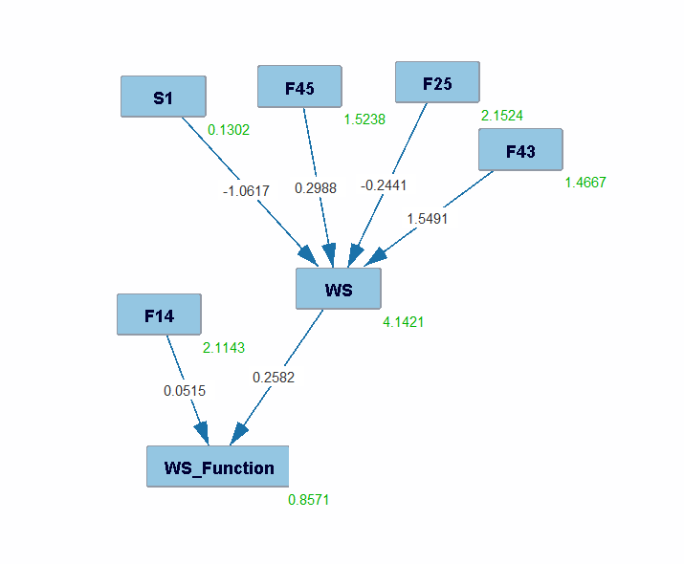

**Note**:

Knowledge 3 tiers, Model PC-MB found that f25/f43/f45/s1 had an effect on WSwhile F14/WS had an effect on S_Function. However, these models don't fit the data

Annex 3.1.2

Images of models for water retention benefit

Data from data_all_numerical_ws_benefit.xlsx

In the models **(OF22,OF25,OF26,F3,F20,F21,F22,F28,F31,F41,F42,F44,F48,F49)**

**Model 1**

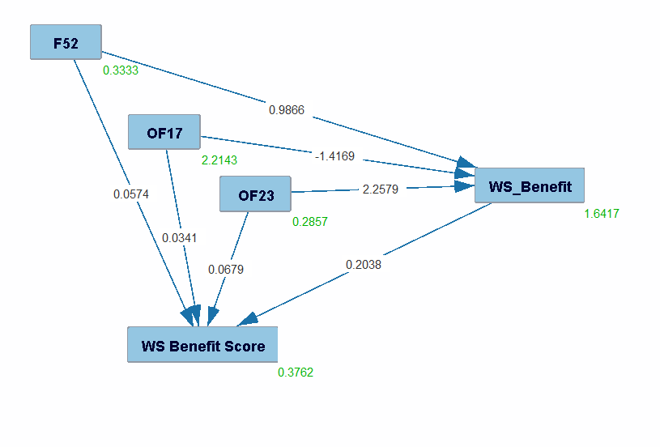

**Note**:

Knowledge 3 tiers, Model PC-MB found that F52/OF17/OF23 had an effect on WS_Benefit while F52/0F17/OF24 had an effect on WS Benefit Score. This model was able to fit the data to an extent with a chi sqaure of 25.4523 and a p value of 1.2418E-5

Annex 3.2.1

Images of models for nitrate retention

Data from data_all_numerical_nr.xlsx

In the models **(OF16,18,22,25,26,27,F1,3,6,17,18,20,21,22,23,24,28,31,33,34,36,41,42,44,48,49,54,65,S5)**

**Model 1**

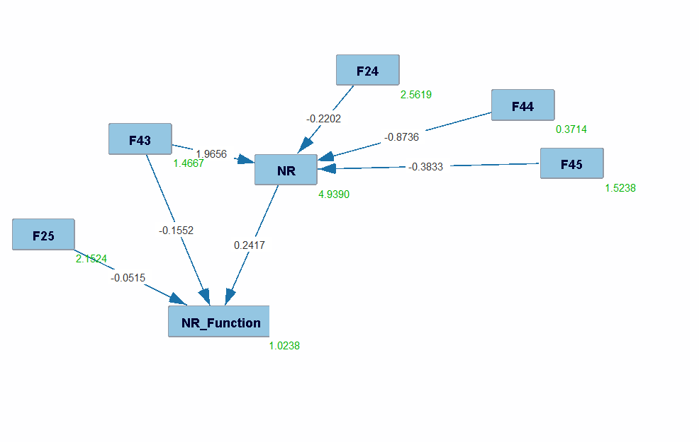

**Note**:

Knowledge 3 tiers, Model PC-MB found that F24/F43/F44/F55 had an effect on NR while F25/F43/NR had an effect on NR_Function. However, these models don't fit the data

Annex 3.2.2

Images of models for nitrateretention benefit

Data from data_all_numerical_nr_benefit.xlsx

In the models **(of9,10,11,19,20,21,22,23,24,f13,40,50,51,52,66,s2)**

**Model 1**

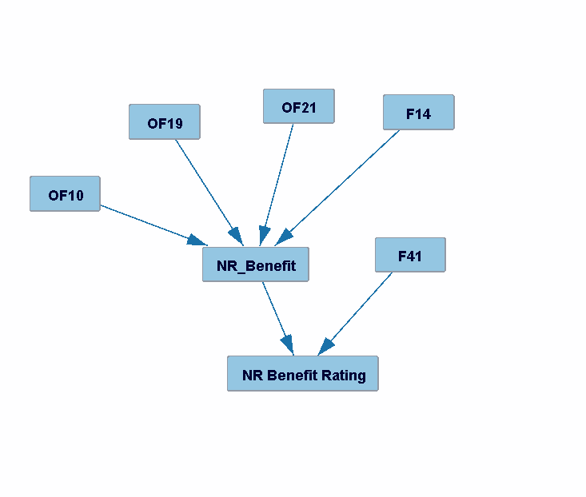

**Note**:

Knowledge 3 tiers, Model PC-MB found that OF10/OF19/OF21/F14 had an effect on NR while /F41/NR had an effect on NR_Function. However, these models don't fit the data

Annex 3.3.1

Images of models for phosphore retention

Data from data_all_numerical_pr.xlsx

In the models **(OF22/26/27/F17/20/F21/23/24/28/29/33/34/36/38/41/42/44/49/63/65)**

**Model 1**

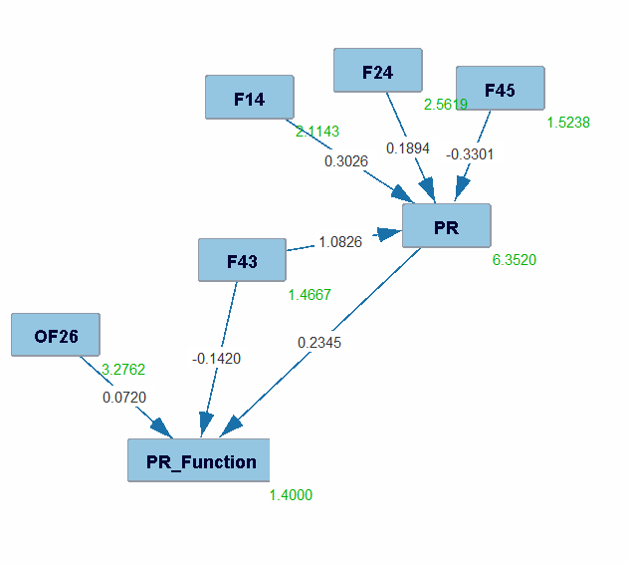

**Note**:

Knowledge 3 tiers, Model PC-MB found that F14/F24/F45/F43 had an effect on PR while OF26/F43/PR had an effect on PR_Function. However, these models don't fit the data

Annex 3.3.2

Images of models for phosphore retention benefit

Data from data_all_numerical_pr_benefit.xlsx

**Model 1**

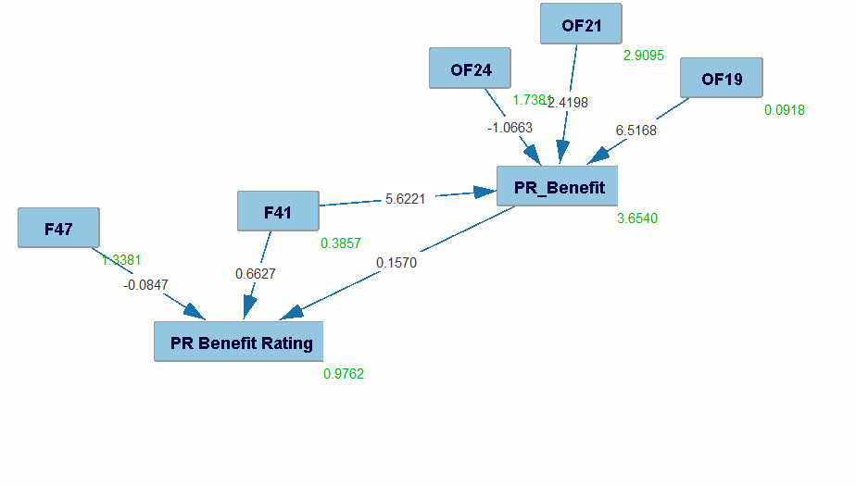

**Note**:

Knowledge 3 tiers, Model PC-MB found that OF19/21/24/F41 had an effect on PR_Benefit while F41/F47/PR_Ben had an effect on PR_Ben_rating. However, these models don't fit the data

Annex 3.4.1

Images of models for sediment retention

Data from data_all_numerical_sr.xlsx

In the model **(of22,26,27,F17,20,22,28,29,31,33,34,35,36,41,42,44,49,S5)**

**Model 1**

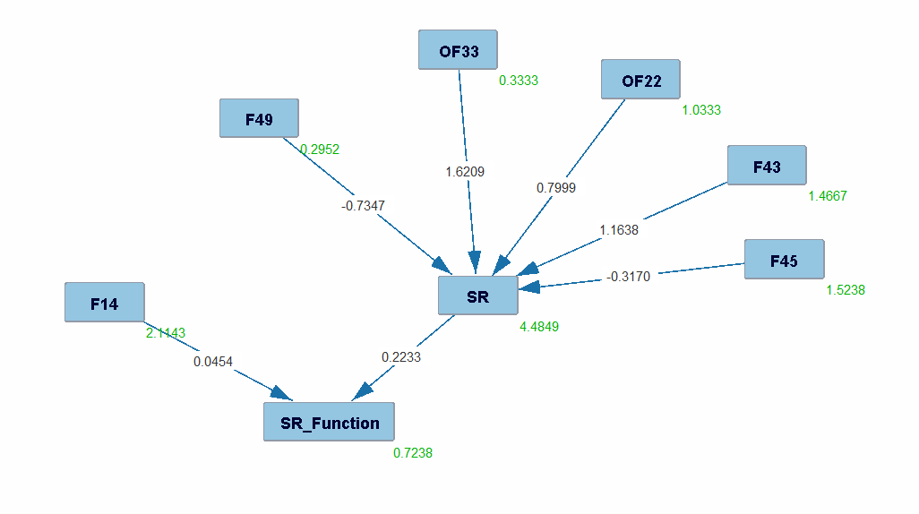

**Note**:

Knowledge 3 tiers, Model PC-MB found that OF22/OF33/F43/F45/F49 had an effect on SR while F14/SR had an effect on SR_Function. However, these models don't fit the data

Annex 3.4.2

Images of models for sediment retention benefit

Data from data_all_numerical_sr_benefit.xlsx

**Model 1**

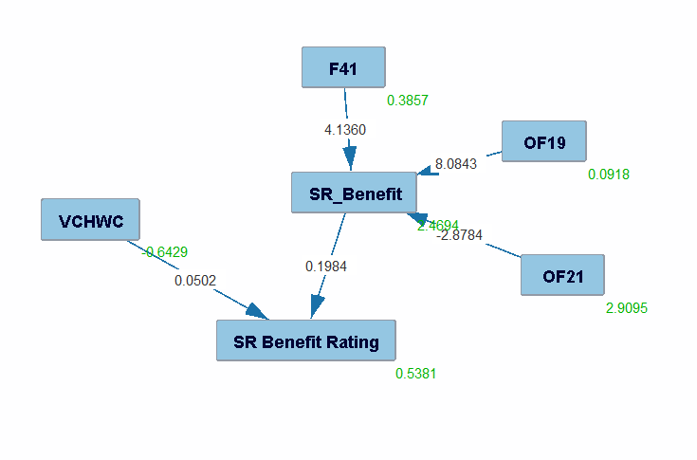

**Note**:

Knowledge 3 tiers, Model PC-MB found that F41/OF19/OF21 had an effect on SR while VCHWC/SR had an effect on SR_Function. This model fits the data with a chi square of 31.1730 and a p value of P Value = 5.4934E-4