Annex 3b.1.1

Reduced available

Images of models for water retention

Data from data_all_numerical_ws_reduced.xlsx

In the models **(OF22,OF25,OF26,F3,F20,F21,F22,F28,F31,F41,F42,F44,F48,F49)**

**Model 1**

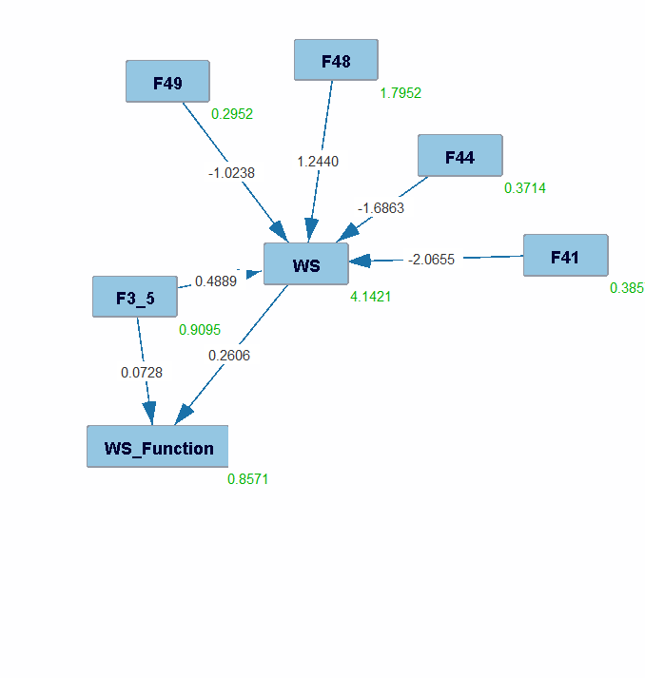

**Note**:

Tier 3 knowledge, PC-MN algorithm, model does not fit the data

Annex 3b.1.2

Images of models for water retention benefit

Data from data_all_numerical_ws_benefit_reduced.xlsx

In the models **(OF22,OF25,OF26,F3,F20,F21,F22,F28,F31,F41,F42,F44,F48,F49)**

**Model 1**

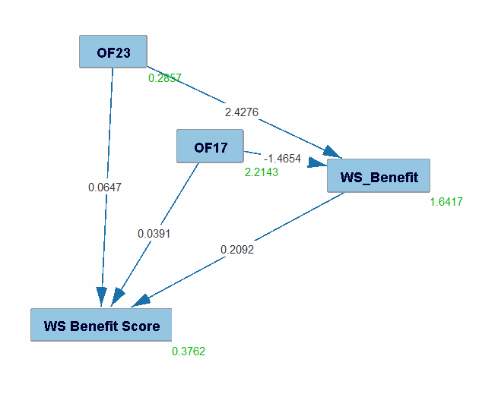

**Note**:

Tier 3 knowledge, PC-MN algorithm, model fits the data with a chi square of 19.5306 and a p value of 9.9001E-6

Annex 3b.2.1

Images of models for nitrate retention

Data from data_all_numerical_nr_reduced.xlsx

In the models **(OF16,18,22,25,26,27,F1,3,6,17,18,20,21,22,23,24,28,31,33,34,36,41,42,44,48,49,54,65,S5)**

**Model 1**

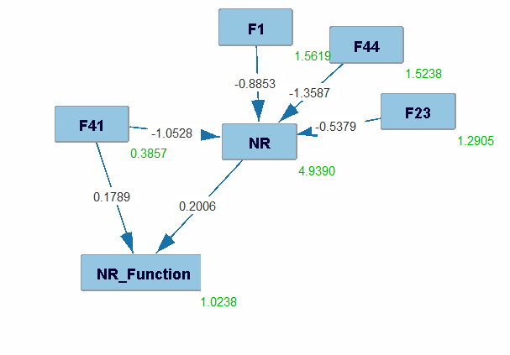

**Note**:

Tier 3 knowledge, PC-MN algorithm, model does not fit the data

**Model 2**

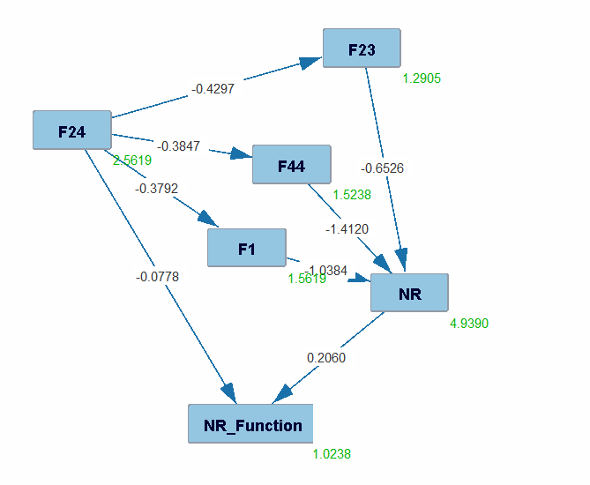

**Note**:

Tier 3 knowledge, FGES-MB algorithm, model fits the data with a chi square of 23.1871 and a p value of 0.0016

Annex 3b.2.2

Images of models for nitrateretention benefit

Data from data_all_numerical_nr_benefit_reduced.xlsx

In the models **(of9,10,11,19,20,21,22,23,24,f13,40,50,51,52,66,s2)**

**Model 1**

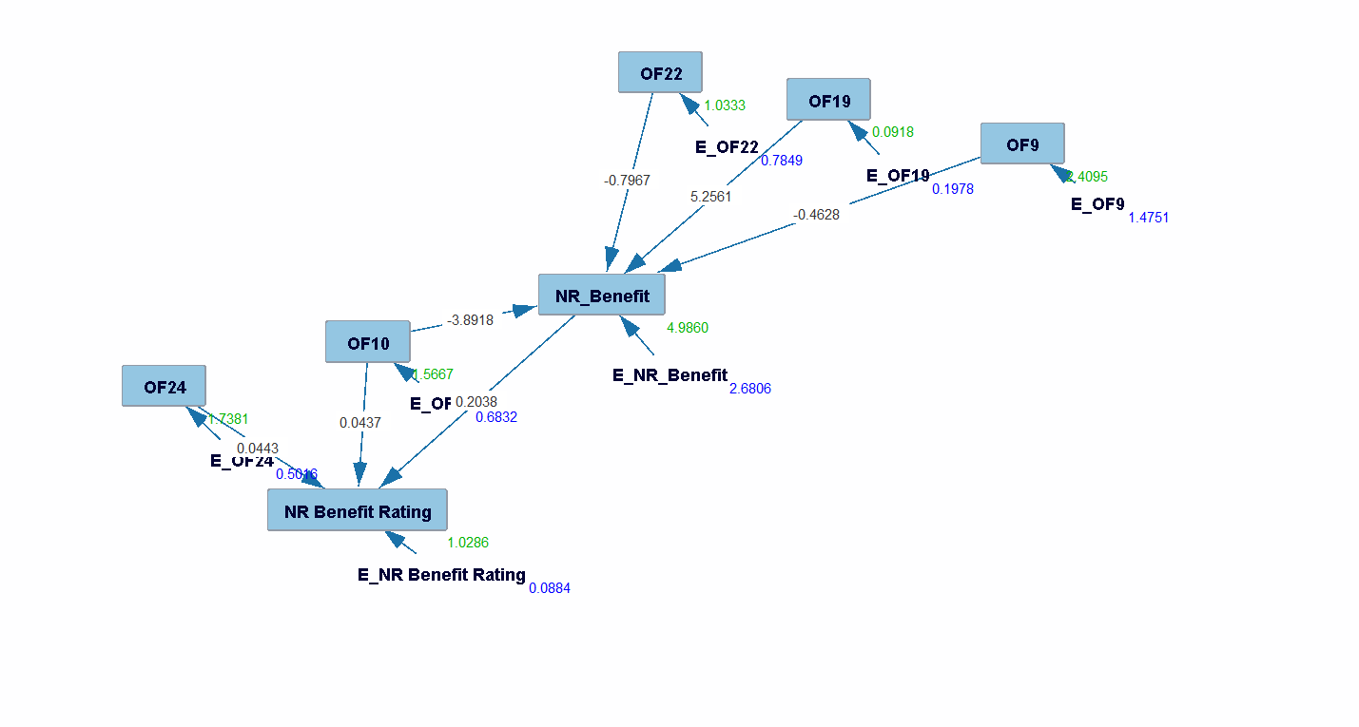

**Note**:

Tier 3 knowledge, PC-MN algorithm, model does not fit the data

**Model 2**

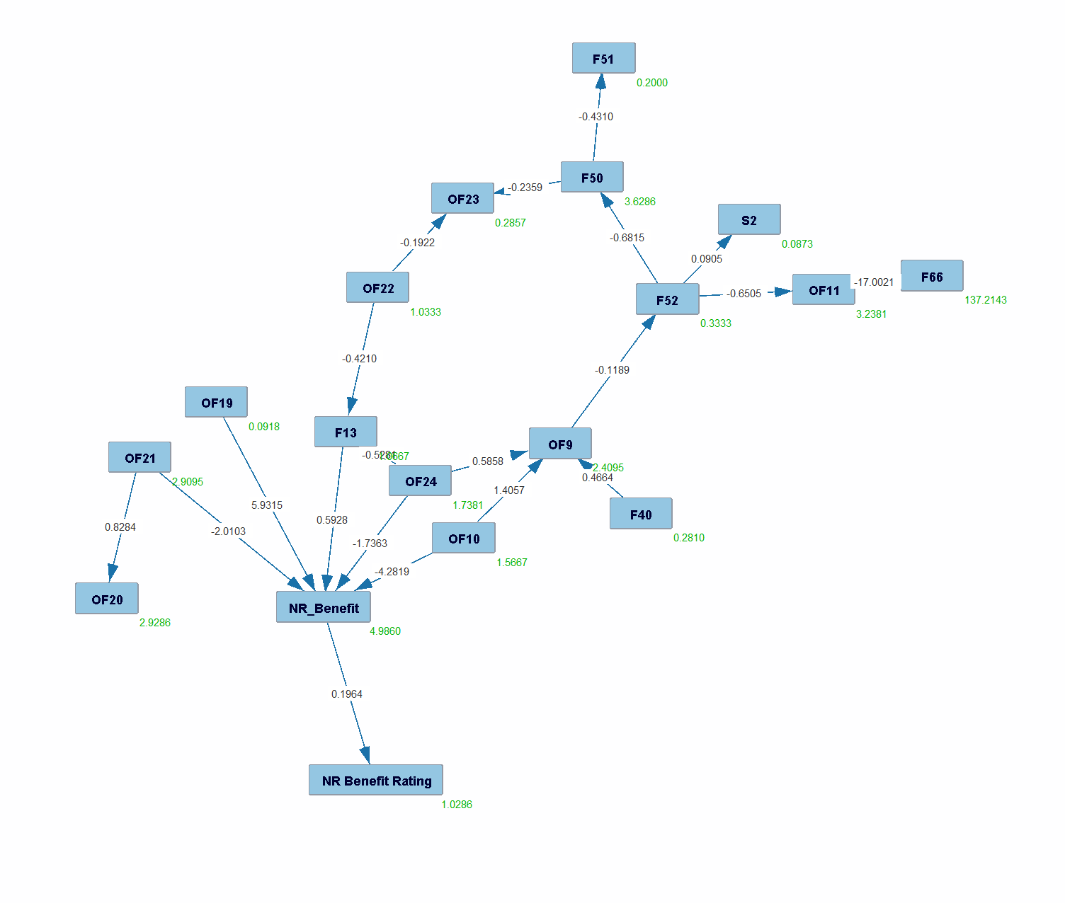

**Note**:

Tier 3 knowledge, BOSS-LINGAM algorithm, model fits the data with a chi square of 191.3614 and a p value of 6.9254E-4

**Model 3**

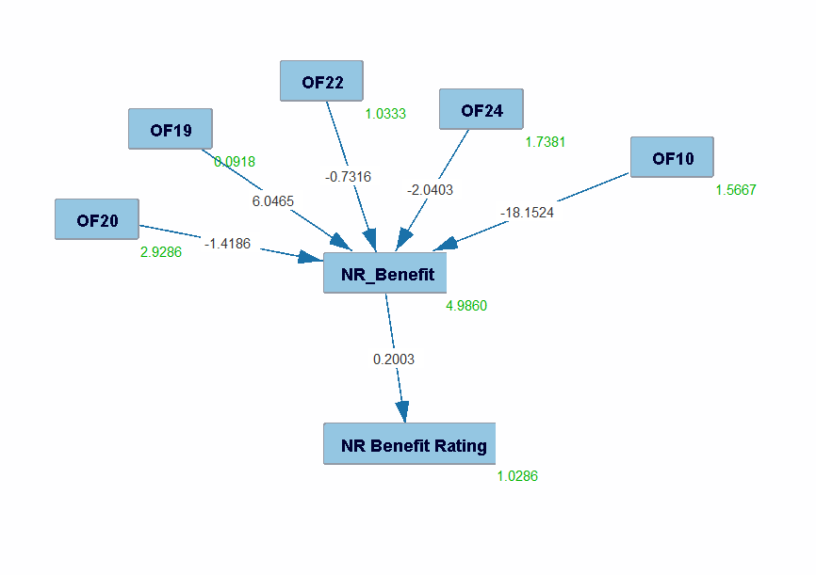

**Note**:

Tier 3 knowledge, FGES-MB algorithm, model does not fit the data

Annex 3b.3.1

Images of models for phosphore retention

Data from data_all_numerical_pr_reduced.xlsx

In the models **(OF22/26/27/F17/20/F21/23/24/28/29/33/34/36/38/41/42/44/49/63/65)**

**Model 1**

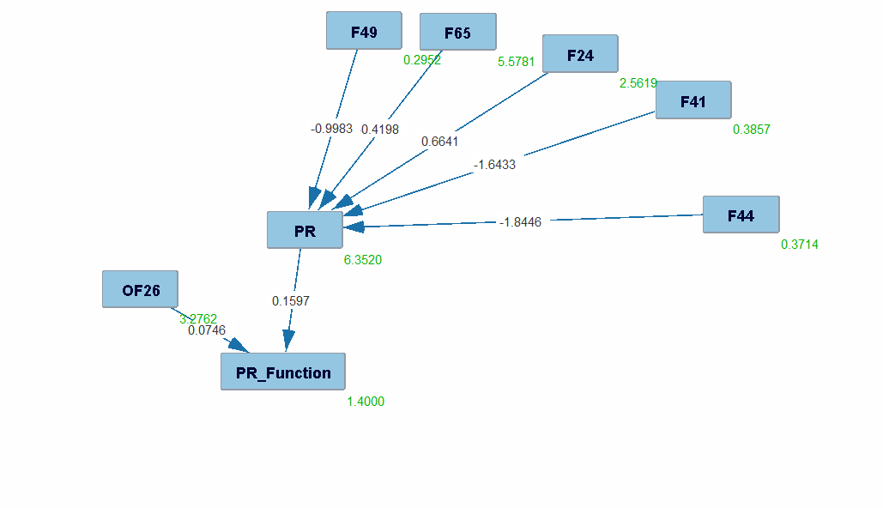

**Note**:

Tier 3 knowledge, PC-MN algorithm, model does not fit the data

**Model 2**

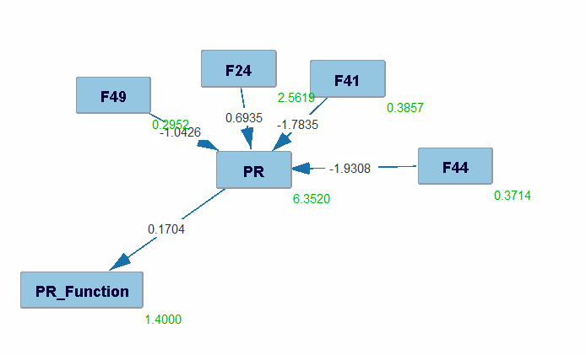

**Note**:

Tier 3 knowledge, FGES-MB algorithm, model fits the data with a chi square of 62.3631 and a p value of 1.2908E-9

Annex 3b.3.2

Images of models for phosphore retention benefit

Data from data_all_numerical_pr_benefit_reduced.xlsx

**Model 1**

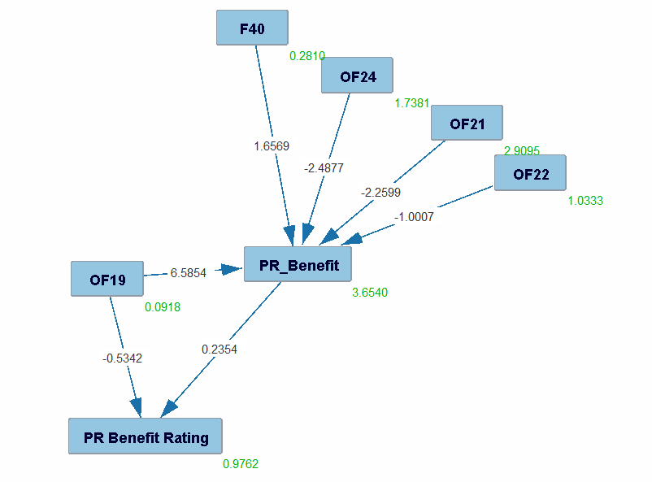

**Note**:

Tier 3 knowledge, PC-MN algorithm, model fits the data with a chi square of 27.2937 and a p value of 0.0176

**Model 2**

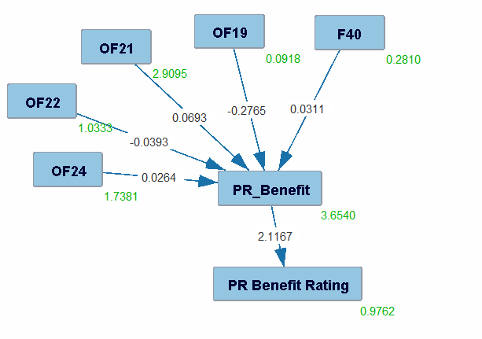

**Note**:

Tier 3 knowledge, FGES-MB algorithm, model does not fit the data

Annex 3b.4.1

Images of models for sediment retention

Data from data_all_numerical_sr_reduced.xlsx

In the model **(of22,26,27,F17,20,22,28,29,31,33,34,35,36,41,42,44,49,S5)**

**Model 1**

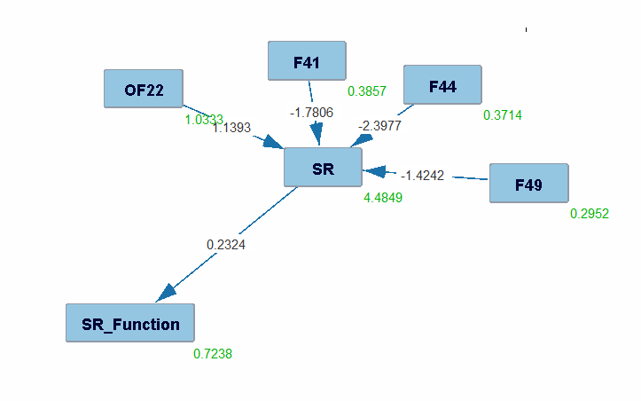

**Note**:

Tier 3 knowledge, PC-MN algorithm, model fits the data with a chi square of 50.6920 and a p value of 1.9904E-7

Annex 3b.4.2

Images of models for sediment retention benefit

Data from data_all_numerical_sr_benefit_reduced.xlsx

**Model 1**

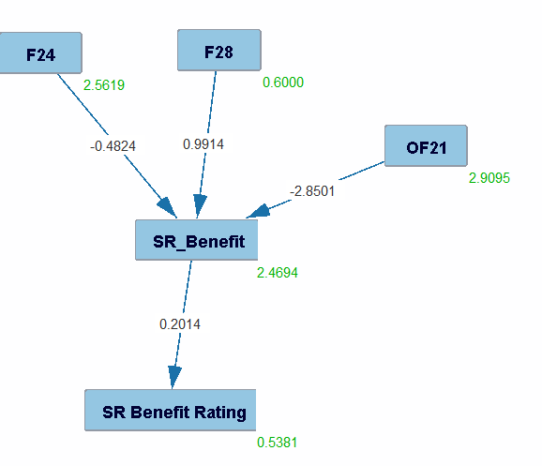

**Note**:

Tier 3 knowledge, PC-MN algorithm, model does not fit the data