Annex 1.1

Images of models for water retention

Data from data_ra_norm_filled_wr.xlsx

**Model 1**

NoMo entry, No knowledge, PC model, graph, PM, Estimator, Custom graph

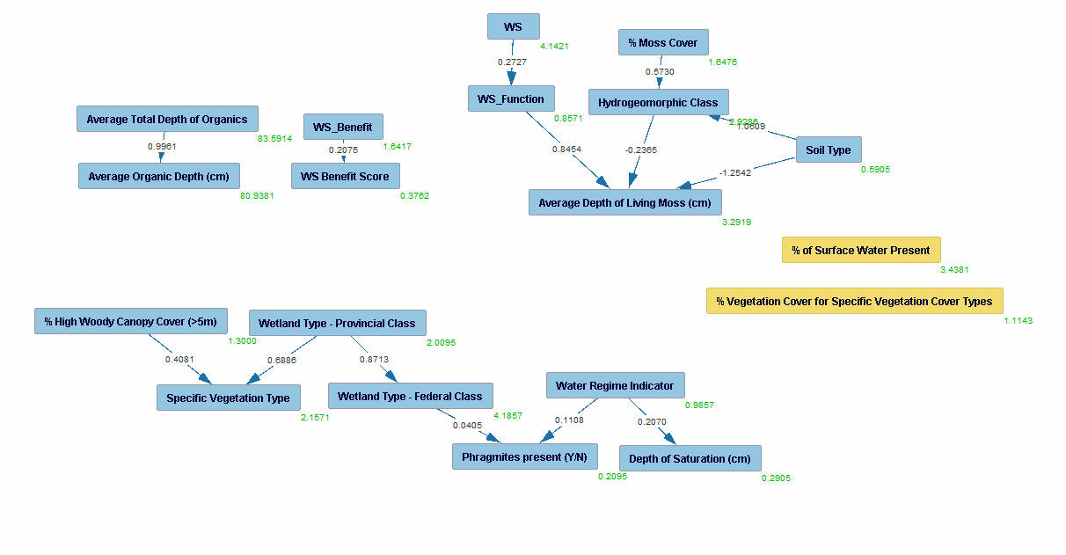

**Note**:

- Unused variables

-Cause->Effet (e.g WS causing avg depth)

**Model 2**

NoMo entry, knowledge (2) tiers, PC model, graph, PM, Estimator, Custom graph

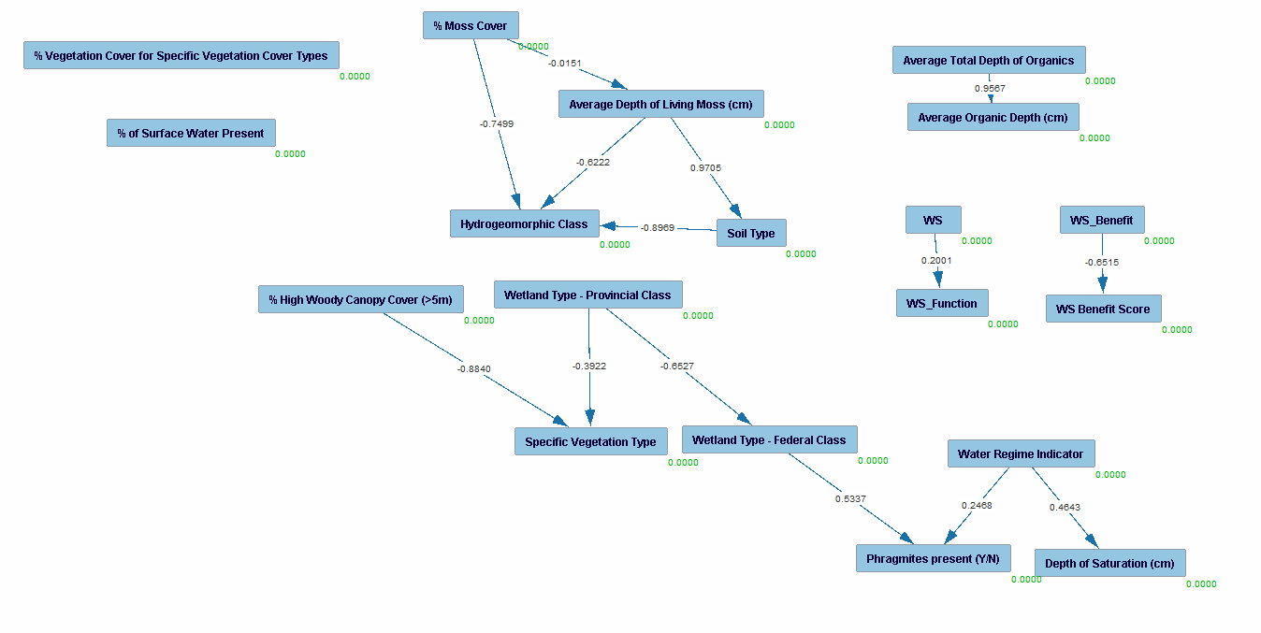

**Note**:

- Disconnected graphs

**Model 3**

NoMo entry, knowledge (2) tiers, BOSS search, graph, PM, Estimator, Custom graph

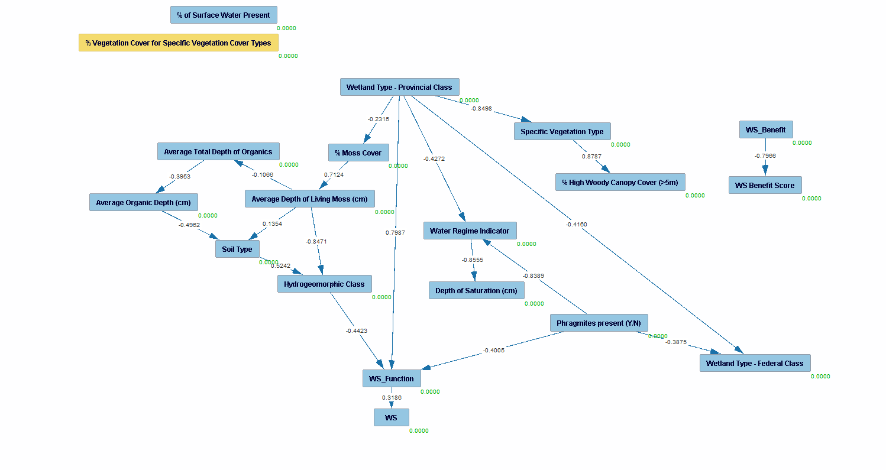

**Note**:

- Disconnected graphs (Benefit & BenScore)

-WS has good graph

-Provincial class seems to be main cause (Class should not effect, move tier)

-

**Model 3**

NoMo entry, knowledge (3) tiers, PC (1) and BOSS (2) search, graph, PM, Estimator, Custom graph

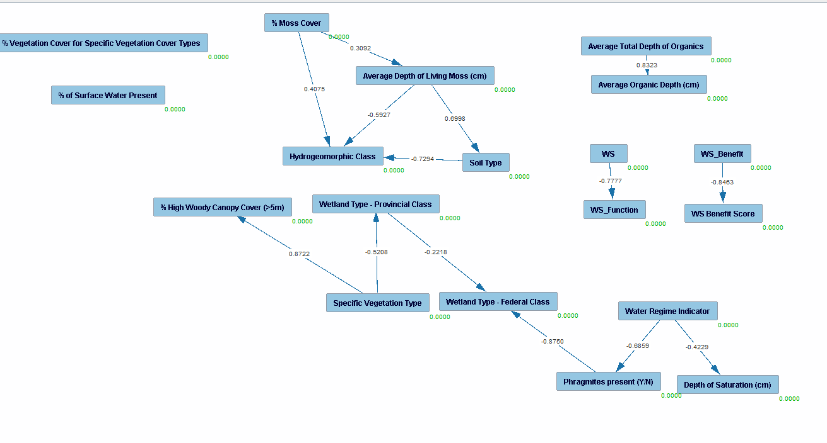

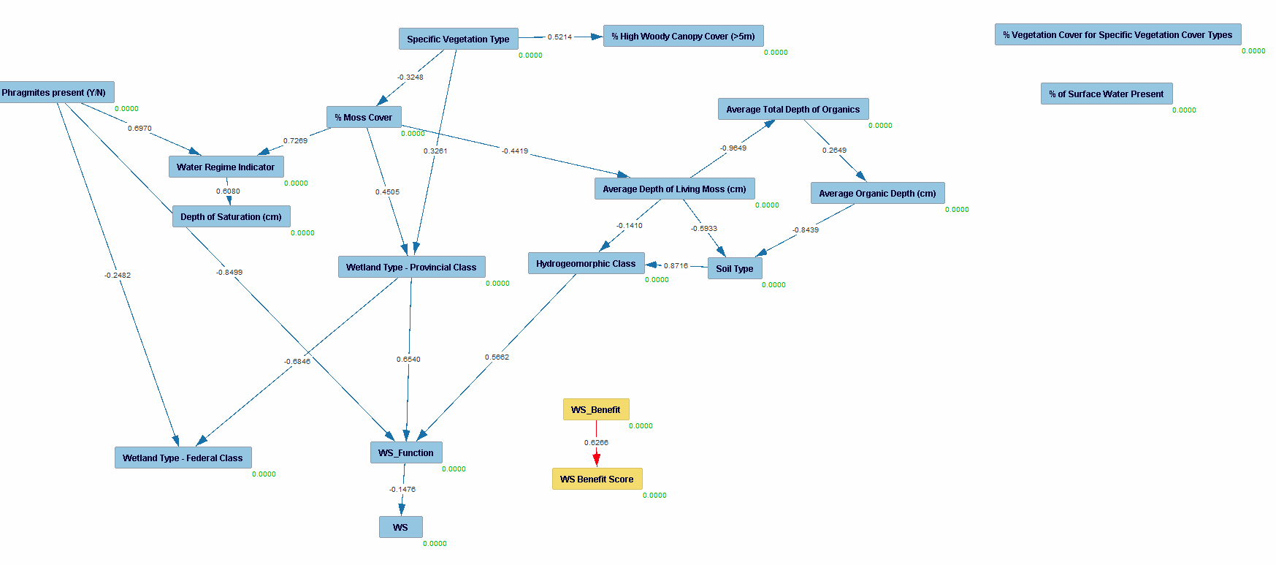

**Note**:

- Disconnected graphs (Benefit & BenScore)

-Score should not cause WS

-Highly complex

-Vegetation type and phragmites seems the main factors

**Model 4**

NoMo entry, knowledge (4) tiers modified with score-function tiers, PC (1) and BOSS (2) search, graph, PM, Estimator, Custom graph

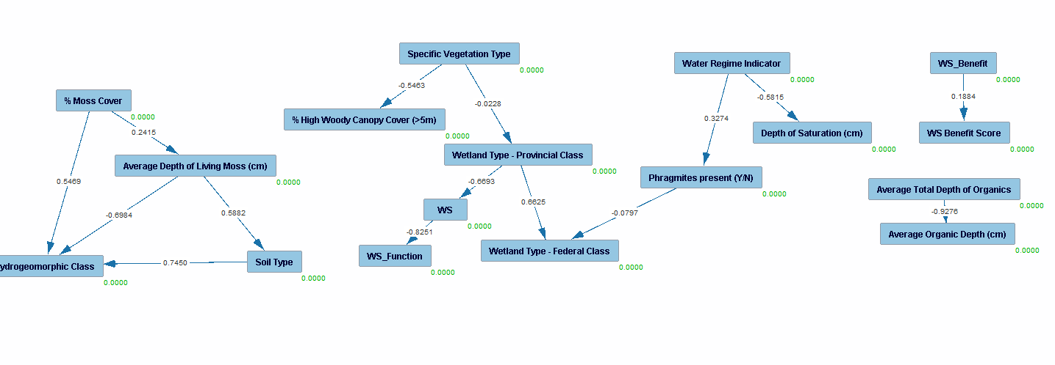

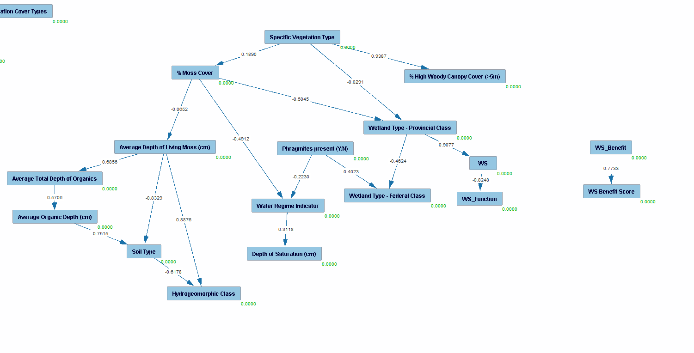

**Note**:

- Disconnected graphs (Benefit & BenScore)

-Highly complex

-Vegetation type seems to be root cause of WS

**Model 5**

NoMo entry, knowledge (4) tiers modified with score-function tiers, PC (1) and BOSS (2) search, graph, PM, Estimator, Custom graph





**Note**:

- Disconnected graphs (Benefit & BenScore)

-Highly complex

-Vegetation type seems to be root cause of WS

**Model 6**

NoMo entry, knowledge (4) tiers modified with score-function tiers, PC-mb with Ws as target , graph, PM, Estimator, Custom graph

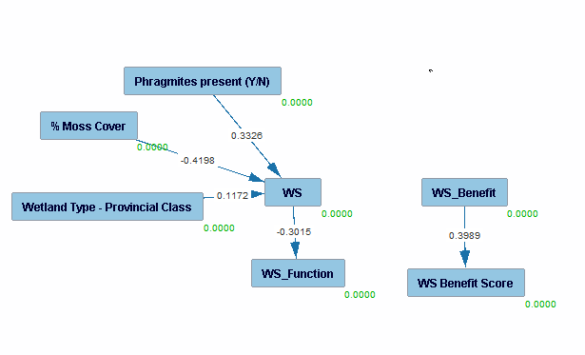

w/regression

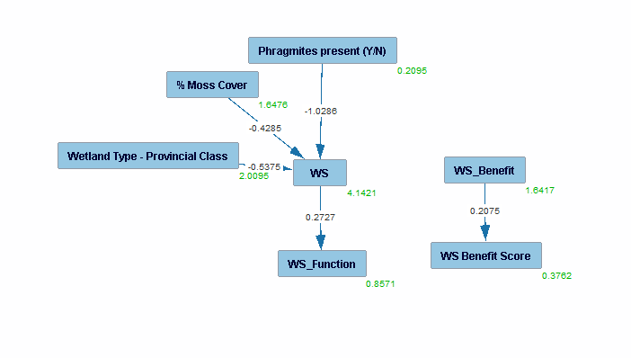

**Note**:

- Works well, isolation of target for WS

-WS_Benefit disconnected

Annex 1.2

Images of models for sediment retention

Data from data_ra_norm_filled_sr.xlsx

**Model 1**

NoMo entry, No knowledge, PC model, graph, PM, Estimator, Custom graph

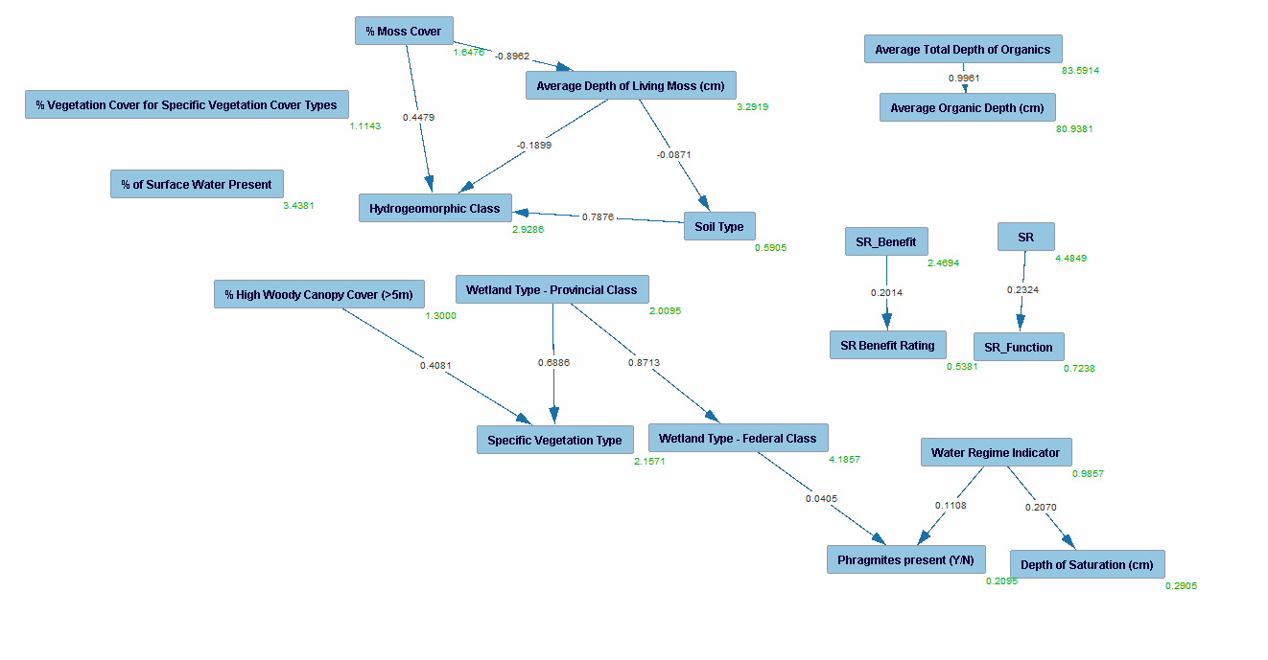

**Note**:

- Unused variables

-Disconnected SR/SR_Benefit from graph

-Chi square (782.9542), P (0.0000) meaning model fit is not adequate

**Model 2**

NoMo entry, knowledge (2) tiers, PC model, graph, PM, Estimator, Custom graph

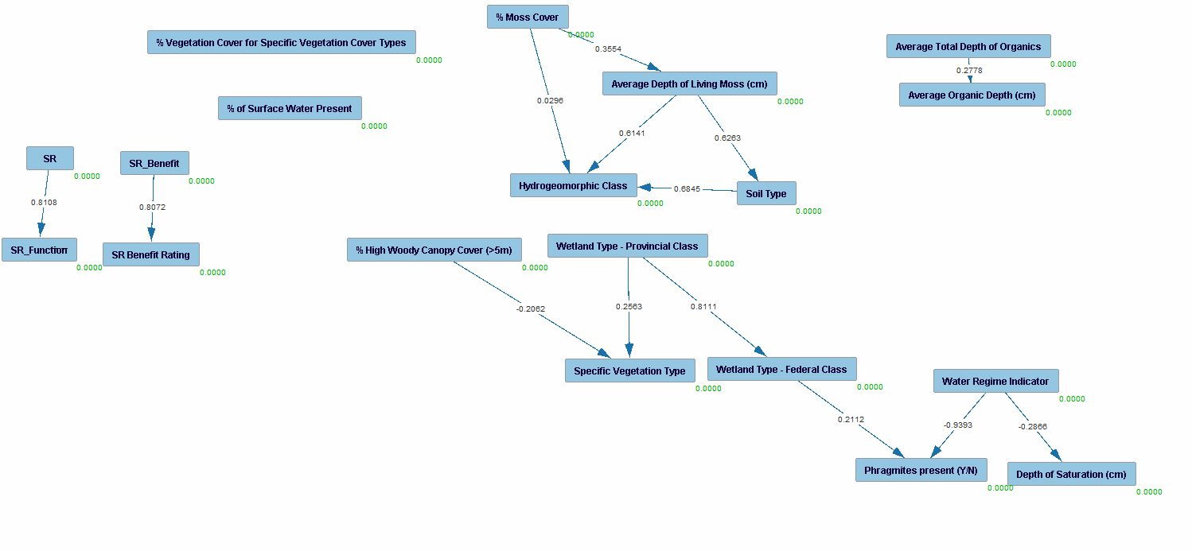

**Note**:

- Disconnected graphs

**Model 3**

NoMo entry, knowledge (2) tiers, BOSS search, graph, PM, Estimator, Custom graph

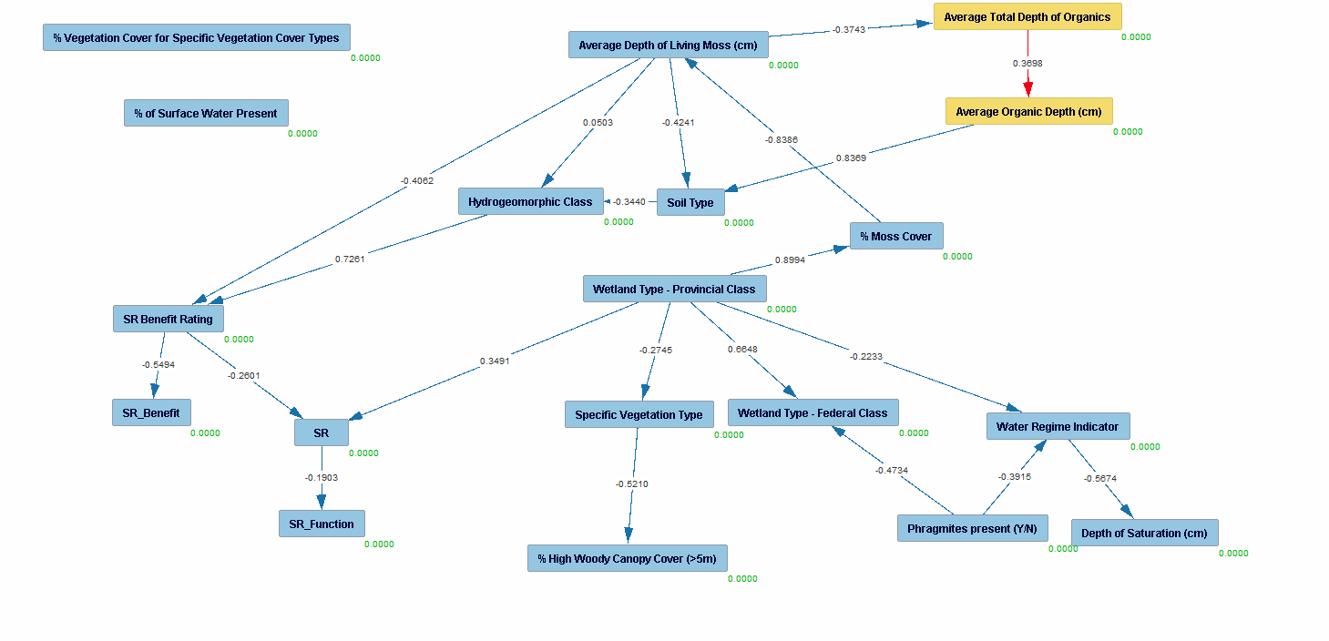

**Note**:

- Rating causing function

- Chi-square (408), P value (000) meaning the model does not fit

-

**Model 4**

NoMo entry, knowledge (3) tiers, PC (1) and BOSS (2) search, graph, PM, Estimator, Custom graph

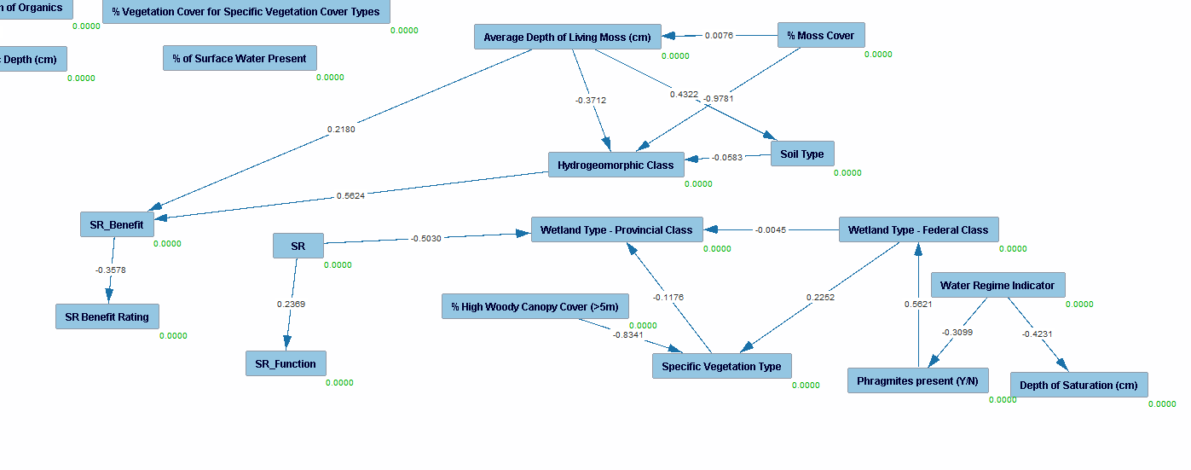

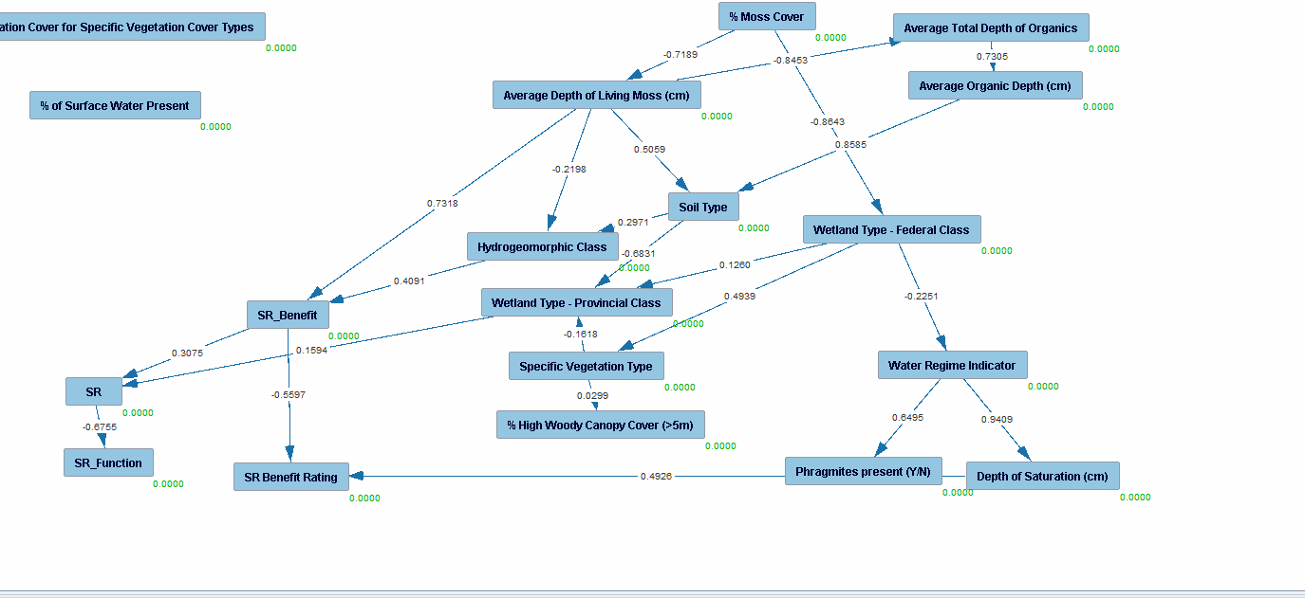

**Note**:

- SR causing Prov. Class in PC model, need additional layer

- In BOSS, SR benefit causes SR, add ban between tiers,

**Model 4**

NoMo entry, knowledge (4) tiers modified with score-function tiers, PC (1) and BOSS (2) search, graph, PM, Estimator, Custom graph

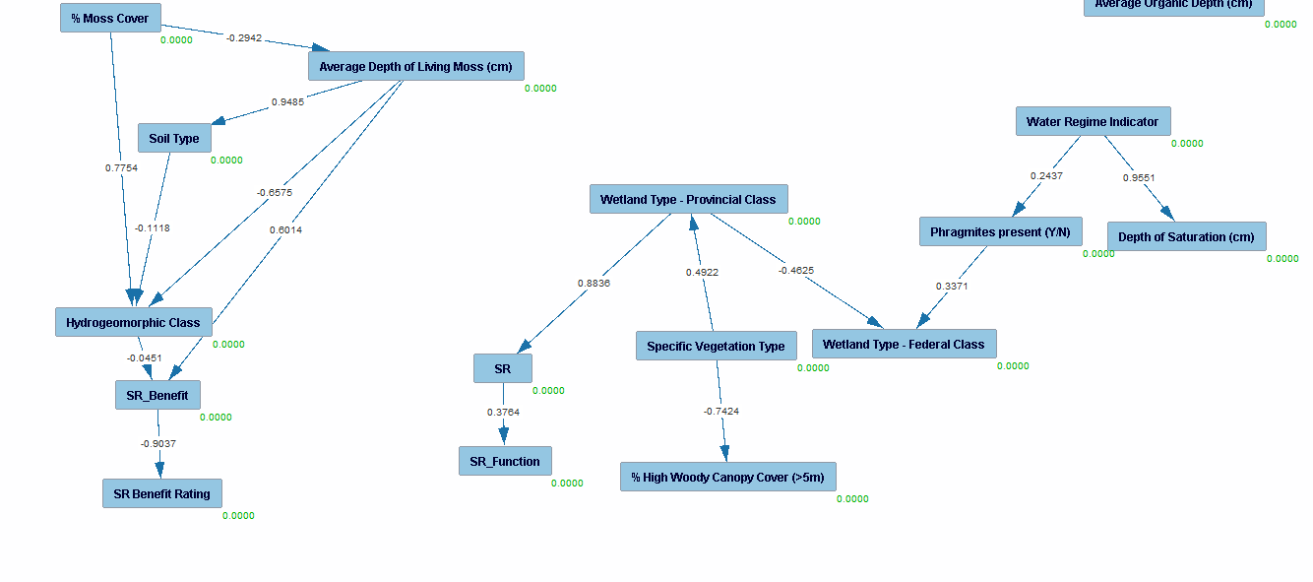

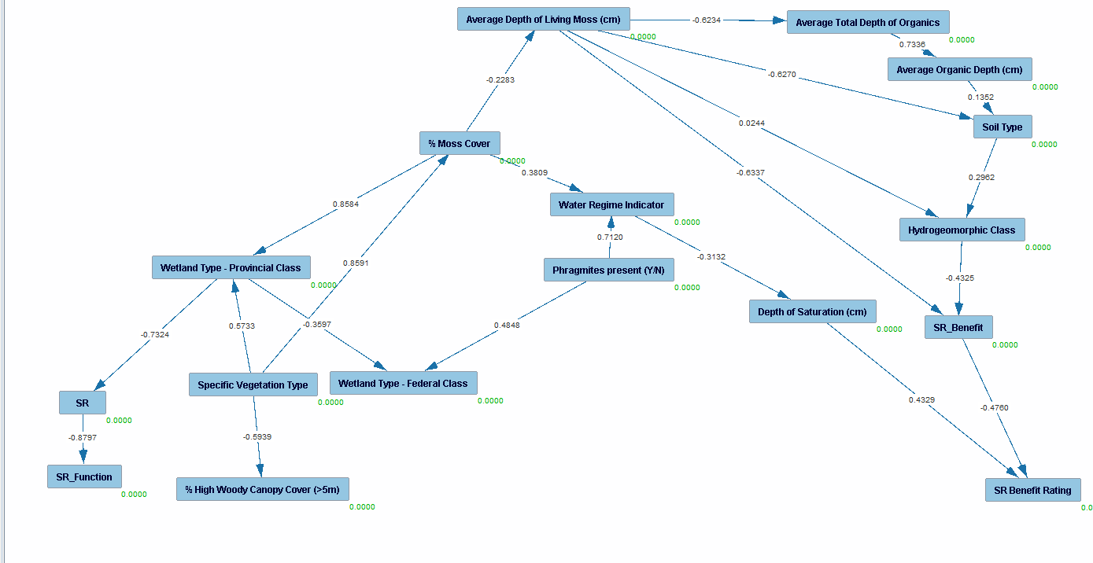

**Note**:

- In PC, Prov class causes SR alone while the hydrogeomorphic class and Avg depth of living moss causes the SR benefit

- In BOSS, the same variables cause SR and SR benefit while depth of saturation also affects the benefit rating.

-Add tier to remove this

**Model 5**

NoMo entry, knowledge (3) tiers, classes in t0, sr in t1, scores in t2, PC (1) and BOSS (2) search, graph, PM, Estimator, Custom graph

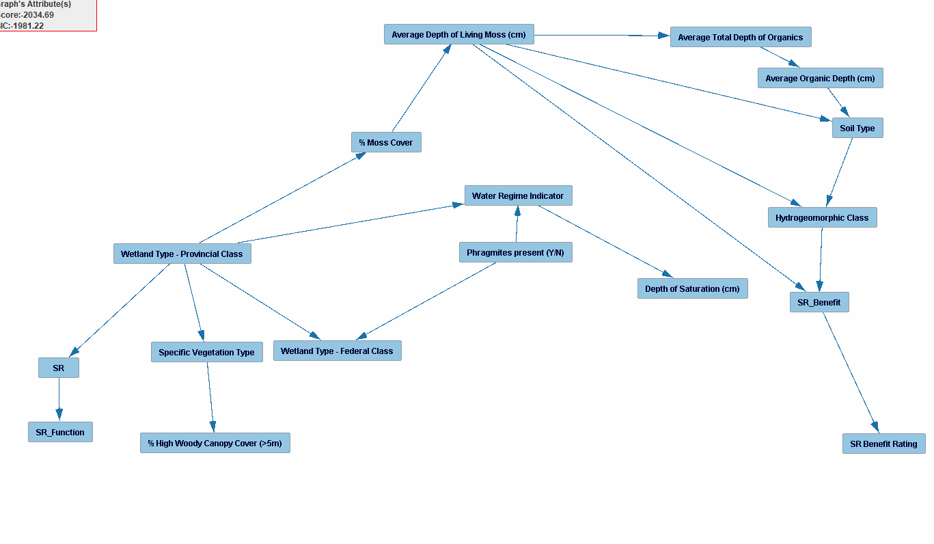

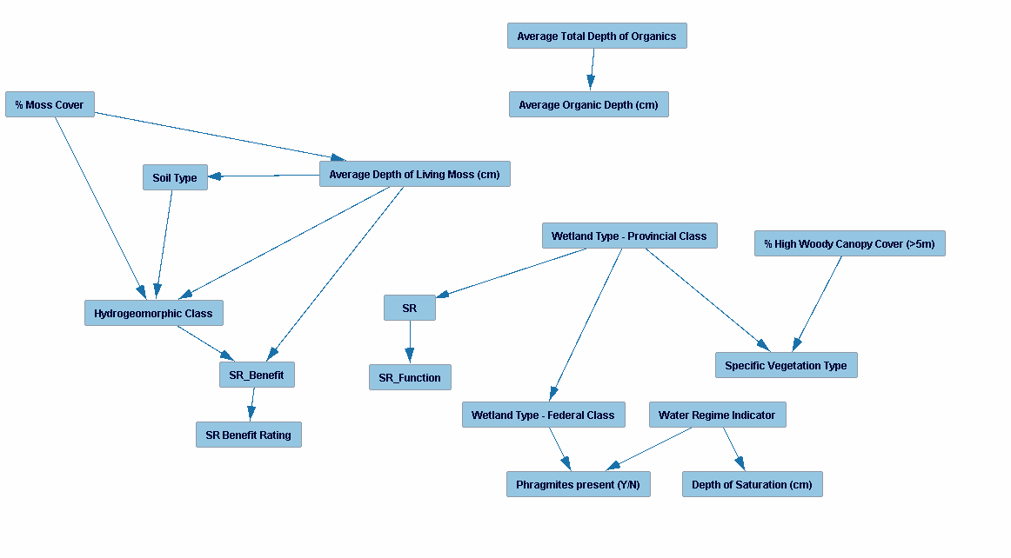

**Note**:

- Both SR and SR benefit have realistic paths

-High chi square, nil Po value, model does not fit data

**Model 6**

NoMo entry, knowledge (4) tiers modified with score-function tiers, PC-mb with Ws as target , graph, PM, Estimator, Custom graph

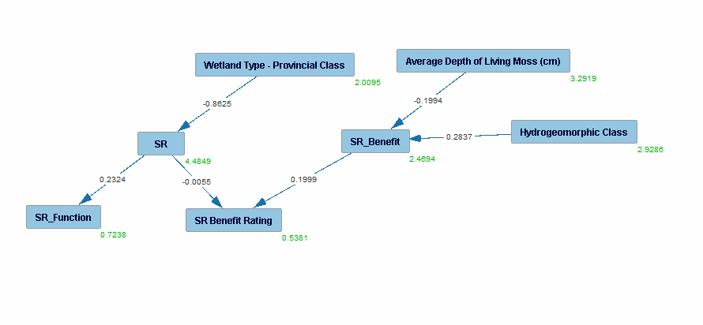

**Note**:

- Works well, isolation of target for SR and SR Benefit

-SR and SRBen affects Ben Rating which makes sense.

-Chi square (100), low **BUT** not nil po value, data as some model fit

Annex 1.3

Images of models for sediment retention

Data from data_ra_norm_filled_pr.xlsx

**Model 1**

NoMo entry, No knowledge, PC model, graph, PM, Estimator, Custom graph

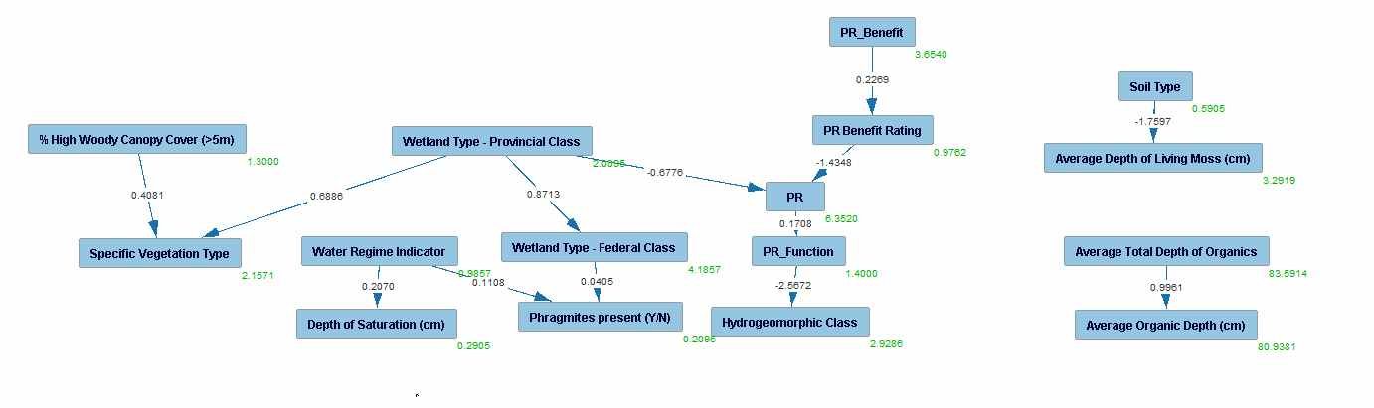

**Note**:

- Unused variables

-Pr Benefit rating causing PR

-Prov class seems to affect a lot, including PR

**Model 2**

NoMo entry, knowledge (3) tiers with ratings t3, function and class t2 and rest t1, PC model, graph, PM, Estimator, Custom graph

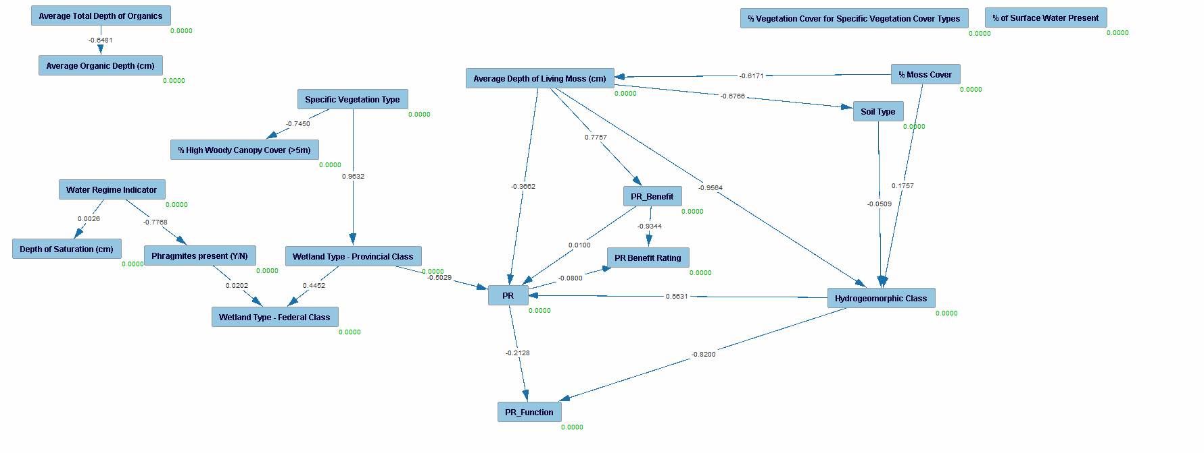

**Note**:

- Pr causes PR function and PR benefit rating while PR benefit causes Rating and PR

-Average depth of living moss seems to be an important fact

-Vegetation type also seems to be important for PR

-High Chi square, nil P value so model does not fit the data

**Model 3**

NoMo entry, knowledge (3) tiers same as model 2, BOSS search, graph, PM, Estimator, Custom graph

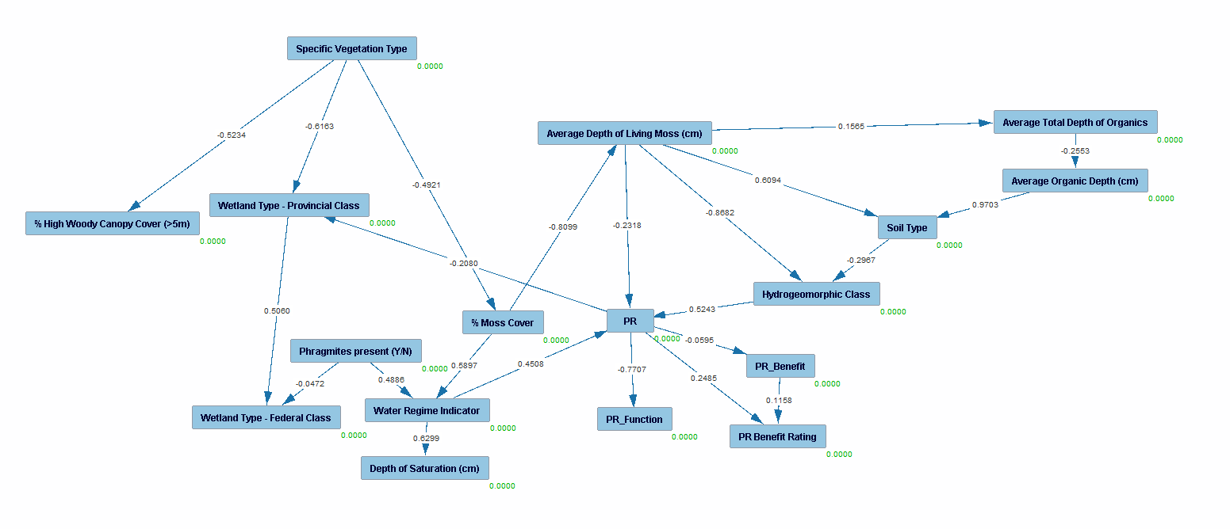

**Note**:

- Model does not fit the data

-Pr causing provincial class, need extra tier

-Similar to model 2, the vegetation type and avg depth of moss seems to be important

**Model 4**

NoMo entry, knowledge (4) tiers, FORBIDDEN between PR and benefits, PC (1) and BOSS (2) search, graph, PM, Estimator, Custom graph

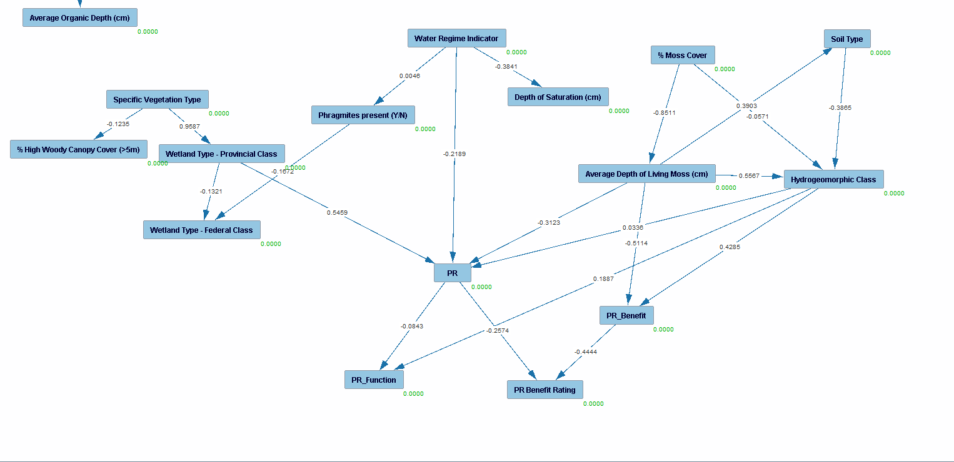

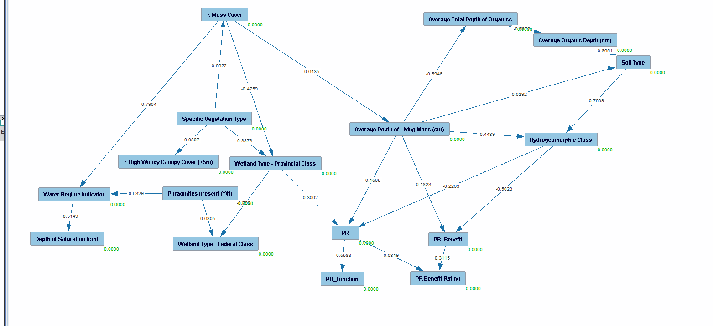

**Note**:

- Average depth of moss seems to be an important factor once again

-Hydrogeomorphic and prov class also seems to have an effect

**Model 4**

NoMo entry, knowledge (4) tiers as previous, PC-mb with Ws as target , graph, PM, Estimator, Custom graph

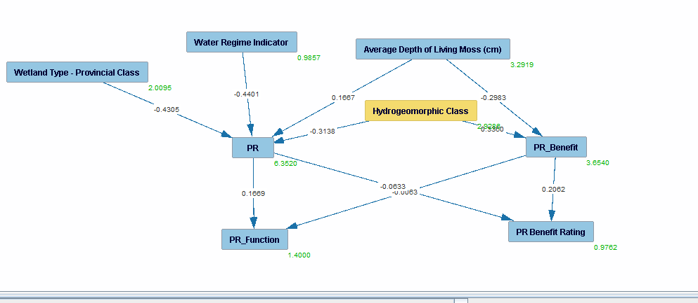

**Note**:

- Works well, isolation of target for SR and SR Benefit

-Pr and Pr benefit affect each other ratings, model 5 adresses that with forbidden

-Chi square of 152, nil p value, model does not fit the data.

**Model 5**

NoMo entry, knowledge (4) tiers as previous with forbidden, PC-mb with Ws as target , graph, PM, Estimator, Custom graph

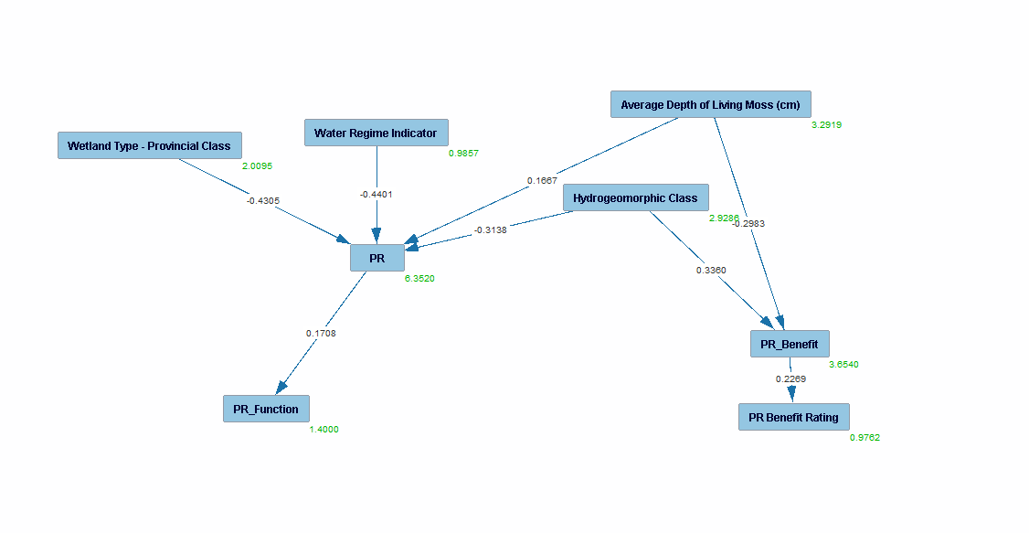

**Note**:

- Works well, isolation of target for SR and SR Benefit

-Pr and Pr benefit affect each other ratings, model 5 adresses that with forbidden

-Chi square of 229, nil p value, model does not fit the data.

Annex 1.4

Images of models for sediment retention

Data from data_ra_norm_filled_nr.xlsx

**Model 1**

NoMo entry, No knowledge, PC model, graph, PM, Estimator, Custom graph

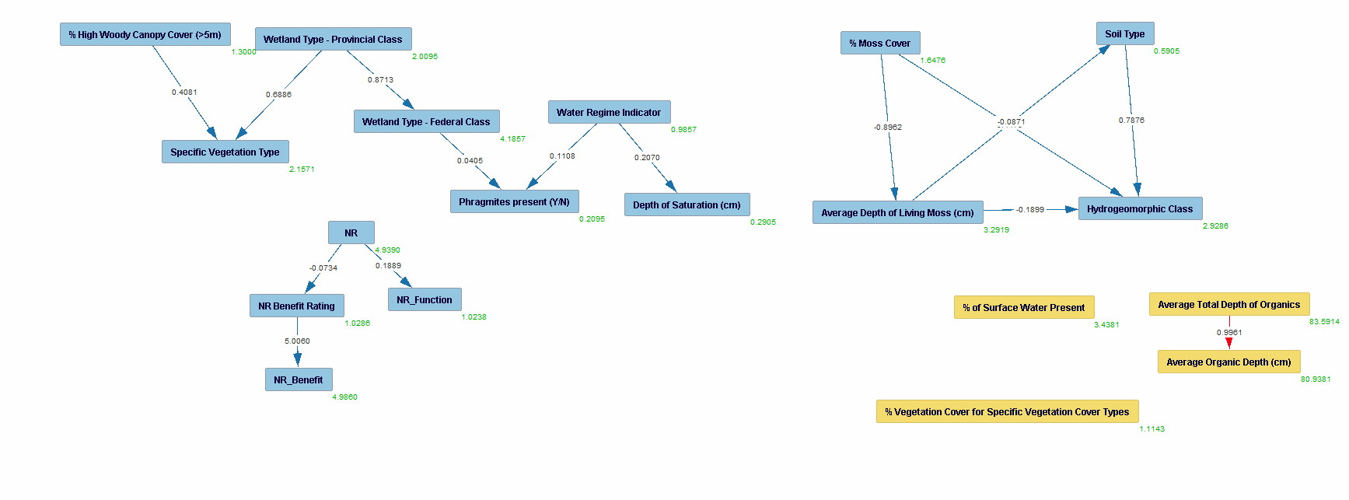

**Note**:

- Unused variables

-Disconnected SR/SR_Benefit from graph

-Chi square (785), P (0.0000) meaning model fit is not adequate

**Model 2**

NoMo entry, knowledge (2) tiers, PC model, graph, PM, Estimator, Custom graph

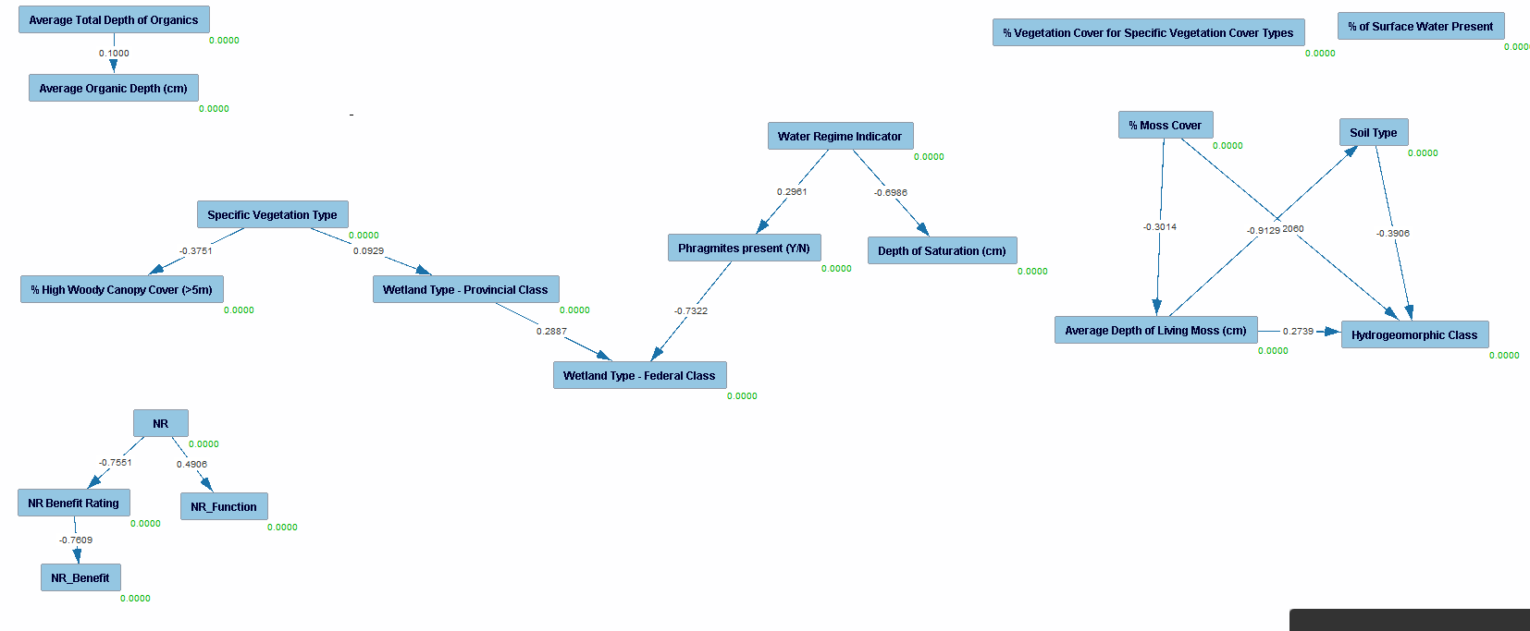

**Note**:

- Disconnected graphs

**Model 3**

NoMo entry, knowledge (2) tiers, BOSS search, graph, PM, Estimator, Custom graph

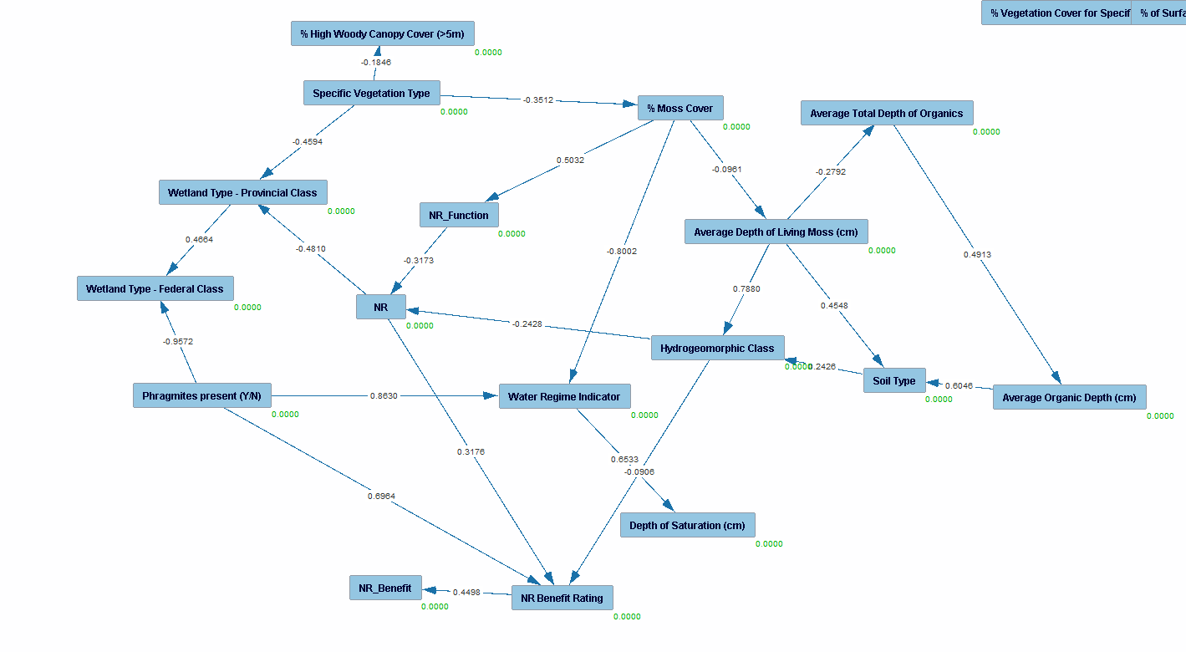

**Note**:

- Rating causing function

- Ratings/Function causing variables

-

**Model 4**

NoMo entry, knowledge (3) tiers, PC (1) and BOSS (2) search, graph, PM, Estimator, Custom graph

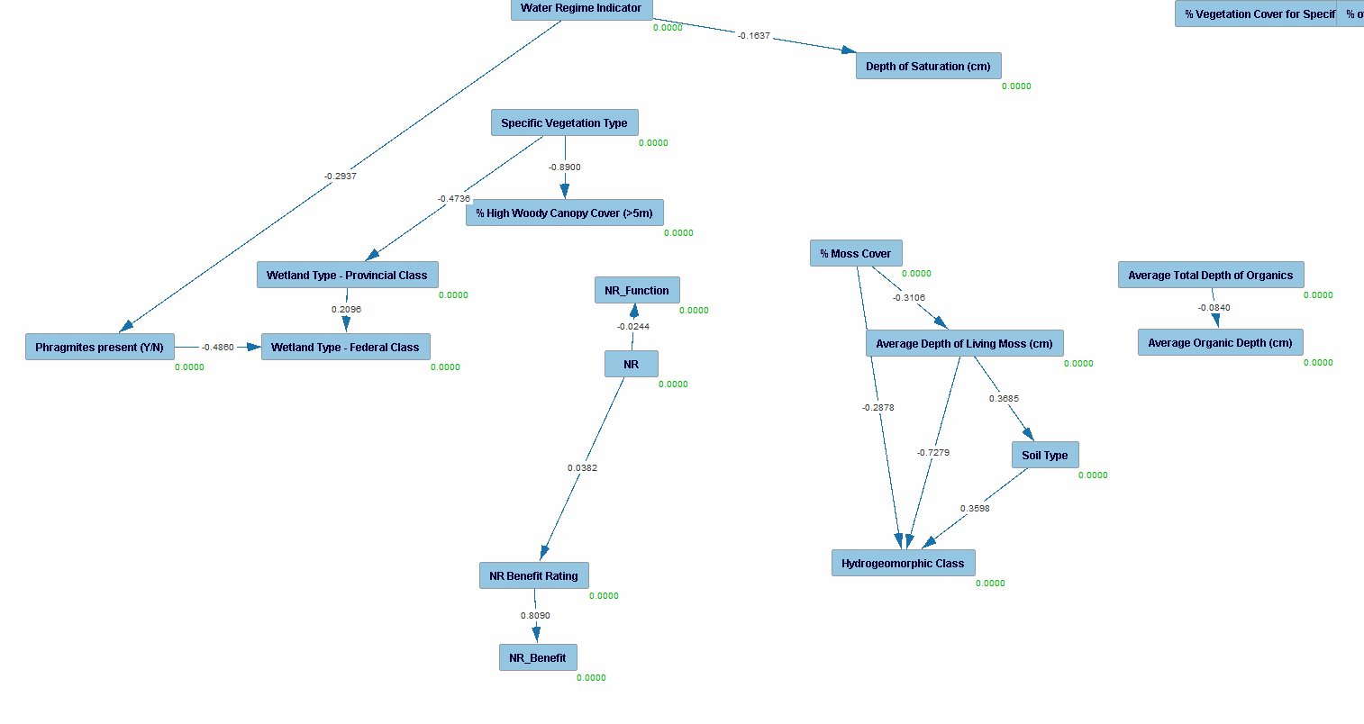

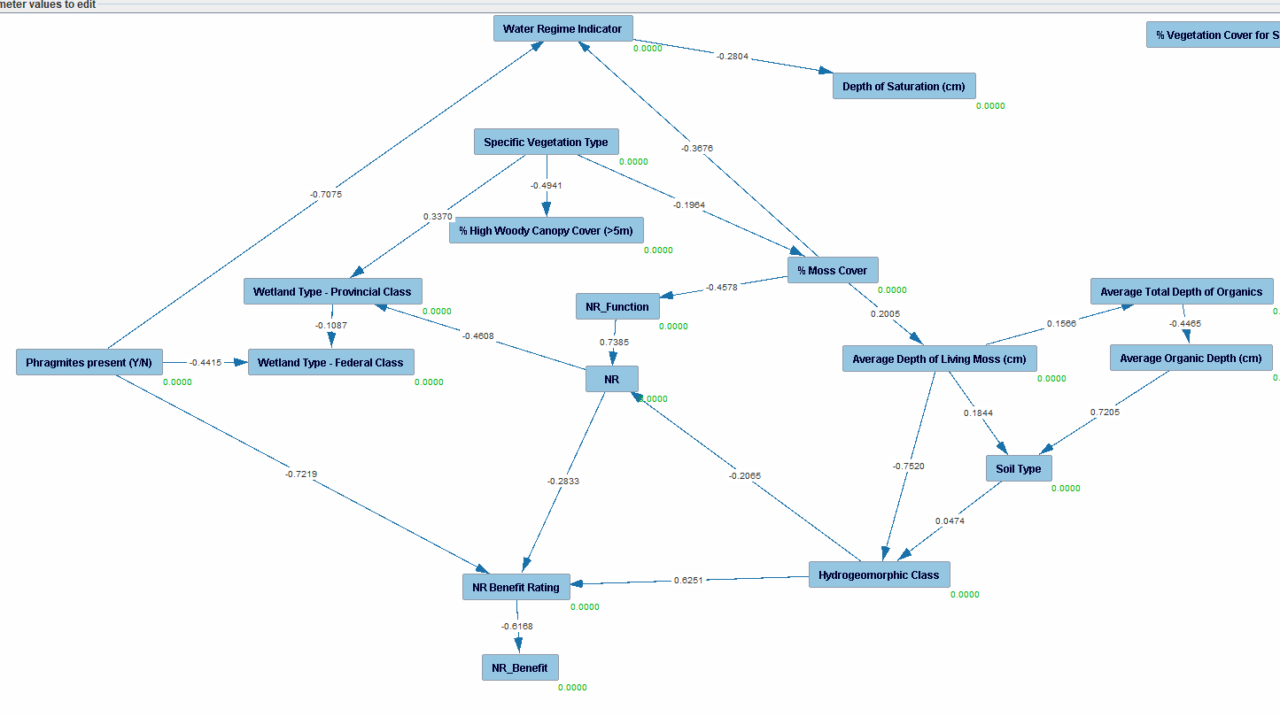

**Note**:

- PC has disconnected graph

-Boss has inversed rating causing function

-

**Model 4**

NoMo entry, knowledge (4) tiers modified with score-function tiers, PC (1) and BOSS (2) search, graph, PM, Estimator, Custom graph

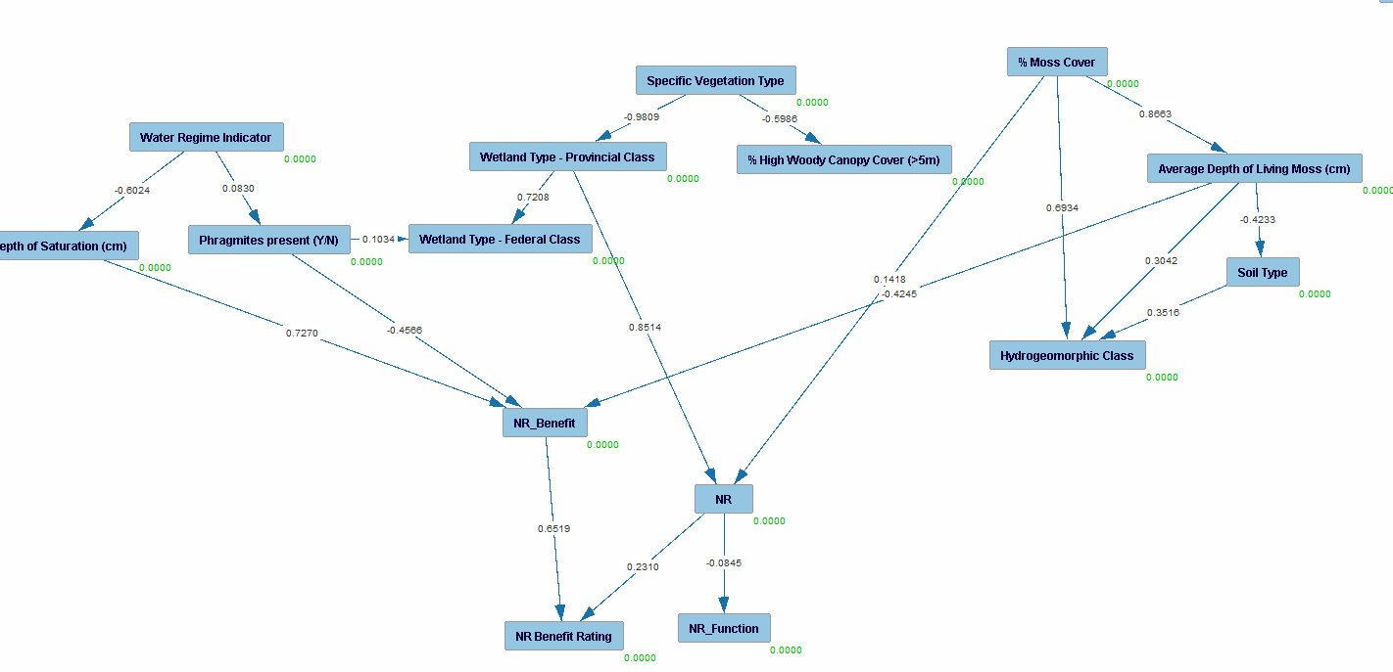

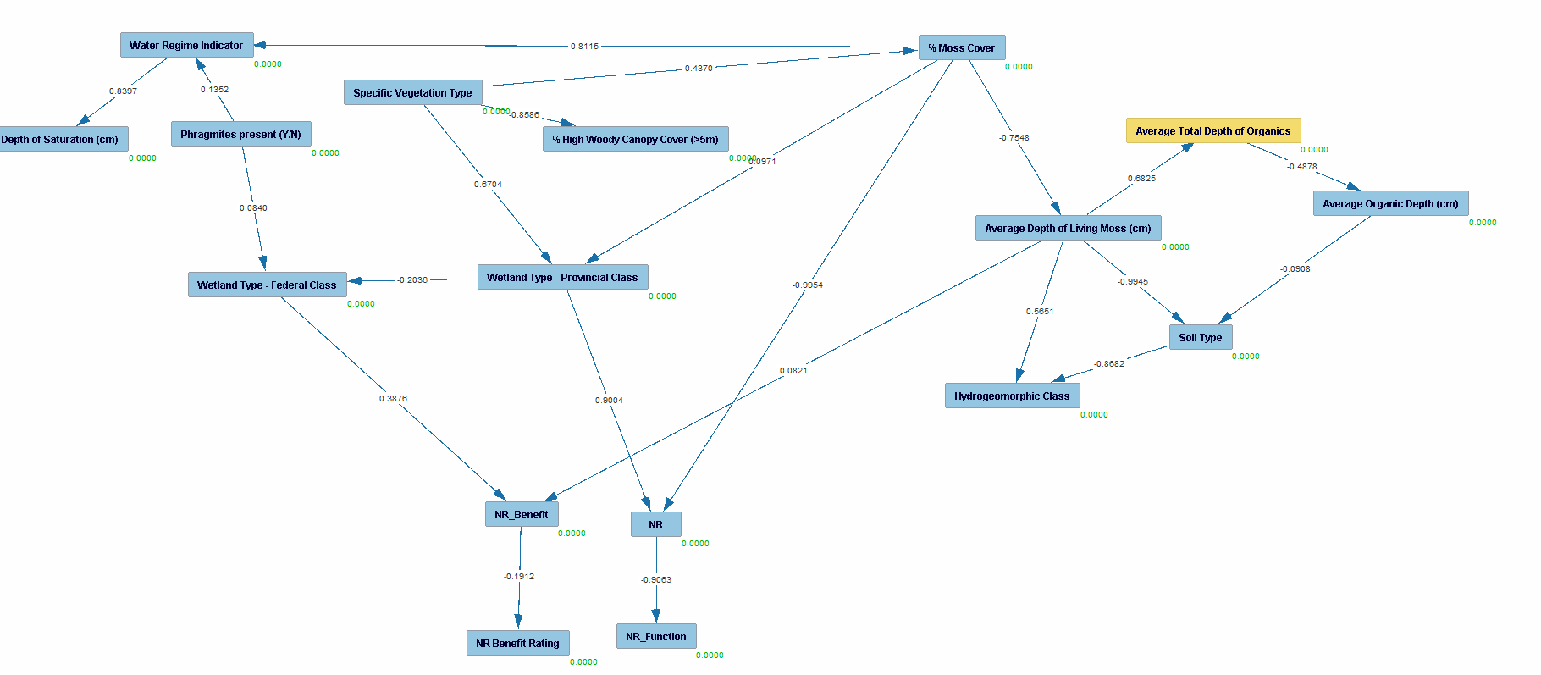

**Note**:

- Both algorithms work well and have similar structures

- Moss cover, prov class, fed class and depth of moss seems to be the most important aspects

**Model 5**

NoMo entry, knowledge (4) tiers modified with score-function tiers, PC-mb with Ws as target , graph, PM, Estimator, Custom graph

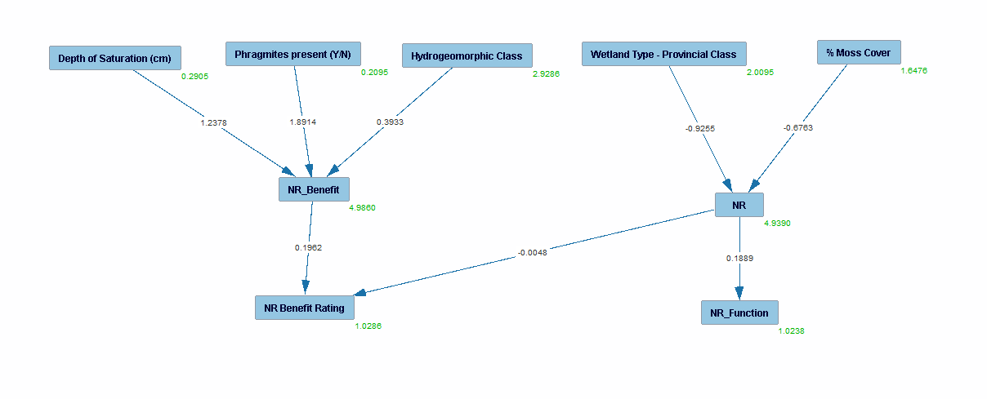

**Note**:

- Works well, isolation of target for NR and NR Benefit

-NR affects NR ben rating

-High chi square and nil p value meaning the data does not fit the model