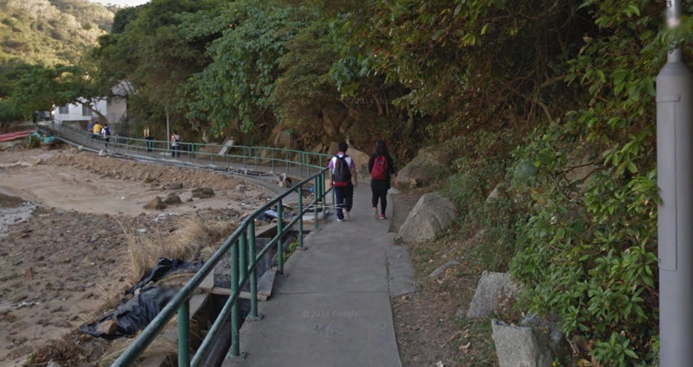
图片内容： 一条有栏杆的小径，两位穿着背包的人（一男一女）正沿着小径向前走，小径一边是树木和岩石山坡，另一边是泥泞的、似乎是干涸河床或被冲刷过的区域。

Two people to walk the rold. 错误(（https://gemini.google.com/share/08f6063f1f4f）
Two people are walking on the path.

The man are have a bag.错误 （https://gemini.google.com/share/defb8a4a8168）
The man has a bag.

The women with a red bag.错误（https://gemini.google.com/share/227f35e7df0a）
The woman is with a red bag.

参考
英语语法知识丨时态+语态
https://mp.weixin.qq.com/s?__biz=MzkyMzI4NDI1OQ==&mid=2247491772&idx=3&sn=d3853410cb126d08de9055637bd37f0d&chksm=c1e5c6f0f6924fe62ad3f4acd595e0c1957271337a08bf3f08d49281b0179fe4c1f52e7798e6&cur_album_id=3151552800406126595&scene=189#wechat_redirect

