Marc Krumbein
ps6_writeup_mak237

This assignment provides goal points to ps6_mak237 through the 'my_interesting_moves' library. The files 'my_interesting_moves.h' and 'my_interesting_moves.cpp' provide functions to pass predetermined goal positions when called in traj_action_client_ps6

Use run the following commands to run:

roslaunch cwru_baxter_sim baxter_world.launch
rosrun baxter_traj_streamer traj_interpolator_as
rosrun baxter_tools enable_robot.py -e
rosrun baxter_traj_streamer traj_action_client_pre_pose
rosrun ps6_mak237 traj_action_client_ps6

The following screenshot shows the output of “roslint” for my_interesting_moves:
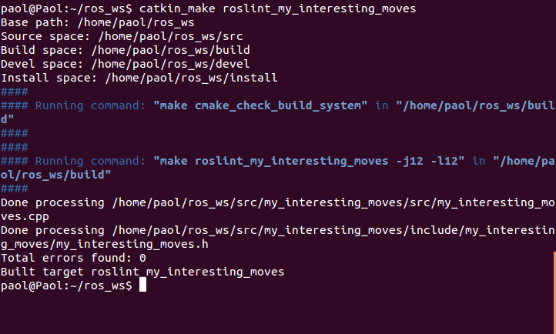

The included video ps6_mak237.mp4 demonstrates Baxter performing the aforementioned moves in the Gazebo simulator.

