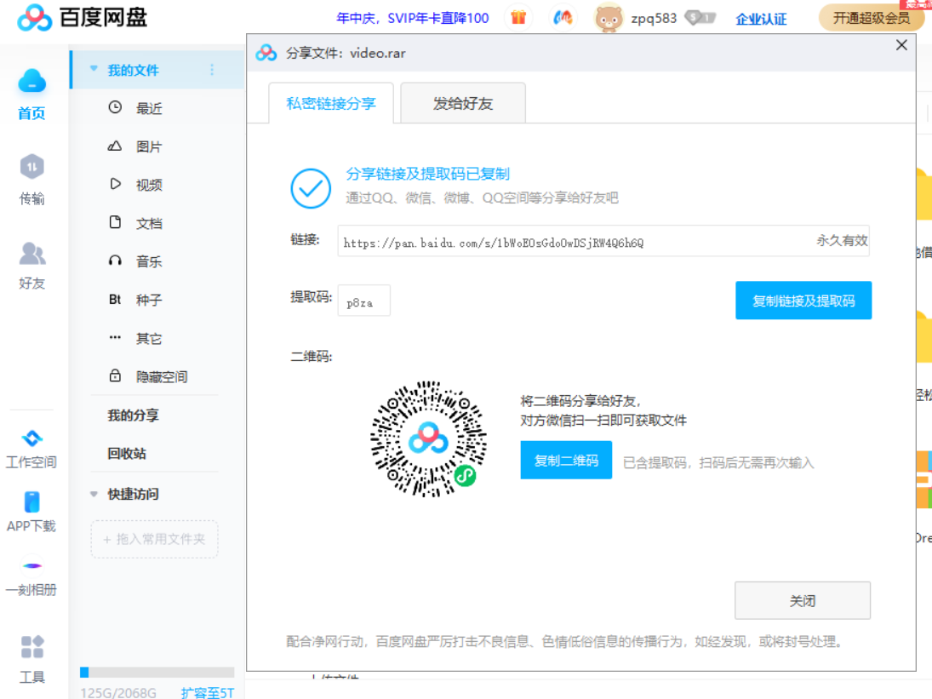

链接：https://pan.baidu.com/s/1bWoE0sGdoOwDSjRW4Q6h6Q

提取码：p8za

