Africa the new Animal Farm

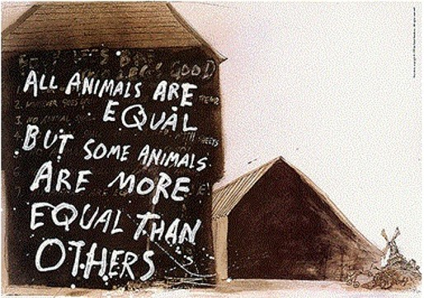

I believe that I must be one of the Africans who are proud to be born-free, not daring to dream to be a leader of my nation one day or rather a general politician. That is what our fore fathers and mothers died for in the liberation wars, they were fighting for our freedom. Yet their fellow brothers and sisters who were privileged to survive the war are now dimming themselves more equal than others. Who am I not to be grateful for the selfless gesture taken by the liberation war fighters towards a free Africa? Just like in [George Orwell](https://www.google.com/search?client=firefox-b-d&sa=X&q=George+Orwell&stick=H4sIAAAAAAAAAOPgE-LWz9U3MDSsMK4sKFfiAHGMTZKKtYyyk6300zKTSzLz8xJz4kvzMstSi4pTkYSSMxKLEpNLUouskotSE0vyixax8rqn5helpyr4F5Wn5uTsYGUEAI5Rh-xgAAAA&ved=2ahUKEwiWmbmstM_pAhVZXRUIHe6VASUQmxMoATAgegQIBBAD)’s novel Animal Farm .The short novel is an allegory in which animals play the roles of the Bolshevik revolutionaries and overthrow and oust the human owners of the farm, setting it up as a commune in which , at first ,all animals are equal; class and status disparities soon emerge, however, between the different animal species. The novel describes how a society’s ideologies can be manipulated and twisted by individuals in position of social and political power’ including how a utopian society is made impossible by the corrupting nature of the very power necessary to create it.

Likening the novel to Africa’s current situation we have most of its nations being ruled by those who fought for their freedom like the pigs character in animal farm. Having most of the political leaders not really politically educated but rather ruling by the fact that they fought for our freedom just like Napoleon. Being a leader is a dream that never comes to pass for the born free generation in other words you must have fought in the war for you to be one. Corruption is now the main predator of the African economy I believe this is because of lack of equality amongst Africans. Getting educated is now mandatory but is getting employed the same? It is now all about who you know for you to get a job in the area you studied or even a higher rank. I bet the liberation war fighters were promised a Wakanda technological future yet they were rewarded with what we have now. To be frank most Africans enjoy their right to food and water a few months before each election when those who fought in the war are campaigning to rule the nation during the next ruling term. Most of the campaign speeches have the same content mainly of how we got our freedom through fighting. I mean, are we not supposed to be looking up for ideas to preserve the freedom we attained .Instead of getting food which will last us for the remaining months before I thrust my ballot, why can we not get boreholes drilled, irrigation schemes put in place and maybe a platform for young entrepreneurs to shine. The leaders who were leading Africa’s nations are still on the same position as the year I was born. Most Africans have known their president to be one person form the day they were born. It’s like for you to be a leader you must have fought for Africa’s freedom. Which is leading our economy into the drain. We never have new ideas being discussed we are grateful for the freedom we got but I believe Africa is the new Wakanda only if we implement fair and just behaviours when we are dealing with our nation. Like in the novel the other animals working hard for a less food ration than before, boxer is one of the hardest working animals. Having the other African citizens working really hard just to put a day’s meal on the table being the Boxer’s of Africa. Propaganda has taken its course maybe from a few years after our freedom was born. Like how Snowball used propaganda to install fear and manipulate the other animals in animal farm I can say the same for Africa.

For Africa to achieve a full use of is potential it needs to get rid of” we did it the other year “to we will do it again and achieve greater” spirit. The animal farm only tells our story as Africans in a clear way and it is up to us as its sons and daughters to do what is right. To stop labelling the youths as future leaders but rather leaders of today.

Written by

Constance Paidarufaro Ruvimbo Chivanga