***My African Dream***

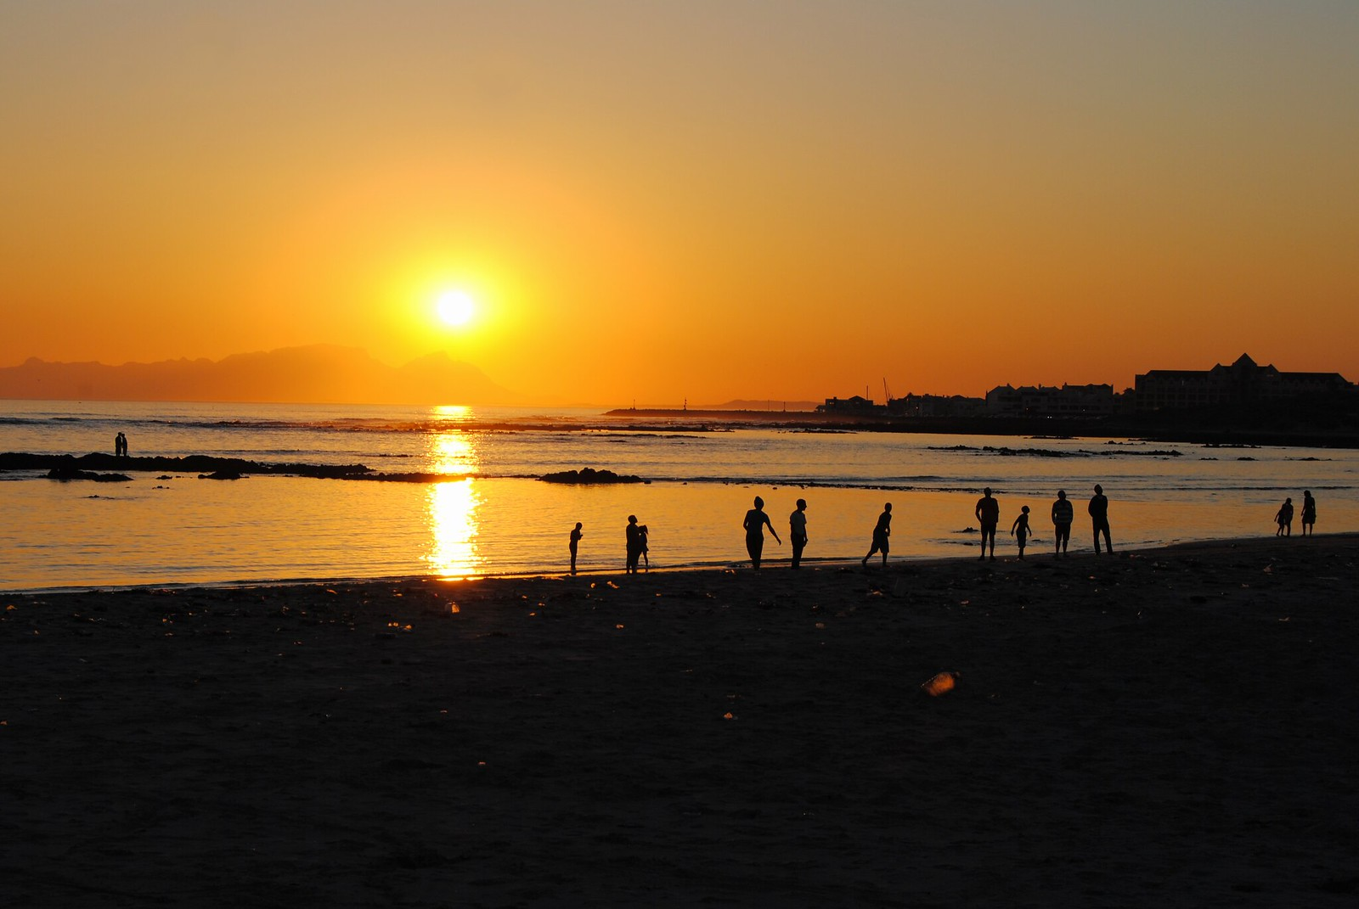

My name is Jonal , my parents gave me that name because they wanted a boy so it is from my father’s name ,Jonathan. I live in Zimbabwe in a humble town called Kadoma. It has already been forty years after Zimbabwe got its independence. They always say we were lucky to be born free but to be honest I don’t feel that way. It all dates back to when my parents got married. It was a few years after independence my mother was from a modern and rather European influenced background which believed in white weddings and one faithful partner. My grandfather who was a soldier in the Rhodesian army found it necessary to have her daughter sent off in that manner. My father’s background was the “hard mashona type “that is how they describe the cultural rooted family which saw the importance of all those African ceremonies. The two were worlds apart meeting in college were my father was on a scholarship. My mother on the other hand came from a rather comfortable uptown lifestyle where meat was a necessity. Their wedding started on a bad note and they only hoped and prayed for a brighter future like any normal couple.

It was only after my mom had moved in with my dad when she discovered that my dad was interested in having a ‘barika’ it is a Shona term for polygamy. She was not in favor of that but she could not turn down the wedding at least now since she already had two beautiful daughters. It was going to be really hard for her but she had to be strong like she was taught at church and encouraged to do. In our culture woman and children were considered wealth but we are now in a free Zimbabwe shouldn’t we accept change? My father had a lot of wives and children besides us. My mother opted out of the wedding six years after I was born.

That is when all the drama began. We both had to go to boarding schools and come home only three months of the year. My father refused to take any responsibility over us. My mother had to work really hard to keep us in school, well clothed and well fed. School was our only place of comfort. We both did well in school doing our best, working hard to live a dream every African child dreams of having. A lavish life and a happy marriage rather. We had one common goal with my sister, not being like our parents by any chance possible. I remember seeing my mother crying one day when she was on a phone call. Apparently my sister had been so obsessed with leading a normal University life and she got herself impregnated by her last nightmare, I should say. The father of the baby was just like my father. Like they always say in our culture” whatever bad you do for the other it will come back to your children” In our case it was nothing but the truth.

My sister Jane was only in her final year when her life had to make its turn. This did not just affect her but rather all of us. Like the money issues and a troublesome “mukwasha” were not enough for my mother. My father who we last heard from ten years back returned this time to only claim his lobola . The father of my sister’s unborn baby was not willing to pay lobola for my sister and he had impregnated five girls at the same time. My mother had to choose the harder life for her baby and herself. She could not send her daughter and the unborn “muzukuru” to a barika she herself could not handle.

She had to face reality and meet her baby’s final year costs and labor costs. Jane graduated and later on gave birth to a fatherless son who was apparently grand fatherless too. Our lives did not get any better my sister joined the rest of the well-educated youths of the free Zimbabwe who were rather unemployed. My sisters’ trials were not properly timed since they all took place during my final year of primary school. I had to pass and just be the best thing my mother had that year. It was honestly hard. I remember scheming a getaway plan from all these misery the world had offered us in Zimbabwe. I was studying so hard though I knew that even after getting the highest level of education I could just seat around like my sister.

I got used to pain to the extent that even after receiving the worst of news I would just smile and let it slide. Being from a divorced background was considered bad luck or rather associated with being cursed .In my case I was not just from a divorced parent’s background I had a sister who was not married but already had a baby. We were the ideal cursed family, our experience and taste of the free Zimbabwe only offered us a bitter sour taste .I was the only option for this broken home. I did pass my grade seven and made my mother the happiest African parent .I remember her screaming with joy. I did my high school at a another cheaper school than my primary school since my mother now had a lot of costs to meet. My African Dream was now in view. My mother just prayed for my success like any loving single parent. I was hoping to get a scholarship like any other African in my shoes. I got one for my University in Europe to study Civil law .My program was inspired by my background. Now my mother was freed of one burden. “Jonal toss your cap in the air you made me a proud mother. My African dream was achieved.

Written by Constance Paidarufaro Ruvimbo Chivanga