

public function cek_login() {

$data = array('username' => $this->input->post('username', TRUE),

'password' => md5($this->input->post('password', TRUE))

);

$this->load->model('mPengguna'); // load model mPengguna

$hasil = $this->mPengguna->cek_user($data);

if ($hasil->num_rows() == 1) {

foreach ($hasil->result() as $sess) {

$sess_data['logged_in'] = 'Sudah Loggin';

$sess_data['username'] = $sess->username;

$sess_data['password'] = $sess->password;

$sess_data['hakakses'] = $sess->hakakses;

$this->session->set_userdata($sess_data);

}

if ($this->session->userdata('hakakses')=='1') {

redirect('cWelcomeAdmin');

}

elseif ($this->session->userdata('hakakses')=='0') {

redirect('cWelcomeUser');

}

} else {

echo "<script>alert('Gagal login: Cek username, password!');history.go(-1);</script>";

}

}

public function logout() {

$this->session->unset_userdata('username');

$this->session->unset_userdata('hakakses');

session_destroy();

redirect('welcome');

}

**HAK AKSES ADMIN**

->beranda



<?php

if ($this->session->userdata('hakakses')==="1") {

?>

<!-- Navigation -->

<nav class="navbar navbar-inverse" role="navigation">

<div class="container-fluid">

<!-- Brand and toggle get grouped for better mobile display -->

<div class="navbar-header">

<button type="button" class="navbar-toggle" data-toggle="collapse" data-target="#navbar1">

<span class="sr-only">Toggle navigation</span>

<span class="icon-bar"></span>

<span class="icon-bar"></span>

<span class="icon-bar"></span>

</button>

<p class="navbar-brand">Penjadwalan Shift</a>

</div>

<!-- Top Menu Items -->

<div class="collapse navbar-collapse" id="navbar1">

<ul class="nav navbar-nav">

<li class="dropdown"><a href="http://wisata-sengkaling.com/home">Sengkaling food festival</a></li>

<li class="dropdown">

<a href="#" class="dropdown-toggle" data-toggle="dropdown"><i class="fa fa-user"></i> Jadwal <b class="caret"></b></a>

<ul class="dropdown-menu message-dropdown">

<li><a href="<?php echo site_url('cWelcomeAdmin/index') ?>">Semua Pegawai</a></li>

<li><a href="<?php echo site_url('cWelcomeAdmin/indexHarianTetap') ?>">Harian Tetap</a></li>

<li><a href="<?php echo site_url('cWelcomeAdmin/indexHarianKontrak') ?>">Harian Kontrak</a></li>

<li class="divider"></li>

<li><a href="<?php echo site_url('cWelcomeAdmin/indexHarianLepas') ?>">Harian Lepas</a></li>

</ul>

</li>

<li class="dropdown">

<a href="#" class="dropdown-toggle" data-toggle="dropdown"><i class="fa fa-user"></i> System <b class="caret"></b></a>

<ul class="dropdown-menu alert-dropdown">

<li><a href="<?php echo site_url('cPegawai/index') ?>">Pegawai</a></li>

<li><a href="<?php echo site_url('cJam/index') ?>">Jam</a></li>

<li><a href="<?php echo site_url('cHari/index') ?>">Hari</a></li>

<li class="divider"></li>

<li><a href="<?php echo site_url('cjadwal/index') ?>">Penjadwalan<span class="sr-only">(current)</span></a></li>

</ul>

</li>

<li class="dropdown">

<a href="#" class="dropdown-toggle" data-toggle="dropdown"><i class="fa fa-user"></i>

<?php echo "ADMIN"; ?>

<b class="caret"></b></a>

<ul class="dropdown-menu">

<li><a href="<?php echo site_url('welcome/logout') ?>">Log Out<span class="sr-only">(current)</span></a></li>

</ul>

</li>

</ul>

</div>

</div>

</nav>

<?php

} else {

?>

<!-- Navigation -->

<nav class="navbar navbar-inverse navbar-fixed-top" role="navigation">

<!-- Brand and toggle get grouped for better mobile display -->

<div class="navbar-header">

<button type="button" class="navbar-toggle" data-toggle="collapse" data-target=".navbar-ex1-collapse">

<span class="sr-only">Toggle navigation</span>

<span class="icon-bar"></span>

<span class="icon-bar"></span>

<span class="icon-bar"></span>

</button>

</div>

<!-- Top Menu Items -->

<ul class="nav navbar-right top-nav">

<li class="dropdown"><a href="http://wisata-sengkaling.com/home">Sengkaling food festival</a></li>

<?php

if ($this->session->userdata('hakakses')==="0") {

?>

<li class="dropdown"><a href="<?php echo site_url('cWelcomeUser/index') ?>">Jadwal Shift</a></li>

<li class="dropdown">

<a href="#" class="dropdown-toggle" data-toggle="dropdown"><i class="fa fa-user"></i> System <b class="caret"></b></a>

<ul class="dropdown-menu alert-dropdown">

<li><a href="<?php echo site_url('cPegawai/index') ?>">Edit Profile</a></li>

</ul>

</li>

<li class="dropdown">

<a href="#" class="dropdown-toggle" data-toggle="dropdown"><i class="fa fa-user"></i>

<?php echo $sal; ?>

<b class="caret"></b></a>

<ul class="dropdown-menu">

<li><a href="<?php echo site_url('welcome/logout') ?>">Log Out<span class="sr-only">(current)</span></a></li>

</ul>

</li>

<?php

}

?> <?php

if ($this->session->userdata('hakakses')==="") {

?>

<li class="dropdown">

<a href="#" class="dropdown-toggle" data-toggle="dropdown"><i class="fa fa-user"></i> System <b class="caret"></b></a>

<ul class="dropdown-menu alert-dropdown">

<li><a href="<?php echo site_url('cPegawai/index') ?>">Edit Profile</a></li>

</ul>

</li>

<li class="dropdown">

<a href="#" class="dropdown-toggle" data-toggle="dropdown"><i class="fa fa-user"></i>

<?php echo $sal; ?>

<b class="caret"></b></a>

<ul class="dropdown-menu">

<li><a href="<?php echo site_url('welcome/logout') ?>">Log Out<span class="sr-only">(current)</span></a></li>

</ul>

</li>

<?php

}

?>

</ul>

</nav>

<?php

}

?>

->System->data calon

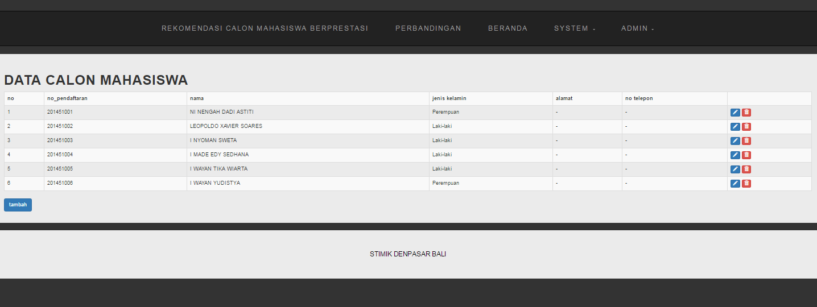

function mCalonMahasiswaLihat(){

$lihat = $this->db->get('calon_mahasiswa');

return $lihat->result();

}

->System->data calon->tambahbutton

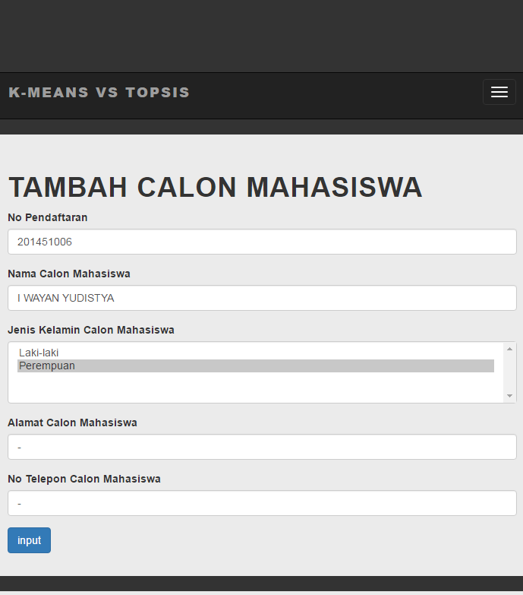

<?php

class mCalonMahasiswa extends CI_Controller{

function __construct(){

parent::__construct();

$this->load->database();

}

function mCalonMahasiswaLihat(){

$lihat = $this->db->get('calon_mahasiswa');

return $lihat->result();

}

function mCalonMahasiswaTambahAct() {

$no_pendaftaran = $this->input->post('no_pendaftaran');

$nama_calon_mahasiswa = $this->input->post('nama_calon_mahasiswa');

$alamat_calon_mahasiswa = $this->input->post('alamat_calon_mahasiswa');

$no_telepon_calon_mahasiswa = $this->input->post('no_telepon_calon_mahasiswa');

$jenis_kelamin_calon_mahasiswa = $this->input->post('jenis_kelamin_calon_mahasiswa');

$data = array (

'no_pendaftaran'=> $no_pendaftaran,

'nama_calon_mahasiswa'=> $nama_calon_mahasiswa,

'alamat_calon_mahasiswa'=> $alamat_calon_mahasiswa,

'no_telepon_calon_mahasiswa'=> $no_telepon_calon_mahasiswa,

'jenis_kelamin_calon_mahasiswa'=> $jenis_kelamin_calon_mahasiswa,

);

$this->db->insert('calon_mahasiswa', $data);

$tambah = $this->db->get('calon_mahasiswa');

return $tambah->result();

}

function mCalonMahasiswaEdit($data){

$this->db->where($data);

$edit = $this->db->get('calon_mahasiswa');

return $edit->result();

}

function mCalonMahasiswaUpdateAct($data,$no_pendaftaran){

$this->db->where('no_pendaftaran', $no_pendaftaran);

$this->db->update('calon_mahasiswa',$data);

}

function mCalonMahasiswaHapus($data){

$this->db->delete('calon_mahasiswa',$data);

}

}

?>

->System->data calon->input parameter->inputbutton

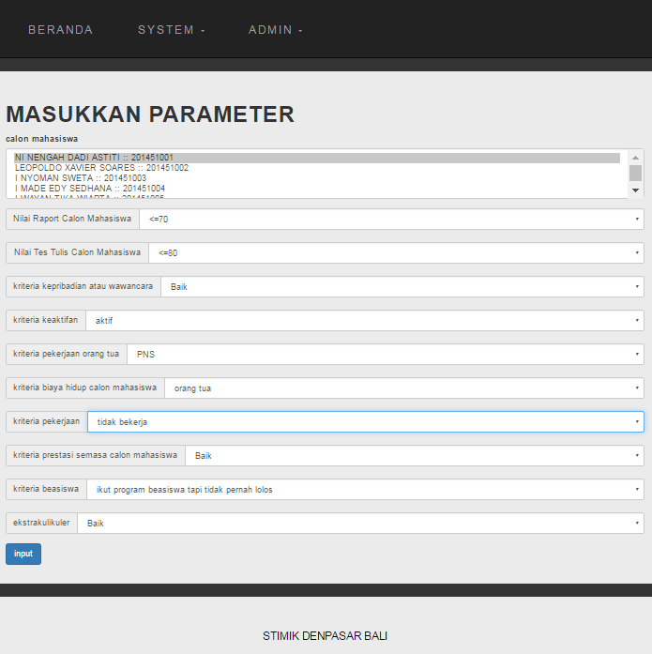

function mParameterTambahAct() {

$no_pendaftaran = $this->input->post('no_pendaftaran');

$nil_raport = $this->input->post('nil_raport');

$tes_tulis = $this->input->post('tes_tulis');

$kepribadian_wawancara = $this->input->post('kepribadian_wawancara');

$keaktifan = $this->input->post('keaktifan');

$pekerjaan_orang_tua = $this->input->post('pekerjaan_orang_tua');

$biaya_hidup_calon_mahasiswa = $this->input->post('biaya_hidup_calon_mahasiswa');

$pekerjaan = $this->input->post('pekerjaan');

$prestasi_semasa_calon_mahasiswa = $this->input->post('prestasi_semasa_calon_mahasiswa');

$beasiswa = $this->input->post('beasiswa');

$ekstrakulikuler = $this->input->post('ekstrakulikuler');

$data = array (

'no_pendaftaran' => $no_pendaftaran,

'nil_raport'=> $nil_raport,

'tes_tulis'=> $tes_tulis,

'kepribadian_wawancara' => $kepribadian_wawancara,

'keaktifan' => $keaktifan,

'pekerjaan_orang_tua' => $pekerjaan_orang_tua,

'biaya_hidup_calon_mahasiswa' => $biaya_hidup_calon_mahasiswa,

'pekerjaan' => $pekerjaan,

'prestasi_semasa_calon_mahasiswa' => $prestasi_semasa_calon_mahasiswa,

'beasiswa' => $beasiswa,

'ekstrakulikuler' => $ekstrakulikuler,

);

$this->db->insert('cluster', $data);

$tambah = $this->db->get('cluster');

return $tambah->result();

}

->System->data calon->input parameter->

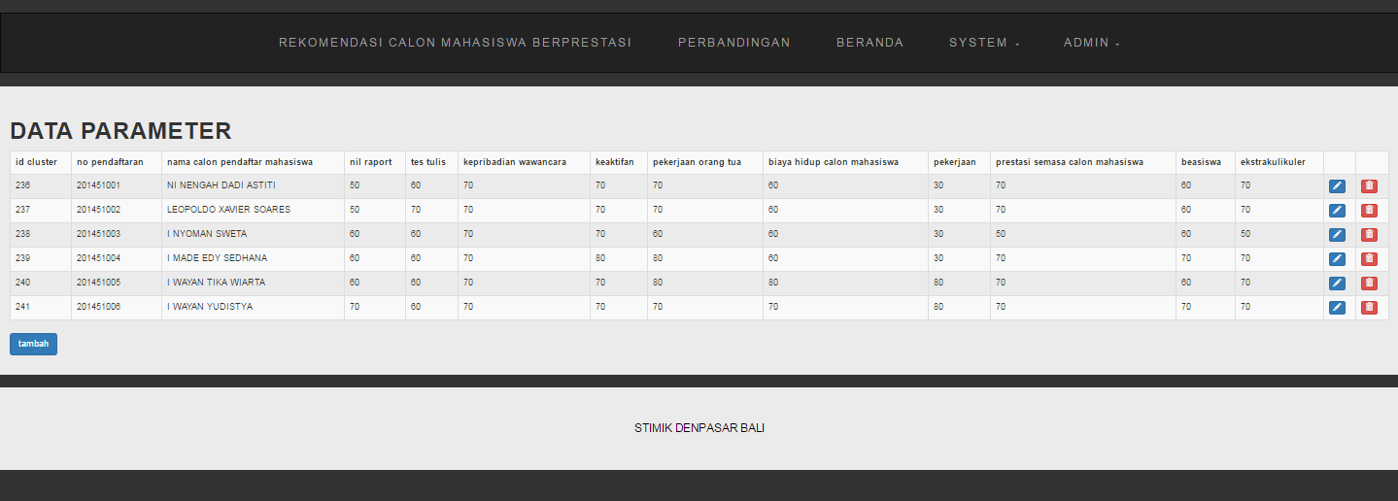

function mParameterLihat(){

$this->db->select('*');

$this->db->from('cluster');

$this->db->join('calon_mahasiswa', 'cluster.no_pendaftaran = calon_mahasiswa.no_pendaftaran' );

$this->db->order_by('cluster.id_cluster', 'asc');

$lihat = $this->db->get();

return $lihat->result();

}

->System->data calon->kriteria bobot



<?php

class mKriteria extends CI_Controller{

function __construct(){

parent::__construct();

$this->load->database();

}

function mKriteriaLihat(){

$lihat = $this->db->get('kriteria');

return $lihat->result();

}

function mKriteriaEdit($data){

$this->db->where($data);

$edit = $this->db->get('kriteria');

return $edit->result();

}

function mKriteriaUpdateAct($data,$keterangan){

$this->db->where('keterangan', $keterangan);

$this->db->update('kriteria',$data);

}

}

?>

->rekomendasi calon

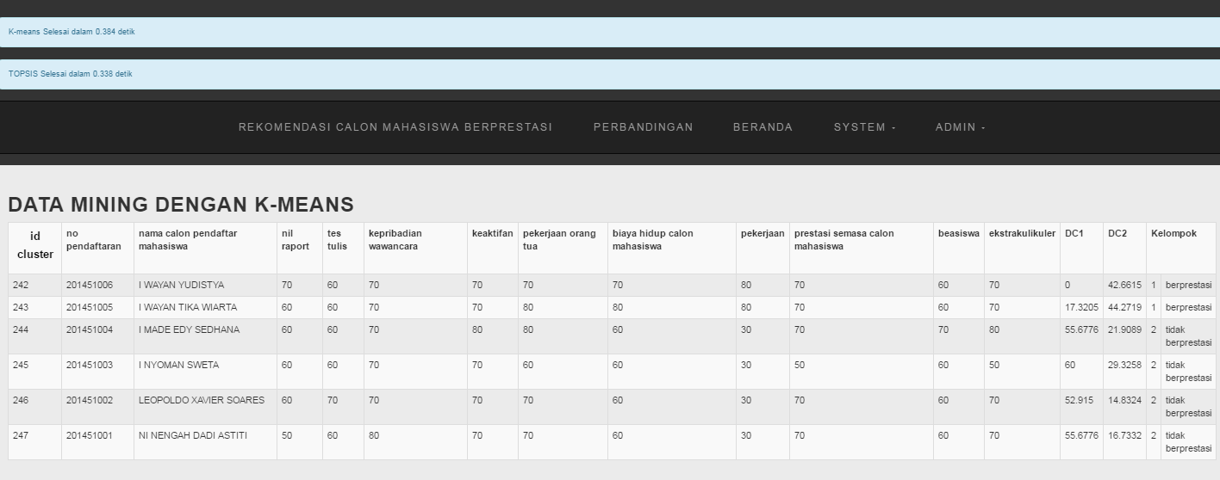

function kMeans() {

//cek jml calon mahasiswa

$queryz = $this->db->query("SELECT COUNT(*) FROM cluster") or 0;

$jmlcalon = $queryz->result();

if ($jmlcalon >= 1) {

if ($jmlcalon >= 2) {

//hitung(1, 1);

$id = 1;

$versi = 1;

if ($jmlcalon >= 3) {

//$hasil = hitung(1, 2);

$id = 1;

$versi = 2;

$urutan = 2;

while (($id == false) && ($versi == false) && ($urutan <= $jmlcalon)) {

$id = $urutan;

$versi = 2;

$urutan++;

}

}

}

}

$datano1 = 0;

$datano2 = 0;

$C1a = 0;

$C2a = 0;

$C1b = 0;

$C2b = 0;

$C1c = 0;

$C2c = 0;

$C1d = 0;

$C2d = 0;

$C1e = 0;

$C2e = 0;

$C1f = 0;

$C2f = 0;

$C1g = 0;

$C2g = 0;

$C1h = 0;

$C2h = 0;

$C1i = 0;

$C2i = 0;

$C1j = 0;

$C2j = 0;

$query1 = $this->db->query('SELECT * FROM cluster');

$no = 1;

foreach ($query1->result() as $data1) {

if ($no == 1 || $no == $id) {

if ($no == 1) {

$datano1 = $data1->id_cluster;

} else if ($no == $id) {

$datano2 = $data1->id_cluster;

}

$C1a += $data1->nil_raport;

$C1b += $data1->tes_tulis;

$C1c += $data1->kepribadian_wawancara;

$C1d += $data1->keaktifan;

$C1e += $data1->pekerjaan_orang_tua;

$C1f += $data1->biaya_hidup_calon_mahasiswa;

$C1g += $data1->pekerjaan;

$C1h += $data1->prestasi_semasa_calon_mahasiswa;

$C1i += $data1->beasiswa;

$C1j += $data1->ekstrakulikuler;

}

$no++;

}

if ($id > 1) {

$C1a = $C1a / 2;

$C1b = $C1b / 2;

$C1c = $C1c / 2;

$C1d = $C1d / 2;

$C1e = $C1e / 2;

$C1f = $C1f / 2;

$C1g = $C1g / 2;

$C1h = $C1h / 2;

$C1i = $C1i / 2;

$C1j = $C1j / 2;

}

if ($versi == 1) {

$queryjmldata2 = $this->db->query('SELECT * FROM cluster LIMIT 1,1') or 0;

$result = $queryjmldata2->row_array();

$jmldata2 = $result['COUNT(*)'];

} else {

$queryjmldata2 = $this->db->query('SELECT COUNT(*) FROM cluster WHERE id_cluster!=' . $datano1 . ' AND id_cluster!=' . $datano2) or 0;

$result = $queryjmldata2->row_array();

$jmldata2 = $result['COUNT(*)'];

}

if ($jmldata2 > 0) {

if ($versi == 1) {

$query2 = $this->db->query('SELECT * FROM cluster LIMIT 1,1');

} else {

$query2 = $this->db->query('SELECT * FROM cluster WHERE id_cluster!=' . $datano1 . ' AND id_cluster!=' . $datano2)or 0;

}

foreach ($query2->result() as $data2) {

$C2a += $data2->nil_raport;

$C2b += $data2->tes_tulis;

$C2c += $data2->kepribadian_wawancara;

$C2d += $data2->keaktifan;

$C2e += $data2->pekerjaan_orang_tua;

$C2f += $data2->biaya_hidup_calon_mahasiswa;

$C2g += $data2->pekerjaan;

$C2h += $data2->prestasi_semasa_calon_mahasiswa;

$C2i += $data2->beasiswa;

$C2j += $data2->ekstrakulikuler;

}

$C2a = $C2a / $jmldata2;

$C2b = $C2b / $jmldata2;

$C2c = $C2c / $jmldata2;

$C2d = $C2d / $jmldata2;

$C2e = $C2e / $jmldata2;

$C2f = $C2f / $jmldata2;

$C2g = $C2g / $jmldata2;

$C2h = $C2h / $jmldata2;

$C2i = $C2i / $jmldata2;

$C2j = $C2j / $jmldata2;

}

//metode k-means

//hitung jarak data dengan centroid euclidean

$query = $this->db->query('SELECT * FROM cluster');

foreach ($query->result() as $data) {

//jarak dengan cluster1

$Dc1 = sqrt(pow(($data->nil_raport) - $C1a, 2) + pow(($data->tes_tulis) - $C1b, 2) + pow(($data->kepribadian_wawancara) - $C1c, 2) + pow(($data->keaktifan) - $C1d, 2) + pow(($data->pekerjaan_orang_tua) - $C1e, 2) + pow(($data->biaya_hidup_calon_mahasiswa) - $C1f, 2) + pow(($data->pekerjaan) - $C1g, 2) + pow(($data->prestasi_semasa_calon_mahasiswa) - $C1h, 2) + pow(($data->beasiswa) - $C1i, 2) + pow(($data->ekstrakulikuler) - $C1j, 2));

//jarak dengan cluster2

$Dc2 = sqrt(pow(($data->nil_raport) - $C2a, 2) + pow(($data->tes_tulis) - $C2b, 2) + pow(($data->kepribadian_wawancara) - $C2c, 2) + pow(($data->keaktifan) - $C2d, 2) + pow(($data->pekerjaan_orang_tua) - $C2e, 2) + pow(($data->biaya_hidup_calon_mahasiswa) - $C2f, 2) + pow(($data->pekerjaan) - $C2g, 2) + pow(($data->prestasi_semasa_calon_mahasiswa) - $C2h, 2) + pow(($data->beasiswa) - $C2i, 2) + pow(($data->ekstrakulikuler) - $C2j, 2));

if ($Dc1 < $Dc2) {

$proseskelompok = $this->db->query('UPDATE cluster SET kelompok=1 WHERE id_cluster=' . $data->id_cluster);

} else {

$proseskelompok = $this->db->query('UPDATE cluster SET kelompok=2 WHERE id_cluster=' . $data->id_cluster);

}

$prosesupdate = $this->db->query('UPDATE cluster SET Dc1=' . $Dc1 . ', Dc2=' . $Dc2 . ' WHERE id_cluster=' . $data->id_cluster);

}

}

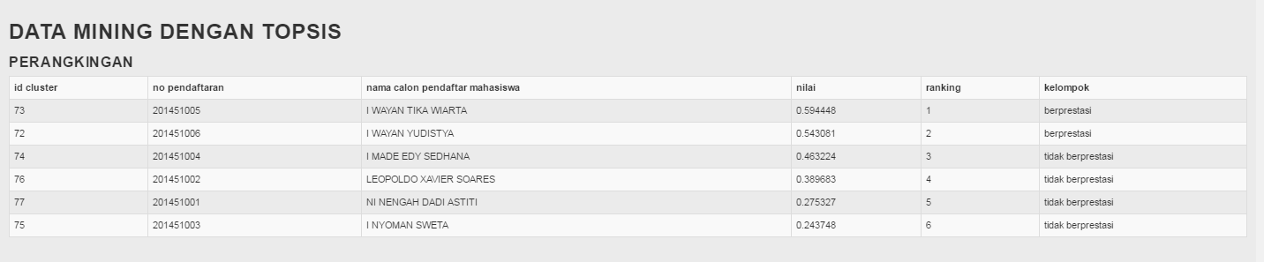

function ranking(){

$rank = $this->db->query("SELECT * FROM kedekatan_relatif ORDER BY dekat_relatif DESC");

$posisi = 1;

foreach ($rank->result() as $peringkat){

$this->db->query("UPDATE rangking SET nilai = '$peringkat->dekat_relatif',

ranking = '$posisi'

WHERE no_pendaftaran = '$peringkat->no_pendaftaran'");

$posisi++;

}

}

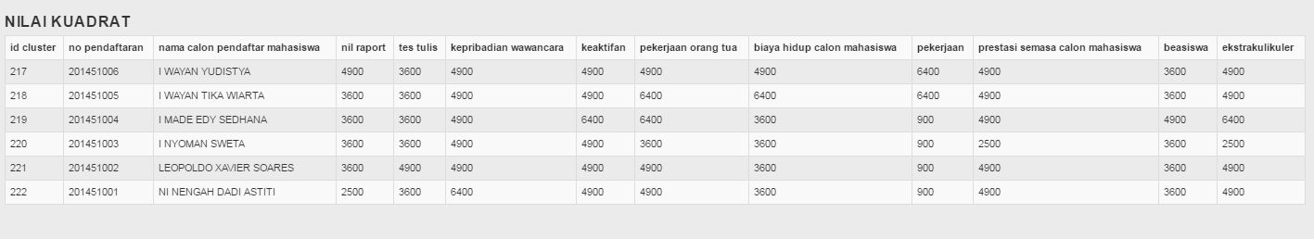

function kuadrat_update() {

$data = $this->db->query("SELECT * FROM cluster");

foreach ($data->result() as $matriks){

$nm1 = $matriks->nil_raport * $matriks->nil_raport;

$nm2 = $matriks->tes_tulis * $matriks->tes_tulis;

$nm3 = $matriks->kepribadian_wawancara * $matriks->kepribadian_wawancara;

$nm4 = $matriks->keaktifan * $matriks->keaktifan;

$nm5 = $matriks->pekerjaan_orang_tua * $matriks->pekerjaan_orang_tua;

$nm6 = $matriks->biaya_hidup_calon_mahasiswa * $matriks->biaya_hidup_calon_mahasiswa;

$nm7 = $matriks->pekerjaan * $matriks->pekerjaan;

$nm8 = $matriks->prestasi_semasa_calon_mahasiswa * $matriks->prestasi_semasa_calon_mahasiswa;

$nm9 = $matriks->beasiswa * $matriks->beasiswa;

$nm10 = $matriks->ekstrakulikuler * $matriks->ekstrakulikuler;

$query = $this->db->query("UPDATE kuadrat SET nil_raport = '$nm1',

tes_tulis = '$nm2',

kepribadian_wawancara = '$nm3',

keaktifan = '$nm4',

pekerjaan_orang_tua = '$nm5',

biaya_hidup_calon_mahasiswa = '$nm6',

pekerjaan = '$nm7',

prestasi_semasa_calon_mahasiswa = '$nm8',

beasiswa = '$nm9',

ekstrakulikuler = '$nm10'

WHERE no_pendaftaran = '$matriks->no_pendaftaran'");

}

}

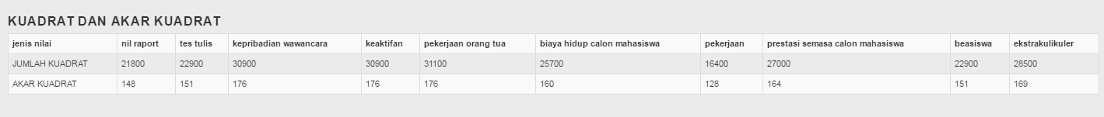

function akar_kuadrat(){

$sum1 = $this->db->query("SELECT SUM(nil_raport) sum FROM kuadrat");

$sum1a = $sum1->row_array();

$sum2 = $this->db->query("SELECT SUM(tes_tulis) sum FROM kuadrat");

$sum2a = $sum2->row_array();

$sum3 = $this->db->query("SELECT SUM(kepribadian_wawancara) sum FROM kuadrat");

$sum3a = $sum3->row_array();

$sum4 = $this->db->query("SELECT SUM(keaktifan) sum FROM kuadrat");

$sum4a = $sum4->row_array();

$sum5 = $this->db->query("SELECT SUM(pekerjaan_orang_tua) sum FROM kuadrat");

$sum5a = $sum5->row_array();

$sum6 = $this->db->query("SELECT SUM(biaya_hidup_calon_mahasiswa) sum FROM kuadrat");

$sum6a = $sum6->row_array();

$sum7 = $this->db->query("SELECT SUM(pekerjaan) sum FROM kuadrat");

$sum7a = $sum7->row_array();

$sum8 = $this->db->query("SELECT SUM(prestasi_semasa_calon_mahasiswa) sum FROM kuadrat");

$sum8a = $sum8->row_array();

$sum9 = $this->db->query("SELECT SUM(beasiswa) sum FROM kuadrat");

$sum9a = $sum9->row_array();

$sum10 = $this->db->query("SELECT SUM(ekstrakulikuler) sum FROM kuadrat");

$sum10a = $sum10->row_array();

$akar1 = sqrt($sum1a['sum']);

$akar2 = sqrt($sum2a['sum']);

$akar3 = sqrt($sum3a['sum']);

$akar4 = sqrt($sum4a['sum']);

$akar5 = sqrt($sum5a['sum']);

$akar6 = sqrt($sum6a['sum']);

$akar7 = sqrt($sum7a['sum']);

$akar8 = sqrt($sum8a['sum']);

$akar9 = sqrt($sum9a['sum']);

$akar10= sqrt($sum10a['sum']);

$this->db->query("UPDATE jumlah_kuadrat SET nil_raport = '$sum1a[sum]',

tes_tulis = '$sum2a[sum]',

kepribadian_wawancara = '$sum3a[sum]',

keaktifan = '$sum4a[sum]',

pekerjaan_orang_tua = '$sum5a[sum]',

biaya_hidup_calon_mahasiswa = '$sum6a[sum]',

pekerjaan = '$sum7a[sum]',

prestasi_semasa_calon_mahasiswa = '$sum8a[sum]',

beasiswa = '$sum9a[sum]',

ekstrakulikuler = '$sum10a[sum]'

WHERE jenis_nilai = 'JUMLAH KUADRAT'");

$this->db->query("UPDATE jumlah_kuadrat SET nil_raport = '$akar1',

tes_tulis = '$akar2',

kepribadian_wawancara = '$akar3',

keaktifan = '$akar4',

pekerjaan_orang_tua = '$akar5',

biaya_hidup_calon_mahasiswa = '$akar6',

pekerjaan = '$akar7',

prestasi_semasa_calon_mahasiswa = '$akar8',

beasiswa = '$akar9',

ekstrakulikuler = '$akar10'

WHERE jenis_nilai = 'AKAR KUADRAT'");

}

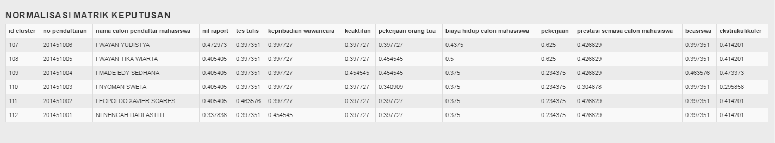

function normalisasi_matriks_update(){

$nilaiaka = $this->db->query("SELECT * FROM jumlah_kuadrat WHERE jenis_nilai = 'AKAR KUADRAT'");

$nilaiakar = $nilaiaka->row_array();

$data = $this->db->query("SELECT * FROM cluster");

foreach ($data->result() as $matriks){

$nm1 = $matriks->nil_raport / $nilaiakar['nil_raport'];

$nm2 = $matriks->tes_tulis / $nilaiakar['tes_tulis'];

$nm3 = $matriks->kepribadian_wawancara / $nilaiakar['kepribadian_wawancara'];

$nm4 = $matriks->keaktifan / $nilaiakar['keaktifan'];

$nm5 = $matriks->pekerjaan_orang_tua / $nilaiakar['pekerjaan_orang_tua'];

$nm6 = $matriks->biaya_hidup_calon_mahasiswa / $nilaiakar['biaya_hidup_calon_mahasiswa'];

$nm7 = $matriks->pekerjaan / $nilaiakar['pekerjaan'];

$nm8 = $matriks->prestasi_semasa_calon_mahasiswa / $nilaiakar['prestasi_semasa_calon_mahasiswa'];

$nm9 = $matriks->beasiswa / $nilaiakar['beasiswa'];

$nm10 = $matriks->ekstrakulikuler / $nilaiakar['ekstrakulikuler'];

$query = $this->db->query("UPDATE normalisasi_matriks SET nil_raport = '$nm1',

tes_tulis = '$nm2',

kepribadian_wawancara = '$nm3',

keaktifan = '$nm4',

pekerjaan_orang_tua = '$nm5',

biaya_hidup_calon_mahasiswa = '$nm6',

pekerjaan = '$nm7',

prestasi_semasa_calon_mahasiswa = '$nm8',

beasiswa = '$nm9',

ekstrakulikuler = '$nm10'

WHERE no_pendaftaran = '$matriks->no_pendaftaran'");

}

}

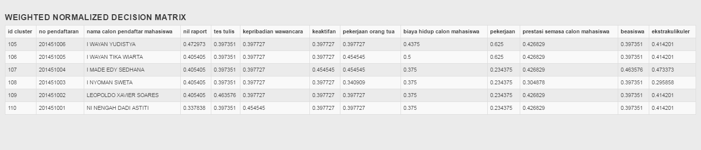

function weighted_normalized_decision_matrix() {

$bobot = $this->db->query("SELECT * FROM kriteria");

$kriteria = $bobot->row_array();

$data1 = $this->db->query("SELECT * FROM normalisasi_matriks");

foreach ($data1->result() as $wndm){

$wn1 = $wndm->nil_raport * $kriteria['nil_raport'];

$wn2 = $wndm->tes_tulis * $kriteria['tes_tulis'];

$wn3 = $wndm->kepribadian_wawancara * $kriteria['kepribadian_wawancara'];

$wn4 = $wndm->keaktifan * $kriteria['keaktifan'];

$wn5 = $wndm->pekerjaan_orang_tua * $kriteria['pekerjaan_orang_tua'];

$wn6 = $wndm->biaya_hidup_calon_mahasiswa * $kriteria['biaya_hidup_calon_mahasiswa'];

$wn7 = $wndm->pekerjaan * $kriteria['pekerjaan'];

$wn8 = $wndm->prestasi_semasa_calon_mahasiswa * $kriteria['prestasi_semasa_calon_mahasiswa'];

$wn9 = $wndm->beasiswa * $kriteria['beasiswa'];

$wn10 = $wndm->ekstrakulikuler * $kriteria['ekstrakulikuler'];

$query1 = $this->db->query("UPDATE weighted_normalized_decision_matrix SET nil_raport = '$wn1',

tes_tulis = '$wn2',

kepribadian_wawancara = '$wn3',

keaktifan = '$wn4',

pekerjaan_orang_tua = '$wn5',

biaya_hidup_calon_mahasiswa = '$wn6',

pekerjaan = '$wn7',

prestasi_semasa_calon_mahasiswa = '$wn8',

beasiswa = '$wn9',

ekstrakulikuler = '$wn10'

WHERE no_pendaftaran = '$wndm->no_pendaftaran'");

}

}

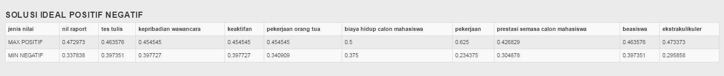

function positif_negatif(){

//pencarian nilai positif

$plus1 = $this->db->query("SELECT MAX(nil_raport) max FROM weighted_normalized_decision_matrix");

$Positif1a = $plus1->row_array();

$plus2 = $this->db->query("SELECT MAX(tes_tulis) max FROM weighted_normalized_decision_matrix");

$Positif2a = $plus2->row_array();

$plus3 = $this->db->query("SELECT MAX(kepribadian_wawancara) max FROM weighted_normalized_decision_matrix");

$Positif3a = $plus3->row_array();

$plus4 = $this->db->query("SELECT MAX(keaktifan) max FROM weighted_normalized_decision_matrix");

$Positif4a = $plus4->row_array();

$plus5 = $this->db->query("SELECT MAX(pekerjaan_orang_tua) max FROM weighted_normalized_decision_matrix");

$Positif5a = $plus5->row_array();

$plus6 = $this->db->query("SELECT MAX(biaya_hidup_calon_mahasiswa) max FROM weighted_normalized_decision_matrix");

$Positif6a = $plus6->row_array();

$plus7 = $this->db->query("SELECT MAX(pekerjaan) max FROM weighted_normalized_decision_matrix");

$Positif7a = $plus7->row_array();

$plus8 = $this->db->query("SELECT MAX(prestasi_semasa_calon_mahasiswa) max FROM weighted_normalized_decision_matrix");

$Positif8a = $plus8->row_array();

$plus9 = $this->db->query("SELECT MAX(beasiswa) max FROM weighted_normalized_decision_matrix");

$Positif9a = $plus9->row_array();

$plus10 = $this->db->query("SELECT MAX(ekstrakulikuler) max FROM weighted_normalized_decision_matrix");

$Positif10a = $plus10->row_array();

//pencarian nilai negatif

$min1 = $this->db->query("SELECT MIN(nil_raport) min FROM weighted_normalized_decision_matrix");

$negatif1a = $min1->row_array();

$min2 = $this->db->query("SELECT MIN(tes_tulis) min FROM weighted_normalized_decision_matrix");

$negatif2a = $min2->row_array();

$min3 = $this->db->query("SELECT MIN(kepribadian_wawancara) min FROM weighted_normalized_decision_matrix");

$negatif3a = $min3->row_array();

$min4 = $this->db->query("SELECT MIN(keaktifan) min FROM weighted_normalized_decision_matrix");

$negatif4a = $min4->row_array();

$min5 = $this->db->query("SELECT MIN(pekerjaan_orang_tua) min FROM weighted_normalized_decision_matrix");

$negatif5a = $min5->row_array();

$min6 = $this->db->query("SELECT MIN(biaya_hidup_calon_mahasiswa) min FROM weighted_normalized_decision_matrix");

$negatif6a = $min6->row_array();

$min7 = $this->db->query("SELECT MIN(pekerjaan) min FROM weighted_normalized_decision_matrix");

$negatif7a = $min7->row_array();

$min8 = $this->db->query("SELECT MIN(prestasi_semasa_calon_mahasiswa) min FROM weighted_normalized_decision_matrix");

$negatif8a = $min8->row_array();

$min9 = $this->db->query("SELECT MIN(beasiswa) min FROM weighted_normalized_decision_matrix");

$negatif9a = $min9->row_array();

$min10 = $this->db->query("SELECT MIN(ekstrakulikuler) min FROM weighted_normalized_decision_matrix");

$negatif10a = $min10->row_array();

$this->db->query("UPDATE positif_negatif SET nil_raport = '$Positif1a[max]',

tes_tulis = '$Positif2a[max]',

kepribadian_wawancara = '$Positif3a[max]',

keaktifan = '$Positif4a[max]',

pekerjaan_orang_tua = '$Positif5a[max]',

biaya_hidup_calon_mahasiswa = '$Positif6a[max]',

pekerjaan = '$Positif7a[max]',

prestasi_semasa_calon_mahasiswa = '$Positif8a[max]',

beasiswa = '$Positif9a[max]',

ekstrakulikuler = '$Positif10a[max]'

WHERE jenis_nilai = 'MAX POSITIF'");

$this->db->query("UPDATE positif_negatif SET nil_raport = '$negatif1a[min]',

tes_tulis = '$negatif2a[min]',

kepribadian_wawancara = '$negatif3a[min]',

keaktifan = '$negatif4a[min]',

pekerjaan_orang_tua = '$negatif5a[min]',

biaya_hidup_calon_mahasiswa = '$negatif6a[min]',

pekerjaan = '$negatif7a[min]',

prestasi_semasa_calon_mahasiswa = '$negatif8a[min]',

beasiswa = '$negatif9a[min]',

ekstrakulikuler = '$negatif10a[min]'

WHERE jenis_nilai = 'MIN NEGATIF'");

}

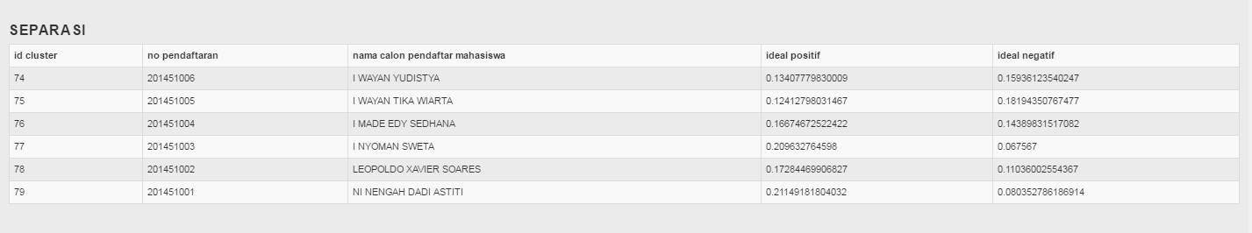

function separasi(){

$pos = $this->db->query("SELECT * FROM positif_negatif WHERE jenis_nilai = 'MAX POSITIF'");

$np = $pos->row_array();

$neg = $this->db->query("SELECT * FROM positif_negatif WHERE jenis_nilai = 'MIN NEGATIF'");

$nn = $neg->row_array();

$sep = $this->db->get('weighted_normalized_decision_matrix');

foreach ($sep->result() as $sp){

$spt1 = ($sp->nil_raport - $np['nil_raport']) * ($sp->nil_raport - $np['nil_raport']);

$spt2 = ($sp->tes_tulis - $np['tes_tulis']) * ($sp->tes_tulis - $np['tes_tulis']);

$spt3 = ($sp->kepribadian_wawancara - $np['kepribadian_wawancara']) * ($sp->kepribadian_wawancara - $np['kepribadian_wawancara']);

$spt4 = ($sp->keaktifan - $np['keaktifan']) * ($sp->keaktifan - $np['keaktifan']);

$spt5 = ($sp->pekerjaan_orang_tua - $np['pekerjaan_orang_tua']) * ($sp->pekerjaan_orang_tua - $np['pekerjaan_orang_tua']);

$spt6 = ($sp->biaya_hidup_calon_mahasiswa - $np['biaya_hidup_calon_mahasiswa']) * ($sp->biaya_hidup_calon_mahasiswa - $np['biaya_hidup_calon_mahasiswa']);

$spt7 = ($sp->pekerjaan - $np['pekerjaan']) * ($sp->pekerjaan - $np['pekerjaan']);

$spt8 = ($sp->prestasi_semasa_calon_mahasiswa - $np['prestasi_semasa_calon_mahasiswa']) * ($sp->prestasi_semasa_calon_mahasiswa - $np['prestasi_semasa_calon_mahasiswa']);

$spt9 = ($sp->beasiswa - $np['beasiswa']) * ($sp->beasiswa - $np['beasiswa']);

$spt10 = ($sp->ekstrakulikuler - $np['ekstrakulikuler']) * ($sp->ekstrakulikuler - $np['ekstrakulikuler']);

$spt = sqrt($spt1 + $spt2 + $spt3 + $spt4 + $spt5 + $spt6);

$sne1 = ($sp->nil_raport - $nn['nil_raport']) * ($sp->nil_raport - $nn['nil_raport']);

$sne2 = ($sp->tes_tulis - $nn['tes_tulis']) * ($sp->tes_tulis - $nn['tes_tulis']);

$sne3 = ($sp->kepribadian_wawancara - $nn['kepribadian_wawancara']) * ($sp->kepribadian_wawancara - $nn['kepribadian_wawancara']);

$sne4 = ($sp->keaktifan - $nn['keaktifan']) * ($sp->keaktifan - $nn['keaktifan']);

$sne5 = ($sp->pekerjaan_orang_tua - $nn['pekerjaan_orang_tua']) * ($sp->pekerjaan_orang_tua - $nn['pekerjaan_orang_tua']);

$sne6 = ($sp->biaya_hidup_calon_mahasiswa - $nn['biaya_hidup_calon_mahasiswa']) * ($sp->biaya_hidup_calon_mahasiswa - $nn['biaya_hidup_calon_mahasiswa']);

$sne7 = ($sp->pekerjaan - $nn['pekerjaan']) * ($sp->pekerjaan - $nn['pekerjaan']);

$sne8 = ($sp->prestasi_semasa_calon_mahasiswa - $nn['prestasi_semasa_calon_mahasiswa']) * ($sp->prestasi_semasa_calon_mahasiswa - $nn['prestasi_semasa_calon_mahasiswa']);

$sne9 = ($sp->beasiswa - $nn['beasiswa']) * ($sp->beasiswa - $nn['beasiswa']);

$sne10 = ($sp->ekstrakulikuler - $nn['ekstrakulikuler']) * ($sp->ekstrakulikuler - $nn['ekstrakulikuler']);

$sn = sqrt($sne1 + $sne2 + $sne3 + $sne4 + $sne5 + $sne6);

$this->db->query("UPDATE separasi SET ideal_positif = '$spt',

ideal_negatif = '$sn'

WHERE no_pendaftaran = '$sp->no_pendaftaran'");

}

}

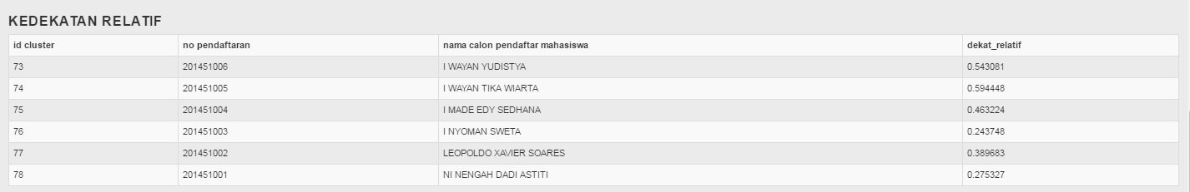

function kedekatan_relatif(){

$relatif = $this->db->query("SELECT * FROM separasi");

foreach ($relatif->result() as $kedekatan){

$hasil = $kedekatan->ideal_negatif / ($kedekatan->ideal_positif + $kedekatan->ideal_negatif);

$this->db->query("UPDATE kedekatan_relatif SET dekat_relatif = '$hasil'

WHERE no_pendaftaran = '$kedekatan->no_pendaftaran'");

}

}

->perbandingan

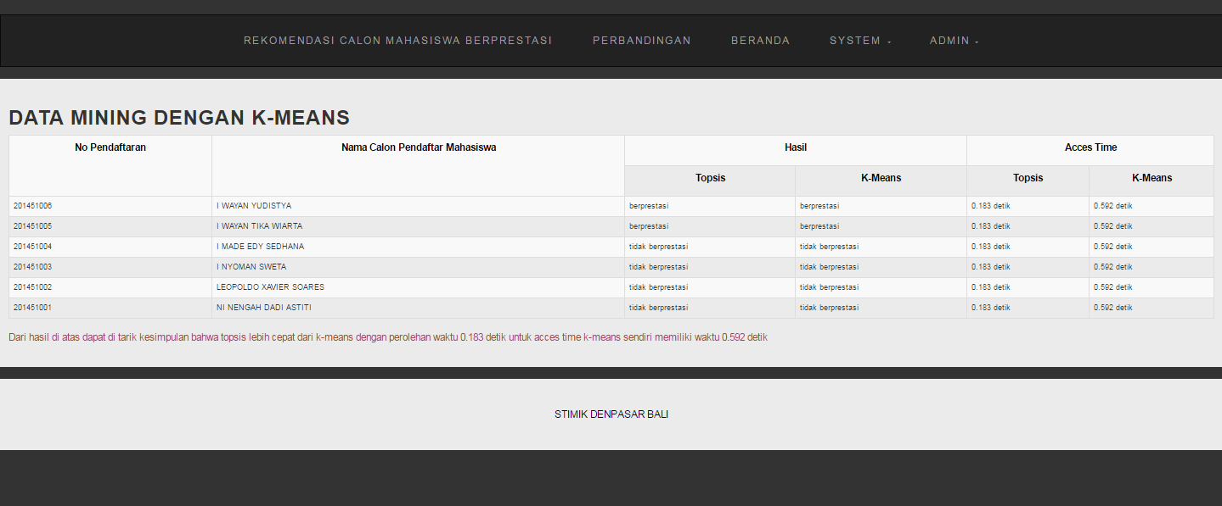

function topsisKmeansAdmin() {

$this->db->select('*');

$this->db->from('cluster');

$this->db->join('calon_mahasiswa', 'cluster.no_pendaftaran = calon_mahasiswa.no_pendaftaran' );

$this->db->join('rangking', 'rangking.no_pendaftaran = calon_mahasiswa.no_pendaftaran' );

$lihatTopsisKMeansUser = $this->db->get();

return $lihatTopsisKMeansUser->result();

}

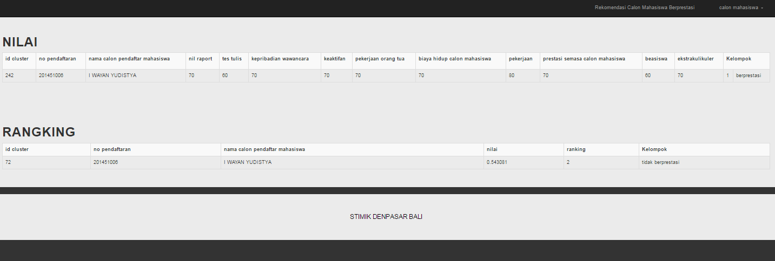

function topsisUser($username) {

$this->db->select('*');

$this->db->from('cluster');

$this->db->join('calon_mahasiswa', 'cluster.no_pendaftaran = calon_mahasiswa.no_pendaftaran' );

$this->db->where('cluster.no_pendaftaran', $username);

$lihatTopsisUser = $this->db->get();

return $lihatTopsisUser->result();

}

function kMeansUser($username) {

$this->db->select('*');

$this->db->from('rangking');

$this->db->join('calon_mahasiswa', 'rangking.no_pendaftaran = calon_mahasiswa.no_pendaftaran' );

$this->db->order_by('rangking.ranking', 'asc');

$this->db->where('rangking.no_pendaftaran', $username);

$lihatKMeansUser = $this->db->get();

return $lihatKMeansUser->result();

}