Problem Definition: From Advanced search page we search and select a unique collection result. When we update and then **save**, the summary page is displaying all the collection results for that collection plan and not just the specific one we searched for using advanced search.

1. Quality>Workbench> Collection Results> Advanced Search

Enter org, Collection plan, Item 102309 and Lot Number C0004. Click on Search. Click on the collection plan name returned.

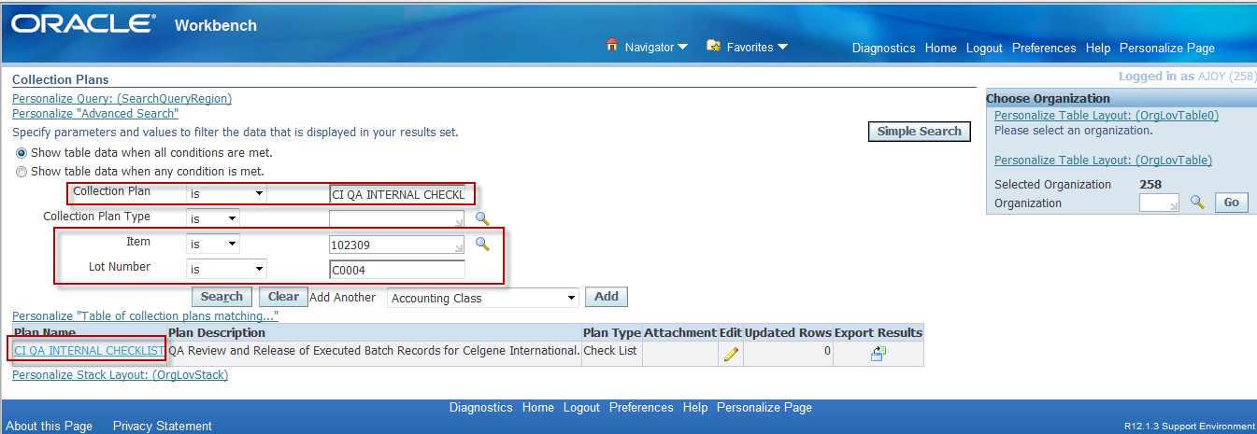

1. Collection result for that particular search criterion is returned. Note that Information field is renamed to “Lot Number/Reference and it displays the lot number of the collection result). Click on update icon.

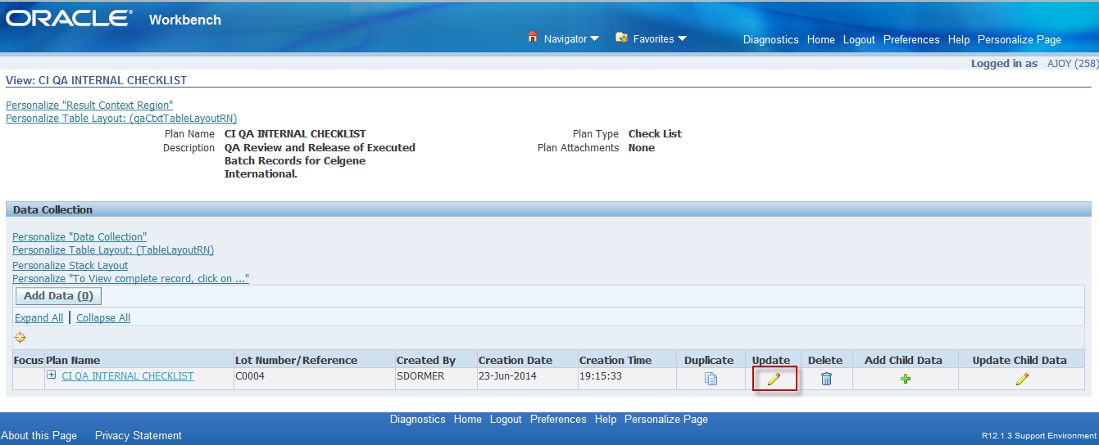

1. Change some element value. For e.g. Primary packaging review to Yes and click on Enter (Finish Button has just been renamed through personalization as Enter)

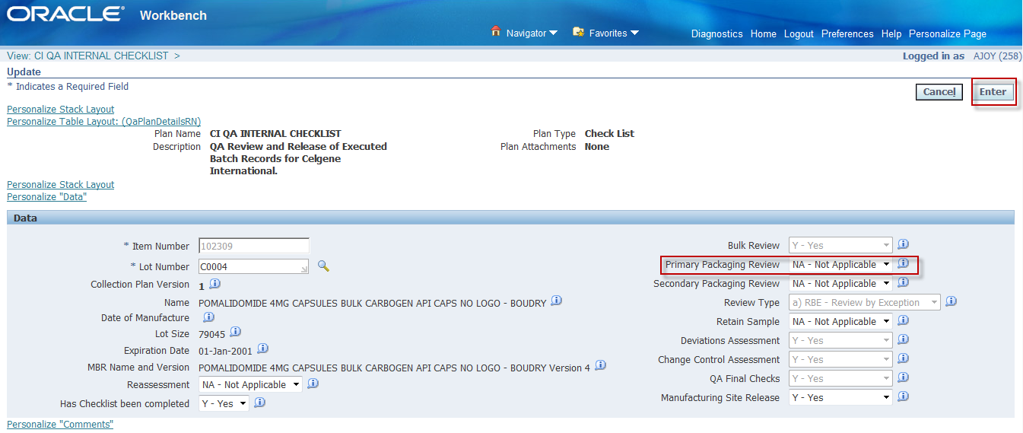

1. The user is returned to the summary page. Once the user clicks on save to save the updates, all the collection results for that collection plan is returned, not just the one for Item 102309 and Lot Number C0004. See next screenshot

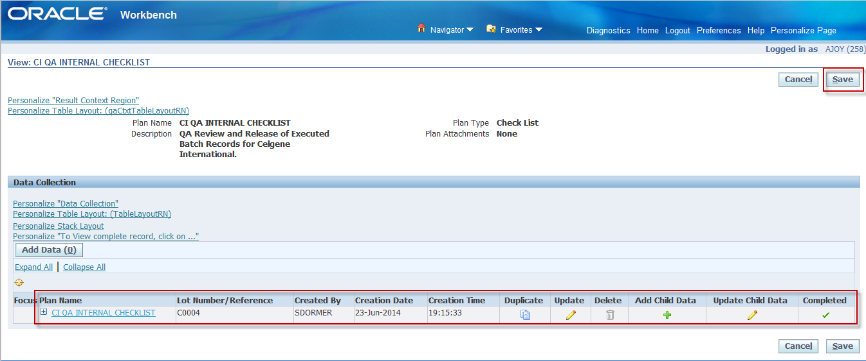

1. This page should just show the result for Lot Number:C0004 and not the others

