# **UML IN 5 MINUTES**

# DATABASE to UML

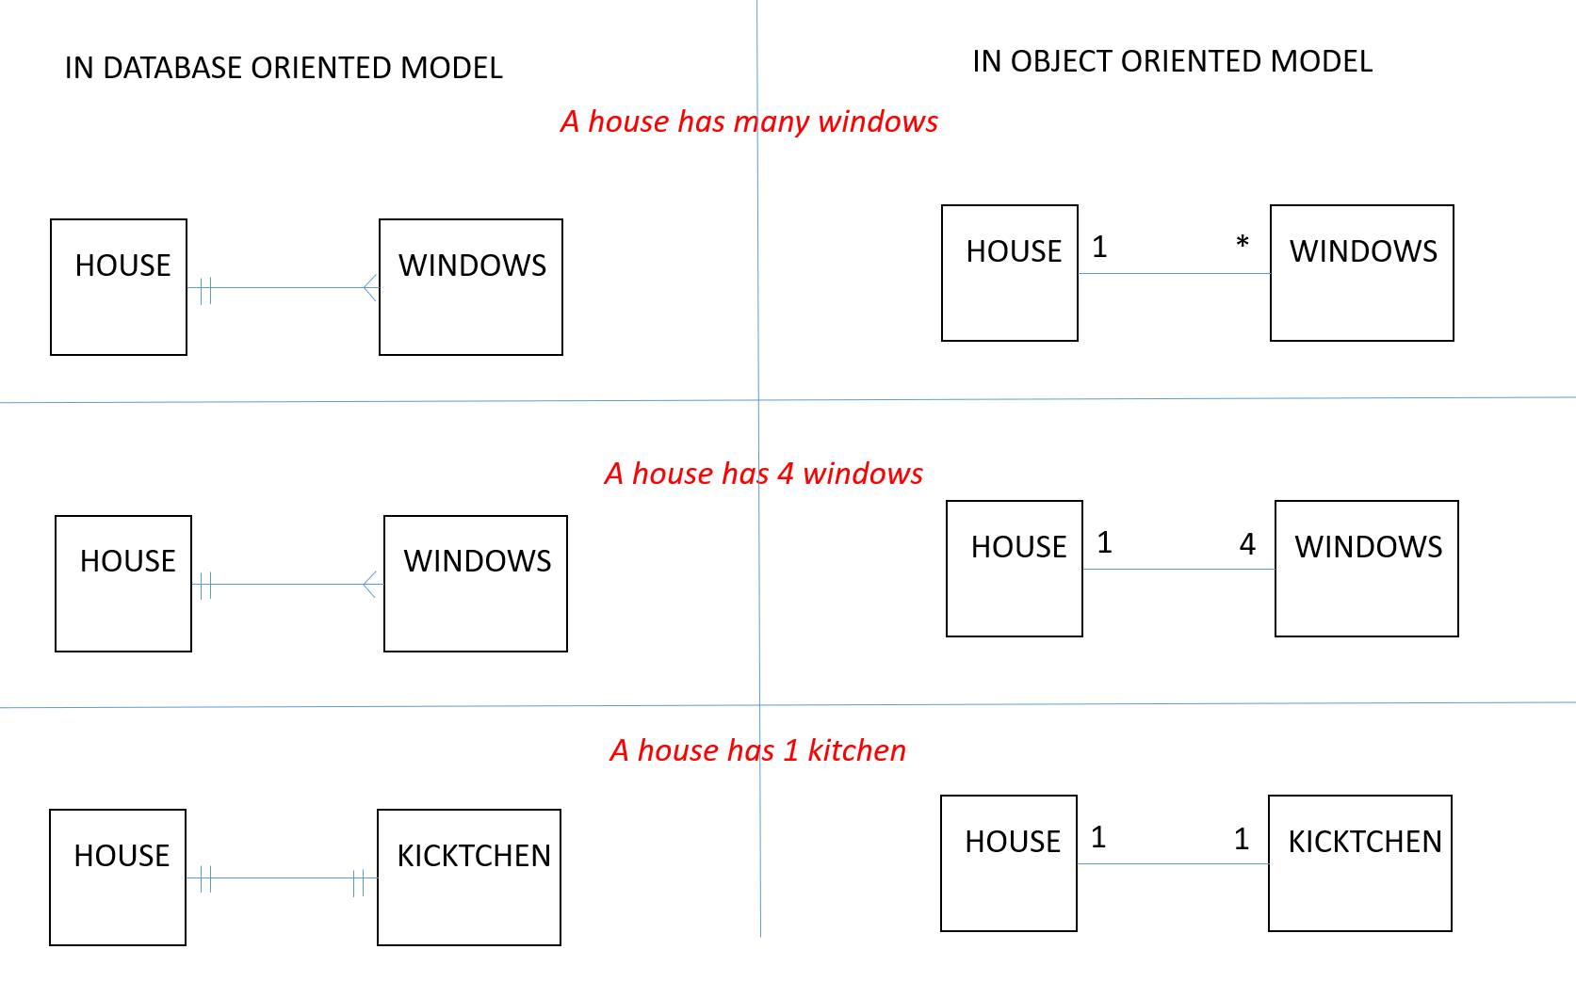

# UML TO DART

