

LPFFIR
FPGA Characterization

Author: Vladimir Armstrong
vladimirarmstrong@opencores.org

Rev. 1.0
March 25, 2019

This page has been intentionally left blank.
Revision History
Rev. | Date | Author | Description
1.0 | 03/25/19 | Vladimir Armstrong | First Draft

Contents
Introduction 1
Measurement Equipment 2
Expected Behavior 3
Expected Magnitude Response Equation 3
Expected Phase Response Equation 3
Measurement Results 5
Measurement Analysis 6
Appendix A 7
Magnitude Response Script Requirements 7
Phase Response Script Requirements 7
Appendix B 8
ADC Key Features 8
DAC Key Features 8
Index 9

Introduction
The LPFFIR [1] FPGA implementation Device Under Test (DUT) is characterized by magnitude and phase response. The magnitude and phase measurement results [4] is obtained by running scripts [Appendix A] on measurement equipment setup [2]. The magnitude and phase measurement results analysis [5] is done by comparing expected behavior [3] versus measurement results [4].

Measurement Equipment
The Measurement Equipment consist of PC, Mixed Signal Oscilloscope [5], FPGA prototyping board [2] , ADC [3] and DAC [4] peripheral modules. The Waveform Generator is connected to ADC peripheral module and Oscilloscope channel 1 (CH1). The Oscilloscope channel 2 (CH2) is connected to DAC peripheral module as shown below.

Figure 1 Measurement equipment block diagram

Expected Behavior

Expected Magnitude Response Equation
$$\left|H\left(z=e^{iω}\right)\right|=2\left|cos\frac{5}{2}ω+cos\frac{3}{2}ω+ cos\frac{1}{2}ω)\right|$$

Expected Phase Response Equation
$$∡ H\left(z=e^{iω}\right)=-\frac{5}{2}ω$$

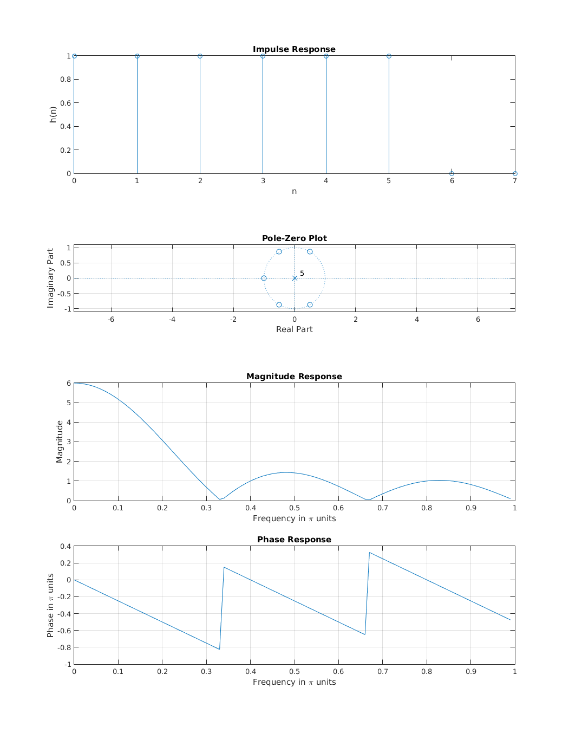
Figure 2 Expected magnitude and phase response plots

Measurement Results
TBD

Measurement Analysis
TBD

Measurement Scripts
The Measurement Scripts consist of SCPI [7] with Python wrapper [6] and is used to controlling the measurement equipment [2] to generate a magnitude and phase response of LPFFIR FPGA implementation.

Magnitude Response Script Requirements
- The script shall control the Waveform Generator to output a 1 V amplitude sinusoidal signal in 1 Hz to 25 MHz frequency range with 1 Hz frequency increment step.
- The script shall control Oscilloscope to sample the output of DAC.
- The script shall generate a magnitude response array by comparing the amplitude of sinusoidal signal from Waveform Generator with DAC output.

Phase Response Script Requirements
- The script shall control the Waveform Generator to output a 1 V amplitude sinusoidal signal in 1 Hz to 25 MHz frequency range with 1 Hz frequency increment step.
- The script shall control Oscilloscope to sample the output of DAC.
- The script shall generate a phase response array by comparing the phase of sinusoidal signal from Waveform Generator with DAC output.

Peripheral Modules
The Analog-to-Digital Converter (ADC) [3] and Digital-to-Analog Converter (DAC) [4] peripheral modules are used for LPFFIR FPGA implementation characterization. The summary of key features of ADC and DCA are listed below:

ADC Key Features
- TBD sample period
- 12-bit analog to digital converter
- I2C interface

DAC Key Features
- TBD sample period
- 12-bit analog to digital converter
- SPI interface

- LPFFIR IP Core Specification: https://opencores.org/projects/lpffir
- FPGA prototyping board: https://reference.digilentinc.com/reference/programmable-logic/basys-3/reference-manual
- ADC peripheral module: https://reference.digilentinc.com/reference/pmod/pmodad2/reference-manual
- DAC peripheral module: https://reference.digilentinc.com/reference/pmod/pmodda4/reference-manual
- Mixed Signal Oscilloscope: https://www.rigolna.com/products/digital-oscilloscopes/mso5000
- Python wrapper: https://pypi.org/project/scpi
- Standard Commands for Programmable Instruments (SCPI): https://en.wikipedia.org/wiki/Standard_Commands_for_Programmable_Instruments

