**Variable PSU with LM317T**

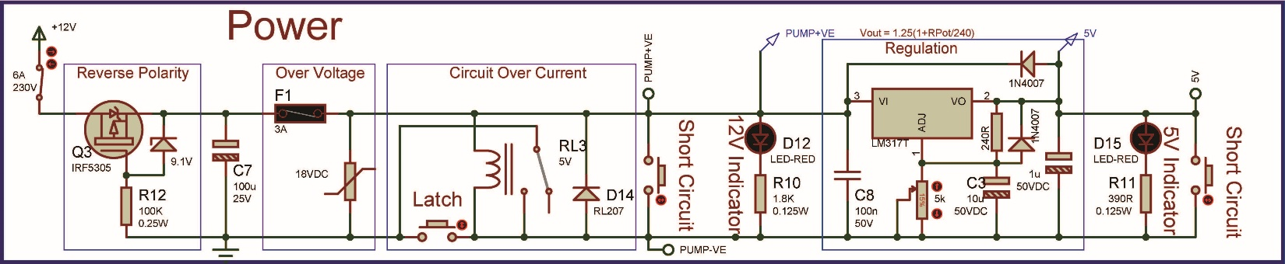

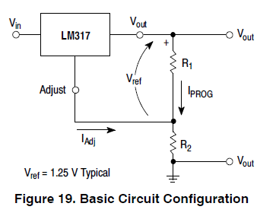**LM317:**

**Basics of LM317:**

**It’s:**

1. Short circuit proof (shutdown).
2. Over temperature shutdown.
3. Floating Operation for High Voltages.

LM317 generate a difference of 1.25V between $V_{out}$ and $Adjustable$ pins ($V_{ref}=1.25V)$.

∵ $V_{out}=V_{R_{1}}+V_{R_{2}}=I_{PROG}(R_{1}+R_{2})+I_{Adj}R_{2}$

∵ $I_{PROG}=\frac{V_{ref}}{R_{1}}$ substitute $I_{PROG}$

∴ $V_{out}=\frac{V_{ref}}{R_{1}}(R_{1}+R_{2})+I_{Adj}R_{2}=V_{ref}(1+\frac{R_{2}}{R_{1}})+I_{Adj}R_{2}$

Because $V_{ref}$ is constant and $I_{PROG}$ must be constant. So, $R_{1}$ must be constant, and then, we can control the O/P with $R_{2}$ value.

But the term $I_{Adj}R_{2}$ is not desired cuz we can’t control it. So, LM317 control it to be less than 100uA which is negligible. So:

$\boxed{V_{out}=V_{ref}(1+\frac{R_{2}}{R_{1}})}$ $\boxed{120≤R_{1}≤1000}$

Often, $R_{1}=240$ which give the best results.

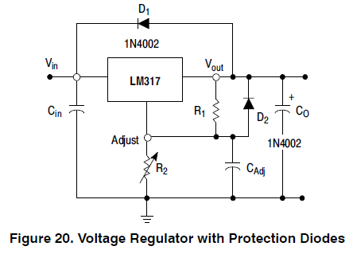 **Tips for LM317 circuit design:**

$R_{2}$**selection:**

$R_{2}$ should make $V_{out\left(max\right)}≤37V$ (max of IC )

∵ ${[V}_{out(max)}=V_{ref}(1+\frac{R_{2}}{R_{1}})]≤37V$

∴ $R_{2}≤(\frac{37}{V_{ref}}-1){*R}_{1}$

Often, $R_{1}=240Ω$ give the best results.

∴ $R_{2}≤\left(\frac{37}{1.25}-1\right)*240=6864Ω$

* We need $V_{out\left(min\right)}=3V$. So, we will put a fixed resistor with the trimmer in case of making it’s resistor = 0.
$$R_{fixed}=\left(\frac{3}{1.25}-1\right)*240=336⋍330Ω$$

* Cuz we don’t need to reach 37V in practical apps, we will choose the value of the trimmer to be $R_{2}$ = 5KΩ, making

$$V_{out(max)}=1.25\left(1+\frac{5000+330}{240}\right)⋍29V$$

**Capacitors:**

1. $C_{in}$ of (0.1uF disc or 1.0uF tantalum) is recommended to reduce the sensitivity to input line impedance.
2. $C_{Adj}$ is recommended to bypass the adjustment terminal to ground to improve ripple rejection. It prevents ripple being amplified as the output voltage is increased. A 10uF disc capacitor improves ripple rejection about 15 dB at 120 Hz in a 10 V application.
3. LM317 is stable with no output capacitance. But certain values of external capacitance can cause excessive ringing. $C_{O}$ of (1.0uF tantalum or 25uF aluminum electrolytic) swamps this effect and insures stability.

**Protection Diodes:**

Protection diodes must be used when capacitors are used to prevent discharging through low current points into the regulator.

1. $D_{1}$ prevents $C_{O}$ discharging thru the IC during an I/P short circuit.
2. $D_{2}$ prevents $C_{Adj}$ discharging thru the IC during an O/P short circuit.
3. $D_{1}$ with $D_{2}$ prevents $C_{Adj}$ discharging thru the IC during an I/P short circuit.

**When $V_{in}≥40$**

LM317 can have its output shorted without damage. But $\boxed{{-0.3V≤(V}_{in}- V_{out})≤40V}$. So, applying 45V to the input, and getting 30V from the output. A 15V appears over the IC which is fine, but if the output gets shorted somehow (i.e. the initial charging of large capacitors $C_{O}$), a full 45V appears above the IC and this is enough to damage it(>40V).

[**Solution**:](https://electronics.stackexchange.com/questions/148340/how-to-protect-lm317-from-output-short/148342#148342)

Replace D1 with a 30V zener rated for several amps(P6KE30A), and a fuse (before Vin) to blow before the zener.

* Normal operation: the zener should not normally conduct.
* Power-off operation: the zener is forward biassed providing the same protection D1 does.
* Power-on operation: with 45V in, the zener will supply current to the load if the LM317 is supplying less than 15V. After that, the LM317 takes over.
* Short circuit operation: the IC goes into current limit and the output voltage drops. The zener conducts before I/O voltage exceeds 40V. The fuse blows.

**Tips for LM317 PCB design:**

1. $R_{1}$ should be connected close to the regulator pins to minimize line drops which appears in series with $V_{ref}$, thereby degrading regulation.
2. The ground end of $R_{2}$ should be connected close to the load ground to provide remote ground sensing and improve load regulation.
3. $C_{in}$ and $C_{O}$ should be connected close to the IC pins to avoid stray inductance.

Resources:

LM317: 🡺 Basic : [(39) LM317: How It Works and Why You Need It (Ep. 2) - YouTube](https://www.youtube.com/watch?v=Kw1IxR5K_gk)

🡺 Increase current: [(39) LM317: How To Increase Amperage (Ep. 3) - YouTube](https://www.youtube.com/watch?v=2W51oVesKP8)