Credit Card Fraud Detection — Project Report
Binary classification model to flag fraudulent transactions from anonymized transaction data

1. Problem & Data
The dataset contains 284,807 credit card transactions, of which only 492 (0.17%) are fraudulent — a 577:1 class imbalance. Each transaction has 28 anonymized PCA-derived features (V1–V28), plus Time and Amount. No missing values were present. The data was split 80/20 (stratified to preserve the fraud ratio in both sets), and features were scaled using a StandardScaler fit only on the training set to avoid test-set leakage.

2. Approach
Four classifiers were trained with class-weight balancing to counteract the imbalance: Logistic Regression, Decision Tree, Random Forest, and SVM (RBF kernel). Models were compared on Precision, Recall, F1-score, and ROC-AUC — F1 and Recall are prioritized over raw accuracy, since accuracy is misleading on a 99.8%-legitimate dataset. The best-performing model (Random Forest) was then tuned via 5-fold grid search (24 parameter combinations), and interpreted using built-in feature importances and per-transaction LIME explanations.

3. Key Findings
Model | Precision | Recall | F1-Score | ROC-AUC
Logistic Regression | 0.061 | 0.918 | 0.114 | 0.972
Decision Tree | 0.132 | 0.786 | 0.226 | 0.891
Random Forest | 0.897 | 0.796 | 0.843 | 0.964
Support Vector Machine | 0.322 | 0.755 | 0.451 | 0.973

- Random Forest was the clear winner on F1-score (0.843), balancing precision and recall far better than the alternatives — Logistic Regression catches 92% of fraud but at a 6% precision, meaning 94 of every 100 flagged transactions would be false alarms.
- Hyperparameter tuning (grid search, 5-fold CV) found only a marginal F1 change (0.843 → 0.837 on the held-out test set), suggesting the untuned Random Forest was already close to this feature set's practical ceiling.
- Top fraud indicators by feature importance: V14, V10, V4, V12, and V17 — together accounting for over half of the model's total importance. Because these are PCA-anonymized components, they cannot be mapped back to interpretable business fields (e.g., merchant category, location) without the original transformation.
- LIME explanations on individual transactions were consistent with the global importances — V4, V14, V17, and V12 recurred as top local drivers for both correctly-flagged fraud and correctly-cleared legitimate transactions, which is a good sign of model stability rather than the model leaning on spurious per-case artifacts.
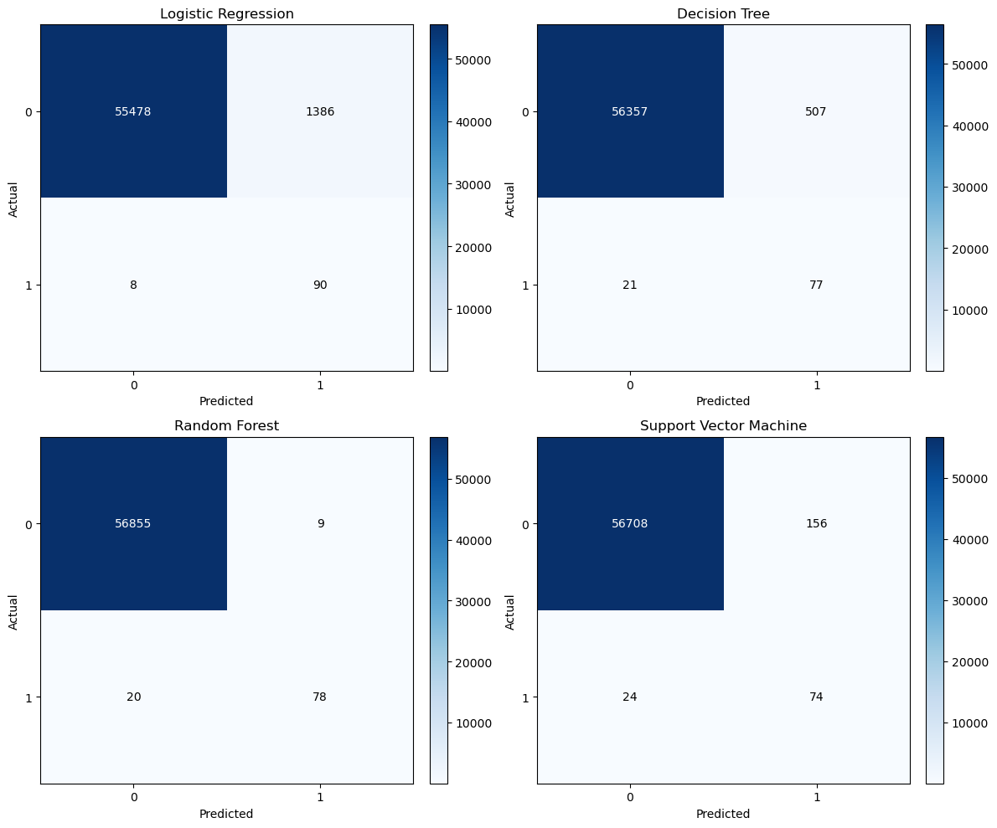
Figure 1. Confusion matrices for all four models on the held-out test set.

4. Deployment Recommendations
- Ship the tuned Random Forest (max_depth=15, min_samples_leaf=2, min_samples_split=5, n_estimators=100) as the production model — it offers the best precision/recall trade-off of the models tested.
- Do not hardcode a single 0.5 probability threshold for both decisions in production. Instead, use two tiers: a lower threshold (e.g., ~0.3–0.4) for automatic soft holds pending secondary review, and a higher threshold (e.g., 0.7+) for near-automatic decline — calibrate both against the real cost of a false decline (customer friction) vs. a missed fraud (direct loss).
- Monitor precision and recall separately in production, not just F1 — fraud patterns drift, and a silent recall drop (missed fraud) is a very different business risk than a precision drop (customer friction from false declines).
- Retrain on a recurring cadence (e.g., quarterly) and immediately after any known shift in fraud tactics, since this model was trained on a static historical snapshot and fraud patterns evolve.
- Log LIME (or SHAP) explanations for every flagged transaction in production — this gives fraud analysts a defensible, per-case rationale and supports any regulatory or customer-dispute review process.

5. Limitations
- Anonymized features (V1–V28): the top fraud indicators cannot be translated into actionable business rules or explained to non-technical stakeholders beyond "component 14 is unusually low," since the underlying PCA transformation isn't available.
- Only 492 fraud examples total (98 in the test set): performance metrics, especially precision, are estimated from a small positive sample and may not generalize reliably; wider confidence intervals should be assumed.
- Static, historical dataset: this data reflects one snapshot of fraud behavior (a specific 2-day European cardholder sample) and doesn't capture fraud pattern drift, seasonality, or adversarial adaptation once a model is deployed and fraudsters learn to evade it.
- No cost-sensitive optimization: the model was tuned on F1-score, which weights precision and recall equally — production deployment should instead optimize against the actual dollar cost of false positives (customer friction, lost trust) vs. false negatives (fraud loss), which are rarely equal.
- SVM training did not scale well and is impractical for frequent retraining at this data volume; if retained for comparison, it should not be considered for production due to inference/training cost at scale.

