Technical design specification
(CrossOver Test Assignment)

Author - Makrand Vichare
Dated: 02-Jan-2017

TABLE OF CONTENTS
0 Preface 1
0.1 Purpose of this document 1
0.2 Specific Design Considerations 1
1 Introduction 2
1.1 Purpose 2
1.2 Scope 2
1.3 Definitions, Acronyms and Abbreviations 2
2 System Overview 3
2.1 System Architecture 3
2.2 Infrastructure Services 3
3 Architecture views 4
3.1 Component Diagram and Layer diagram (merged to save time) 4
3.2 activity diagram 5
3.3 Sequence diagram 6
4 Design Method and Standards 8
4.1 Software development tool and Technologies 8

0 Preface
0.1 Purpose of this document
This document is a Technical Design Document for use by understanding the application architecture and testing framework of the test assignment project of crossover. It provides guidance which is intended to assist the relevant management or technical staff, whether client or supplier, in producing a project-specific Technical Design Document. It is also useful background reading for anyone involved in developing or monitoring the assignment.
0.2 Specific Design Considerations
- The specification is developed for the dotnet technologies like asp.net mvc, asp.net web api2 and client side technologies likes angularjs .
the Unified Modelling Language (UML) paradigm is used to develop design diagrams, which is rapidly becoming recognised as an industry standard in software development.

Introduction
This document provides a complete application architecture and unit testing architecture. The application is a web based and can be accessed with proper access rights. The application will be used to demand, maintain requests and browse books available in their libraries.

Purpose
          - The purpose of the document is to provide a design guidelines while developing the application. The document will give complete details of the application design, assumptions and will assist client and relevant teams.

Scope
          - Deliver a web application which will be used by libraries and their customers.
          - Deliver a library service as a web api which can be consumed and accessed by any device.

Definitions, Acronyms and Abbreviations
          - The following is a list of definitions for this template based on the UML approach to system design:

Class Diagram | Describes the structure of a system
Activity Diagram | Describes activities and actions taking place in a system
Sequence Diagram | Shows one or several sequences of messages sent among a set of objects

System Overview

System Architecture
- The application is N layer application which has the following layers.
UI layer - it facilitates access by both external and internal clients through technologies such as web browsers. This is developed using the technologies like asp.net mvc, angular js and typescript.
Web Api Service layer - it authenticate user and provide access to the resource server . this layers allows to integrate with various devices e.g. web browser, mobile , desktop app. This is developed using asp.net web api2 which provides token based authentication and can be scaled easily. This layer interacts with underlying domain service layer.
Domain Service layer – it contains the business information layer. This is a class library project which interact with data access layer.
Data Access layer - it provides the facilities to store data. The data is stored in no sql database – mongodb so it can handles huge data and can be scaled horizontally.

Infrastructure Services
- The Infrastructure Services can be built incrementally, implementing to handle the following concerns -
          - Security – resource server is secured by implementing authorization server and the gated resource cannot be accessed until users are authenticated. In the future need to implement different roles with various access rights.
          - Audit – not yet implemented (here we can store all the action taken on a request by various roles like customer, librarian, system admin.
          - Performance monitoring and reporting – not yet implemented
          - Error Handling – handled limited way. Need to implement tool like Elmah module which handles and maintains all unhandled exceptions.
          - Debugging & logging – infrastructure layer is available and can used to store all debug and log info.

Architecture views

Component Diagram and Layer diagram (merged to save time)

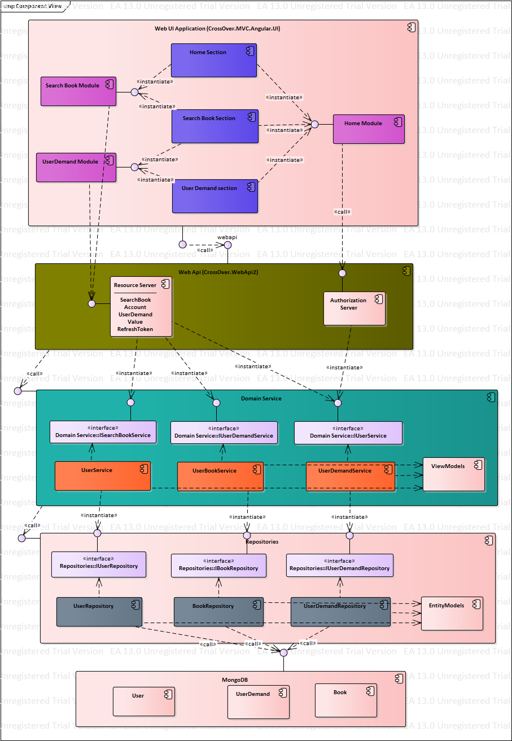

activity diagram

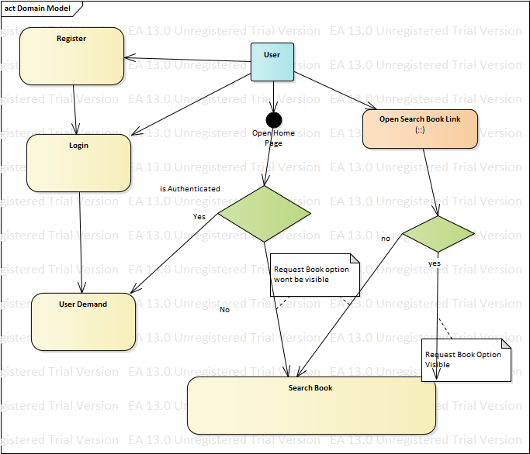

Sequence diagram

Search Book (Unauthenticated User)

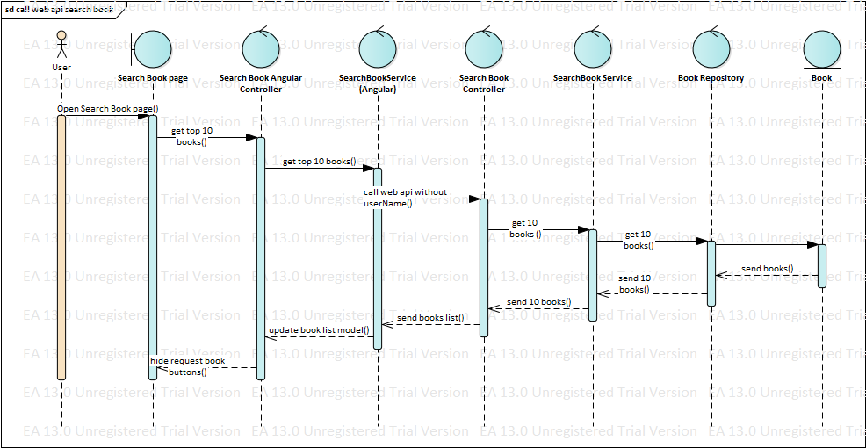

Search Book (Authenticated User)

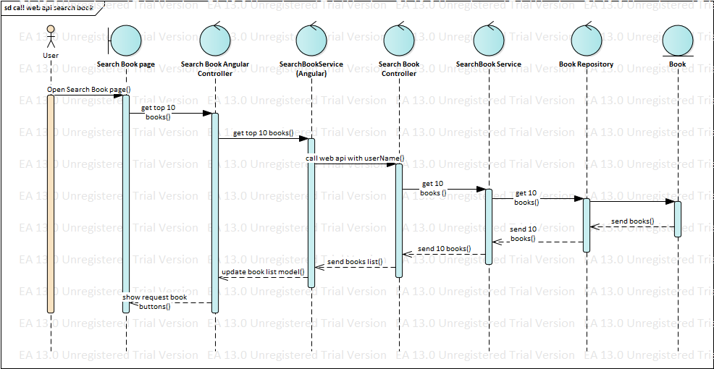

Demand Book (Authenticated)

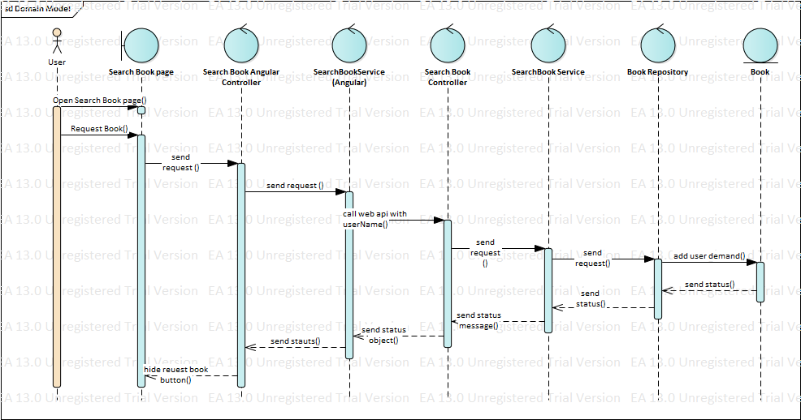

Design Method and Standards

The following design patterns are used:

N- layer pattern, MVC pattern (asp.net mvc)

MVVM pattern using angularjs

Repository and Unit of Work pattern (for persistency layer)

Inversion of control using structuremap

Managed Extensibility Framework (MEF) – to remove need of referencing f all project for IOC registration. (Domain and Repository dlls gets copied to web api project automatically on build but we use of interface references in the web api project)

Software development tool and Technologies
Development Environment –
. Asp.net MVC
AngularJs
TypeScript
StructureMap
MOQ
Asp.net Web Api2
C#
Mongodb
Mongodb C# driver
Automapper

