Editing to be done on home page

1. Home page slider – Get Visa button to be connected to application page

Short term visa only 2 packages not 4, i.e. 96 hours and 14 days

96 hours

Pls note 96 hours wording is wrong, it should be Dubai Transit Visa not transit visa, pls have only following wording

96 Hours

Dubai Transit Visa

$ 10

Visa Type - Single Entry

Average Processing Time - 3 business days

Visa Validity - 30 days from date of issue

Stay Period - 96 hours from date of entry

Get Visa Now (Button) – this button should connect to application form

14 Days

Dubai Visit Visa

$ 10

Visa Type - Single Entry

Average Processing Time - 3 business days

Visa Validity - 60 days from date of issue

Stay Period - 14 days from date of entry

Get Visa Now (Buton) – connect to application form

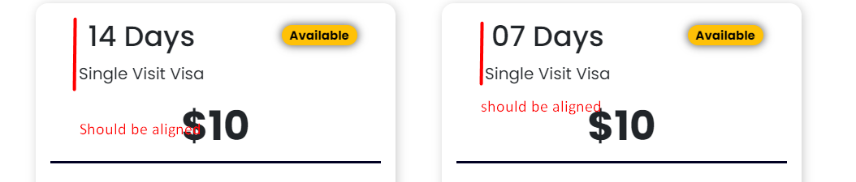

Here short term visa finish

Long term visas

There are 4

In the website what you have done 1st 2nd packages are 60 days and 30 days, it should be

First Line - 30 Day Single / Multiple Entry

30 days 30 days

Second Line - 60 Day Single / Multiple Entry

60 days 60 days

Pls follow the same wording for all 4 as per below

30 Days

Dubai Visit Visa

$ 10

Visa Types - Single Entry

Average Processing Time - 3 business days

Visa Validity - 60 days from date of issue

Stay Period - 30 days from date of entry

Extension - Extension is available.

Get Visa Now (Buton)

---------------------------------

30 Days

Dubai Visit Visa

$ 10

Visa Types

Multiple Entry

Average Processing Time - 3 business days

Visa Validity - 60 days from date of issue

Stay Period - 30 days from date of entry

Extension - Extension is available.

Get Visa Now (Buton)

60 Days

Dubai Visit Visa

$ 10

Visa Types - Single Entry

Average Processing Time - 3 business days

Visa Validity - 60 days from date of issue

Stay Period - 30 days from date of entry

Extension - Extension is available.

Get Visa Now (Buton)

60 Days

Dubai Visit Visa

$ 10

Visa Types - Mul􀆟ple Entry

Average Processing Time - 3 business days

Visa Validity - 60 days from date of issue

Stay Period - 30 days from date of entry

Extension - Extension is available.

Get Visa Now (Buton)

All the buttons should connect to application form

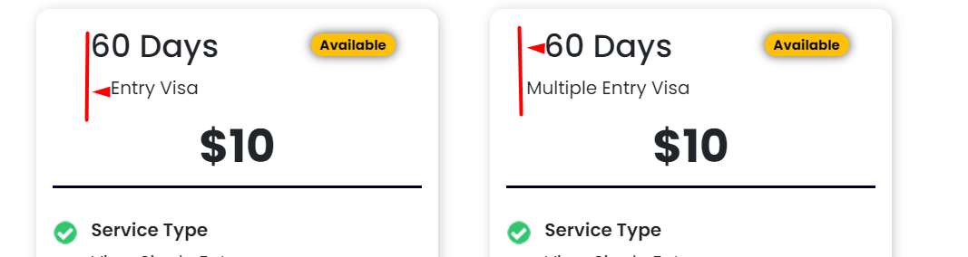

Home bottom slider (visa) bottom is not moving auto, also it should have 2 arrows on both side

Top menu visa tab, short term and long term, you have to put the packages, and client will give a small write up about short term and long term visas

Application

Header image is ok

Remove – Reach out to our team and make the heading “visa application”

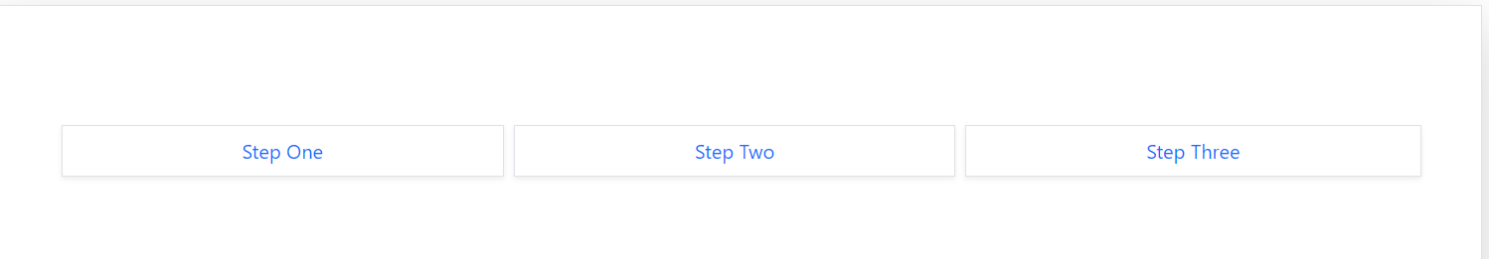

The above should replace the 4 icos, choose a appropriate one with a animation if possible

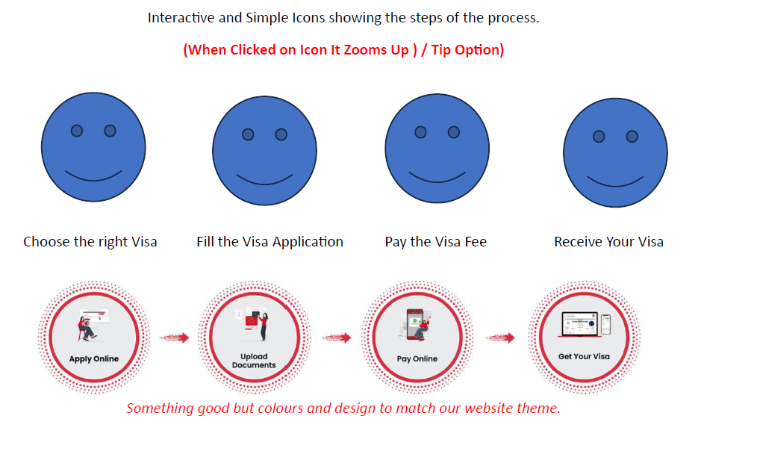

Not 8 icons, only 4

Use the wording on the 1st line, 2nd line is a sample

First name as in the passport

Second name as in the passport

The above should be shown in the place holder

Drop down menu should have all 6 packages



When the client choose a package rate on right side should change accordingly

Asterisk \* should be removed and kept only for Passenger information and contact information

Current job/ position – to be removed

Country of residence: ability to choose from countries

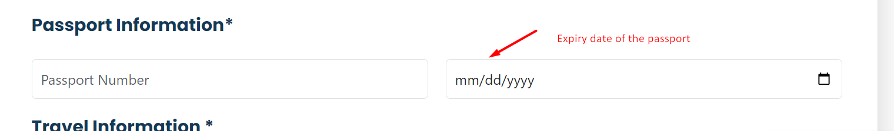

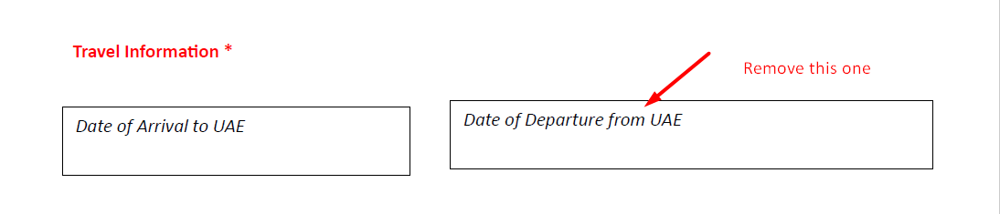

In the above ‘Date of arrival to UAE should be on place holder

Remove the Date of Departure from UAE

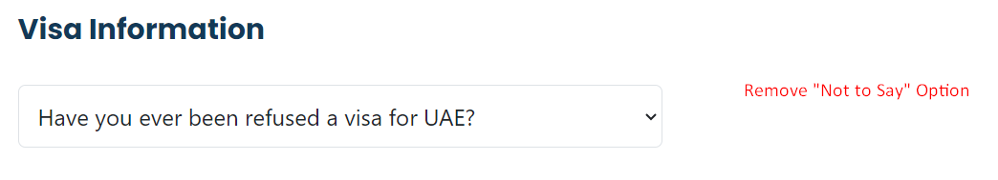

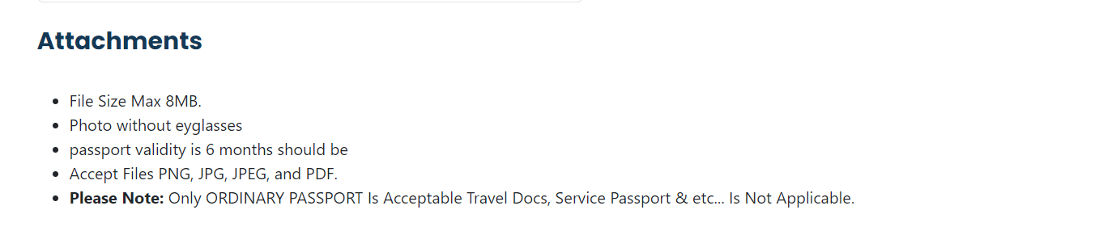

Instead of above use following content

When uploading images/ documents, please adhere to the following guidelines to simplify the process.

Max file size is 8MB

Photograph should be without wearing eyeglasses

Passport should remain valid for 6 months

Accepted files are PNG, JPG and PDF

We accept only ordinary passport, we do not accept travel documents, service passport etc

The following has to be at the bottom of the application page

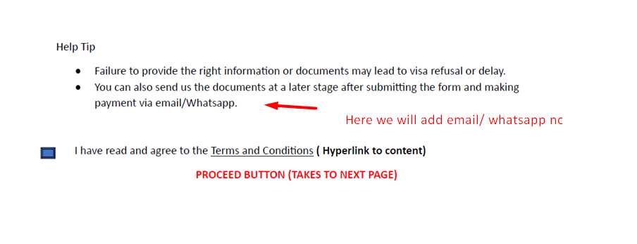

Footer

Compay

About us

Corporate enquiry

Contact us