Install docker desktop

wsl --install

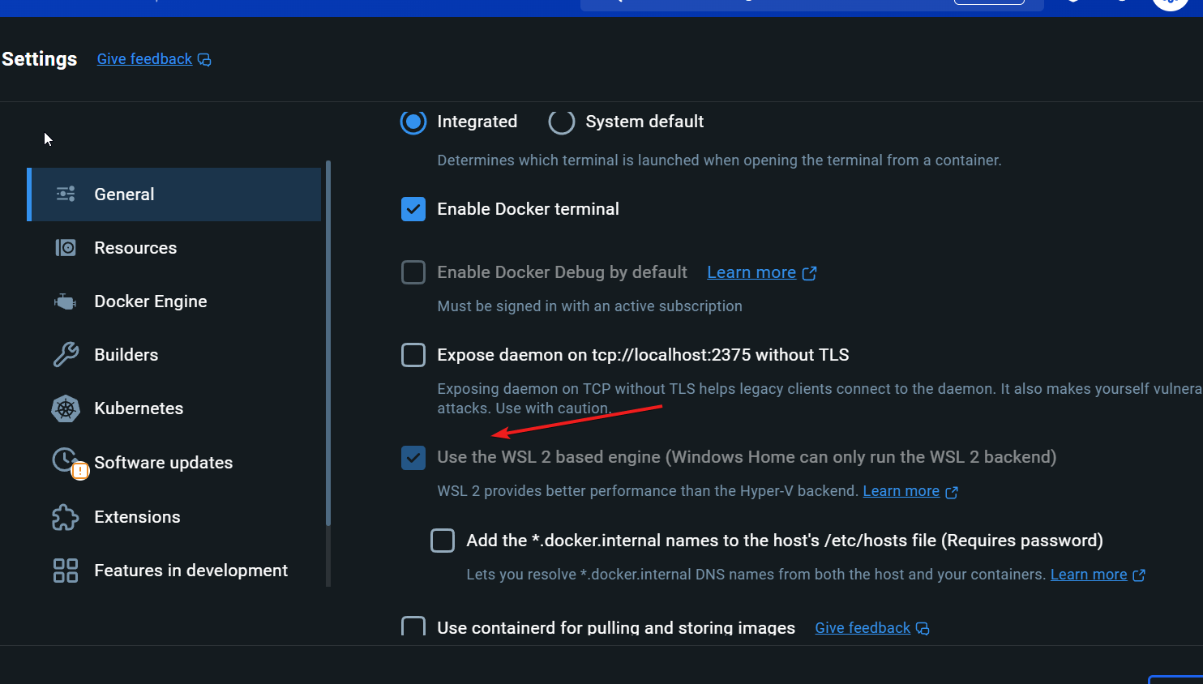

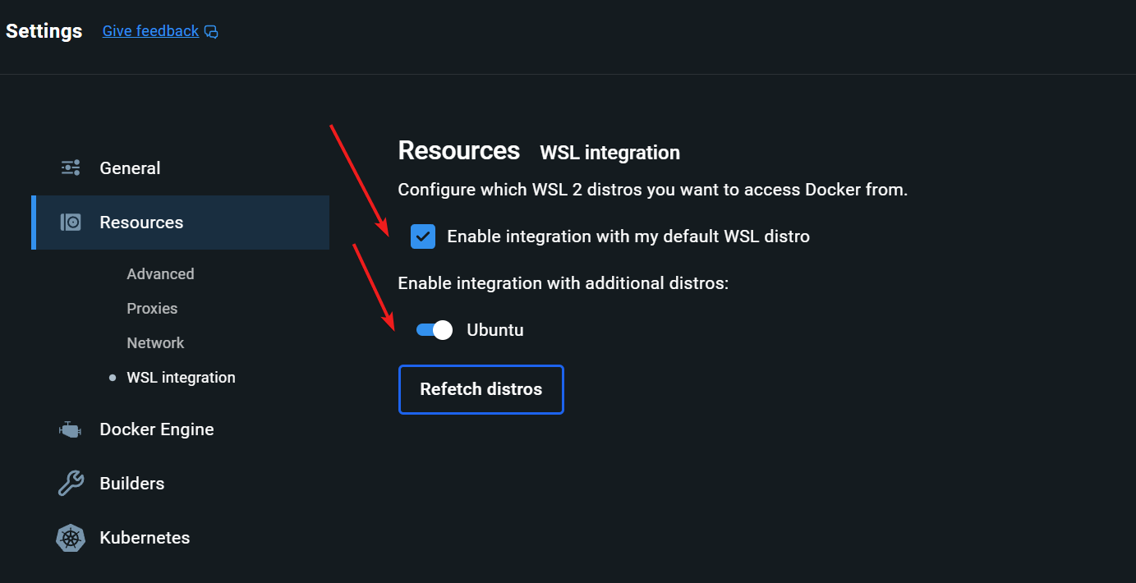

**Local simulator**

Update env file

docker compose -f "D:\2025\PracticeRepos\service-bus-emulator\emulator\docker-compose.yaml" up -d