**Web API**

**Tools and Tech**

* Using Clean Architecture
* Following Domain driven design
* Using MediatR
* Nsubstutite
* xunit

**Installation Guide**

1. dotnet tool install --global dotnet-ef
2. dotnet ef database drop
3. Build complete solution
4. open developer command prompt
5. CD D:\2025\PracticeRepos\DotNetPractice\BikeShop.API> goto BikeShop.API folder
6. run this command - dotnet ef migrations add InitialCreate -c AppDbContext -p ../BikeShop.Infrastructure/BikeShop.Infrastructure.csproj -s BikeShop.Api.csproj -o Data/Migrations
7. you should see migration folder and the related migration files in the BikeShop.Infrastructure project
8. run this command now to create the db
9. dotnet ef database update
10. check if the db is created with tables in the sql server
11. Uncomment out this line

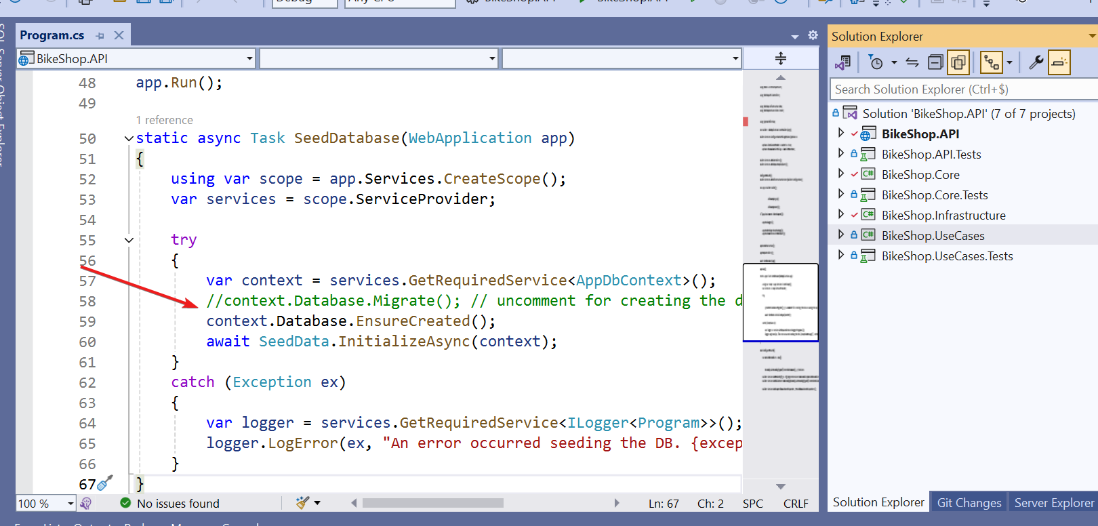

1. Build Solution BikeShop.API.sln
2. Set the API project as start up and run the project
3. This should create
   1. Sql server db - BikeShop
   2. Populate all look up tables
   3. Populate bikes table using bikes.json
4. Tests Result  
     
   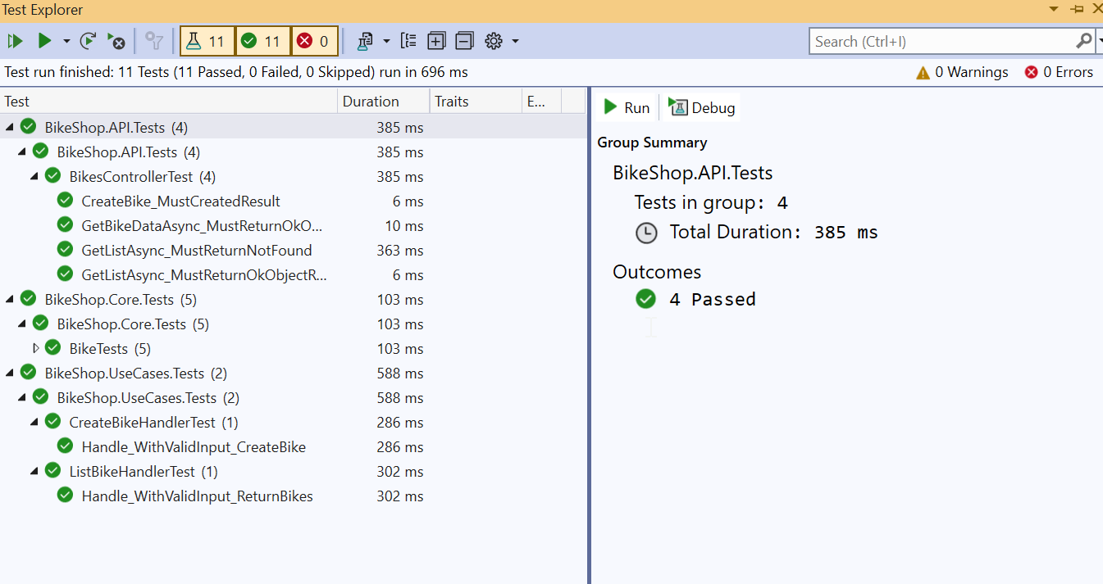

Now you are ready to consume it in the UI project

**Angular UI**

1. **Installation Guide**

Open AngularPractice folder in VS Code

Run npm install

1. **Test Result**

