Makara Ramoabi

20240045

Introduction to database

1.E-commerce

A store uses an ER diagram on their online store to keep track of customers, products purchased, and inventory management. It uses entities, attributes, and relationships to keep track of what is going on, and makes it easier to understand.

Entities- are concepts that store data e.g. Customer

Attributes- are the unique identifiers/ properties e.g. Name

Relationships- is how the different fields of data are connected e.g. 1 to many (1-N)

Customer

|  |  |  |
| --- | --- | --- |
| CustomerID | Name | OrderID |
| 028807979 | Khaula Molapo | 57066195 |
| 028807980 | Tankiso Masoebe | 57763477 |

Order

|  |  |  |
| --- | --- | --- |
| OrderID | Date | ProductID |
| 57066195 | 9/09/2025 | 027869052539056 |
| 57763477 | 11/09/2025 | 048690866412679 |

Product

|  |  |  |
| --- | --- | --- |
| ProductID | Product | price |
| 027869052539056 | Meta Quest2 | M 8236.78 |
| 048690866412679 | Lenovo ThinkPad | M 5783.64 |

Above is a simple diagram that displays the entities, attributes, and the relationship of the online store (e-commerce system). It starts with the customer; they have a unique identifier in the form of the CustomerID. Then it is linked to the OrderID, which leads to the order table (entity). It further links to the product table through the ProductID. Showing what was bought, when, and by whom.

2.Attributes

Attributes are the properties of entities; they further give meaning or identity to each entity. They could be a name, primary key, phone number, or an Address. This adds additional information needed to simplify managing and locating data. Attributes further define each individual piece of data. It can differentiate between two students with the same name and scores, by using primary keys. They can further be used to group data, like to find student with a score <90 in a classroom. To find the most ordered inventory supplies, or to even find the exact number of units sold in a certain period. Attributes define data in a way that makes it easier to manage and manipulate.

3.

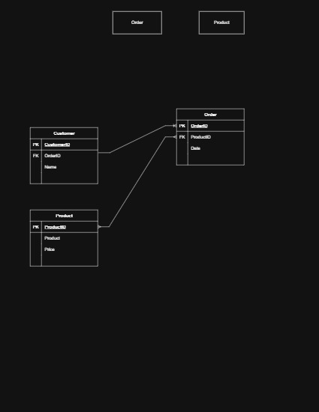

Using Draw.io was a simple enough to begin. I immediatley went to ‘entity realtionship’ and chose a table. Chose three tables and named them Customer, Order, and Product (these are the entities). Showed the primary key (PK) for all the table, and the foreign key (FK) to show relations. Then used the relationship lines to show how they are connected. Customer entity and order entity have a one to many realtionship (1:N), the Order entity and the Product entity have a many to many relationship (M:N). The Customer entity and the Product entity don’t have any sort of relationship, they are linked by the Order entity.

4.I used Canva, using the whiteboard to create my design. Went to tools, then selected two tables. Deleted one column for each table, then changed the layout. Gave both tables names (entities), then represented primary keys and one foreign key. Added the attributes and used arrows to indicat the relationship.