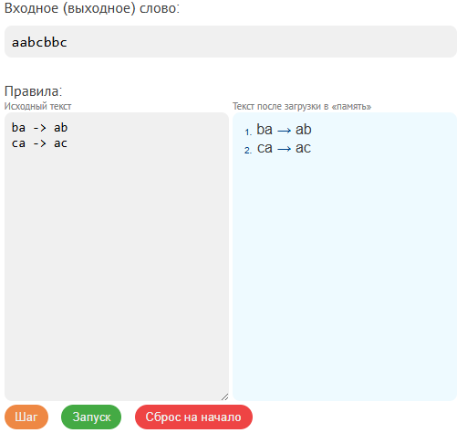

ba -> ab
ca -> ac

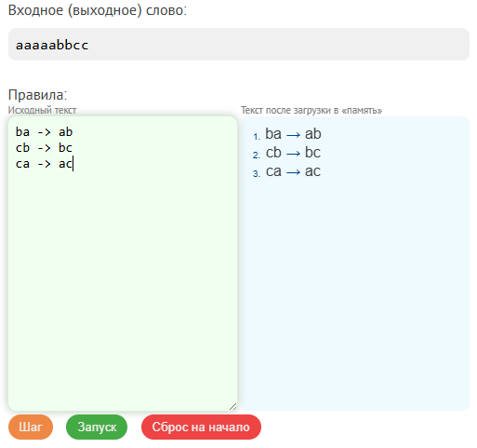
ba -> ab
cb -> bc
ca -> ac
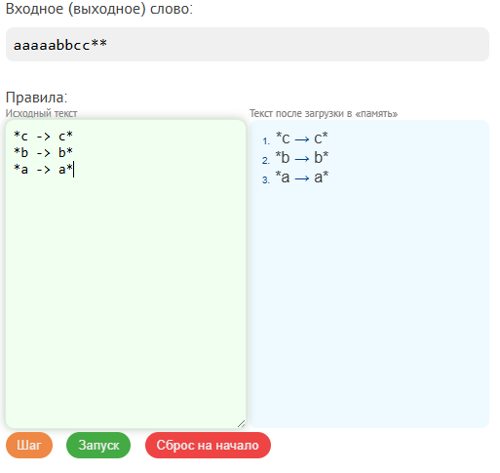
*c -> c*
*b -> b*
*a -> a*

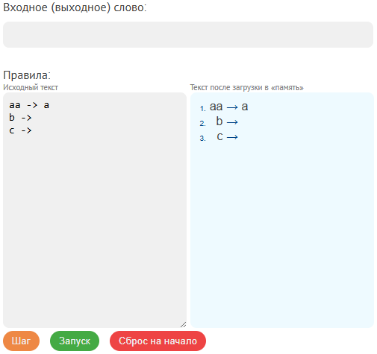
aa -> a
b ->
c ->

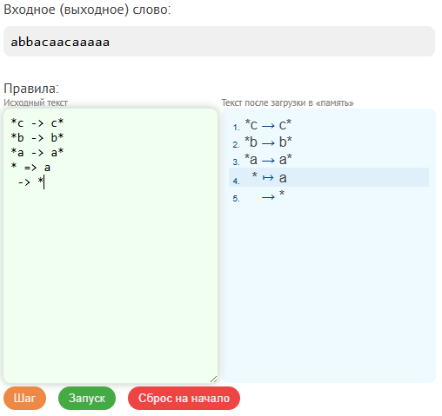
*c -> c*
*b -> b*
*a -> a*
* => a
-> *

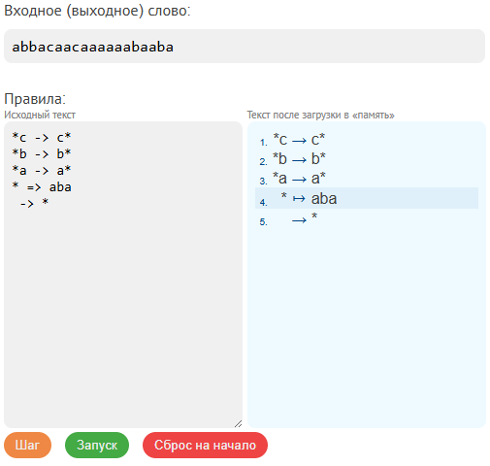
*c -> c*
*b -> b*
*a -> a*
* => aba
-> *

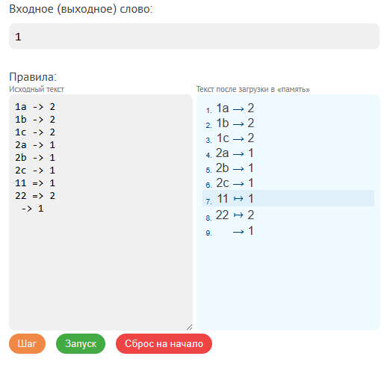
1a -> 2
1b -> 2
1c -> 2
2a -> 1
2b -> 1
2c -> 1
11 => 1
22 => 2
-> 1

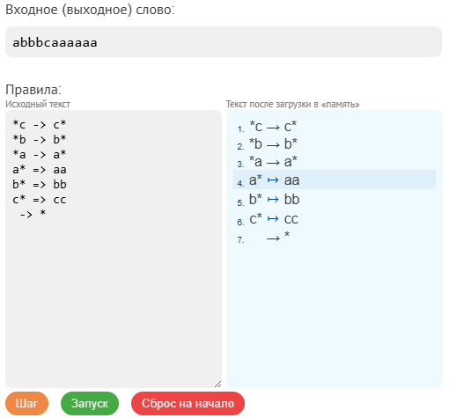
*c -> c*
*b -> b*
*a -> a*
a* => aa
b* => bb
c* => cc
-> *

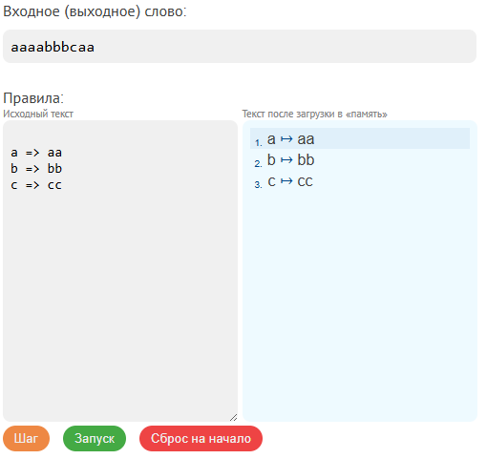
a => aa
b => bb
c => cc
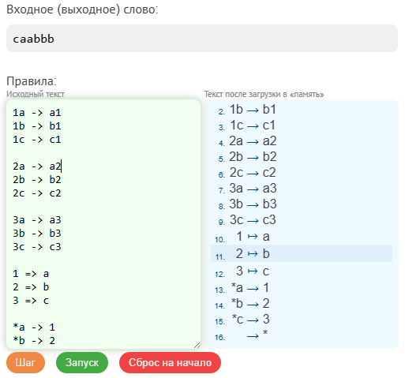
1a -> a1
1b -> b1
1c -> c1

2a -> a2
2b -> b2
2c -> c2

3a -> a3
3b -> b3
3c -> c3

1 => a
2 => b
3 => c

*a -> 1
*b -> 2
*c -> 3
-> *
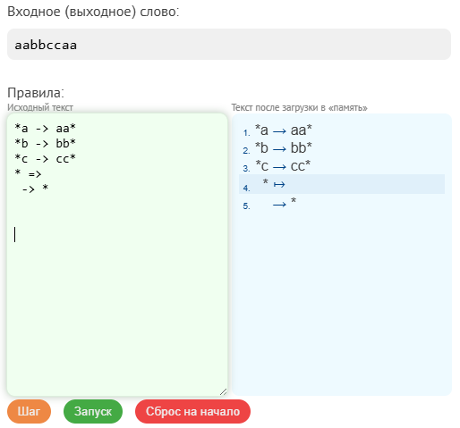
*a -> aa*
*b -> bb*
*c -> cc*
* =>
-> *
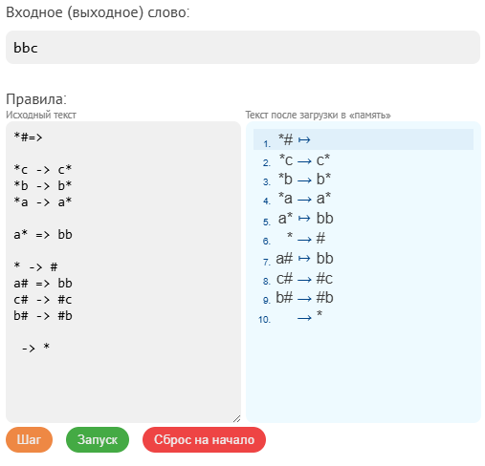
*#=>

*c -> c*
*b -> b*
*a -> a*

a* => bb

* -> #
a# => bb
c# -> #c
b# -> #b

-> *
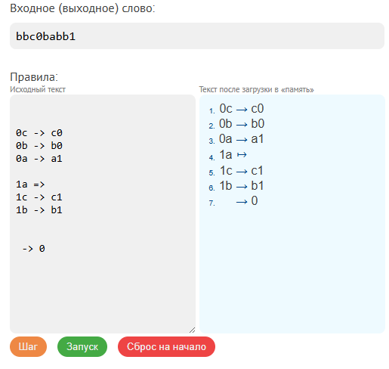
0c -> c0
0b -> b0
0a -> a1

1a =>
1c -> c1
1b -> b1

-> 0

