1 General Server Configurations
This is required steps to follow before setting up as more specific type of MU server.

[Server configuration table]
No | Steps | Description
1 | Setup BIOS | Configure date, time and OS type etc.
2 | Setup array configuration | Single HDD – Raid 0, Multiple HDD - Raid 5.
3 | Install OS | Windows 2000 Server SP4 and Windows 2003 Standard or Web edition has been approved for MU server.
4 | Install service pack and hotfix | Always apply the latest service pack and hotfix.
5 | Install driver and vender software | Regularly update the hardware driver and firmware.
6 | Apply Local security policy | You can use a pre-compiled INF file and then import it from the Local security policy console.
7 | Apply the registry tweak | Disable functions which can be a potential security hole. Ex) dontDisplayLastUserName, NoRecentDocsHistory
8 | Disable unnecessary Windows Service | You can use a pre-compiled REG file.
9 | Setup time server | Time synchronization across the MU system.
10 | Add GSAuth IP in the hosts file | Optional setting for game and FSGate server. You can locate the hosts file in “C:\WINDOWS\system32\drivers\etc” folder
11 | Install utilities | Win Commander for file management and system shutdown utility
12 | Configure server environment | - set best performance option in system advanced menu  - Allow remote desktop  - Set maximum terminal session to 2  - Use classic start menu  - Disable monitor power off  - Disable the screen saver  - Add event viewer, win commander and MU application shortcut into the quick start button  - Disable Microsoft network files and printer sharing on public network interface  - Use 800x600 resolutions with high Color option

[Default Desktop]
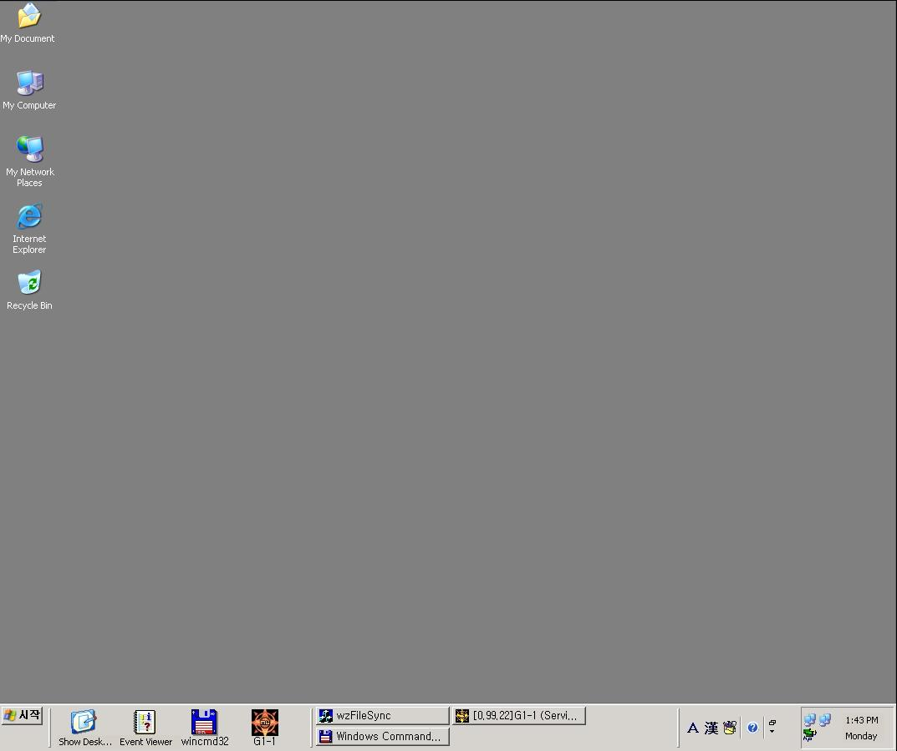
2 Terminal Service Configuration
This part of manual explains how to configure each server’s terminal service correctly. It simply disables some unnecessary functions such as disk mapping which allows any logon user to copy company’s confidential files to his/her PC. You have two options to implement this either by following below instructions or execute the provided registry tweak

remote_setting.reg
REGEDIT4

[HKEY_LOCAL_MACHINE\SYSTEM\CurrentControlSet\Control\Terminal Server\WinStations\RDP-Tcp]
"fDisableCpm"=dword:00000001

[HKEY_LOCAL_MACHINE\SYSTEM\CurrentControlSet\Control\Terminal Server\WinStations\RDP-Tcp]
"fDisableCdm"=dword:00000001

[HKEY_LOCAL_MACHINE\SYSTEM\CurrentControlSet\Control\Terminal Server\WinStations\RDP-Tcp]
"fDisableCcm"=dword:00000001

[HKEY_LOCAL_MACHINE\SYSTEM\CurrentControlSet\Control\Terminal Server\WinStations\RDP-Tcp]
"fDisableLPT"=dword:00000001

[HKEY_LOCAL_MACHINE\SYSTEM\CurrentControlSet\Control\Terminal Server\WinStations\RDP-Tcp]
"fDisableCam"=dword:00000001

Or Manual Configuration
1. Click on Start >> Administrative Tools >> Terminal Services Configuration
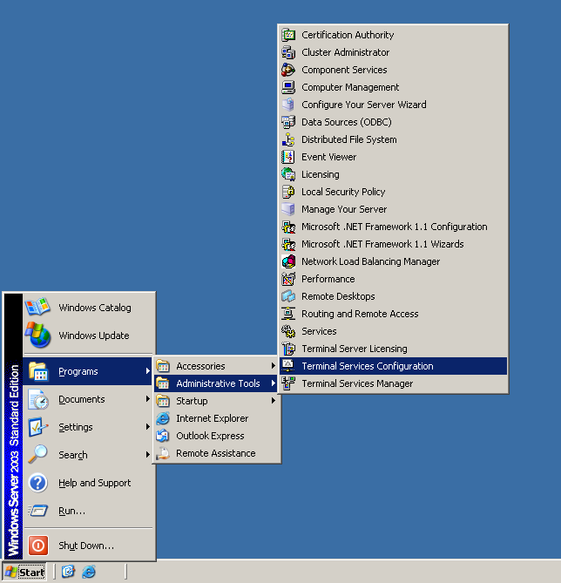

2. Double Click on “RDP-Tcp” Connection in main window
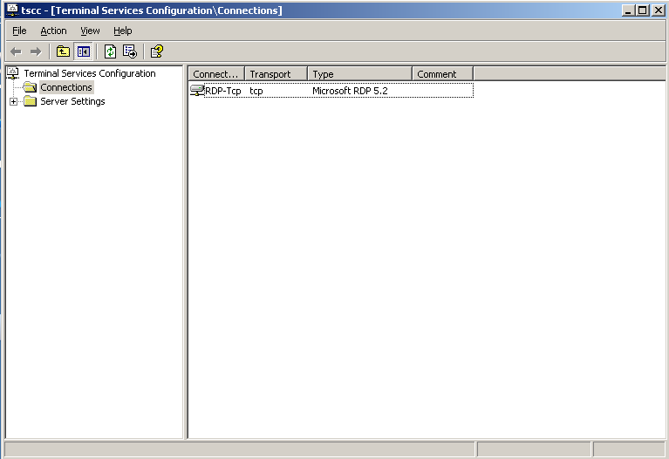
3. Click on Client Settings Tab
Check Drive mapping, COM port mapping, Windows printer mapping, LPT port mapping and Audio mapping (default).
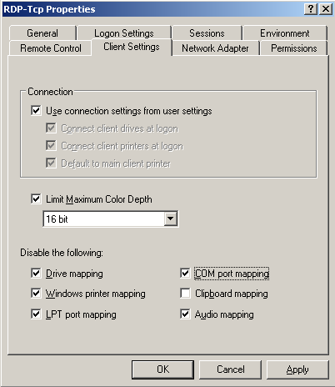

3 Unattended Installation
You can simplify the general Windows installation by using an unattended mode.

Preparation: | Original Windows CD
 | bbie.exe – Boot Image Extractor
 | cdimage.exe - CD-ROM Premastering Utility
 | Others – hotfix, utility and anything you want to include in the CD

[Create unattended CD]
No | Steps | Description
1 | Copy Windows CD | Copy all Windows CD contents to the local hard drive.
2 | Create a ‘WINNT.SIF’ answer file | You can manually create this file or use a setupmgr.exe tool to automatically create one. And then copy this file into the ‘i386’ folder.
3 | Create a ‘/$OEM$/$$/Temp’ folder | We’re using the $OEM$ distribution folders to install our hotfixes and registry tweaks. But to make this work, we need to specify two values in the WINNT.SIF file under [unattended] section.  [Unattended]  OemPreinstall=Yes  UnattendSwitch=Yes
4 | Copy all prepared hotfixes, registry and utilites etc. | Copy these files into the ‘/$OEM$/$$/Temp’ folder
5 | Extract a boot image | Use bbie.exe to extract a boot image from the original Windows CD  Example:  C:\Bbie [CD drive]
6 | create an ISO image file | Use CDimage.exe to create an ISO image file  Example:  C:\cdimage –l[volume_name] -h -n -o –b[boot_image] [source_file] [destination_file]

4 MS SQL server 2000 SP3a Installation
Please follow below steps to install MS SQL 2000 server.

[MS SQL 2000 Installation]
1. Click “SQL Server 2000 Components” |  | 2. Click “Install Database Server”
1-1 MS SQL 2000 Setup window  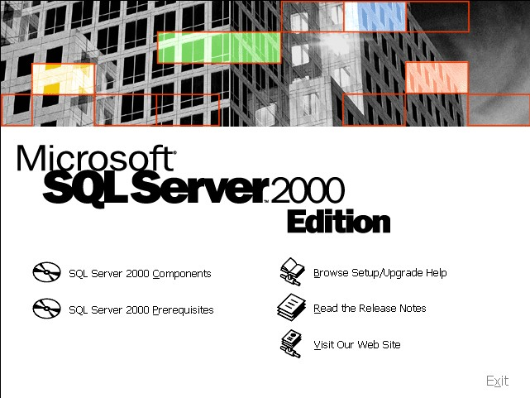 |  | 1-2 Install Components window  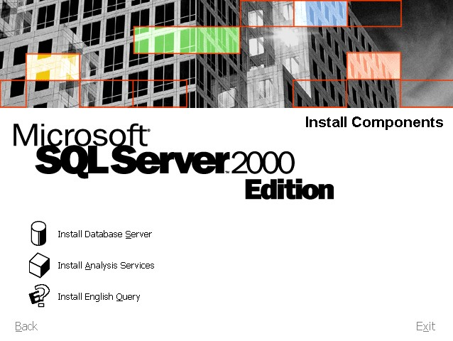
3. Click “Next” |  | 4. Select Local Computer(Default) and Click “Next”
1-3 Welcome  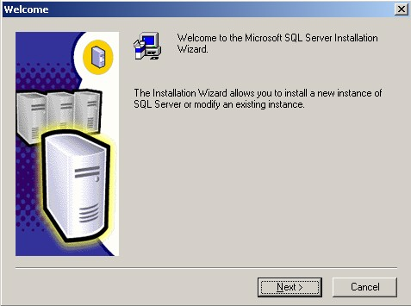 |  | 1-4 Computer Name  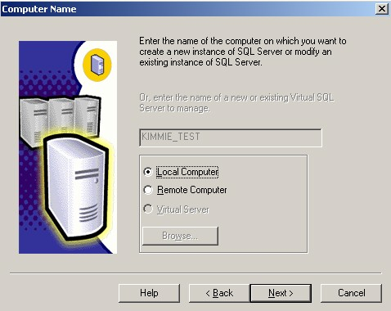
5. Select “Create a new instance of SQL Server or Install Client Tools” (Default) and Click “Next” |  | 6. Enter Name and Company
1.5 Installation Selection  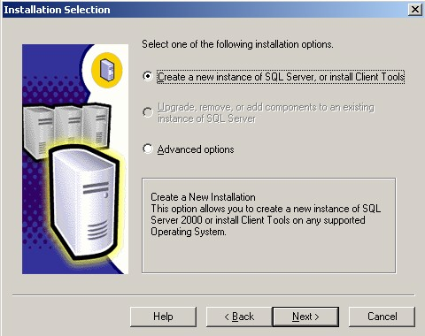 |  | 1.6 User Information  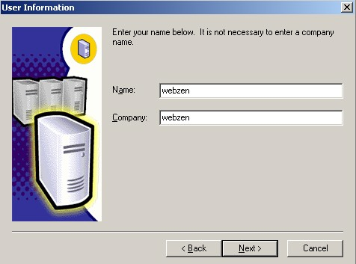

7. Click “Yes” |  | 8. Select “Server and Client Tools” (Default) and Click “Next”
1-7 Software License Agreement  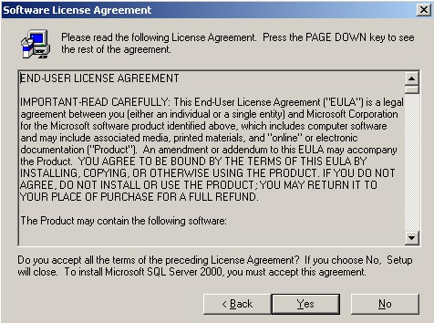 |  | 1-8 Installation Definition  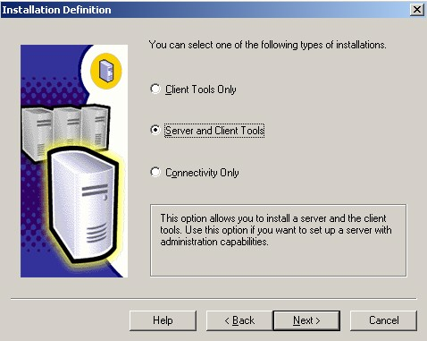
9. Check “Default” and Click “Next” |  | 10. Select “Custom” , Choose a Destination Folder and Click “Next”
1-9 Instance Name  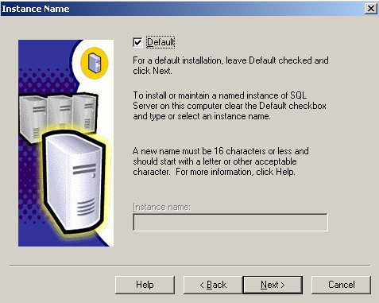 |  | 1-10 Setup Type  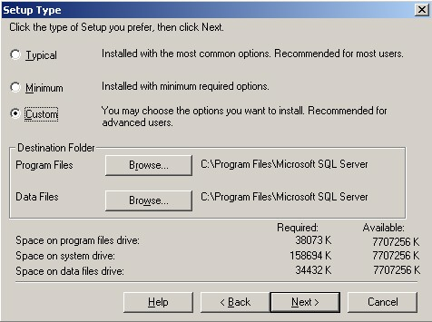
11. Click “Next” |  | 12. Select “Use the Local System account” and Click “Next”
1-11 Select Components  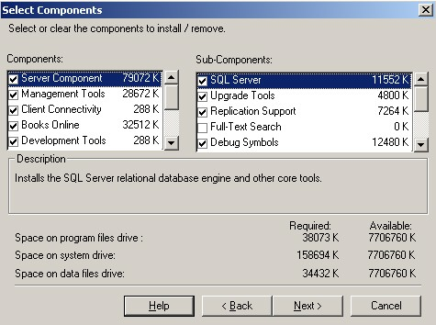 |  | 1-12 Services Accounts  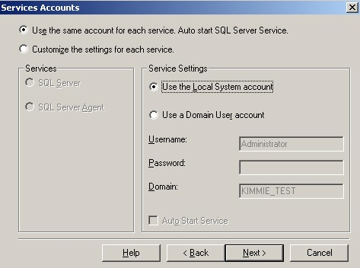

13. Select “Mixed Mode”, Enter Password and Click “Next” |  | 14. Select “Collation Designator” and Check “Case sensitive”, “Accent sensitive”, “Kana sensitive” and “Width sensitive”. Click “Next”
1-13 Authentication Mode  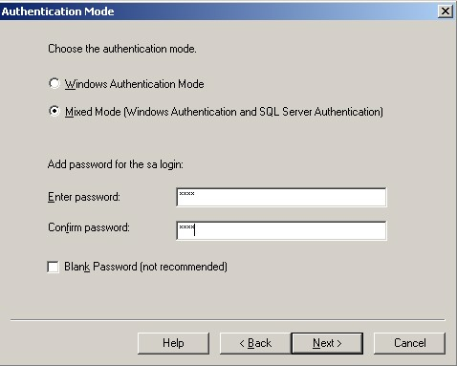 |  | 1-14 Collation Settings  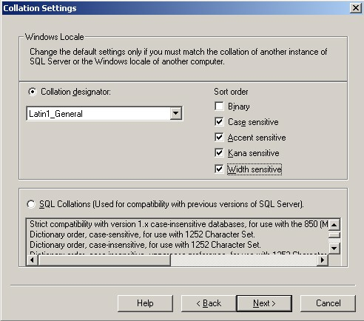
15. Click “Next” |  | 16. Click “Next”
1-15 Network Libraries  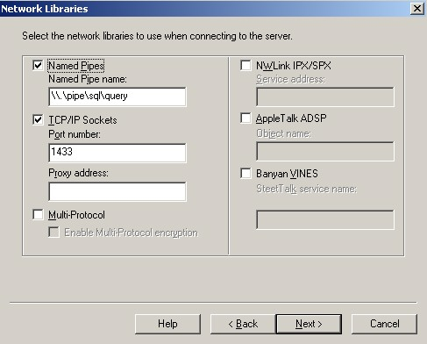 |  | 1-16 Start Copying Files  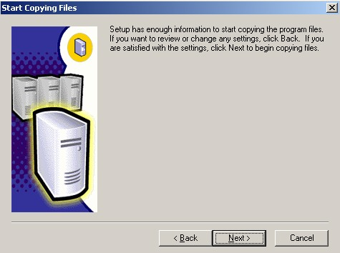
17. Setup Complete
1-19 Setup Complete
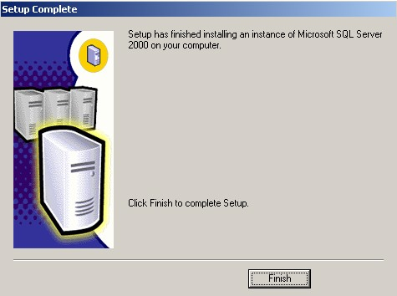

Post MS SQL 2000 Installation
Apply all critical MS SQL 2000 related hotfixes. And run below SQL query from the query analyzer.

select @@servername,@@version,getdate()
go
print 'no1'
go
use master
go
revoke execute on xp_regread from public
go
revoke execute on xp_instance_regread from public
go
print 'no2'
go
use msdb
go
revoke execute on sp_add_job from public
go
revoke execute on sp_add_jobstep from public
go
revoke execute on sp_add_jobserver from public
go
revoke execute on sp_start_job from public
go
print 'no3'
go
revoke all on msdb.dbo.mswebtasks from public
go
print 'no4'
go
use master
go
revoke execute on master.dbo.sp_runwebtask from public
go
print 'no5'
go
use msdb
go
sp_dropuser 'guest'
go
use msdb
go
revoke execute on sp_get_sqlagent_properties from public
go
print 'no7'
go
use pubs
go
sp_dropuser guest
go
use Northwind
go
sp_dropuser guest
go
print 'no9'
go
use msdb
go
revoke execute on msdb.dbo.sp_enum_dtspackages from public
go
revoke execute on msdb.dbo.sp_get_dtspackage from public
go

5 MU Application Setup

[MU Application Overview]
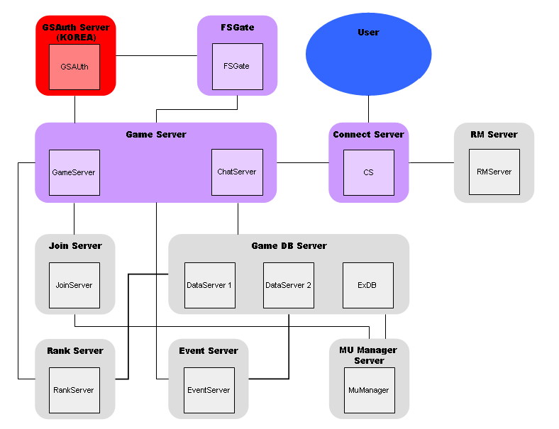

Application | GSAuth.exe
Server | GSAuth Server
Description | This server is located only at WEBZEN Korea. The purpose of this server is preventing the illegal use of MU game server by authenticate only the authorized game server. GSAuth server has pre-configured with authorized game server and FSGate IP list therefore it will authenticate the particular game servers when they start up. And then It will pass the location of corresponding FSGate.
Installation | N/A (Only for WEBZEN Korea)

Application | WzFSGate.exe
Server | FSGate Server
Description | It will transfer the game server data file to the authenticated game servers.
Connected to | GSAuth, Game Server
MS-SQL | Not Required
Installation | - Create folders like below.  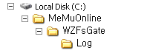  - Copy WzFSGate.exe to C:\MeMuOnline\WZFsGate  - Create a WzFSGate.exe shortcut into the quick launch. You don’t require to modify its target setting

Application | JoinServer.exe
Server | Join Server
Description | User authentication and billing management (commercial version) system.
Connected To | Game Server, MU Manager, Member_Web, Billing, Web Manager, Statistics DB
MS-SQL | Required
Installation | - Create folders as below.  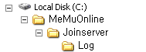  - Copy JoinServer.exe and corresponding DLL files to C:\MeMuOnline\Joinserver  - Create a JoinServer.exe Shortcut into the quick launch and modify its target as below.  [Options]  ▪ /p : JoinServer’s port number (Default 55970)  ▪ /ca : Connection Server IP address (required to enter)  ▪ /cp : Connection Server’s port number(default 55557)  Example: JoinServer.exe /caxxx.xxx.xxx.xxx

Application | CS.exe
Server | Connect Server
Description | Client version and game server list management. MU client connects to this server first.
Connected To | Game Server
MS-SQL | Not Required
Installation | - Create folders as below.  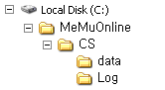  - Copy CS.exe to C:\MeMuOnline\CS  - Copy ServerList.dat and ServerInfo.dat to C:\MeMuOnline\data  [ServerList.dat Configuration]  [ServerCode] [ServerName] [ServerIP] [ServerPort] [STATUS]  Example : 0 "GameServer1-1" "10.1.100.4" 55901 "SHOW" or “HIDE”  [ServerInfo.dat Configuration]  [FtpServerInfo]  Address = xxx.xxx.xxx.xxx ;Auto Patch FTP address  Port = 21 ; FTP Port  ID = MuUpdate ; FTP account  PASS = MuUpdate  [GameServerInfo]  ClientVersion = 00.98.03 ; Client Version  ClientVersion_TEST = 00.98.03 ; Test Client Version  VersionFileName = version.wvd ; File name which contains a version information  - Create a CS.exe shortcut into the quick launch You don’t require to modify its target setting.

Application | MU_RANKING_DB_SERVER.exe
Server | Ranking Server (Devil Square)
Description | Game users gain an access to the quest at certain time period if they can provide the required special items. And this quest will help users to gain an extra experience rate. Ranking server will support these quests and gather all necessary data.
Connected To | Game Server, Game DB Server
MS-SQL | Required
Installation | - Create folders as below.  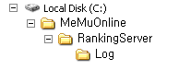  - Copy MU_RANKING_DB_SERVER.exe to C:\MeMuOnline\RankingServer  - Create a MU_RANKING_DB_SERVER.exe shortcut into the quick launch. You don’t require to modify its target setting.

Application | WZ_MU_EVENT_SERVER.exe
Server | Event Server
Description | Event management Server.
Connected To | Game Server, Data Server
MS-SQL | Required
Installation | - Create folders as below.  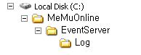  - Copy WZ_MU_EVENT_SERVER.exe to C:\MeMuOnline\EventServer  - Create a WZ_MU_EVENT_SERVER.exe shortcut into the quick launch. You don’t require to modify its target setting.

Application | RM_Server.exe
Server | RM Server
Description | It is Server-Client architecture. You can use a RM client to view total user, concurrent user statistic and each game server’s status etc.
Connected To | Join_Log, Connect Server, RM Client
MS-SQL | Not Required
Installation | - Create folders as below.  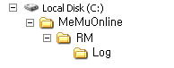  - Copy RM_Server.exe to C:\MeMuOnline\RM  - Create a RM_SERVER.exe shortcut into the quick launch. You don’t require to modify its target setting.

Application | MuManager.exe
Server | MU Manager
Description | Character and item management server. It provides add/remove/view/update functions to the game masters.
Connected To | Game DB Server, Join Server
MS-SQL | Not Required
Installation | - Create folders as below.  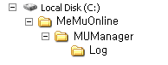  - Copy MuManagerServer.exe to C:\MeMuOnline\MuManager  - Create a MuManagerServer.exe shortcut into the quick launch. You don’t require to modify its target setting.

Application | GameServer.exe
Server | Game Server
Description | Actual server that communicates directly with a client. This server acts as an interface between a client and the other MU servers such as Join, Data and Ranking etc.
Connected To | GSAuth, FSGate, Data Server, ExDB, Chat Server, Join Server, Connect Server, Ranking Server, Event Server
MS-SQL | Not Required
Installation | - Create folders as below.  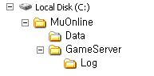  - Copy serverinfo.dat to C:\MuOnline\Data  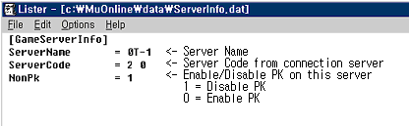  - Copy GameServer.exe and corresponding DLL files to C:\MuOnline\GameServer  - Create a GameServer.exe Shortcut into the quick launch and modify its target as below.  Target: GameServer.exe [Login_IP] [Login_Port] [GameDB_IP] [GameDB_Port] [GameServer_Port]  Example: GameServer.exe 10.1.1.254 55970 10.1.1.100 55960 55901  - Add GSAuth IP address in the hosts file (C:\WINDOWS\system32\drivers\etc)  127.0.0.1 localhost  218.38.44.100 gsauth.muonline.co.kr ; add this line  - Create a network Drive M: mapping to \\[Corresponding_Game_DB_IP]\data

Application | GameServer.exe
Server | Siege Game Server
Description | It supports the castle siege within a same cluster. Installation of siege game server is exactly same as above game server installation. Use the right executable file since game and siege game server’s executable file name is identical.
Connected To | GSAuth, FSGate, Data Server, ExDB, Chat Server, Join Server, Connect Server, Ranking Server, Event Server
MS-SQL | Not Required
Installation | - Create folders as below.  - Copy serverinfo.dat to C:\MuOnline\Data  - Copy GameServer.exe and corresponding DLL files to C:\MuOnline\GameServer  - Create a GameServer.exe Shortcut into the quick launch and modify its target as below.  Target: GameServer.exe [Login_IP] [Login_Port] [GameDB_IP] [GameDB_Port] [GameServer_Port]  Example: GameServer.exe 10.1.1.254 55970 10.1.1.100 55960 55901  - Add GSAuth IP address in the hosts file (C:\WINDOWS\system32\drivers\etc)  127.0.0.1 localhost  218.38.44.100 gsauth.muonline.co.kr ; add this line  - Create a network Drive M: mapping to \\[Corresponding_Game_DB_IP]\data

Application | ChatServer.exe
Server | Game Server
Description | It supports the chat communication between users during a game play. ChatServer.exe can be installed on one of the game server within a same cluster.
Connected To | Game Server, ExDB
MS-SQL | Not Required
Installation | - Create folders as below.  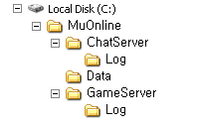  - Copy ChatServer.exe and corresponding DLL files to C:\MuOnline\ChatServer  - Create a ChatServer.exe Shortcut into the quick launch and modify its target as below.  Target: ChatServer.exe [ExDB_IP]  Example: ChatServer.exe xxx.xxx.xxx.xxx

Application | Dataserver.exe
Server | Game DB Server
Description | It manages all game data and store/retrieve this information to MS-SQL. It can be set up as a dual structure which can minimize the downtime by using an active and standby mode.
Connected To | Game Server
MS-SQL | Required
Installation | - Create a folder as below.  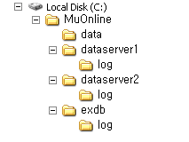  - Copy all configuration files to C:\MuOnline\data. This folder is going to be shared from all game servers within a same cluster.  - Enable share folder option for C:\MuOnline\data.  - Copy Dataserver.exe to C:\MuOnline\dataserver1 and C:\MuOnline\dataserver2  - Create a Dataserver.exe Shortcut into the quick launch and modify its target as below.  Target: Dataserver.exe [GameDB_Port] [Window_Position_No]  Example: Dataserver.exe 55960 1  - Create another Dataserver.exe shortcut into the quick launch and modify its target as below.  Example: Dataserver.exe 55960 2

Application | ExDB.exe
Server | Game DB Server
Description | Guild, Chatting and Friend list management Server.
Connected To | Game Server, Chat Server
MS-SQL | Required
Installation | - Create a folder as below.  - Copy ExDB.exe and corresponding DLL files to C:\MuOnline\exdb  - Create an ExDB.exe Shortcut into the quick launch and modify its target as below.  Target: ExDB.exe [Chat_Public_IP]  Example: ExDB.exe xxx.xxx.xxx.xxx

