Tool used to read Siemens S7 PLC data.

Front-end built with [React](https://reactjs.org/), Back-end made with [Express](https://expressjs.com/) and [NodeS7](https://github.com/plcpeople/nodeS7).

Front-end is hosted locally at localhost:9000, and the back-end is hosted locally at localhost:8080.

Installation

Made for Windows 64bit machines.

* Extract zip file to desired location.
* Open build folder, Right-click “TT13_Send.exe” > Send to > Desktop (create shortcut)
* Double-click shortcut to run.
* Leave the cmd pop-up window running while using.

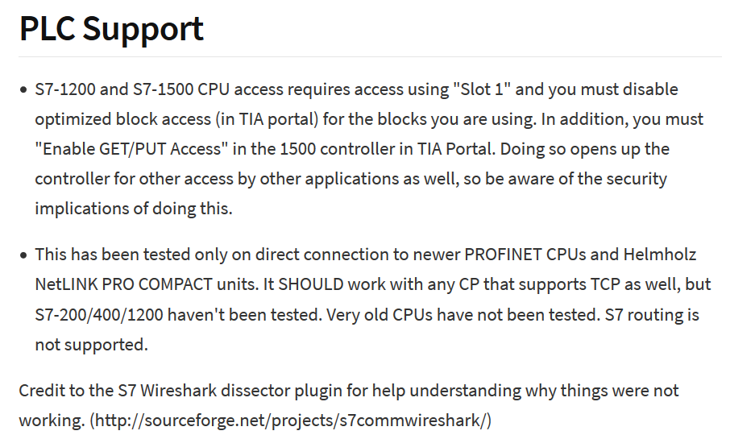

To change the PLC connection configurations, modify the “Connections.json” file located in the config folder. The following options are available.

