***This lightly edited work is part of an ongoing literature review that I am engaged in as a PhD student in HCI at IUPUI. I am broadly investigating the potential barriers to accessibility in text-to-image generative AI platforms like Midjourney and DALLE. I draw upon the current debates within the HCI discourse about the nature of creativity of such AI platforms and their harms to artists’ identities and economies. I also emphasize the lack of literature on the dangers such platforms produce particularly in stereotyping and invisibilizing people with disabilities like blindness.***

# Introduction

The definition of what constitutes “generative AI” (CHI 2023), what sort of responsibility its creators and consumers have with respect to disability and other marginalities like race and gender, and its place in culture and art are still being debated. For blind people, the lack of captions and audio descriptions could be a major barrier to accessibility on platforms like DALL-E and MidJourney. This potentially also prevents them from being part of the collaborative work which makes use of the abilities of generative AI. However, such platforms also open up the space for new kinds of collaborations and forms of art to emerge, in which people with diverse abilities should be able to participate. This is in line with the aim of the workshop and also my larger research goal of investigating how blind individuals engage in the production of art for purposes of joy and “self-expression” (Kleege, 2019).

The tension of humans being ‘replaced’ or ‘substituted’ by such platforms and tools was noted by several researchers (Cetinic & She, 2021, Du Satoy, 2021). In the context of blind artists, their engagement with and reactions to art generated by such platforms is still awaiting exploration. The participation of blind people in the larger discussion on AI’s ‘true’ creativity, and the value ascribed to art generated through it is also pending. The question of ‘value’ also extends to the nature of creative work that AI tools and platforms may be used for, beyond just art. People with disabilities, like blind artists and art consumers, already suffer from (intersectional) marginalization and invisibilisation in a techno-capitalist society (Kleege, 2019). Hence their participation in this discourse, about the powers and potential harms of large scale generative AI use is as vital, if not more than that of able individuals. I see my work as shaped by the legacy of disability justice work (Costanza Chock, 2021), especially its presence in the HCI discourse on the need for accessible systems including AI systems and platforms.

# Blindness and (visual) art

The work of blind visual artists is seen as “paradoxical” in that their being blind, prevents them from engaging with the medium in a meaningful way (Mirzoeff, p-379, 2006). This notion comes from a long and problematic discursive tradition, outlined by Kleege (2019), which views the lifeworld of blind people as being fundamentally incomplete because they cannot see and experience what comes with sight:

Since…Denis Diderot’s “Notes on Painting” (1765)...when theorists imagine a spectrum of human visual experience they place the blind man at one end, standing for the complete absence of vision. The other endpoint is occupied not by a person with merely average vision, but by the *artist*, someone understood to possess *extra special vision* ... .a superman of seeing.

(Kleege, 2019, p-2, italics own)

Mirzoeff (2006) echoes this when he discusses how blindness came to represent “an interplay between the metaphor of insight and the physiological structures of sight” in Western art (p-379). Ideas about blind people, and people with other disabilities have evolved through time. He discusses the rather fascinating eighteenth century philosophy of Sensualism which “held that the mind was formed directly from sensory experience and that those with *differing senses* had *differing minds*” (p-381). Such sentiments are behind the assumed ‘benefits’ of a disability like blindness, for example, Diderot assuming that the blind had tactile memory almost at par with if not exceeding the visual memory of the sighted (p-381). They also shape the cultural mindset that blind artists can never equal or exceed the capabilities of sighted artists.

Similarly in a non-Western context, the work of Shiro Fukurai, (1974) who trained several blind children in clay sculptures and finger painting in post-War Japan, underscores the nearly universal reality of misplaced notions surrounding the value and artistic ‘merit’ of the work of blind individuals. Initially he himself held such problematic ideas about how the initial work of his students was not always ‘alive’ and therefore not of high quality. However he saw them overcome their inferiority complex vis-a-vis sighted children when they won prizes and submitted their sculptures to art exhibitions alongside them (pp 52-56). In doing so, his own ideas of the value, merit and worth of artworks by blind individuals were challenged, as well as his role as a sighted art instructor to blind children. This is evidence of blind artists seeking space for self-evaluation and criticism with respect to sighted artists but in ways that aren’t paternalistic or compromising the dignity of the blind art creator.

His work also revealed how the children took a keen interest in using clay to express themselves and the world around them, even if it initially seemed uninteresting or beyond their reach, or as one child noted, their blindness meant they could “only be blind masseurs” (Fukurai, 1974, p-40). Therefore one might ask, if Fukurai’s students could transform from seeing clay as a medium that held them back and was “clammy” and “awful”, to those who won prizes for their work, is it not possible for AI platforms to also be a medium for today’s blind creators to produce satisfying and ‘valued’ work? Indeed, my research aims to explore how blind individuals and artists react to and use such platforms, if they do and further what sorts of tools and accommodations can be made to make such platforms more accessible.

The question of how blind individuals and artists see their work, as well as their phenomenology and exploration of their blindness, is integral to understanding this. Georgina Kleege (2019) is the partially blind daughter of two visual artists, who was raised in the environment of their work and their relationships with other artists. She sees the need for blind people to access and engage with art and spaces like museums and galleries, as a vital step in their own journey to possibly produce art. This process is referred to as engaging in “self-expression” (p-9) and a way for blind people to produce, consume and share knowledge about their life experiences the way sighted artists do.

She notes how for blind artists, this process begins with rebuffing the earlier discussed notion of their incomplete understanding of the world, and themselves in it, and in enshrining their right to public space, culture and institutions. The invisibilization and exclusion of blind people and their art from public discourse on art has meant that they are seen as not just incapable of sight but also sometimes of emotion. She notes how Ray Charles, the blind musician was asked by an interviewer following the World Trade Center’s collapse in 2001, if this was the one time in his life he was lucky not to have the ability to see (p-21). She sees this as an attempt to cement the idea of blind people not needing to or being able to respond to grave events the way sighted individuals can.

# Issues faced by blind visual artists

This idea of blind people being ‘othered’ as inferior in their lack of sight or somehow enriched by it, is important at two levels. One it extends to what kinds of art blind people may or may not produce, what is appropriate and accessible for them, and who decides that. For example, while tactile art is extremely important, a heavy emphasis on tactile art seems to encourage the idea that all blind people have gained an extraordinary sense of touch to compensate for their blindness, or that it is their only meaningful way of understanding the world (Descartes in Kleege, 2019, p-20). Kleege (2019) reaffirms that it is important for blind artists to have access to and create visual art, as much as other kinds of art, because they also live in worlds of color and create and share knowledge about it in ways that mirror and diverge from those of sighted people.

Second it extends to the existing bodies of art which depict the life and experiences of blind people, often built, and consumed without them, by sighted artists and consumers. This is a vast subject in itself, which extends from the ideas about blindness discussed earlier to the depictions of blindness in art beyond the strictly visual, like movies, plays, literature and folklore. Kleege discusses “*The Blind Man’s Meal*” by Picasso (1903) as an example of sighted people using blindness as a metaphor for their own body’s capabilities. The hands of the painting are a reference to the artist’s own artistry as well as the blindness of the subject, who is “groping” presumably to avoid breaking the jug, unlike the extended fingers of a sighted person, who would not have such a fear (p-123). She asks the following questions of Picasso, as a blind person making sense of her community’s depiction in art, while relying on the interpretations of sighted individuals like Derrida (1993):

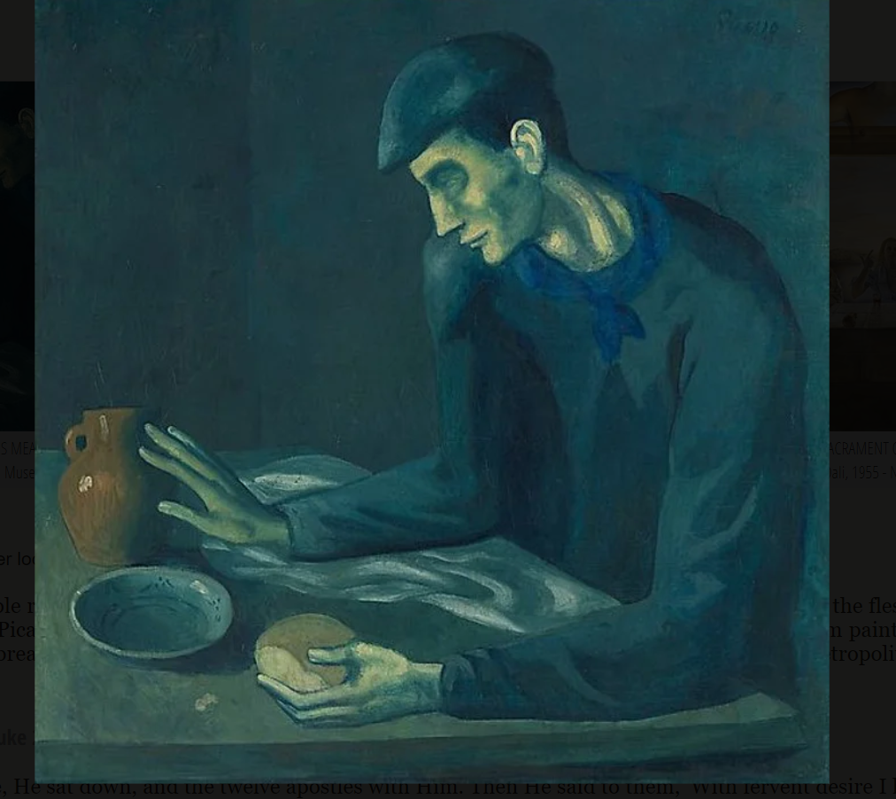

Did Picasso feel some sort of affinity for this blind man? In showing the blind man’s hands - one grasping, the other groping- is the relatively young Picasso saying something about his own artistic process where he clings to the conventions of his classical training while groping to the unknown experiments of his future career? (Kleege, 2019, p-125)

# What is ‘creativity’?

Therefore the creation of art is a process involving several intertwined sub processes. One, the ‘creative’ process of seemingly giving birth to something that didn’t exist before. Second of using that ‘original’ work as a meditation on life experience and reflection on the world around oneself. The consumption of art therefore is also tied to being able to experience and appreciate ‘creativity’ as much as ‘relativity’, in that art is something even those who did not create it, can experience and relate to.

Marcus Du Satoy (2021) describes creativity as “the drive to come up with something that is new, surprising and of value” (p-3) and art as the “outpouring of human code” (p-96). He draws upon Margaret Boden’s theorizing of creativity of three types, namely “exploratory”, “transformational” and “combinational" to explain how the work of AI tools in this area can be categorized. In Cetinic and She’s work (2021) there are elaborate descriptions of AI tools ‘learning’ from and drawing upon “object detection” and “similarity retrieval” from existing collections of art works. This could lead to the ‘art’ it produces being seen as an example of ‘creativity’ but again, if the value of such work is up for debate, so is the nature of this creativity:

…applications of AI technologies are rapidly advancing towards more user-friendly and easily operated frameworks. It is therefore difficult to estimate if the value of a particular AI artwork should depend on the technological complexity and innovation involved in its production, or only on the final visual manifestation and contextual novelty. (Cetinic & She, 2021, p-8)

Sherman and Morrissey (2017) corroborate this by emphasizing that the way artists and communities of art consumers decide that a particular artwork has value, is dependent on multiple factors, including its “socio-epistemic” value. This refers to the process of art appreciation occurring bidimensional at the cultural or social level, as well as the individual and emotional levels (Sherman & Morrissey, 2017, p-2). They found that while psychologists and scientists in fields like neuroaesthetics have been concerned with the latter, “the social context of art creation and art appreciation” has largely been ignored (p-3). They emphasize that the worth or value or art and its appreciation should not center simply around its aesthetic values, which seem to be the primary concerns of most philosophers and psychologists studying art appreciation.

They concur that such an approach fails to “fully capture or appreciate the social, cultural, or historical situatedness of the art-object or the person whose experience is being studied” (p-3). Therefore they advocate that the appreciation of art be understood in ways beyond just the individual’s response in neurological terms, and in terms of “socially-related outputs”.

This means recognising that art is a ‘social practice’ in terms of its generation and consumption over long periods of time:

Consider, for example, the social practice of portraiture, a genre of painting which depicts a human subject, often in which the face is the main theme. This genre has existed historically across many, varied communities, and the genre develops and is shaped by the cultural, economic, and moral commitments of various social groups, in addition to the artistic styles and technological developments within these communities. “Painting a portrait” is done with respect to norms, standards, and expectations of the genre that are, in an important sense, public. Moreover, these norms and standards constitute criteria for having created an excellent portrait. That is, we can individually and collectively deliberate and debate about whether some particular artwork is a portrait, or is a *good* portrait. (Sherman & Morrissey, 2017, p-4)

# The ‘artistic process’ and AI

Art itself is very hard to define objectively, because it has “no set of necessary and sufficient properties'' (Weitz, 1956 in Daniel and Song, 2019, p-156). This means that while definitions like art as the “outpouring of human code” are valid, they are also perhaps not the most useful (Du Satoy, 2021, p-96). Sherman and Morrisey's work (2017) on how art has a ‘socio-epistemic value’, was outside the HCI discourse, in that of art history and appreciation. Therefore, their highlighting of the lack of enough research on the “social context of art creation” implies that this is a larger systemic issue that precedes the emergence of AI platforms in this space. Within the HCI discourse several researchers working in this area have tried to develop at least a working definition of art and its ‘value’ to enable understanding the nature of AI art and the experience of its creation and consumption.

Daniel and Song (2019) emphasize the “social and cultural value of art as a means of human agency as well as a representation of a culture’s identity through time” (p-155). This is significant because it lays bare two of the central threads in the fabric of this conversation.

One, around individual human agency, or the role played by human actors in creating and affirming the value of art objects, extending in this case, to AI art. Second, the larger social and cultural structures within which the individual exercises ‘artistic’ agency and the evolution of these structures.

This distinction, or more holistic understanding of the phenomenon is significant. This is because the effects of AI use in art creation are felt on the individual level by artists and their communities. At the cultural level they reinforce “social stereotyping” and existing “hegemonies'' (Jiang et al, 2023). This aligns with one of the several definitions of art that Daniel and Song (2019) probe, where Dickie (1969) “poses two conditions for art to exist: 1) to be an artifact; 2) some society or sub-group needs to confer the status of “candidate for appreciation"” (Dickie, 1969, in Daniel and Song, 2019, p-157).

Therefore while art remains something felt and created at an individual level it is also embedded in a political structure within which its value is determined, shared and legitimized. This ‘feeling’ or emotional and neurobiological response to art is also a form of “empathic knowledge” (Novitz, 1987 in Daniel and Song, 2019, p-157). This refers to the process by which individuals compare their views of the world with others through “direct experience” in this case, of art and art creation or consumption. So art is a means of communication, where humans can represent themselves as well as aspects of themselves, real or imagined, to those around them. Daniel and Song (2019) refer to it as a “meta-language to express things we cannot communicate with other means” (p-157). I therefore understand art to be a subjectively experienced means of human self-expression and communication, embedded within a socio-cultural and symbolic structure. The human element here is distinguished not just from non-human actors like AI tools but also other living beings like birds and animals (Jiang et al, 2023, p-365). This is because in humans, art extends beyond being a response to “organic pressures” or the bare neurobiological state of being, and encompasses all the aspects touched upon previously, which include the cultural and individual states of its experience.

# AI ‘art’, bias and disability

Jiang et al (2023) find that this human experience and control of the creation of art has meant an erroneous conflation of what image generators ‘do’ with what ‘real’ artists do. They call this the “anthropomorphization of AI” and posit that this is harmful, for several reasons. One of their major concerns is around the creation of these tools and the processes involved in their training and deployment. They remain deeply critical of the current discourse around these tools that seems to obscure the responsibility of their failures away from the organizations that created them as they are currently. An example of this they point to is of references to such tools being “inspired” by the works and styles of real artists, which is a uniquely human experience. This is opposed to the reality of them simply being trained on datasets and producing recreations of existing styles found in them (Jiang et al, 2023, p-365).

Daniel and Song (2019) also sought to demystify the perceived autonomy of AI tools. They find that it enabled them to be seen as capable of achieving “high forms of human abilities like art making” (p-158). They affirm that the role of AI in ‘computational arts’ and ‘computational creativity’ should be understood within that of the human “margin of control” over the final output (p-157). The centralisation and crystallization of the human within the AI art process means that even in art that is AI generated, the human element is what retains importance, as opposed to the “technological complexity and innovation involved in its production, or only the final visual manifestation and contextual novelty” (Cetinic & She, 2021, p-8).

Sherman and Morrissey (2017) also point out that the skills required to appreciate art are necessarily social because they necessitate an understanding of cultural and social realities as well as “one’s ability to better understand oneself and other people, and to potentially revise one’s own moral, political, or social commitments” (p-4). The idea of arts-as-a-practice is therefore particularly vital to understanding the discourse on the supposed powers and capacities of generative AI platforms like DALL-E and MidJourney. This is because their larger cultural appreciation is often in terms of how ‘photorealistic’ they are or the powers they give users to create artworks in seconds that might have taken years, using features such as “outpainting” or “zoom out”, for example (Edwards, 2023). However, while such tools are increasingly popular for these features, there are also those who feel that the artistic work of AI is “more a process of mimicry than intelligence” (Cetinic & She, 2021, p-9).

The core concern surrounding these platforms is one that has plagued previous large scale AI tools and experiments around amplification of existing biases and discriminatory structures in society. Artists with disabilities such as blindness might find themselves faced with two levels of potential bias, one from the larger art community, and one from what AI tools reproduce.

The latter has received much critical scrutiny from the HCI community, at the algorithmic level, and now in the case of generative AI, at the prompt level in text-to-image platforms (Chowdhury & Kuzminykh, 2023). In their early analysis of public discourse on Reddit and Twitter on the potential biases around tools like DALL-E and Stable Diffusion, Chowdhury and Kuzminykh (2023) found significant proof of concern of gender and racial biases as well as economic and political biases. They noted individuals recounting how they entered the prompts “handsome man” and found Asian men to be rarely if ever included in the response images (p-3). Similarly darker skinned men and women also seemed to be barely represented in the kinds of images generated by these tools. There were also concerns pertaining to the safety and dignity of women as one individual shared how “even the weakest link to womanhood or some aspect of what is traditionally conceived of as feminine returned pornographic imagery” (p-4).

However, this work didn’t take into account disability as an axis along which bias was possible or relevant. The responses of organizations like OpenAI to these criticisms in terms of mitigation techniques also needs deeper examination.

The questions Kleege (2019) raises are evidence of the social and epistemological evaluation of art of the kind Sherman and Morrissey (2017) discussed earlier. In the context of mainstream generative AI platforms it is not clear if these processes take place or are feasible on them, and if the platform itself has ways of analyzing the ‘art' it produces for contextual nuances, like what Kleege (2019) is doing.

Therefore extending Kleege’s work to the present context of generative AI based platforms for art creation and consumption, several tensions and concerns arise around the nature of participation and space for blind artists. These include, as discussed earlier, problematic conceptions of the blind, evidence of bias in the images produced by these platforms, as well as the socio-epistemic value of this ‘art’. These are pressing because as these tools become entrenched in daily life and culture, their role in shaping and building knowledge about disabilities and marginalities like blindness, cannot be undermined. The work that Chowdhury and Kinzukh (2023) have undertaken needs to be extended to the realm of disability bias.

The space for authentic self-expression by blind artists on such platforms needs to be safe and accessible without further reinforcing discriminatory and exclusionary biases. The design of such spaces therefore needs to be informed by engaging with the blind artist community and their vision for their art and its place alongside AI generated art as well as that generated by sighted artists. Reliance on such tools to represent the lived experience and artistic self-expression of blind artists could therefore be problematic. It would imply the amplification, or otherwise complication, of existing biases and lacunae, in representing the experiences of marginalized and invisibilized individuals like those with disabilities. It is also not clear if these existing databases have enough knowledge of the visual art of people with disabilities such as blind artists, and if there are ways that blind people react to and engage with this art.

**Conclusion**

New advances in generative AI art creation tools have been used by [some](https://www.facebook.com/groups/officialmidjourney/permalink/486301523661417/?paipv=0&eav=AfbenjLvBfvrGafF8cxMltApEyv_fnumBDzcTJObVh2YV9HhY7RrZf-QYcjjF0xoGgw&_rdr) blind artists, but blind artists’ experiences and preferences around AI art creation have not yet been adequately explored in the scientific literature. Below, I describe two potential challenges that may arise with the use of AI tools for art creation by blind artists: existing conceptions within the art world about the “legitimacy” of AI-generated art, and the potential bias these tools might display against people with disabilities .

Based on what has been identified in this review, I propose two research questions:

**Q1. How do artists and more specifically artists with disabilities (like blindness) relate to their art, and the art of others like them? How is it shared, consumed and evaluated?**

**Q2. Do blind artists use or seek to use such tools to create and share art? What is their experience of art generated through such tools? Do they engage with such art in the same way as they would with the art of each other and sighted artists' work? If there is a difference, why?**

The first question will require me to engage with literature in the space of disability studies art and the latter will be at the intersection of that and the larger discourse on generative AI in HCI. I conclude by stating that I am optimistic my participation in the workshop will enable me to continue making progress towards these goals.

# References:

Benj Edwards - Jun 23, 2023 8:18 pm UTC. (2023, June 23). *“Stunning”-midjourney update wows ai artists with camera-like feature*. Ars Technica. https://arstechnica.com/information-technology/2023/06/stunning-midjourney-update-wows-ai-artists-with-camera-like-feature/

*The Blind Man’s Meal*. . The Met. Retrieved from https://www.metmuseum.org/art/collection/search/488596.

Cetinic, E., & She, J. (2022). Understanding and creating art with AI: Review and outlook. *ACM Transactions on Multimedia Computing, Communications, and Applications*, *18*(2), 1–22. https://doi.org/10.1145/3475799

Chowdhury, N., & Kuzminykh, A. (n.d.). *An Exploration of Prompt-Based Biases in AI art generated tools.* GenerativeAIandHCI.github.io. https://github.com/GenerativeAIandHCI/GenerativeAIandHCI.github.io/blob/main/papers/Prompt-based-biases.pdf

Costanza-Chock, S. (2020). *Design justice: Community-led practices to build the worlds we need*. The MIT Press.

Daniele, A., & Song, Y.-Z. (2019). Ai + art = human. *Proceedings of the 2019 AAAI/ACM Conference on AI, Ethics, and Society*. https://doi.org/10.1145/3306618.3314233

Fukurai, S. (1974). *How can I make what I cannot see*. Van Nostrand Reinhold.

Jiang, H. H., Brown, L., Cheng, J., Khan, M., Gupta, A., Workman, D., Hanna, A., Flowers, J., & Gebru, T. (2023). Ai art and its impact on artists. *Proceedings of the 2023 AAAI/ACM Conference on AI, Ethics, and Society*. https://doi.org/10.1145/3600211.3604681

Kleege, G. (2019). *More than meets the eye: What blindness brings to art*. Oxford University Press.

Mirzoeff, N. J. (2006). Blindness and Art. In *The disability studies reader*. essay, Routledge.

Sautoy, D. M. (2020). *The creativity code: How ai is learning to write, paint and think*. 4th Estate.

Sherman, A., & Morrissey, C. (2017). What is art good for? the socio-epistemic value of art. *Frontiers in Human Neuroscience*, *11*. https://doi.org/10.3389/fnhum.2017.00411