**Gear Parameters**

**Terminology**

Gear Tooth Gear Ratio

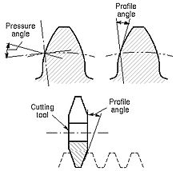 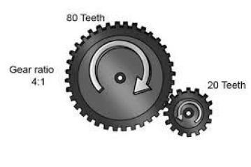

Gear

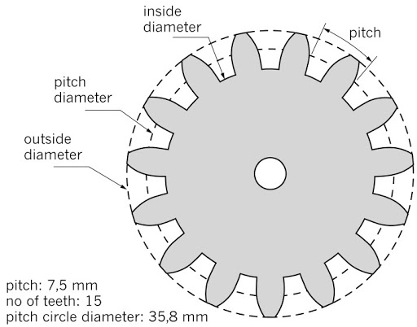

Gear Module: <http://fab.cba.mit.edu/classes/863.09/people/cranor/How_to_Make_%28Almost%29_Anything/David_Cranor/Entries/2009/10/12_Entry_1_files/module.pdf>

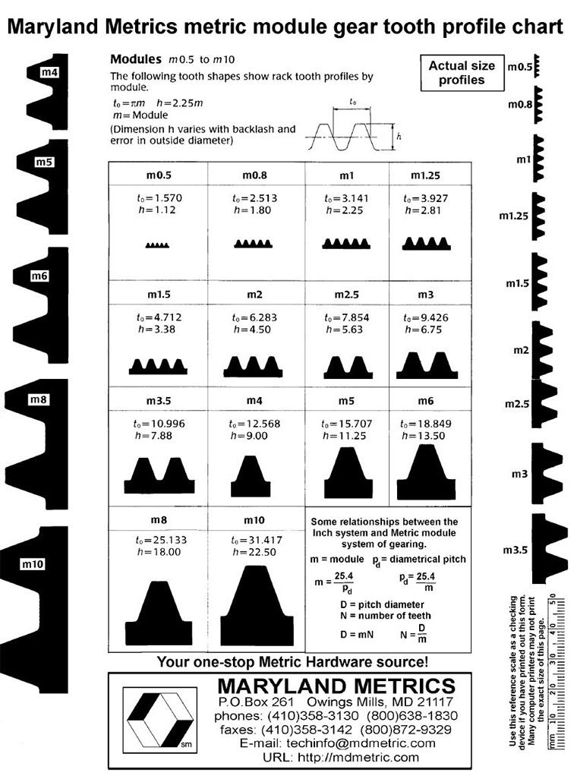

Backslash in Gears

Backlash, a clearance between mating gear teeth, is built into speed reducers to let the gears mesh without binding and to provide space for a film of lubricating oil between the teeth. This prevents overheating and tooth damage.

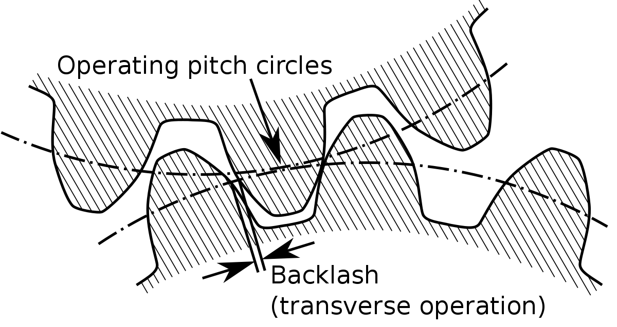

More Parameters in Gears

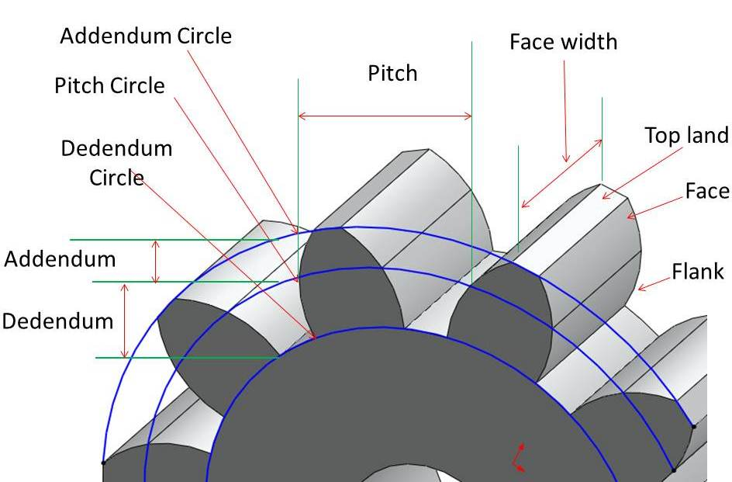

|  |  |  |
| --- | --- | --- |
|  | Recommended Parameters | Printing example |
| Meshing condition | 1. Identical modules  2. Identical pressure angles |  |
| Gear ratio | 1. The recommended ratio for 3D printed gears is **from 0.2 to 5**. It affects the number of teeth on your gear.  2. For gear ratios greater than 5:1, consider a two-stage gear set. |  |
| Pressure Angle | For 3D printing a **20-25 deg angle** is a good balance of chunkiness and efficient motion transfer on a palm sized gear. |  |
| Number of Teeth | 1. Single Gear: Recommended for**20-degree pressure angle** number of teeth is **minimum 13**. For a **25-degree angle**, the number of teeth lowers to a **minimum of 9**.  2. Gear Train: For **the same gear ratio 2:1**, with 15 and 30, the teeth will be worn out quicker. **With 15 and 31 teeth**, the signs of use will be evenly spread.  3. Printing Example: 12P, 16P, 20P, 24P, 32P, 48P | <https://www.thingiverse.com/thing:3211633> |
| Pitch Diameter | Printing Example:  Sample can be scaled down | <https://www.thingiverse.com/thing:2021770> |
| Module | Printing Example:  M0.5-M3 | <https://www.thingiverse.com/thing:3207992> |
| Involute geometry | Plugin GearGen for Rhinoscript  <https://makearchitecture.wordpress.com/people-2/varvara-toulkeridou/involute-gear-plug-in-demo/>  Plugin Gear for grasshopper  <https://www.food4rhino.com/app/gear#downloads_list> |  |
| **Backlash** | 1. As a rule of thumb **the average backlash**is defined as **0.04 divided by the diametral pitch; the minimum** being **0.03** divided by the diametral pitch and **the maximum 0.05** divided by thediametral pitch. In a gear train, backlash is cumulative.  2. This breathing space is extra spacing to ensure free rotation. For 24p gears, it’s about .003″, while larger gears will need around .005″. |  |
| Face Widths | 1. Single Gear: A good general rule is for the thickness to be at least **three to five times the circular pitch of the gear**. Doubling the width of the gear essentially doubles its strength.  2. Gear Train: The **face widths** (the thickness of the gears) **should roughly match** to make the best use of the material. |  |

**Online Demonstration for Different Parameters**

<https://geargenerator.com/#200,200,100,6,1,3,0,4,1,8,2,4,27,-90,0,0,0,0,0,0,16,4,4,27,-60,0,0,0,0,1,1,12,1,12,20,-60,0,0,0,0,2,0,60,5,12,20,0,1,0,0,0,0,0,3,-515>

**Mechanical Backlash Standard**

