**Basic design (minimum requirements):**

* Map displayed in DOM – uses external jQuery library for styled map
* Markers/Pins on each city with pro team
* Clickable cities buttons to display data for selected team/city in table
* Table (repeating element) – displays sports data (schedule, scores, etc)on selected team
* Optional features can be added as stretch goals (see advanced design below)

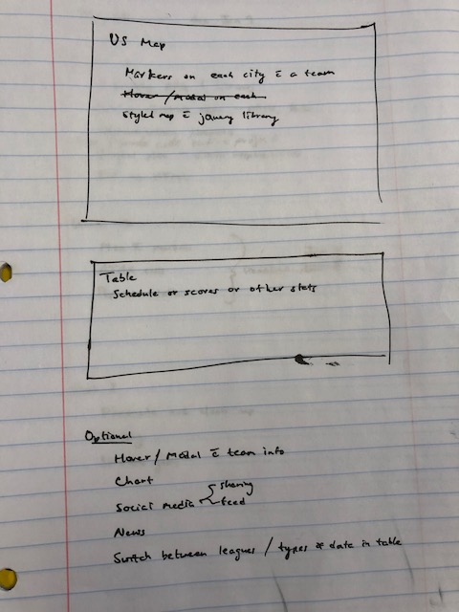

**Advanced design (optional features):**

* Hover/Modal displays various data/objects when user hovers over pin
  + Team logo/Team name/Team website
  + current record/schedule/scores/stats/charts
* Chart/data visualization API to display team data
* Social media sharing options
* William Hill API for integrating betting/odds data
* Additional sports – buttons to allow user to select different sports
* Recent news items for selected team
* 3rd section for users to search for individual player stats and display in DOM

