SUPER PATCH
Chiropractor Channel Content

Website Content for channel.superpatch.com

Drug-Free Wellness Technology
Backed by Peer-Reviewed Clinical Evidence

How Super Patch Fits a Chiropractic Practice
Chiropractic care centers on the relationship between spinal alignment and nervous system function, enabling the body's innate healing capacity. Super Patch's Vibrotactile Technology (VTT) is the ideal complement to your adjustments, providing drug-free support that works with the same neural pathways you understand.

Our patches offer patients take-home solutions to maintain progress between visits, manage discomfort without medication, and support the body's natural recovery process. With peer-reviewed clinical evidence backing our Freedom patch, you can confidently recommend technology that aligns with your drug-free, non-invasive philosophy.

Benefits Overview
Benefit | Title | Products
Pain Management | Drug-Free Pain Relief | 5 products
Balance & Mobility | Enhanced Stability & Movement | 4 products
Recovery & Rehabilitation | Accelerated Healing Between Visits | 6 products
Whole-Body Wellness | Holistic Patient Support | 7 products

Benefit 1: Pain Management
Support your patients' pain management between adjustments with clinically-studied, non-pharmaceutical solutions that work with the body's neural pathways.

Freedom - Extend Your Adjustment
Clinically proven to reduce pain severity and improve range of motion, helping patients maintain progress between visits.
Published: Pain Therapeutics (2025) - Peer-reviewed RCT, ClinicalTrials.gov: NCT06505005
Key Results:
- 118 participants, 14-day double-blind study
- Significant pain reduction AND ROM improvement vs. placebo

Study Reference:
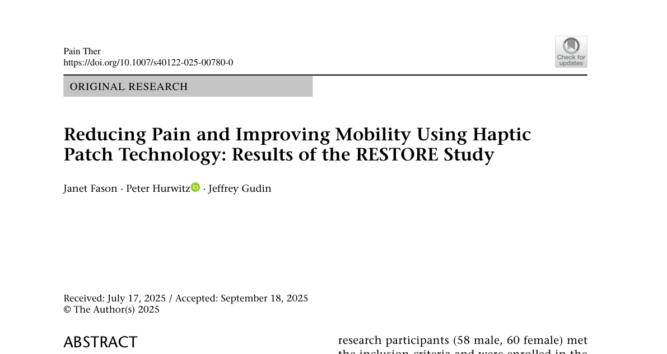

Peace - Calm the Tension
Supports stress reduction that can exacerbate muscle tension and spinal misalignment.
Why for Chiropractors: Chronic stress causes muscle guarding and tension that works against adjustments. Peace helps patients maintain a relaxed state that supports spinal health.
Key Results:
- 33% reduction in Perceived Stress Scale (PSS)
- 24% improvement in mental health domain

Liberty - Move Without Limits
Improves balance and stability, reducing compensatory movements that cause pain.
Why for Chiropractors: Poor balance leads to compensatory movement patterns that strain the spine. Liberty supports proper biomechanics.
Published: International Journal of Physical Medicine & Rehabilitation (2022)
Key Results:
- 31% improvement in balance scores (p<0.05)
- Measured using validated Sway Medical Balance Assessment

Study Reference:
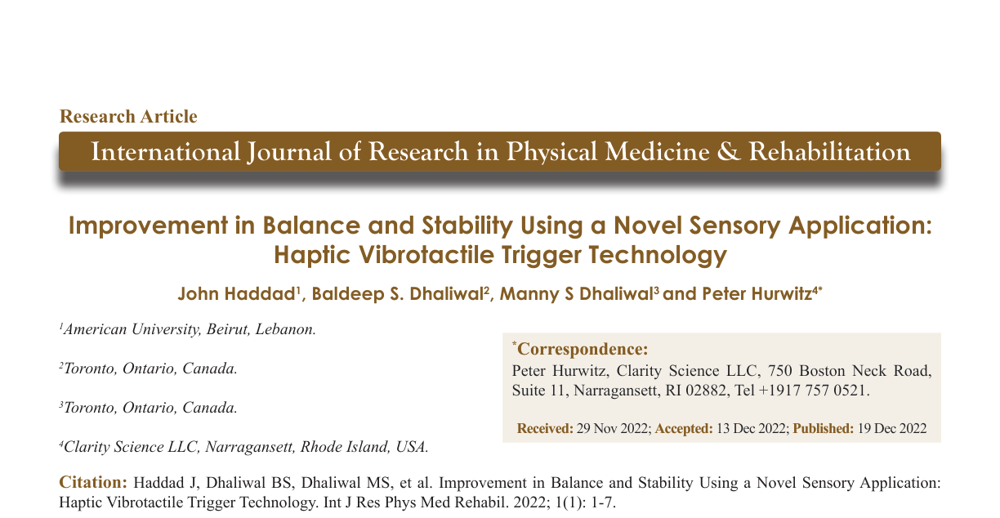

REM - Rest to Repair
Deeper sleep accelerates the body's natural healing process after adjustments.
Why for Chiropractors: Sleep is when the body repairs tissue and consolidates the benefits of spinal care. Poor sleep undermines adjustment outcomes.
Published: HARMONI Study - Prospective Clinical Trial (113 participants)
Key Results:
- 46% faster sleep onset (69 min → 37 min)
- +1.5 hours additional sleep per night
- 80% of participants stopped sleep medications

Study Reference:


Victory - Recover Stronger
Supports athletic patients with performance recovery and reduced muscle soreness.
Why for Chiropractors: Athletes and active patients need support for post-adjustment recovery and ongoing performance.
Key Results:
- 17% improvement in average concentric and eccentric force
- 22% improvement in average power

Benefit 2: Balance & Mobility
Help patients improve balance and mobility for better quality of life, reduced fall risk, and enhanced outcomes from your care.

Liberty - 31% Better Balance
Clinically shown to improve balance and stability, ideal for seniors and fall-risk patients.
Why for Chiropractors: Falls are the #1 cause of injury death in adults 65+. Many chiropractic patients present with balance concerns that affect their daily function and safety.
Published: International Journal of Physical Medicine & Rehabilitation (2022)
Key Results:
- 31% improvement in balance scores (p<0.05)
- 69 subjects using Sway Medical Balance Assessment

Study Reference:

Freedom - Pain-Free Mobility
Reduces discomfort that limits movement, helping patients stay active.
Why for Chiropractors: Pain restricts movement patterns and discourages activity. Freedom supports mobility by addressing the pain that holds patients back.
Published: Pain Therapeutics (2025)
Key Results:
- Significant ROM improvement at Day 7 and Day 14

Victory - Strength & Stability
Supports improved strength and agility for better functional movement.
Why for Chiropractors: Strong, agile patients maintain better posture and have fewer compensatory patterns that lead to spinal issues.
Key Results:
- 17% improvement in peak force
- 22% improvement in average power

Boost - Energy for Activity
Clean, sustained energy to encourage patients to stay active and mobile.
Why for Chiropractors: Fatigue leads to inactivity, which leads to deconditioning and poor posture. Boost supports the energy patients need to stay moving.
Key Features:
- 12+ hours of clean energy
- No sugar, no caffeine, no taurine
- No crashes or slumps

Benefit 3: Recovery & Rehabilitation
Provide patients with at-home support that enhances the effectiveness of your adjustments and speeds their recovery journey.

Freedom - At-Home Pain Support
Drug-free relief between adjustment sessions to maintain treatment gains.
Why for Chiropractors: Patients often lose 50% of their adjustment benefits between visits due to pain and muscle tension. Freedom provides ongoing support.
Published: Pain Therapeutics (2025) - Peer-reviewed RCT
Key Results:
- Significant pain severity reduction vs. placebo
- No drug interactions or contraindications

REM - Restorative Sleep
Better sleep quality supports tissue repair and nervous system recovery.
Why for Chiropractors: Sleep is when the body does its deepest healing work. Poor sleep undermines every adjustment you make.
Published: HARMONI Study - Prospective Clinical Trial
Key Results:
- 74% reduction in night waking
- +1.5 hours additional sleep per night
- 70% of participants preferred patch over sleep medications

Liberty - Restore Balance
Helps rebuild proprioception and stability after injury or adjustment.
Why for Chiropractors: Many patients present with compromised proprioception. Liberty supports the neuromuscular coordination needed for proper function.
Published: International Journal of Physical Medicine & Rehabilitation (2022)
Key Results:
- 31% improvement in balance scores
- Enhances proprioceptive pathways

Victory - Rehabilitation Support
Enhances strength and recovery for patients in active rehab programs.
Why for Chiropractors: Patients recovering from injury or surgery need support for both strength and coordination as they progress through care.
Key Results:
- 17% improvement in average force
- Supports post-injury recovery protocols

Peace - Relaxation for Healing
Reduces stress that can inhibit the body's natural healing response.
Why for Chiropractors: The stress response causes muscle tension and inflammation that work against healing. Peace supports a calm state conducive to recovery.
Key Results:
- 33% reduction in Perceived Stress Scale

Boost - Energy for Rehab
Provides clean energy for physical therapy exercises and daily activities.
Why for Chiropractors: Rehabilitation requires energy. Patients who are fatigued don't do their home exercises. Boost supports the vitality needed for active recovery.
Key Features:
- Drug-free, no stimulants
- 12+ hours of sustained energy

Benefit 4: Whole-Body Wellness
Address the full spectrum of patient wellness with solutions for stress, energy, immunity, and overall vitality that complement your spinal care.

Peace - Stress & Spine Health
Chronic stress contributes to muscle tension and spinal issues – help patients find calm.
Why for Chiropractors: Stress is a major contributor to the muscle guarding, tension headaches, and postural problems you see daily. Addressing stress addresses the root.
Key Results:
- 33% reduction in Perceived Stress Scale (PSS)
- 24% improvement in mental health domain

Liberty - Foundation for Active Living
Better balance and stability supports an active lifestyle and independence at any age.
Why for Chiropractors: Balance is fundamental to quality of life. Patients who feel stable and confident move more, exercise more, and maintain better overall health – creating a positive cycle that supports spinal wellness.
Published: International Journal of Physical Medicine & Rehabilitation (2022)
Key Results:
- 31% improvement in balance scores (p<0.05)
- Supports longevity and vitality through enhanced mobility

Study Reference:

Joy - Positive Healing Mindset
Emotional well-being supports better treatment compliance and healing outcomes.
Why for Chiropractors: Patients with positive emotional states are more likely to follow through on home care recommendations and experience better outcomes.
Key Features:
- Supports general feelings of well-being and contentment
- Drug-free mood support

Defend - Immune Support
A healthy immune system supports overall wellness and recovery.
Why for Chiropractors: The nervous system and immune system are intimately connected. Spinal health supports immunity, and immune health supports healing.
Key Features:
- Supports natural immune function
- Drug-free wellness support

Focus - Mental Clarity
Helps patients stay present and follow through on home care instructions.
Why for Chiropractors: Patients need mental clarity to remember and execute home care recommendations – posture reminders, exercises, and ergonomic adjustments.
Key Features:
- Supports concentration and attention
- Helps manage daily distractions

Ignite - Metabolic Health
Weight management reduces spinal load and supports overall wellness.
Why for Chiropractors: Excess weight places additional stress on the spine. Supporting healthy metabolism supports spinal health.
Key Results:
- 25% improvement in Resting Metabolic Rate (RMR)

Boost - Drug-Free Energy
Clean energy without caffeine to support active, healthy lifestyles.
Why for Chiropractors: Active patients are healthier patients. Boost provides the energy for exercise, proper posture maintenance, and active living.
Key Features:
- 12+ hours of clean energy
- No sugar, caffeine, or taurine

Key Messaging for Chiropractors

Philosophy Alignment
- Drug-free: Aligns with chiropractic commitment to non-pharmaceutical care
- Non-invasive: Works externally through neural pathways
- Supports innate healing: Activates the body's own mechanisms
- Evidence-based: Peer-reviewed clinical studies

Patient Value Propositions
- Maintain adjustment benefits between visits
- Drug-free pain relief without NSAIDs or opioids
- Better sleep for tissue repair and recovery
- Improved balance for fall prevention and mobility
- Whole-body wellness that complements spinal care

Practice Value Propositions
- Differentiate your practice with innovative technology
- Improve outcomes with take-home support
- 25% wholesale discount for practice profitability
- Affiliate commissions on patient referrals
- Clinical evidence to share with confidence

