|  |
| --- |
|  |
| HydroGarden Software Proposal |
| [Company name] |

|  |
| --- |
| [Jonathon Makepeace]  4-4-2022  [Version 1.0] |

Contents

A. Introduction 3

A.1. Purpose Statement 3

A.2. Overview of the Problem 3

A.3. Goals and Objectives 3

A.4. Prerequisites 3

A.5. Scope 3

A.6. Environment 3

B. Requirements 4

B.1. Business Requirements 4

B.2. User Requirements 4

B.3. Functional Requirements 4

B.4. NonFunctional Requirements 4

C. Software Development Methodology 5

C.1. Advantages of the waterfall method 5

C.2. Disadvantages of the waterfall method 5

C.3. Advantages of {a different method} 5

C.4. Disadvantages of {a different method} 5

C.5. Best suited 5

D. Design 6

D.1. Storyboard or Flowchart (Change title to fit needs) 6

D.2. UML Diagram (Change title to fit needs) 7

D.3. GUI (Change title to fit needs) 8

E. Testing 9

E.1. Testing Type (change name to fit your needs) 9

E.1.1. Test Name 1 9

E.1.2. Test Name 2 9

E.1.3. Test Name 3 10

F. Sources 12

# Introduction

Provide a brief introduction to the proposed system. This section should be no longer than one paragraph.

The proposed system will contain a website that will provide functionality for a Hydroponic Garden business. The website will contain the ability to provide information about the business, provide a dashboard for users, which will include the owners and customers interface, place orders, and save information to a database. The cost will be under discussion and will determine the scale of the database and the scalability of the solution. For test purposes, everything will be developed locally until the stakeholder decides to precede further.

# A.1. PUrpose Statement

The purpose of this document is to organize the requirements of the solution, determine the scope, and outline the process that the project will need to be successful.

# A.2. Overview of THE PROBLEM

Provide a brief overview of the problem that the proposed solution will solve.

The business needs a solution that will create a front-end website for users to interact and perform a variety of tasks. Employees will use the website to monitor incoming orders and manage stock. Customers will use the website to read about the company, ask questions, or order products.

# A.3. Goals and Objectives

Provide the goals and objectives for the project and solution.

The goal is to create a website that will solve all the described problems in a cost-effective manner. The project will be hosted locally until the stakeholder decides to move forward.

The objectives include creating a website that can handle both employee and customer traffic, handle transactions, keep stock of products, provide a dashboard for stakeholders, and save the information to a database.

# A.4. Prerequisites

Outline any aspects that need to be in place prior to the design, development, and implementation of the project proposed in this document. Be sure to be clear and concise for all listed prerequisites. Also, clearly outline why each prerequisite is needed.

*Note: If no prerequisites are needed, include a paragraph justifying why there are no prerequisites.*

|  |  |  |  |
| --- | --- | --- | --- |
| Number | Prerequisite | Description | Completion Date |
| 1 | PR1 | Initial Requirements – includes layout and preferences for website |  |
| 2 | PR2 | Data requirements – Details for the database |  |
|  |  |  |  |
|  |  |  |  |

# A.5. Scope

Provide a brief overview of what the proposed solution will cover and what the proposed solution will not cover. It is important to set clear boundaries for the project.

# A.6. Environment

Describe the IT and hardware environments that the solution will be deployed in.

S

# Requirements

Provide a brief introduction on requirements. You may select the correct subsections that match the needs of your solution and the key requirements that you identified from the profile document.

*Note: All requirements must be in your own words and interpret the requirements found in the “CRM Requirements” attachment. Please do not copy and paste word for word from the requirements in the “CRM Requirements” attachment.*

# Business Requirements

Provide a brief introduction to the business requirements for the proposed system.

The business will need the website to handle a low amount of traffic but provide the ability to be scaled up if necessary. The current goal is to handle employee login amount of 3 people or less. The customer amount needs to handle at least 10 people concurrently unless the stakeholders would like to scale up the amount.

A dashboard will be necessary to monitor resource usage and stock to ensure cost are within budget.

# User Requirements

Provide a brief introduction to the user requirements for the proposed system.

There will be two main categories of users for this proposal, business related and customers. Business related could be stakeholders, owners, or employees, while customers will correlate to potential buyers of the product.

The website will need a login for business related users to monitor resources and perform tasks such as putting orders together. There will need to be the functionality to login as a user, or proceed as guest, to place an order or see past orders and their statuses.

# Functional Requirements

Provide a brief introduction to the functional requirements for the proposed system.

Users should be able to view the description of the company and access contact information.

Users should be able to purchase products and specify the amount needed.

Users should be able to view product status and obtain an estimate of completion. (Can be manually updated for now).

Employees should be able to view orders

# NonFunctional Requirements

Provide a brief introduction to the nonfunctional requirements for the proposed system.

# SOFTWARE DEVELOPMENT METHODOLOGY

The company has selected the waterfall software development methodology for this project. Examine the waterfall methodology and compare it to other software development methodologies (e.g., Agile). Include a brief introduction to the development process as well.

*Note: All subsections are required. Refer to the requirements section and rubric section of the assessment for additional information.*

# Advantages of the waterfall method

Describe the advantages of the waterfall methodology and how they will benefit this project.

# disAdvantages of the waterfall method

Describe the disadvantages of the waterfall methodology and how they may hinder this project.

# Advantages of {A DIFFERENT METHOD}

Describe the advantages of a different methodology and how they will benefit this project.

# disAdvantages of {A DIFFERENT method}

Describe the disadvantages of a different methodology and how they may hinder this project.

# best SUITED

Describe why the waterfall methodology is the best software development methodology for this project.

**OR**

Provide the details of a different development process and outline why you would have selected it and how it would have been better suited for this project.

# Design

Provide a brief overview of the proposed design.

*Note: These subsections may be copied, rearranged, and modified to fit the needs of the solution. At least two visual representations of your design need to be present.*

# Storyboard or Flowchart (Change title to fit needs)

Provide a storyboard or flowchart of the application.

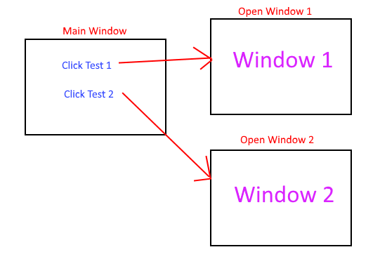

Figure 1: Sample Storyboard

# UML Diagram (Change title to fit needs)

Provide a set of UML diagrams that cover the proposed solution. This can include but is not limited to class diagrams, database diagrams, and use case diagrams. Also, ensure that all diagrams are clearly discussed and noted.

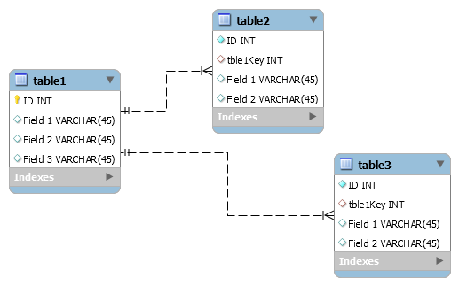

Figure 2: Sample Database

# GUI (Change title to fit needs)

Provide a mock-up of the proposed GUI forms that will be used in the proposed solution. Also, clearly indicate where the GUI components point inside the application.

<https://www.demoblaze.com/>

Above is a site similar to the design for this proposal

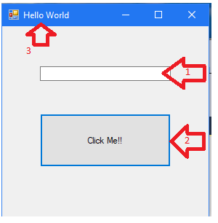

Figure 3: Sample GUI Mock-up

|  |  |  |  |
| --- | --- | --- | --- |
| GUI Control Mapping | | | |
| ID | Control | Property | Data Source |
| 1 | Textbox | On application open text = “” or null | NA |
| 1 | Textbox | On click of button text = “Hello World” | Internal Variable |
| 2 | Button | On click change text of textbox 1 to “Hello World” | Internal Variable |
| 3 | Form | Text= “Hello World” |  |