Weekly Management Report — Week ….
Reporting period: …… | Infinity IT Group
EXECUTIVE SUMMARY

P5 · STYLE OF WORK — CULTURE

P4 · LEARNING & GROWTH — SYSTEMS & CAPABILITY

P3 · INTERNAL PROCESS — OPEN AND CLOSED TICKETS

New (this wk) | Solved (this wk) | Currently Open* | Avg Resolve (solved this wk)

P2 · CUSTOMER / STAKEHOLDER — PIPELINE

Phase | # Leads | Value (฿)
Prospect
Qualify
Discover
Preliminary Proposal
Final Proposal
Total
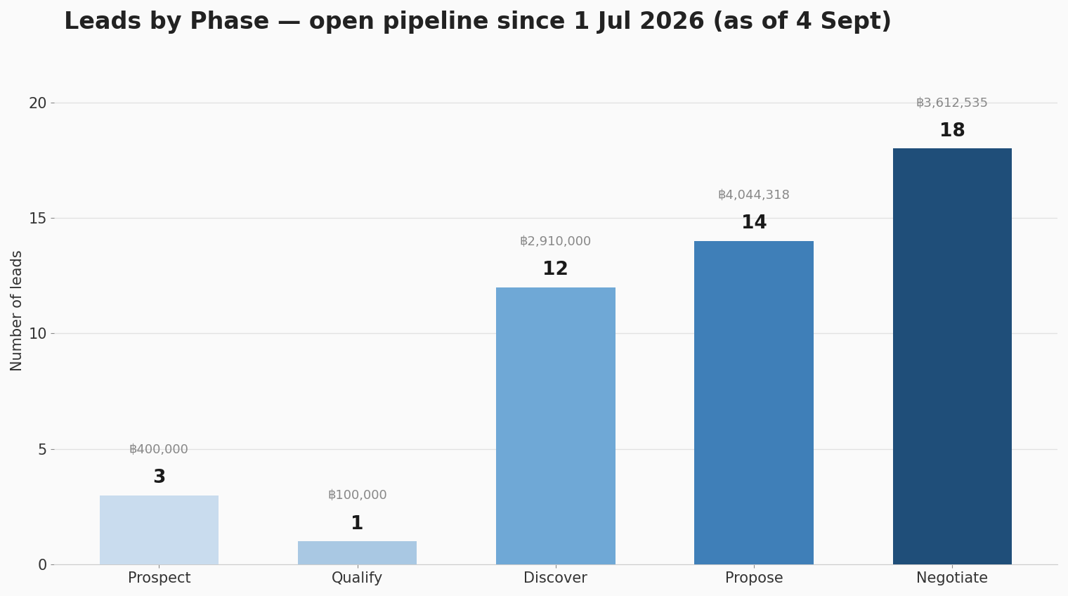

New leads entered this week:
Opportunity | Salesperson | Stage | Value (฿) | Created
Open Pipeline by Salesperson:
Salesperson | Open Leads | Open Value (฿)
P1 · FINANCIAL — STEWARDSHIP
- Income statement, Week………….

- Profit & Loss, YTD + Budget + Variance

- Balance Sheet
Metric | Actual
Cash & Banks
Accounts Receivable (Dom.)
Current Assets (Total)
Current Liabilities
Working Capital (CA − CL)
Net Fixed Assets
Total Equity

