[todo] insert picture of the datalogger

Table Of Contents
Introduction 2
Measurement Modes 3
Mode 1: Manual Sample Mode 3
Mode 2: External Trigger Mode 3
Mode 3: Logging Mode 5
Mode 4: SD Card Logging Mode 5
Mode 5: Serial Interface Control 6
Usage 8
Step 1: Plug the Shield into the Arduino MEGA. 8
Step 2: Upload the Arduino Sketch. 8
Step 3: Connect Indicators 8
Step 4: Connect via Serial Port 8
Step 5: Using the Data 9
Change Log 10

Introduction

The Mitutoyo SPC Data Logger is a shield for the Arduino MEGA. The shield is an extra set of electronics that plugs into your Arduino MEGA and provides additional functionality.

This particular shield will allow you to interface with up to 6 Mitutoyo devices that provide an SPC interface. The SPC protocol allows you to communicate electronically with your Mitutoyo device and read the current value from the device.

Mitutoyo devices that provide the SPC interface include:

- Digimatic Calipers
- Digimatic Linear Indicators
- Digimatic Micrometers
- Digimatic Height Gages
- Digimatic Depth Gages
- Digmatic Scale Units
- Digimatic Thickness Gages

Please note: both the Mitutoyo measuring devices and interface cables are sold separately.

Fig 1: Mitutoyo Digimatic Calipers:

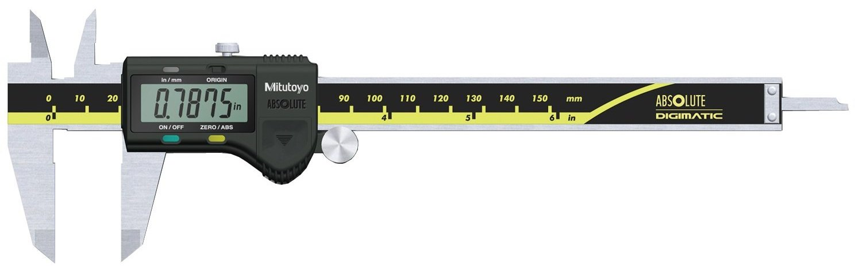

Measurement Modes

The data logger software has a variety of interfaces. Some of these are useful for automated testing, while some of them are useful for manual testing. Changing the mode can be accomplished by pressing the MODE button on the shield. Each time the mode button is pressed, it will switch to the next mode.

When the mode changes, it will blink the MODE LED the same number of times as the current mode number. It will also output a message on the serial port.

All 5 modes output the data in the same CSV format for easy processing.

Mode 1: Manual Sample Mode

In manual sample mode, the device will output the current measured position every time the SAMPLE button is pressed on the shield. This is great for taking manual measurements where you know exactly what each measurement means.

Mode 2: External Trigger Mode

In trigger mode, the device will output the current measured position every time the trigger line is taken LOW (GND). This trigger mode allows the device to be controlled by an external system such as an Extruder Controller or other custom logic interface. This mode allows fully automated testing such as moving a 3D printer axis and then taking readings.

Fig. 2: Trigger Interface Circuit Diagram

Note: The trigger pin is connected to an internal pullup resistor to 5V which is not part of the Eagle design files.

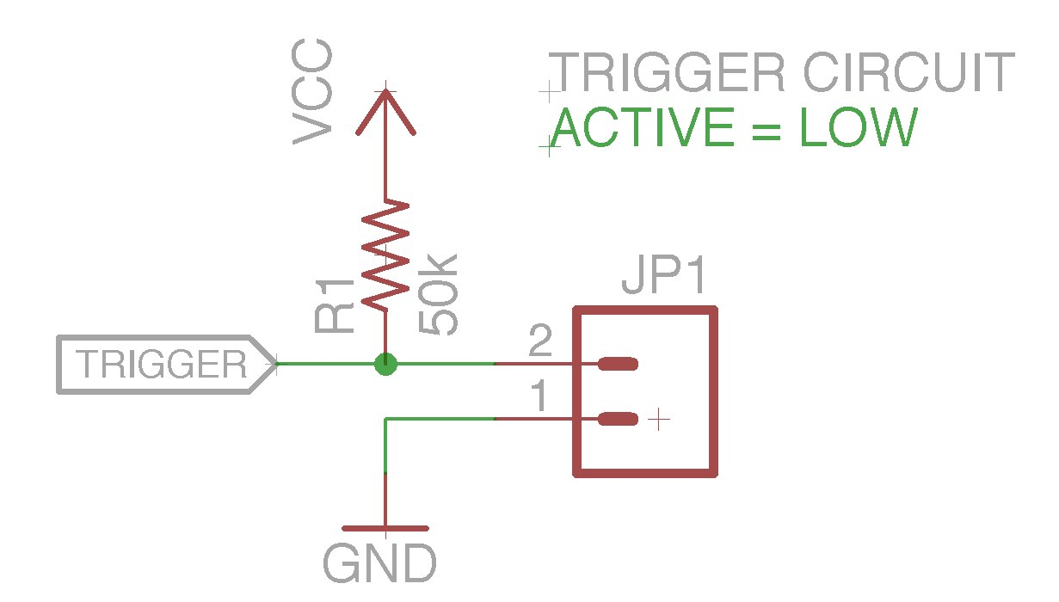

Connecting to MakerBot Gen4 Electronics

For use with the MakerBot automated tests, wire the NEGATIVE side of the FAN output to the TRIGGER input. This will allow the testing gcode to automatically trigger a reading during testing.

Fig. 3: identify the negative side of the extruder FAN output:

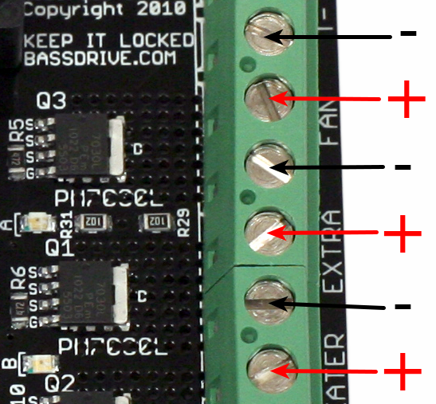

Mode 3: Logging Mode

In logging mode, the device will output the current measured position at roughly 100ms intervals (10hz). This is useful for gathering lots of data over time. Keep in mind that it will be hard to correlate the measurement time to an exact ‘real world’ time due to the Arduino clock resetting to zero every time it is powered on.

Mode 4: SD Card Logging Mode

In SD card logging mode, the datalogger will log continuously to a microSD card. The logging can be turned on and off by pressing the SAMPLE button.

When SD logging is enabled, the device will log to the SD Card continuously at a 10hz frequency. It will write the data to a file called “mitutoyo.log”. The format of this file will be the same CSV format that is sent over the serial port.

The data logger supports FAT16 and FAT32 formatted cards with a maximum capacity of 32GB. Larger cards are not supported at this point in time.

Mode 5: Serial Interface Control

In serial interface control mode, the datalogger can be controlled over the serial port connection. The serial protocol is a simple, single byte protocol that can be used to control the mode, request samples, or other various operations.

The serial connection is 57600 baud, 8N1. The Arduino contains a serial to USB converter, and connects to the computer over USB. You may need to install the USB to Serial converter drivers included with Arduino in order to connect to the device.

Serial Commands

The datalogger firmware listens on the serial port for single-byte commands. The commands are specified as ASCII characters for ease of programming and documentation.

Command | Description
1 | Changes the current and default mode to “Manual Sampling Mode”.
2 | Changes the current and default mode to “External Trigger Mode”.
3 | Changes the current and default mode to “Continuous Logging Mode”.
4 | Changes the current and default mode to “SD Logging Mode”. Please note that you must manually activate the actual logging with a separate command below.
5 | Changes the current and default mode to “Serial Interface Mode”.
T | Triggers a reading that output to the serial port. Must be in Mode 5.
A | Activates the SD Card continuous logging mode. Must be in Mode 4.
D | Activates the SD Card continuous logging mode. Must be in Mode 4.

Usage

Step 1: Plug the Shield into the Arduino MEGA.

This is pretty straightforward... just plug it in. It should already be assembled.

Step 2: Upload the Arduino Sketch.

There is a simple Arduino sketch that contains the code required to drive the datalogger shield. In order to switch to different recording modes, the code must be edited and re-uploaded. The assembled datalogger at Jetta should be set to external trigger mode.

The code is located in the arduino_logger directory of the design .zip (or on Github: https://github.com/makerbot/Mitutoyo-SPC-Interface)

Step 3: Connect Indicators

This shield is designed to interface with Mitutoyo brand gauges that use the SPC interface. In order to do this, a special cable is required to connect the gauge to the shield. For the Digimatic indicators, this cable is a 2x5 pin header on one end, and a custom spring loaded cable on the other end.

The spring loaded end of the cable goes into a port on the indicator. First, remove the protective covering and then insert the cable. Make sure it is fully seated. There is a halfway position that feels like it is fully inserted, but it is not. There should be 2 ‘clicks’ when inserting the cable properly.

The other end of the cable plugs into the header on the data logger PCB. Take note of the channel used, although the current shield at Jetta will only work with Channel 1.

Step 4: Connect via Serial Port

In order to get the data from the tester, you will need to connect using a serial terminal. The easiest way to do this is with Arduino. Plug the data logger into your computer using a USB cable and then open the Arduino program.

Open the Serial Monitor and set the speed to 57600. This will cause the Arduino to reset and then it should display “MakerBot Mitutoyo SPC Logger v2.0” and a line describing the current mode. At this point you are now ready to receive data.

Step 5: Using the Data

After logging, copy all of the data from the Serial Monitor to a text file and save it with a .csv extension. You can then open this file with Excel or Open Office and convert it into a spreadsheet. The format of the data is this:

Milliseconds – the # of milliseconds since the Arduino sketch was started
CH1 – the reading from CH1, in mm.
Sample# - the # of samples the device has received (ignore this)

Sample Data:

MakerBot Mitutoyo SPC Logger v2.0
External Trigger Mode
Milliseconds, CH1, SAMPLE#,
4740, +001.663, 1,
6706, +002.656, 2,
8762, +003.655, 3,
10819, +004.638, 4,
12784, +005.609, 5,
14841, +006.604, 6,
16908, +007.595, 7,
18874, +008.590, 8,
20930, +009.567, 9,
22987, +010.560, 10,

Change Log
Rev | Notes | Written by | Approved
A | Initial draft of documentation | Zach Smith  9/10/11 | Zach Smith  9/10/11
B | Updated documentation to reflect the new code and new RevC pcb. | Zach Smith  Jan 3, 2012

