ESP32-2432S028R的淘寶購買連結:
https://item.taobao.com/item.htm?from=cart&id=692235616325&mi_id=0000muWNKYAVsJ6HoSDmxjuv90pe2ac7W_jdWZsA3LgyfiM&skuId=5264281654591&spm=a1z0d.6639537%2F202410.item.d692235616325.1e947484zGWtHW&upStreamPrice=5850

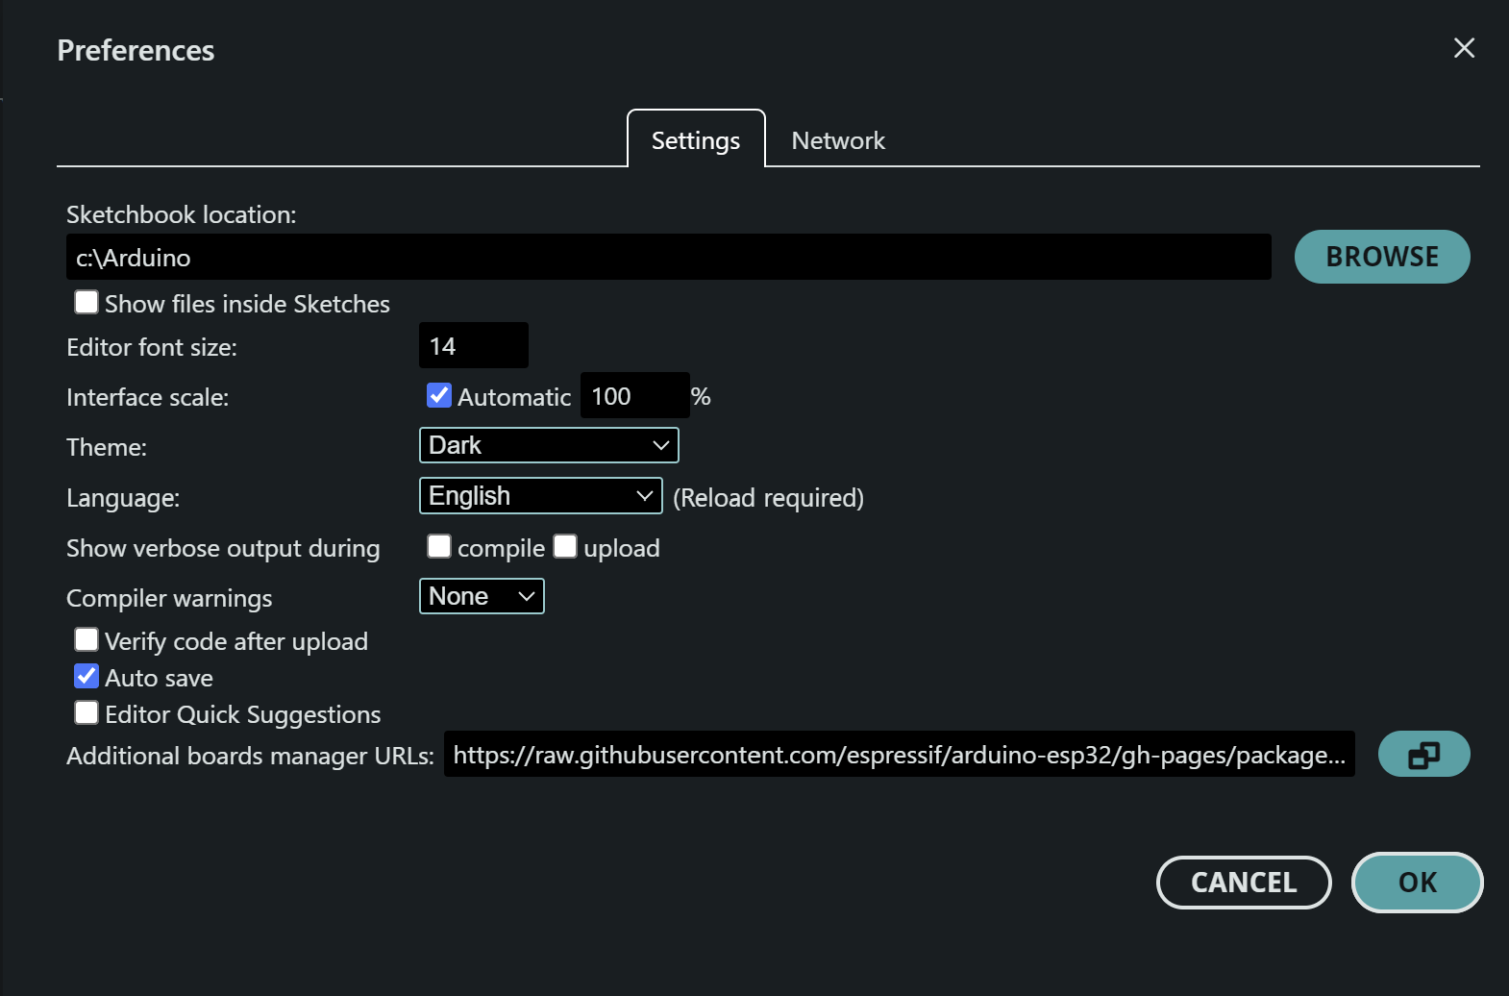
Additional broad manager URLs:
https://raw.githubusercontent.com/espressif/arduino-esp32/gh-pages/package_esp32_index.json

