BestFirstSearch.search,
GreedyBestFirstSearch.evaluation
AStarSearch.evaluation
WeightedAStarSearch.evaluation
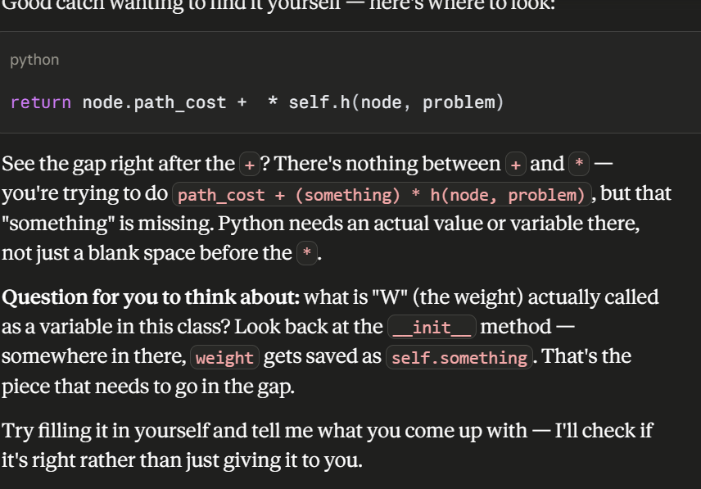
def evaluation(self, node: Node, problem: Problem) -> float:
# f(n) = g(n) + W * h(n)
return node.path_cost + self.weight * self.h(node, problem)
