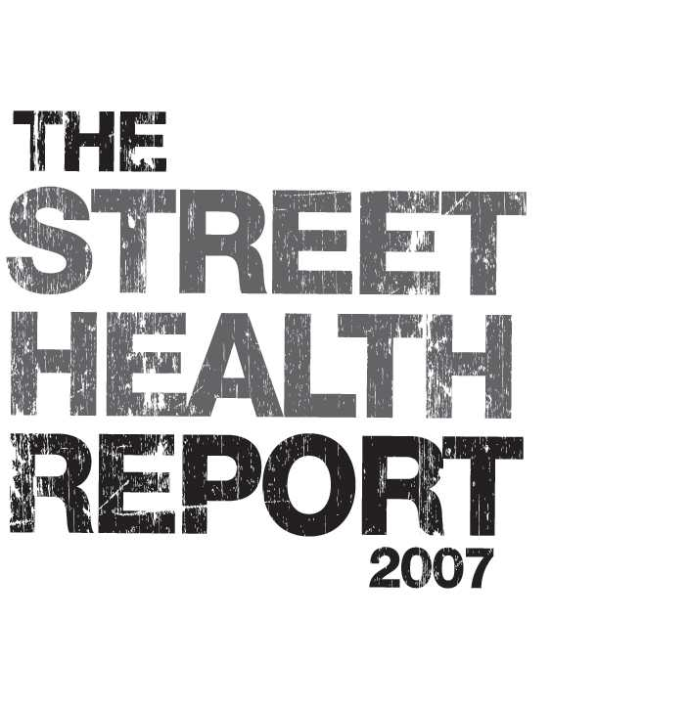
Report Release: September 19th 2007

The Street Health Report 2007 presents the findings of a survey of 368 homeless adults in Toronto on their health and access to health care, conducted in the winter of 2006/2007 by Street Health. The report reveals a picture of homelessness that demands immediate action.

Join us on:
Wednesday, September 19th at 10:00 a.m.
Church of the Holy Trinity
10 Trinity Square (East of Bay/South of Dundas)
[wheelchair accessible at south entrance]

As we release our report, the National Film Board of Canada will launch Street Health Stories, a collection of portraits and audio-recordings of the stories of eight survey participants. Street Health Stories exhibit hours: Sept 19 - 27 (except Sunday), 11:00 a.m. - 3:00 p.m.
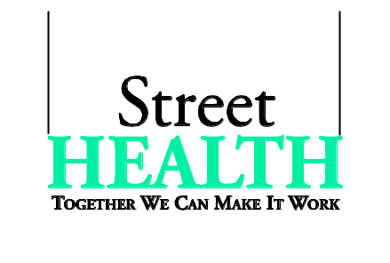
www.streethealth.ca
www.nfb.ca/streethealthstories

This study was conducted by Street Health in partnership with the Wellesley
Institute. Funding for this study was provided by United Way of Greater
Toronto, Wellesley Institute and Metcalf Foundation.

