# 3D Printing Summary

|  |  |
| --- | --- |
| **Metrics** |  |
| Total Print Time (min) | 224 - 241 |
| Total Number of Components | 1 - 5 |
| Typical Total Mass (g) | 36 - 39 |
| Typical Number of Print Setups | 1 - 5 |

# 3D Printing Settings

|  |  |  |  |  |  |  |  |
| --- | --- | --- | --- | --- | --- | --- | --- |
| **Print File Name** | **Qty** | **Total Print Time (hr:min)** | **Mass (g)** | **Infill (%)** | **Support** | **Layer Height/ Nozzle Diameter(mm)** | **Notes (orientation, special settings, etc.)** |
| Bottle_Opener_30.stl | 1 | 3:47 | 37 | 50 | No Support | 0.2/0.4 | Adjust number of perimeters to 3-4. |
| Bottle_Opener_35.stl | 1 | 3:44 | 36 | 50 | No Support | 0.2/0.4 | Adjust number of perimeters to 3-4. |
| Bottle_Opener_40.stl | 1 | 3:46 | 36 | 50 | No Support | 0.2/0.4 | Adjust number of perimeters to 3-4. |
| Bottle_Opener_45.stl | 1 | 3:51 | 38 | 50 | No Support | 0.2/0.4 | Adjust number of perimeters to 3-4. |
| Bottle_Opener_50.stl | 1 | 4:01 | 39 | 50 | No Support | 0.2/0.4 | Adjust number of perimeters to 3-4. |

# Post-Processing

* Remove any burrs or sharp edges that may occur if applicable.

# Customization Options

* There are parameters given in the CAD file (.f3d) to change the cap size and handle size if desired.
* Can be printed in any colour.

# Examples of Quality Prints:

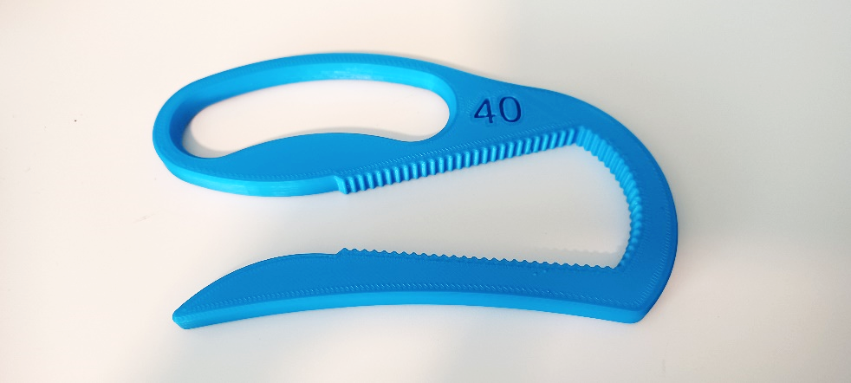

Example of Bottle Opener 40

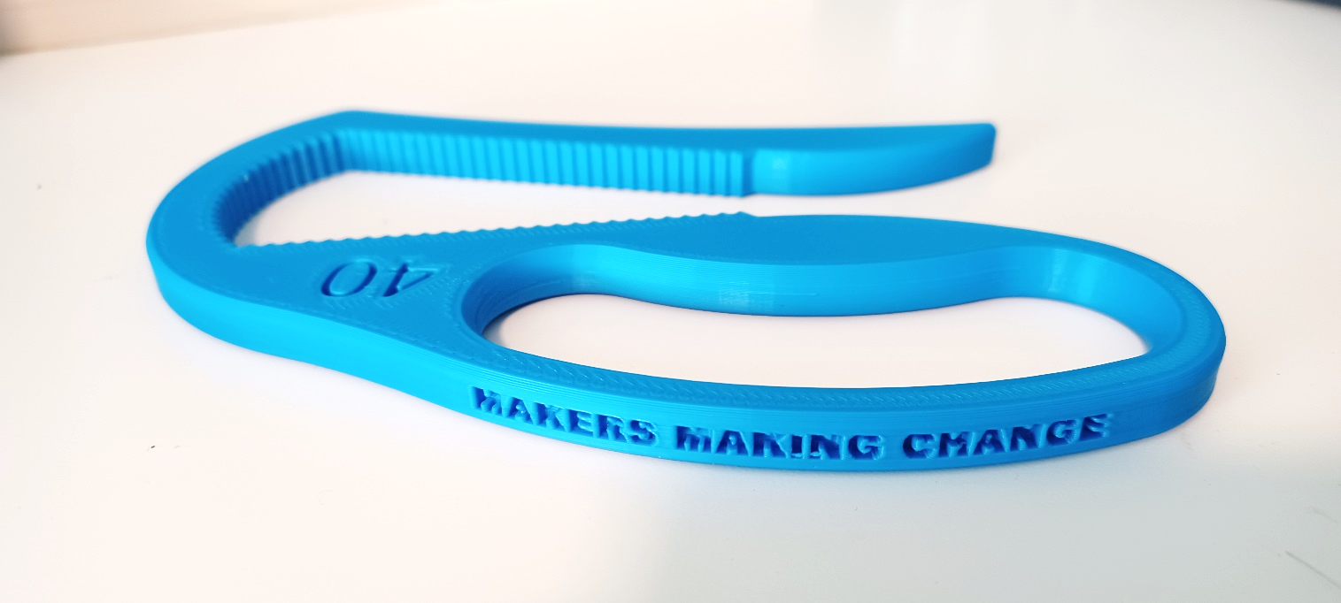

Example of Bottle Opener 40

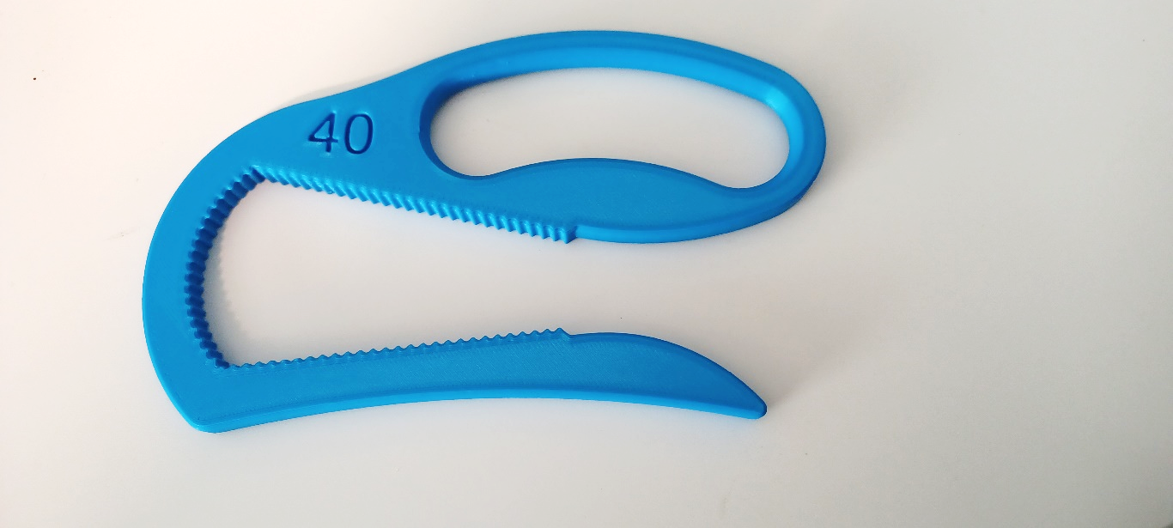

Example of Bottle Opener 40