# Overview

The Device Summary is intended to be a detailed summary of the device, product, and maker information for the Adaptive Utensils, making it easier to add to the Makers Making Change website. It is intended for anyone who will view the device listing.

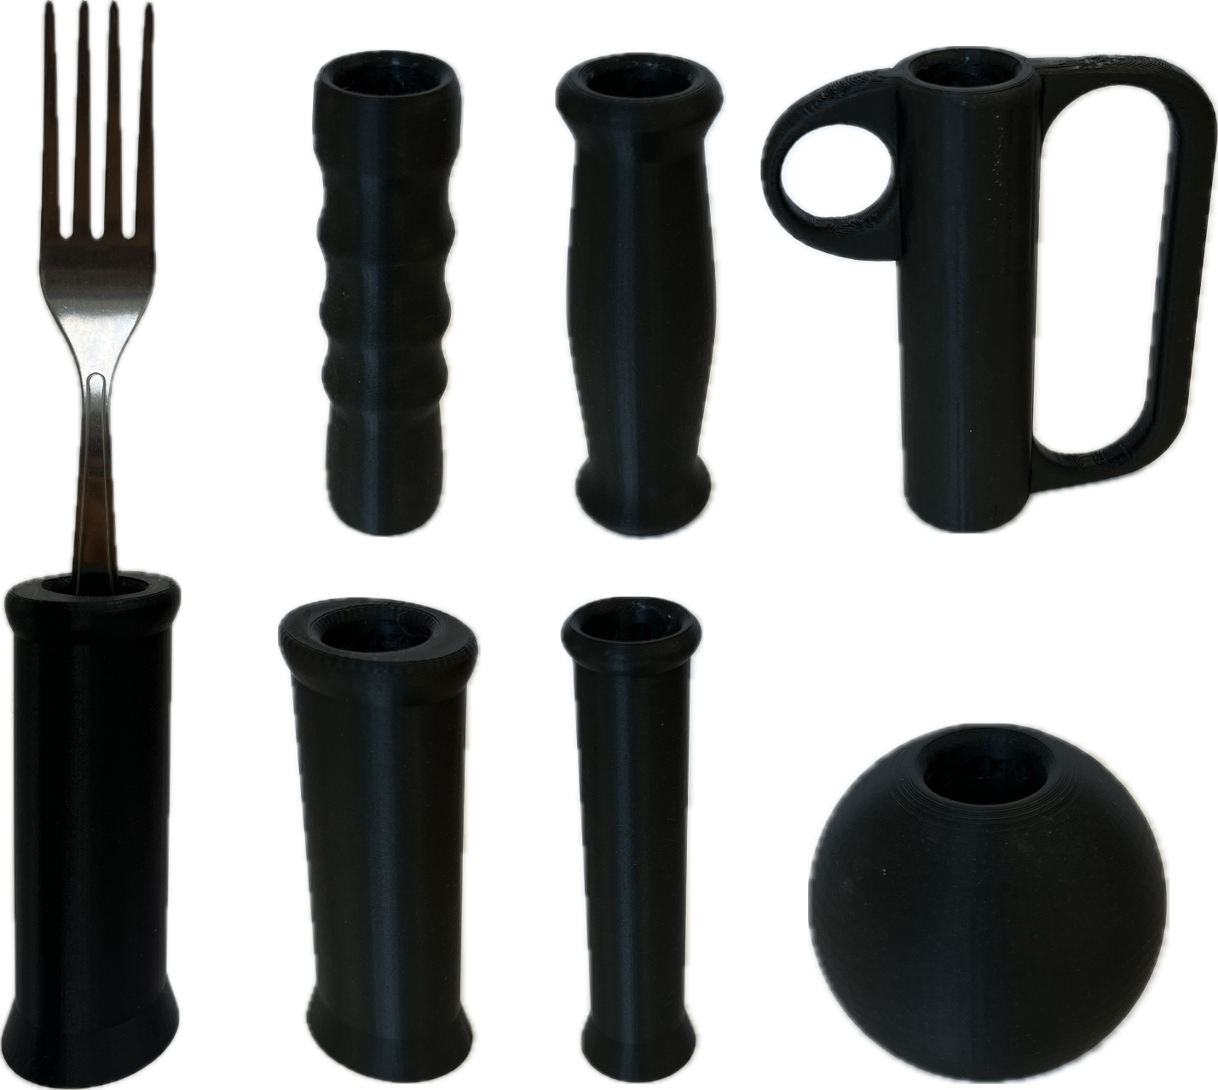

# Product Information

## Product Name

ADAPTIVE HANDLES FOR IKEA IDENTITET UTENSILS

## Device Category

Mark any relevant categories with an “X”:

|  |  |
| --- | --- |
|  | Adapted Toys |
| X | Aids for Daily Living (ADL) |
|  | Assistive Switches |
|  | Communication Aids (AAC) |
|  | Computer Access |
|  | Environmental Controls |
|  | Gaming |
|  | Keyguard |
|  | Kits |
|  | LipSyncs |
|  | Mounting |
|  | Recreation and Leisure |
|  | Seating and Positioning |
|  | Switch Interfaces |
|  | Writing Aids |

## User Value Statement

These 3D Printed Adaptive Utensils function as standard commercially available adaptive utensils in how they allow individuals with poor fine motor control to eat independently. Each of the handles offer a large, smooth area to grasp for improved ergonomics. Some handles mimic common shapes for commercial adaptive utensils, and others have more experimental shapes to explore the possibilities of 3D printing with adaptive utensils.

## Designer

Alberta Health Services, Research and Innovation

# Device Information

## Overview

This device acts as a cost effective substitution for commercial adaptive utensils which lowers the barrier-to-entry and allows individuals to trial different handle shapes to develop their own preference. Afterwards, users may 3D print more of their preferred handle or purchase a similar commercial adaptive utensil set for long-term usage.

## Disability Type

Select one or more disability types and mark with an “X”:

|  |  |
| --- | --- |
| X | Agility / Dexterity |
| X | Arthritis |
|  | Cognitive |
|  | Hearing |
|  | Mobility |
|  | Pain |
|  | SCI |
|  | Vision |
|  | Other |

## Disability Type Description

The 3D printed Adaptive Utensils are for individuals who struggle to grasp and manipulate utensils. The affected patient population includes weakness in arm or grip strength, tremors/shakiness, limited range of motion, and poor fine motor skills.

## How To Use

Once assembled and properly adjusted, the 3D Printed Adaptive Utensils may be used as regular utensils to eat independently.

## Estimated Cost

The estimated material cost of the device for a single build:

|  |  |
| --- | --- |
|  | $0 - $10 |
| X | $11 - $25 |
|  | $26 - $50 |
|  | $51 - $100 |
|  | $101 - $250 |
|  | $250+ |

## Attribution

Alberta Health Services, Research and Innovation

### Contributors

* Anson Chung
* Kendra Smart
* Holden Holzer
* Tod Vandenberg
* Michael Cimolini
* Adam Bulat
* Robert Hirsche

# Maker Information

## Project Skills

Mark the required project skills with an “X”:

|  |  |
| --- | --- |
| X | 3D Printing |
|  | Custom PCB |
|  | Electronics |
|  | Laser Cutting |
|  | Mechanics |
|  | Software |
|  | Soldering |
|  | Woodworking |
|  | Other |

## Skills Description

Requires basic 3D Printing skills for enabling support and slicing STL files.

## Tools Needed

|  |  |
| --- | --- |
| X | 3D Printer |
| X | Common Hand Tools |
|  | Common Power Tools |
|  | Laser Cutter |
|  | Soldering Iron |
|  | Specialized Tooling |

## Print time (hrs)

17.5 hours

## Assembly time (hrs)

0.25 hours

## Build Instructions

Requires approximately 22 g of PETg and 330 g of PLA 3D printing filament as well as 1 large spoon and 1 large fork from the IKEA IDENTITET utensil set.

Auto-orient and enable supports for each STL, then 3D print all required parts. When complete, assemble the core assembly around each utensil and test the fits inside each handle.

## Download Link

<https://github.com/makersmakingchange/Adaptive_Utensil_Handles_for_IKEA_IDENTITET/archive/refs/heads/main.zip>

## Project Link

# https://github.com/makersmakingchange/Adaptive_Utensil_Handles_for_IKEA_IDENTITET

# License

## License

CC BY SA 4.0 License