# Overview

This document contains the necessary information to use the Adaptive Utensils, a set of adjustable and interchangeable 3D printed adaptive utensil handles.

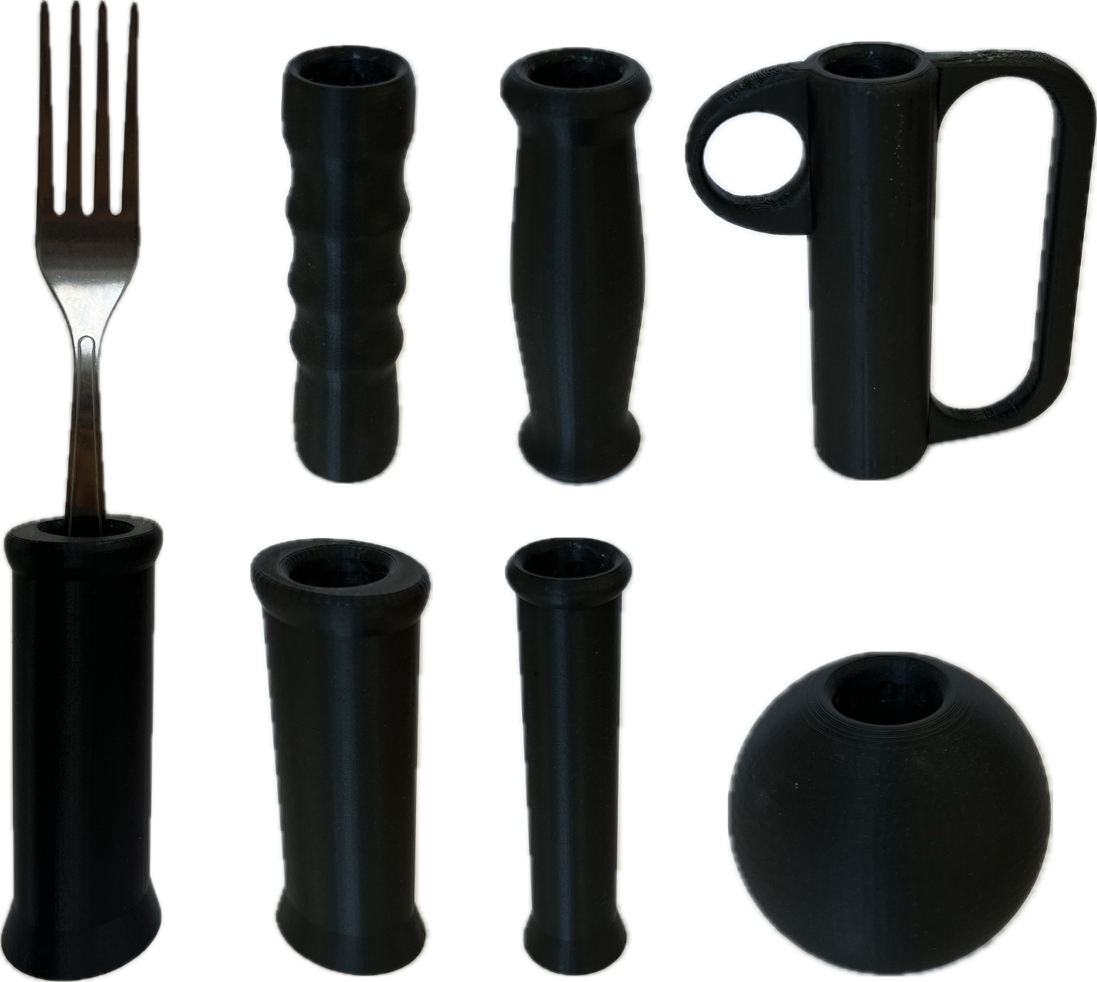

Contents

Overview 1

Introduction 3

Features 3

Specifications 7

Compatibility 8

Usage 8

Initial Setup 8

Regular Use 8

Takedown / Storage 8

Care 8

Cleaning 8

Disposal 8

## Introduction

Commercially available adaptive utensils are expensive commitments where buyers are unable to trial different styles of handles and determine what best suits their needs. Some purchased sets cannot be returned, which may leave individuals with adaptive utensils that are uncomfortable to use.

The 3D printed Adaptive Utensils play the same role as commercially available adaptive utensils, which is to allow individuals with poor fine motor control to eat independently. However, the 3D printed handles fulfill a different niche in how they are fast and cheap to manufacture, which lowers the barrier-to-entry and lets individuals trial different handle shapes to develop their own preference. Afterwards, users may 3D print more of their preferred handle or purchase a similar commercial adaptive utensil set for long-term usage.

The 3D printed Adaptive Utensils are for individuals who struggle to grasp and manipulate utensils. The affected patient population includes weakness in arm or grip strength, tremors/shakiness, limited range of motion, and poor fine motor skills.

## Features

There are 3 main components to this design: IKEA IDENTITET utensils, 3D printed handles, and 3D printed core assemblies to interface between the utensils and handles.

The core assemblies consist of two parts, where the core part is designed to clamp around the utensil bases while a separate shell can slide around the core clamp to lock it closed. The cores have 2 separate models with specific slot cutouts to hold the IKEA IDENTITET large spoon and fork profiles. Separate colors help differentiate the core profiles, so the spoon core is commonly printed with white PETG and the fork core is commonly printed with black PETG. Otherwise, the core types can be labeled with a permanent marker.

Once together with the proper utensil, the core assemblies can be inserted into any of the 3D printed handles. The core's ball socket mechanism correlates to 24 hemisphere cutouts in the handles such that the utensils can be locked in the handle while still allowing adjustment and removal when sufficient force is applied to the utensil. The cutouts are arranged in 3 rings of 8, which allow for 3 levels of depth adjustment in increments of 20mm and for 8 levels of rotation adjustment in increments of 45°.

Below are two images demonstrating the depth and angular adjustment range of the cores:

Each of the handles offer a large, smooth area to grasp for improved ergonomics. Some handles mimic common shapes for commercial adaptive utensils, and others have more experimental shapes to explore the possibilities of 3D printing with adaptive utensils. All the 9 handle types for the 3D printed Adaptive Utensils are listed below:

|  |  |  |
| --- | --- | --- |
| Ellipse  (Cylinder handle with an oval cross section shape) | **Finger Grip**  (Handle with finger groove indentations) | **Finger Support-Large**  (Rigid support around the fingers; 33mm spacing) |
|  |  |  |
| Finger Support-Small  (Rigid support around the fingers; 27mm spacing) | **Rounded Grip**  (Thickest in the middle and tapers thinner at the top and bottom) | **Sphere-Large**  (Spherical handle; 70 mm diameter) |
|  |  |  |
| Sphere-Small  (Spherical handle; 52 mm diameter) | **Straight-Large**  (Cylinder handle with a circular cross section; 42 mm diameter) | **Straight-Small**  (Cylinder handle with a circular cross section; 27 mm diameter) |
|  |  |  |

## Specifications

|  |  |  |
| --- | --- | --- |
| Part | Item | Adaptive Utensils |
| Fork (IKEA IDENTITET) | Maximum Handle Extension Length [mm] | 145 |
| Mass [g] | 34.5 |
| Spoon (IKEA IDENTITET) | Maximum Handle Extension Length [mm] | 140 |
| Mass [g] | 38.9 |
| Fork Core | Size (Length x Width x Height) [mm] | 26 x 23 x 61 |
| Mass [g] | 9.06 |
| Spoon Core | Size (Length x Width x Height) [mm] | 26 x 23 x 61 |
| Mass [g] | 8.99 |
| Shell | Size (Length x Width x Height) [mm] | 22 x 22 x 44 |
| Mass [g] | 3.58 |
| Ellipse | Size (Length x Width x Height) [mm] | 38 x 48 x 110 |
| Mass [g] | 32.78 |
| Finger Grip | Size (Length x Width x Height) [mm] | 32 x 32 x 120 |
| Mass [g] | 25.65 |
| Finger Support – Large | Size (Length x Width x Height) [mm] | 36 x 107 x 120 |
| Mass [g] | 50.84 |
| Finger Support – Small | Size (Length x Width x Height) [mm] | 36 x 101 x 120 |
| Mass [g] | 50.19 |
| Rounded Grip | Size (Length x Width x Height) [mm] | 37 x 37 x 120 |
| Mass [g] | 30.29 |
| Sphere – Large | Size (Length x Width x Height) [mm] | 70 x 70 x 63 |
| Mass [g] | 45.38 |
| Sphere – Small | Size (Length x Width x Height) [mm] | 53 x 53 x 45 |
| Mass [g] | 20.85 |
| Straight – Large | Size (Length x Width x Height) [mm] | 46 x 46 x 130 |
| Mass [g] | 48.98 |
| Straight – Small | Size (Length x Width x Height) [mm] | 34 x 34 x 130 |
| Mass [g] | 25.15 |

## Compatibility

The core assemblies are only compatible to hold the IKEA IDENTITET large spoon and fork and can only be inserted into the 3D printed handles included with this device.

## Usage

### Initial Setup

Assemble the cores with the IKEA utensils and shells, then insert them into a 3D printed handle at the desired position. Make sure the core assembly locks into a socket before use.

### Regular Use

Once assembled, the 3D Printed Adaptive Utensils may be used as a regular utensil to eat.

### Takedown / Storage

When not in use, the Adaptive Utensils should be stored in a cool place out of direct sunlight.

## Care

The Adaptive Utensils is made of 3D printed plastic. Exposure to high heat may cause warping and/or negatively affect function. Extended exposure to sunlight will also weaken the plastic on the device. Please dry the 3D printed parts after washing.

### Cleaning

The Adaptive Utensils can be wiped with a damp cloth. The Adaptive Utensils can also be cleaned by scrubbing with warm water and dish soap. Do not use hot water or clean in a dishwasher.

## Disposal

PLA filament may be industrially compostable in your area. Check with your waste management company if PLA can be composted or must be thrown in the garbage.

Disassemble the Adaptive Utensils and separate out the recyclable and compostable components, and those that must be thrown out.