## Introduction

This is a low-cost analog thumbstick that is compatible with the Xbox Adaptive Controller (XAC). This device is a more affordable option to commercial joysticks on the market. This joystick is easy to use and gets plugged into the back of the XAC.

## Features

The thumbstick sits into a 3D printed housing and was designed using a traditional PS2 joystick. The wiring connected to the joystick extends out to a headphone adapter that will be plugged into the XAC (1). The joystick will have two headphone adapters attached if the “press down” function on the joystick was requested by the user (2). Both thumbsticks shown below are displayed in their intended orientation with the wires coming out of the back of the thumbstick.

|  |  |
| --- | --- |
|   **1** | **2** |

The thumbstick can either be used with a single finger with the original thumbstick topper (3), or the user can request a 3D printed "U" shaped topper that is typically used with more than one finger (4). This topper may be beneficial to someone who may have limited finger sensation but still has enough wrist movement to operate a joystick.

|  |  |
| --- | --- |
| **3** | **4** |

## Usage

This thumbstick is intended to be paired with an Xbox Adaptive Controller. The joystick can be used by plugging it into the "X1 " (5) or " X2" (6) jacks on back of the controller.

If it was requested that the “push button” feature is enabled on the joystick, the second jack (the one with less wires) can be plugged into the "L" (7) or "R" (8) mono jack that look like joystick icons as shown below.

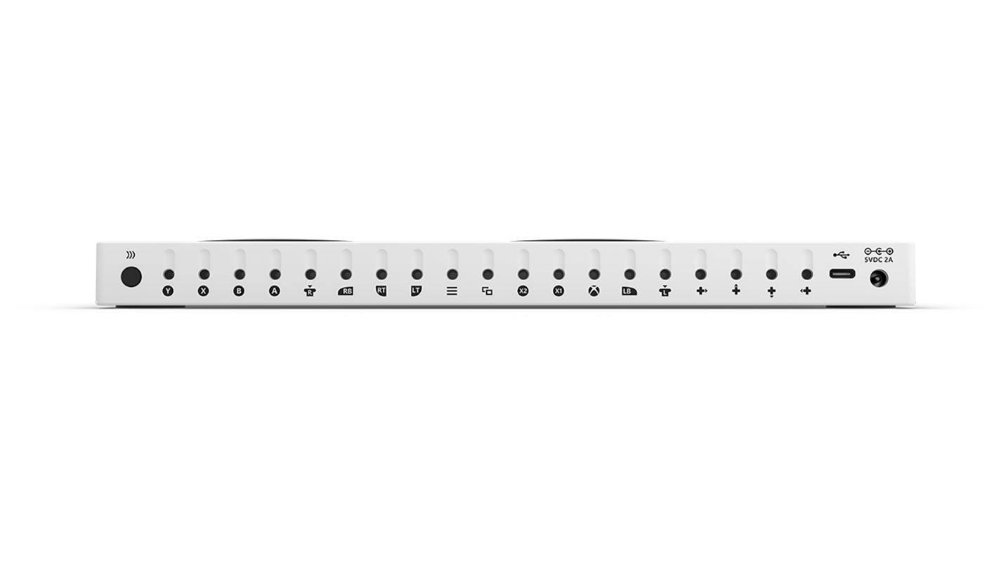

**8**

**7**

**6**

**5**

## Compatibility

This thumbstick is compatible with the Xbox Adaptive controller. The XAC can be used with an Xbox Series X|S or Xbox One, Windows PC, iOS devices, Android mobile devices, as well as other gaming consoles with an appropriate adapter.

## How to Connect the Xbox Adaptive Controller to Your Device

Instructions on how to connect the Xbox Adaptive Controller to your device are linked below. Note, the XAC can connect to other consoles than the ones listed but an additional adapter may be required.

|  |  |
| --- | --- |
| Device | Link |
| iOS | <shorturl.at/dfsyY> |
| Android | <shorturl.at/aqvMN> |
| Windows PC | <shorturl.at/rxzFZ> |
| Xbox | <shorturl.at/cCZ18> |

## How to Test the Joystick

Testing the Analog Thumbstick may be required as the Maker who built the device would not have been able to test out the device unless they had access to an Xbox Adaptive Controller.

### Option 1: Testing the Joystick with the Gamepad Tester (for PC, iOS, or Android)

Once you have the joystick plugged in according to the steps above and the XAC is connected to the device, go to the Gamepad Tester website: <https://gamepad-tester.com/>. From here, you should be able to move your joystick in any direction and if the joystick on the screen moves in the same directions, it should work. If this is not the case, please contact the maker who built the device or a Makers Making Change employee.

### Option 2: Testing the Joystick by Browsing Through the Menu (Xbox)

Once you have the joystick plugged in according to the steps above, and the XAC is connected to the Xbox, you should be able to use the joystick to move up, down, left, and right through the options on the general menu. If your joystick does not work as expected, please contact the maker who built the device or a Makers Making Change employee.

## 3D Printed Base Dimensions

|  |  |  |  |  |
| --- | --- | --- | --- | --- |
|  | **Length (mm)** | **Width (mm)** | **Height (mm)** | **Mass (g)** |
| Joystick Housing | 69 | 69 | 23 | 39 |
| U-shaped Topper (if requested) | 90 | 71 | 45 | 45 |

## Cleaning

The Analog Joystick and 3D printed joystick topper can be wiped down with sanitizing cleaners. Do not wash the Analog Joystick in high heat as this is unsafe for electronics (i.e., **do not** put in the dishwasher, the washing machine, or soak in hot water).