# Bag Carrier: Changelog

# Version 1.0 | Date 01/31/2018

This bag carrier was very strong, but ultimately replaced as the print time was much too long, and the handle was quite bulky.

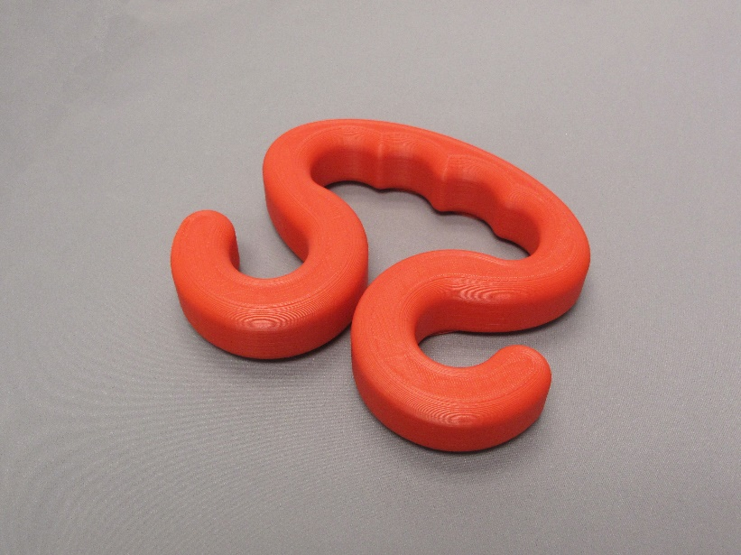

# Version 2.0 | Date 02/28/2022

This is a newly designed handle to replace the old one.

Improvements:

* Significantly reduced print time
* Designed 3 different sized handles to better accommodate different sized hands. The width and the height of the handle hole increases for the larger sized handles.
* Made the handle less bulky.
* Increased the strength per gram of the handle by connecting the two hooks.

