## Introduction

The Bag Carrier is a low-cost, 3D-printed handheld tool that distributes the weight of bags carried. This 3D Printed Assistive Device can assist people with arthritis or other disabilities to carry plastic bags and reusable bags. The Bag Carrier comes in 3 different sizes: small, medium, and large.

## Features

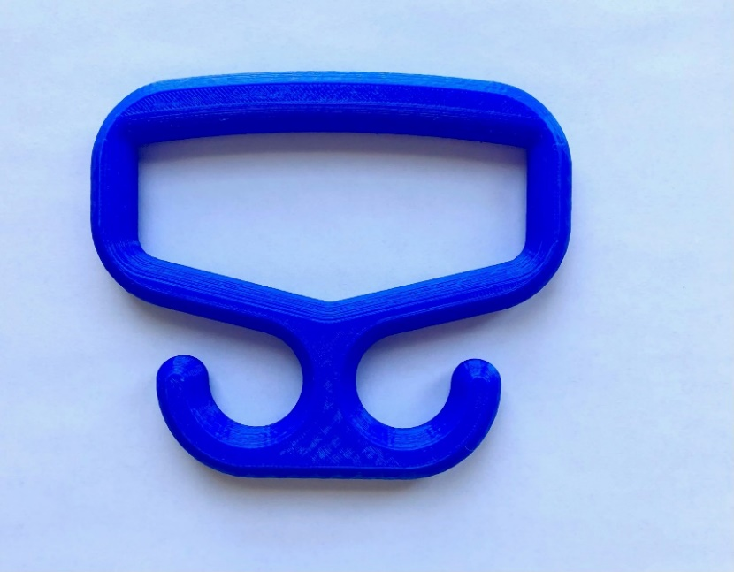

**Handle**

**Bag Hook**

**Bag Hook**

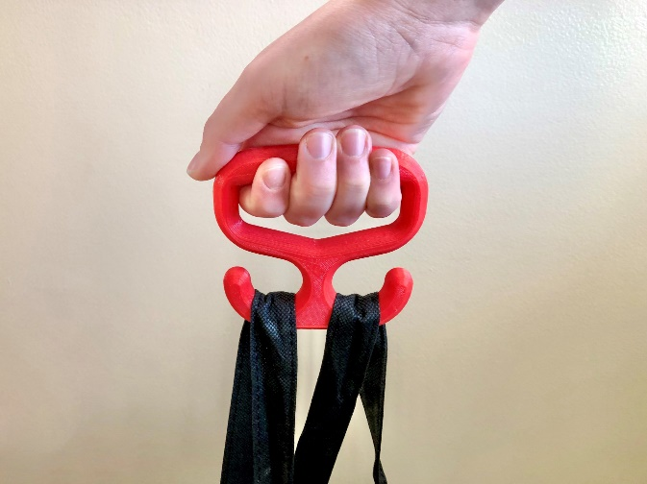

## Usage

This handle is used to carry plastic or reusable bags. This handle can either be carried in hand or can attach onto the side of a wheelchair. The bag handles can easily loop around the two curved hooks.

## Compatibility

There are 3 different sized handles in order to try and accommodate many different hand sizes. Please refer to the Sizing Guide to determine which size handle will work best for you.

## Specifications

|  |  |  |  |  |  |
| --- | --- | --- | --- | --- | --- |
| **Version** | **Weight (g)** | **Dimensions (mm)** | | | |
| **Overall Width** | **Overall Height** | **Grip Width** | **Thickness** |
| **Small** | 35 | 97 | 96 | 75 | 46 |
| **Medium** | 38 | 113 | 101 | 90 | 46 |
| **Large** | 41 | 127 | 106 | 105 | 46 |

## Cleaning

The Bag Carrier can be cleaned with warm soapy water. Do not expose the device to high heat as it may deform or break. (i.e., do not put it in the dishwasher or washing machine).