## Introduction

This device is used to open the pull-tabs of beverage cans by simply placing the hook inside the top loop of the can pull-tab and using a lever motion.

## Features

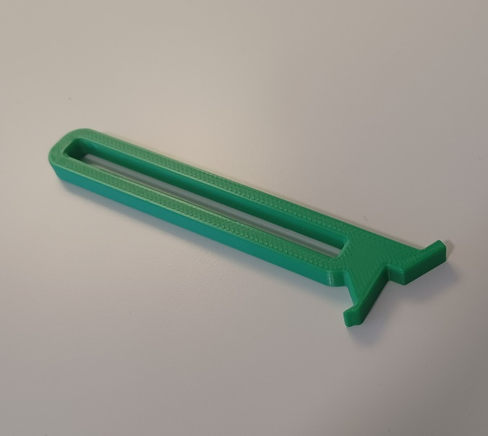

**Handle**

**Hook for Can Pull-Tab**

## Compatibility

This device is compatible with aluminum beverage cans with pull tabs.

Some aluminum cans contain a pull-tab with some graphic or logo in the top hole of the tab, as seen in the left of the photo above. Only cans with a tab like the one shown on the right, with a hole in the top of the tab, can be used with this device.

## Usage

1. Slide the hook of the Can Opener into the hole in the top of the can pull-tab. A picture containing indoor, metalware, lock

   Description automatically generated
2. Grip the Can opener and pull backwards like pulling a lever.

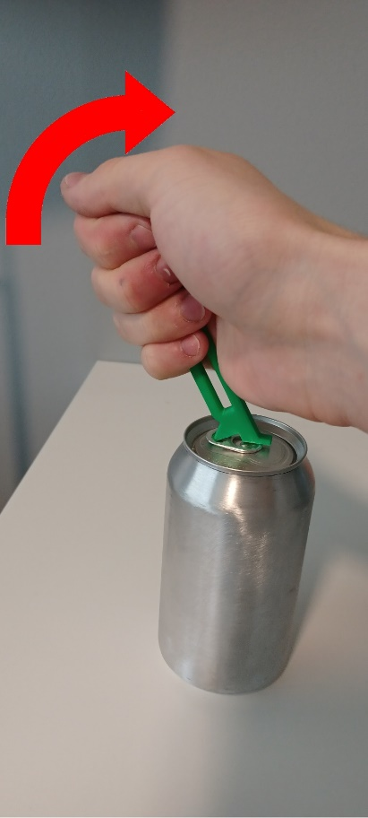

## Specifications

The device should be approximately 106 mm long, 26 mm wide, and 6 mm thick.

## Cleaning

Wipe with sterilizing cloth or spray with sterilizing spray. Do not expose to high heat or wash in dishwasher.