# 3D Printing Summary

|  |  |
| --- | --- |
| **Metrics** | **3D Printed Braille** |
| Total Print Time (min) | 140 |
| Total Number of Components | 19 |
| Typical Total Mass (g) | 18 |
| Typical Number of Print Setups | 19 |

# 3D Printing Settings:

**Important Notes:**

* Ensure all Braille is printed vertically (shown in picture below)
* Print each label individually to eliminate stringing or blobbing in print

|  |  |  |  |  |  |  |  |
| --- | --- | --- | --- | --- | --- | --- | --- |
| **Print File Name** | **Qty** | **Total Print Time (hr:min)** | **Mass (g)** | **Infill (%)** | **Support (Y/N)** | **Layer Height/ Nozzle Diameter(mm)** | **Notes (orientation, special settings, etc)** |
| Nemeth_zero.stl | 1 | 0:07 | .5 | 20 | N | 0.2/0.4 | Print in orientation given in STL. |
| Nemeth_one.stl | 1 | 0:07 | .5 | 20 | N | 0.2/0.4 | Print in orientation given in STL. |
| Nemeth_two.stl | 1 | 0:07 | .5 | 20 | N | 0.2/0.4 | Print in orientation given in STL. |
| Nemeth_three.stl | 1 | 0:07 | .5 | 20 | N | 0.2/0.4 | Print in orientation given in STL. |
| Nemeth_four.stl | 1 | 0:07 | .5 | 20 | N | 0.2/0.4 | Print in orientation given in STL. |
| Nemeth_five.stl | 1 | 0:07 | .5 | 20 | N | 0.2/0.4 | Print in orientation given in STL. |
| Nemeth_six.stl | 1 | 0:07 | .5 | 20 | N | 0.2/0.4 | Print in orientation given in STL. |
| Nemeth_seven.stl | 1 | 0:07 | .5 | 20 | N | 0.2/0.4 | Print in orientation given in STL. |
| Nemeth_eight.stl | 1 | 0:07 | .5 | 20 | N | 0.2/0.4 | Print in orientation given in STL. |
| Nemeth_nine.stl | 1 | 0:07 | .5 | 20 | N | 0.2/0.4 | Print in orientation given in STL. |
| Nemeth_division_sign.stl | 1 | 0:07 | 1 | 20 | N | 0.2/0.4 | Print in orientation given in STL. |
| Nemeth_minus_sign.stl | 1 | 0:07 | 1 | 20 | N | 0.2/0.4 | Print in orientation given in STL. |
| Nemeth_multiplication_sign.stl | 1 | 0:07 | 1 | 20 | N | 0.2/0.4 | Print in orientation given in STL. |
| Nemeth_plus_sign.stl | 1 | 0:07 | 1 | 20 | N | 0.2/0.4 | Print in orientation given in STL. |
| Nemeth_decimal_point.stl | 1 | 0:07 | 1 | 20 | N | 0.2/0.4 | Print in orientation given in STL. |
| Nemeth_enter.stl | 1 | 0:07 | 1 | 20 | N | 0.2/0.4 | Print in orientation given in STL. |
| Nemeth_ground.stl | 1 | 0:07 | 1 | 20 | N | 0.2/0.4 | Print in orientation given in STL. |
| Nemeth_reset.stl | 1 | 0:07 | 1 | 20 | N | 0.2/0.4 | Print in orientation given in STL. |
| Nemeth_start.stl | 1 | 0:07 | 1 | 20 | N | 0.2/0.4 | Print in orientation given in STL. |

# Post-Processing

* If you notice any blobs on the side of the Braille tiles try using a blade to clean up the prints. Braille is hyper specific so any bumps or abnormalities on the print that could affect readability should be removed.

# Customization Options

* Braille is standardized so any changes in the model could render the tiles unreadable. Therefore, **do not:** 
  + Resize the Braille
  + Alter the model in the slicer
  + Change the Braille dot orientation in any way

# Examples of Quality Prints:

* Below are some photos of acceptable prints and one example of what issues can occur if you print all together

**Good Example of Prints Using Above Settings:**

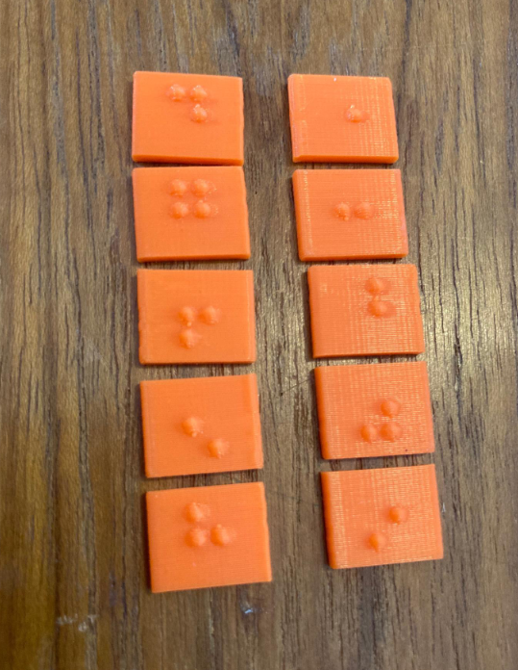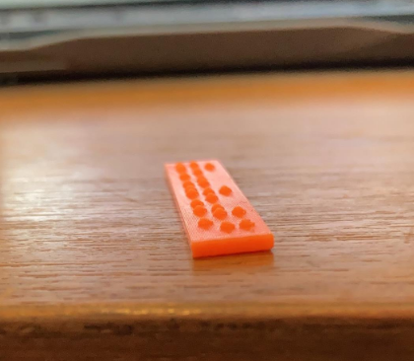

Below is how the Braille should be printed:

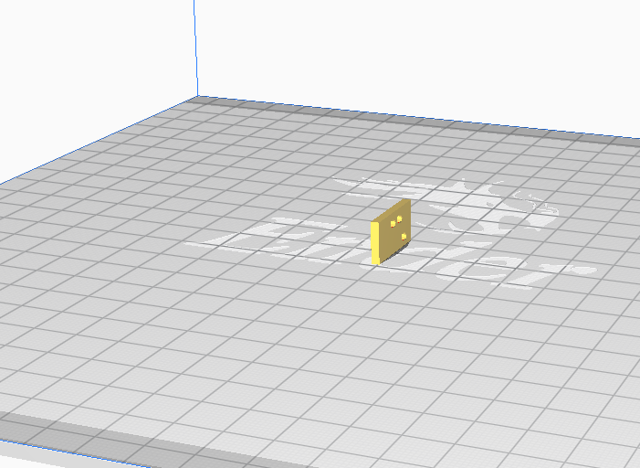

**Example of Stringing When Printed in Groups Rather Than 1 by One:**

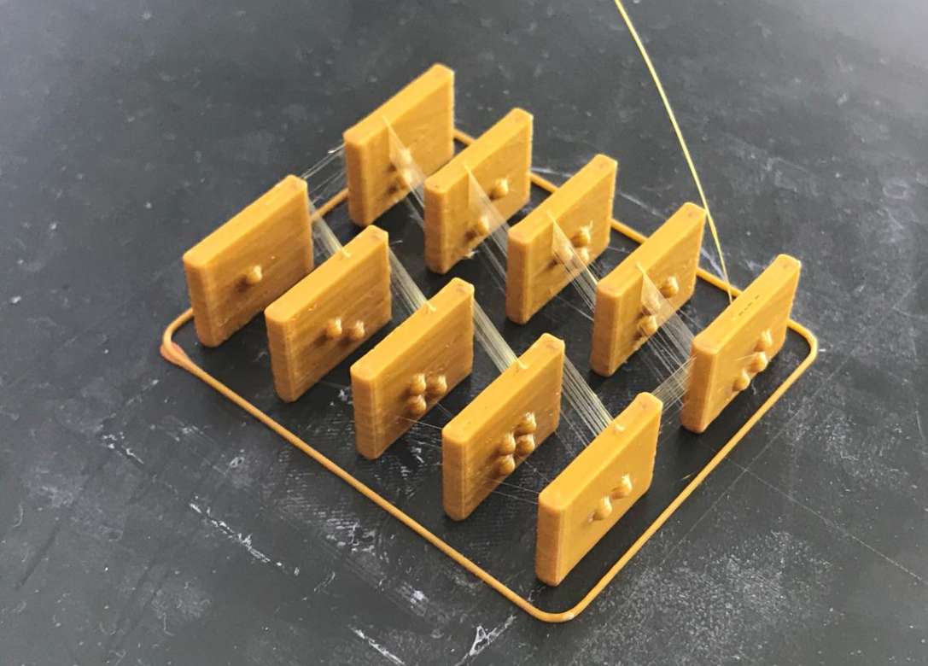

This can occur when printed in batches. May not occur on all printers and can be a relatively simple clean up. But to avoid this please print one Braille tile at a time