**Title**

Camera Mount Adapters for the Logitech Adaptive Gaming Kit.

**Subtitle**

An adapter to fit the various buttons from the Logitech Adaptive Gaming Kit to camera mounts using ¼” – 20 threads.

## Device Specifications

**Stage:** Recently Added

**Designer:** AT Makers

**Material Cost:** $0 - $10

**Disability Type:** Mobility / Physical

**Capabilities Needed:** 3D Printing

**Usage:** Aids for Daily Living (ADL), Mobility, Computer Access

**Difficulty:** Beginner

**Time to Complete:** 1 – 4 hr

**License:** Attribution-ShareAlike 4.0 International

## Device Details

### Overview

The Camera Mount Adapters for Logitech Adaptive Gaming Kit are inexpensive, easy, and quick to build adapters for the four different Buttons from the [Logitech Adaptive Gaming Kit](https://www.logitechg.com/en-us/products/gamepads/adaptive-gaming-kit-accessories.943-000318.html). These adapters allow the buttons to be mounted on standard camera mounting equipment using the standard camera mount threads (¼”-20 UNC). These adapters were originally designed by [ATMakers](http://atmakers.org/) and more information on their switch mounts is available [here](http://atmakers.org/2017/02/at-switch-adapters/).

### Usage

The Camera Mount Adapters for the Logitech Adaptive Gaming Kit are attached to the buttons by two screws. A ¼”-20 threaded T-Nut is attached to the adapter to provide reliable threads for camera mounting equipment such as tripods or mounting arms.

### Sizing

|  |  |  |
| --- | --- | --- |
| **Size** | **Photo of Button** | **Photo of Camera Adapter** |
| Large | Logitech Large button on wood background. | Camera mount adapter for Logitech Large Button on white background. |
| Small | Logitech Small button on wood background. | Camera mount adapter for Logitech Small Button on wood background. |
| Trigger | Logitech Trigger button on wood background. | Camera mount adapter for Logitech Trigger Button on wood background. |
| Light Touch | Logitech Light Touch button on wood background. | Camera mount adapter for Logitech Large Button on wood background. |

**Compatibility**

This device is compatible with the appropriate buttons from the Logitech Adaptive Gaming Kit only.  
[Logitech G Adaptive Gaming Kit for the Xbox - Canada](https://www.logitechg.com/en-ca/products/gamepads/adaptive-gaming-kit-accessories.943-000318.html)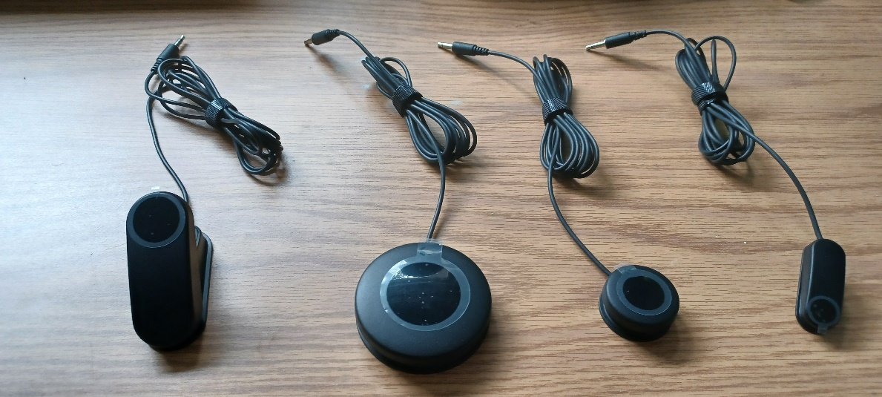

### Camera Mounting Options:

Some possible mounting options using these camera mount adapters are tripods, flexible “gooseneck” mounts or a magic arm as shown below:

### Cost

The total cost of this device includes the cost of the PLA filament used to print the device, the T-Nut used to provide threads, and the two screws used to attach the device to the appropriate Logitech Button.

The total cost of one mount comes to approximately $2.26 (price calculated using the largest and most expensive mount).

The total cost of the full kit (12 mounts) comes to approximately $26.15.

A ¼” washer and a ¼” – 20 screw (at least ½” length) are temporarily needed to install the T-Nut. If needed to purchase, this will increase the cost of the device to approximately $2.  
  
A more complete Bill of Materials is provided in the BOM spreadsheet in the linked GitHub repository.

### Build Instructions

This device consists of a single 3D-Printed part, two screws and one T-Nut. The necessary files and instructions for 3D printing as well as the assembly guide are in the linked GitHub Repository.

#### Skills Required

* **3D Printing**

#### Time Required

For single mount:

* **3D printing** ~1.5 hours
* **Assembly** ~10 minutes

For full kit:

* **3D printing** ~11.57 hours
* **Assembly** ~30 minutes

#### Tools

* 3D Printer
* Screwdriver
* ¼”-20 machine screw (at least ½” length) and washer for assembly.

#### Components

* 3D-Printed housing.
* ¼”-20 Barbed T-Nut 5/16” barrel length.
* 2x M3 x 8mm machine screws.

#### 3D Printing

Refer to the 3D Printing Guide available in the Linked GitHub Repository.

### Attribution

[Original design](https://www.thingiverse.com/thing:4128904) created by [ATMakers](http://atmakers.org/) under the CC BY-SA 3.0 license.

Documentation, modified design, design files and build files created by Neil Squire / Makers Making Change under the CC BY-SA 4.0 license