## Introduction

The Camera Mount Adapters for the Logitech Adaptive Gaming Kit provides a way to attach the various buttons from the Logitech Adaptive Gaming Kit to standard ¼”-20-inch camera mounting systems.

## Features

Threads to attach to Camera mount.

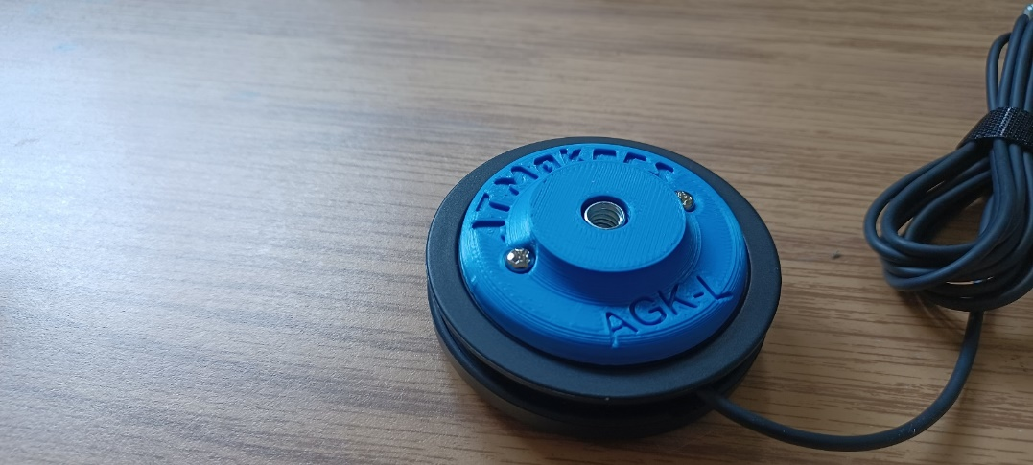

Screws to attach to Logitech button.

## Sizing

There are for different adapters to suit the different sizes of buttons from the Logitech adaptive gaming kit:

|  |  |  |
| --- | --- | --- |
| **Size** | **Button** | **Camera Mount Adapter** |
| Large | Logitech Large button on wood background. | Camera mount adapter for Logitech Large Button on white background. |
| Small | Logitech Small button on wood background. | Camera mount adapter for Logitech Small Button on wood background. |
| Trigger | Logitech Trigger button on wood background. | Camera mount adapter for Logitech Trigger Button on wood background. |
| Light Touch | Logitech Light Touch button on wood background. | Camera mount adapter for Logitech Large Button on wood background. |

### Installation

To attach the adapter to the Logitech Switches, place two M3 x 8 mm machine screws into the adapter. Line up the screw with the holes in the appropriate button and tighten the screws.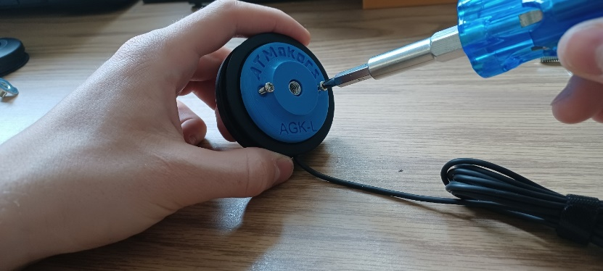

To use with a camera mount, simply screw the camera mount threads into the adapter and adjust camera mount to the desired location.

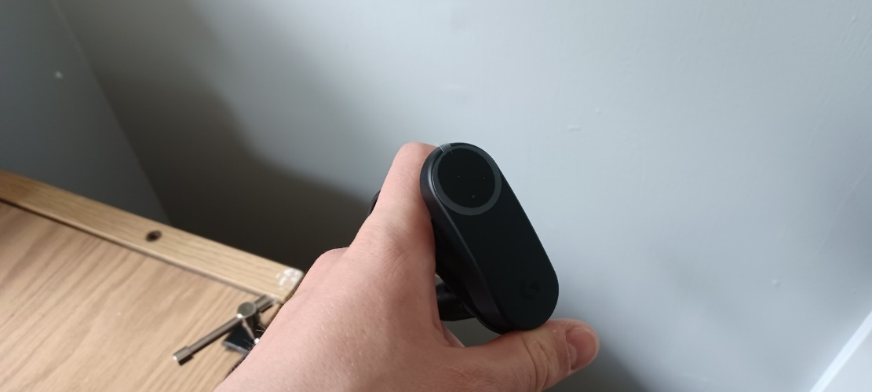

## Cleaning

Wipe with sterilizing cloth or spray.