# Introduction

The Can Stabilizer is an aid that helps stabilize a beverage can so that a user with limited hand dexterity can more easily and more confidently open the can or pick it up independently with less fear of knocking it over.

# Research

Beverage cans are available in a variety of sizes but fall under 3 diameters: 53 mm (202), 58 mm (204.5) and 66 mm (211)[1]. The 66 mm size is the one used in the standard 355 ml / 12 fl oz can most used in North America.

# Requirements

## Goals

|  |  |
| --- | --- |
| G01 | Stabilize the can so user can open or form a grip without fear of knocking it over. |

## Functional Requirements

|  |  |
| --- | --- |
| F01 | The device must allow the can to be easily inserted. |
| F02 | The device must prevent the inserted can from being knocked over while being opened. |
| F03 | The device must allow the can to be easily removed. |

# Design

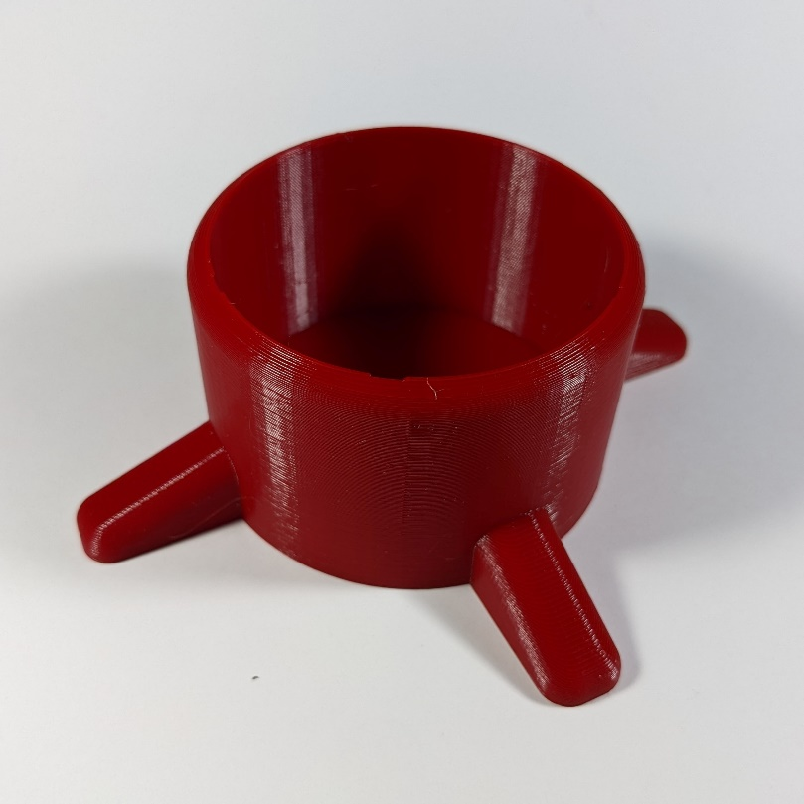

This design consists of a cylindrical sleeve with 4 stabilizing arms that extend outwards.

# Opportunities for Improvement

* Add material on the bottom to make it grip better (e.g., Non-slip material like Dycem)
* Add a chamfered or bevel to the top inside edge of the stabilizer to make it easier (i.e., require less positional accuracy) to insert the can
* Add holes to the bottom of the stabilizer to allow air to escape when the can is removed and inserted to make it easier to insert and remove the can.
* Create variants to accommodate additional can sizes
* Add chamfer to bottom printing edge to reduce risk of abrasion

1. <https://www.crowncork.com/beverage-packaging/beverage-cans>