# Overview

This document contains the necessary information to build a Can Stabilizer.

Contents

Overview 1

Maker Checklist 2

Maker To Do List 2

Items to Give to User 2

Tool List 3

Customization Guide 4

Aesthetics 4

Personalization 4

3D Printing Guide 5

3D Printing Summary 5

3D Printing Settings 5

Post-Processing 5

Examples of Quality Prints 5

Assembly Guide 6

Testing 6

# Maker Checklist

This list provides an overview of the steps required to build and deliver the device.

## Maker To Do List

* Read through the Assembly Guide to become familiar with required components, tools, supplies, and safety gear and overall assembly steps.
* Talk to User about customization options (e.g., color, any special requests, etc.)
* Gather tools, supplies, and safety equipment.
* 3D print the device
* Post process the 3d Print
* Test device
* Print “User Quick Guide”

## Items to Give to User

* Assembled, tested device
* “User Quick Guide”

# Tool List

* Hobby knife (Post processing)
* Sand paper (Post processing)

# Customization Guide

## Aesthetics

The Can Stabilizer can be printed in one or more colours. Layer switching can be used to print in multiple colors.

## Personalization

The print files could be modified to include text such as a name or initials on the outside of the Can Stabilizer.

# 3D Printing Guide

## 3D Printing Summary

|  |  |
| --- | --- |
| **Metrics** | **V3** |
| Total Print Time (min) | 152 |
| Total Number of Components | 1 |
| Typical Total Mass (g) | 52 |
| Typical Number of Print Setups | 1 |

## 3D Printing Settings

|  |  |  |  |  |  |  |  |
| --- | --- | --- | --- | --- | --- | --- | --- |
| **Print File Name** | **Qty** | **Total Print Time (hr:min)** | **Mass (g)** | **Infill (%)** | **Support(Y/N)** | **Layer Height/ Nozzle Diameter(mm)** | **Notes** |
| Can-Stabilizer-v3.1.stl | 1 | 2:32 | 52 | 20 | N | 0.3/0.4 |  |

## Post-Processing

Ensure there are no rough edges on the print.

## Examples of Quality Prints

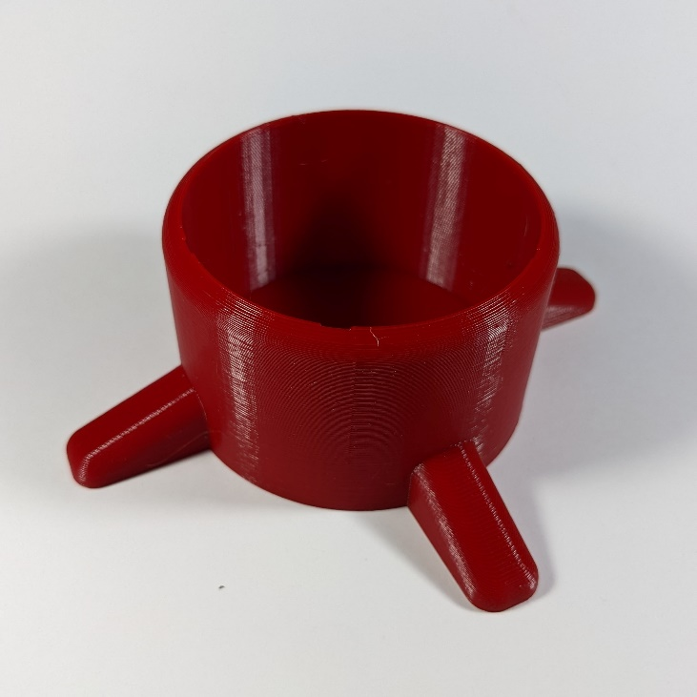

# Assembly Guide

This device devices requires no assembly.

# Testing

Before delivery to the user, the device should be tested by inserting the intended beverage can.