## Introduction

The Can Stabilizer is an aid intended to stabilize a standard sized beverage can to make it easier to open or form a grip for those with limited hand dexterity.

## Features

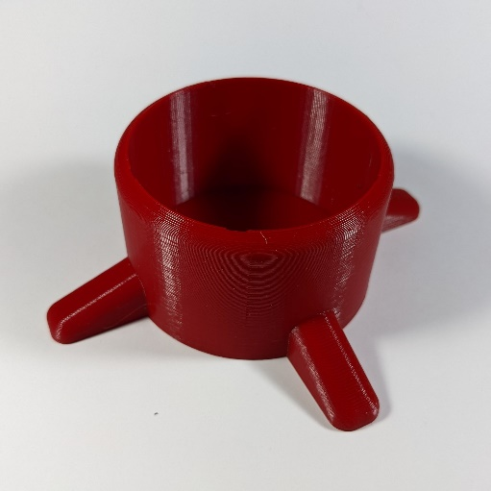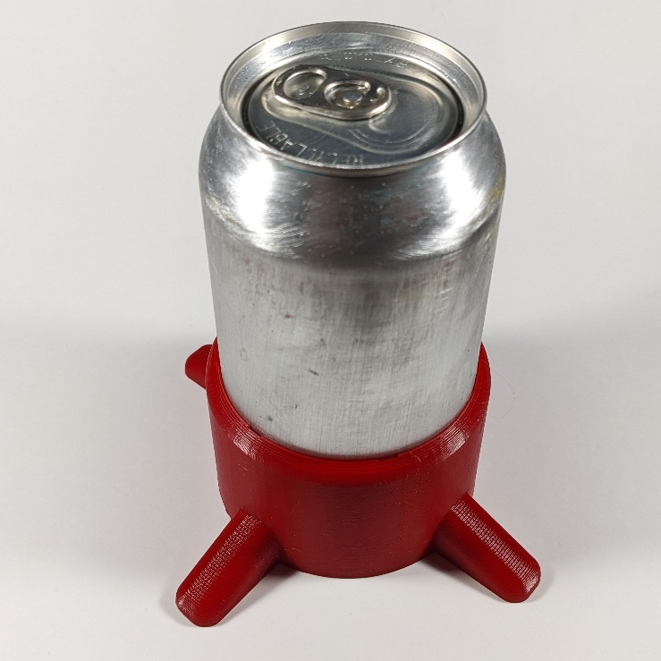

## Usage

Place the Can Stabilizer on a flat steady surface. Insert and remove a beverage can as needed.

## Compatibility

This design is intended for beverage cans with an outer diameter of 66 mm. This is the standard 355 mL / 12 fl oz size.

## Cleaning

The device can be wiped clean with a damp cloth. Do not expose to high temperatures (e.g., dishwasher).